As filed with the Securities and Exchange Commission on March 26, 2026

Registration No. 333-

UNITED STATES

SECURITIES AND EXCHANGE COMMISSION

Washington, D.C. 20549

FORM F-3

REGISTRATION STATEMENT UNDER THE SECURITIES ACT OF 1933

Helport AI Limited

(Exact name of registrant as specified in its charter)

British Virgin Islands |  | N/A
(State or other jurisdiction of |  | (I.R.S. Employer
incorporation or organization) |  | Identification Number)

9 Temasek Boulevard #07-00, Suntec Tower Two,

Singapore 038989

(Address, including zip code, and telephone number, including area code, of registrant’s principal executive offices)

Helport AI, Inc

9171 Towne Centre Dr., Suite 335

San Diego, CA 92122

858-925-3271

(Name, address, including zip code, and telephone number, including area code, of agent for service)

Copies to:

Ying Li, Esq.

Lisa Forcht, Esq.

Hunter Taubman Fischer & Li, LLC

950 Third Avenue, 19th Floor

New York, NY 10022

Tel: (212) 530-2206

Facsimile: (212) 202-6380

Approximate date of commencement of proposed sale to the public: From time to time after the effective date of the registration statement.

If the only securities being registered on this Form are being offered pursuant to dividend or interest reinvestment plans, please check the following box. ☐

If any of the securities being registered on this Form are to be offered on a delayed or continuous basis pursuant to Rule 415 under the Securities Act of 1933, check the following box. ☒

If this Form is filed to register additional securities for an offering pursuant to Rule 462(b) under the Securities Act, please check the following box and list the Securities Act registration statement number of the earlier effective registration statement for the same offering. ☐

If this Form is a post-effective amendment filed pursuant to Rule 462(c) under the Securities Act, check the following box and list the Securities Act registration statement number of the earlier effective registration statement for the same offering. ☐

If this Form is a registration statement pursuant to General Instruction I.C. or a post-effective amendment thereto that shall become effective upon filing with the Commission pursuant to Rule 462(e) under the Securities Act, check the following box. ☐

If this Form is a post-effective amendment to a registration statement filed pursuant to General Instruction I.C. filed to register additional securities or additional classes of securities pursuant to Rule 413(b) under the Securities Act, check the following box. ☐

Indicate by check mark whether the registrant is an emerging growth company as defined in Rule 405 of the Securities Act of 1933.

Emerging growth company ☒

If an emerging growth company that prepares its financial statements in accordance with U.S. GAAP, indicate by check mark if the registrant has elected not to use the extended transition period for complying with any new or revised financial accounting standards† provided pursuant to Section 7(a)(2)(B) of the Securities Act. ☐

- The term “new or revised financial accounting standard” refers to any update issued by the Financial Accounting Standards Board to its Accounting Standards Codification after April 5, 2012.

The Registrant hereby amends this registration statement on such date or dates as may be necessary to delay its effective date until the registrant shall file a further amendment that specifically states that this registration statement shall thereafter become effective in accordance with Section 8(a) of the Securities Act of 1933, as amended, or until this registration statement shall become effective on such date as the Securities and Exchange Commission, acting pursuant to said Section 8(a), may determine.

The information in this prospectus is not complete and may be changed. We may not sell these securities until the registration statement filed with the Securities and Exchange Commission is effective. This prospectus is not an offer to sell these securities and it is not soliciting an offer to buy these securities in any state where the offer or sale is not permitted.

SUBJECT TO COMPLETION, DATED MARCH 26, 2026

PROSPECTUS

Helport AI Limited

$100,000,000 of

Ordinary Shares

Preferred Shares

Debt Securities

Warrants

Units

and

Rights

and

215,942 Ordinary Shares offered by Selling Shareholders

We may, from time to time in one or more offerings, offer and sell up to $100,000,000 in the aggregate of ordinary shares, par value $0.0001 (the “Ordinary Shares”), preferred shares, warrants to purchase Ordinary Shares or preferred shares, debt securities, rights or any combination of the foregoing, either individually or as units comprised of one or more of the other securities. The prospectus supplement for each offering of securities will describe in detail the plan of distribution for that offering. For general information about the distribution of securities offered, please see “Plan of Distribution” in this prospectus.

This prospectus also related to the resale by certain selling shareholders (the “Selling Shareholders”) described herein of an aggregate of 215,942 Ordinary Shares of Helport AI Limited (the “Resale Shares”). The Resale Shares were issued pursuant to two subscription agreements dated October 2, 2025, and November 15, 2025, respectively. The Selling Shareholders may, from time to time, sell, transfer, or otherwise dispose of any or all of their Resale Shares registered herein on any stock exchange, market, or trading facility on which the Resale Shares are traded or in private transactions. These dispositions may be at fixed prices, at prevailing market prices at the time of sale, at prices related to the prevailing market price, at varying prices determined at the time of sale, or at negotiated prices. We will not receive any of the proceeds from the sale or other disposition by the Selling Shareholders of their Resale Shares, but we will bear all costs, fees and expenses in connection with the registration of the Resale Shares. The Selling Shareholders will bear all commissions and discounts, if any, attributable to the sale of their Resale Shares offered for resale through this prospectus. For information regarding the Selling Shareholders and the times and manner in which they may offer or sell the Resale Shares, see “Selling Shareholders” and “Plan of Distribution.”

This prospectus provides a general description of the securities we or the Selling Shareholders may offer. We will provide the specific terms of the securities offered in one or more supplements to this prospectus. We may also authorize one or more free writing prospectuses to be provided to you in connection with these offerings. The prospectus supplement and any related free writing prospectus may add, update or change information contained in this prospectus. You should read carefully this prospectus, the applicable prospectus supplement and any related free writing prospectus, as well as the documents incorporated or deemed to be incorporated by reference, before you invest in any of our securities. This prospectus may not be used to offer or sell any securities unless accompanied by the applicable prospectus supplement.

Pursuant to General Instruction I.B.5. of Form F-3, in no event will we sell the securities covered hereby in a public primary offering with a value exceeding more than one-third of the aggregate market value of our Ordinary Shares in any 12-month period so long as the aggregate market value of our outstanding voting and non-voting Ordinary Shares held by non-affiliates is below $75 million. During the 12 calendar months prior to and including the date of this prospectus, we have not offered or sold any securities pursuant to General Instruction I.B.5 of Form F-3. The aggregate market value of our outstanding voting and non-voting Ordinary Shares held by non-affiliates as of March 26, 2026 was approximately $66.58 million based on the closing price of $3.30 per Ordinary Share on January 27, 2026 and 20,177,224 Ordinary Shares held by non-affiliates as of March 26, 2026.

Our Ordinary Shares and Warrants, with each whole Warrant entitling the holder thereof to purchase one Ordinary Share at a purchase price of $11.50 per share (the “Warrants”), are listed on the Nasdaq Capital Market under the symbols “HPAI” and “HPAIW”, respectively. The applicable prospectus supplement will contain information, where applicable, as to other listings, if any, on the Nasdaq Capital Market or other securities exchange of the securities covered by the prospectus supplement.

Investing in our securities involves a high degree of risk. See “Risk Factors” on page 6 of this prospectus and in the documents incorporated by reference in this prospectus, as updated in the applicable prospectus supplement, any related free writing prospectus and other future filings we make with the U.S. Securities and Exchange Commission (the “SEC”) that are incorporated by reference into this prospectus, for a discussion of the factors you should consider carefully before deciding to purchase our securities.

We and the Selling Shareholders may sell these securities directly to investors, through agents designated from time to time or to or through underwriters or dealers. For additional information on the methods of sale, you should refer to the section entitled “Plan of Distribution” in this prospectus. If any underwriters are involved in the sale of any securities with respect to which this prospectus is being delivered, the names of such underwriters and any applicable commissions or discounts will be set forth in a prospectus supplement. The price to the public of such securities and the net proceeds we expect to receive from such sale will also be set forth in a prospectus supplement.

Neither the SEC nor any state securities commission has approved or disapproved of these securities or determined if this prospectus is truthful or complete. Any representation to the contrary is a criminal offense.

The date of this prospectus is | , 2026.

 |  |  |  |  |  |  |  |  |  |  |  |  |  |  |  | TABLE OF CONTENTS
 |  |  |  |  |  |  |  |  |  |  |  |  |  |  |  |  | Page
About this Prospectus |  |  |  |  |  |  |  |  |  |  |  |  |  |  |  |  | ii
Note Regarding Forward-Looking Statements |  |  |  |  |  |  |  |  |  |  |  |  |  |  |  |  | iii
Prospectus Summary |  |  |  |  |  |  |  |  |  |  |  |  |  |  |  | 1
Risk Factors |  |  |  |  |  |  |  |  |  |  |  |  |  |  |  | 6
Use of Proceeds |  |  |  |  |  |  |  |  |  |  |  |  |  |  |  | 17
Dilution |  |  |  |  |  |  |  |  |  |  |  |  |  |  |  | 17
Description of the Securities We May Offer |  |  |  |  |  |  |  |  |  |  |  |  |  |  |  | 18
Selling Shareholders |  |  |  |  |  |  |  |  |  |  |  |  |  |  |  | 29
Plan of Distribution |  |  |  |  |  |  |  |  |  |  |  |  |  |  |  | 30
Legal Matters |  |  |  |  |  |  |  |  |  |  |  |  |  |  |  | 32
Experts |  |  |  |  |  |  |  |  |  |  |  |  |  |  |  | 32
Financial Information |  |  |  |  |  |  |  |  |  |  |  |  |  |  |  | 32
Information Incorporated by Reference |  |  |  |  |  |  |  |  |  |  |  |  |  |  |  | 33
Where You Can Find More Information |  |  |  |  |  |  |  |  |  |  |  |  |  |  |  | 34
Enforceability of Civil Liabilities |  |  |  |  |  |  |  |  |  |  |  |  |  |  |  | 34
Indemnification for Securities Act Liabilities |  |  |  |  |  |  |  |  |  |  |  |  |  |  |  | 36

i

ABOUT THIS PROSPECTUS

This prospectus is part of a registration statement that we filed with the Securities and Exchange Commission, or the SEC, under the Securities Act of 1933, as amended, or the Securities Act, using a “shelf” registration process. Under this shelf registration process, we may from time to time sell ordinary shares, preferred shares, warrants to purchase ordinary shares or preferred shares, debt securities or any combination of the foregoing, either individually or as units comprised of one or more of the other securities, in one or more offerings up to a total dollar amount of $100,000,000, and the selling shareholders (the “Selling Shareholders”) referred to in this prospectus and identified in supplements to this prospectus may sell up to an aggregate of 215,942 Ordinary Shares, par value $0.0001 per share (the “Resale Shares”). We have provided to you in this prospectus a general description of the securities we and the Selling Shareholders may offer. Each time we sell securities under this shelf registration, we will, to the extent required by law, provide a prospectus supplement that will contain specific information about the terms of that offering. We may also authorize one or more free writing prospectuses to be provided to you that may contain material information relating to these offerings. The prospectus supplement and any related free writing prospectus that we may authorize to be provided to you may also add, update or change information contained in this prospectus or in any documents that we have incorporated by reference into this prospectus. Notwithstanding the foregoing, the Selling Shareholders may sell their Resale Shares offered by them and registered hereby without being accompanied by a prospectus supplement. To the extent there is a conflict between the information contained in this prospectus and the prospectus supplement or any related free writing prospectus, you should rely on the information in the prospectus supplement or the related free writing prospectus; provided that if any statement in one of these documents is inconsistent with a statement in another document having a later date – for example, a document filed after the date of this prospectus and incorporated by reference into this prospectus or any prospectus supplement or any related free writing prospectus – the statement in the document having the later date modifies or supersedes the earlier statement.

Neither we nor the Selling Shareholders have authorized any dealer, agent or other person to give any information or to make any representation other than those contained or incorporated by reference in this prospectus and any accompanying prospectus supplement, or any related free writing prospectus that we may authorize to be provided to you. You must not rely upon any information or representation not contained or incorporated by reference in this prospectus or an accompanying prospectus supplement, or any related free writing prospectus that we may authorize to be provided to you. This prospectus and the accompanying prospectus supplement, if any, do not constitute an offer to sell or the solicitation of an offer to buy any securities other than the registered securities to which they relate, nor do this prospectus and the accompanying prospectus supplement constitute an offer to sell or the solicitation of an offer to buy securities in any jurisdiction to any person to whom it is unlawful to make such offer or solicitation in such jurisdiction. You should not assume that the information contained in this prospectus, any applicable prospectus supplement or any related free writing prospectus is accurate on any date subsequent to the date set forth on the front of the document or that any information we have incorporated by reference is correct on any date subsequent to the date of the document incorporated by reference (as our business, financial condition, results of operations and prospects may have changed since that date), even though this prospectus, any applicable prospectus supplement or any related free writing prospectus is delivered or securities are sold on a later date.

The Selling Shareholders are not offering to sell or seeking offers to purchase securities in any jurisdiction where the offer or sale is not permitted. Neither we nor the Selling Shareholders have done anything that would permit this offering or possession or distribution of this prospectus in any jurisdiction where action for that purpose is required, other than the United States. Persons outside the jurisdiction of the United States who come into possession of this prospectus are required to inform themselves about and to observe any restrictions relating to this offering and distribution of this prospectus applicable to that jurisdiction.

As permitted by SEC rules and regulations, the registration statement of which this prospectus forms a part includes additional information not contained in this prospectus. You may read the registration statement and the other reports we file with the SEC at its website or at its offices described below under “Where You Can Find More Information.”

Unless the context otherwise requires, all references in this prospectus to “Helport AI,” “we,” “us,” “our,” the “Company,” the “Registrant” or similar words refer to Helport AI Limited, together with our subsidiaries.

ii

NOTE REGARDING FORWARD-LOOKING STATEMENTS

This prospectus and our SEC filings that are incorporated by reference into this prospectus contain or incorporate by reference forward-looking statements within the meaning of Section 27A of the Securities Act and Section 21E of the Exchange Act. All statements other than statements of historical fact are “forward-looking statements,” including any projections of earnings, revenue or other financial items, any statements of the plans, strategies and objectives of management for future operations, any statements concerning proposed new projects or other developments, any statements regarding future economic conditions or performance, any statements of management’s beliefs, goals, strategies, intentions and objectives, and any statements of assumptions underlying any of the foregoing. The words “believe,” “anticipate,” “estimate,” “plan,” “expect,” “intend,” “may,” “could,” “should,” “potential,” “likely,” “projects,” “continue,” “will,” and “would” and any variation of the foregoing and similar expressions are intended to identify forward-looking statements, although not all forward-looking statements contain these identifying words. Forward-looking statements reflect our current views with respect to future events, are based on assumptions and are subject to risks and uncertainties. We cannot guarantee that we actually will achieve the plans, intentions or expectations expressed in our forward-looking statements and you should not place undue reliance on these statements. There are a number of important factors that could cause our actual results to differ materially from those indicated or implied by forward-looking statements. These important factors include those discussed under the heading “Risk Factors” contained or incorporated by reference in this prospectus and in the applicable prospectus supplement and any free writing prospectus we may authorize for use in connection with a specific offering. These factors and the other cautionary statements made in this prospectus should be read as being applicable to all related forward-looking statements whenever they appear in this prospectus. Except as required by law, we undertake no obligation to update publicly any forward-looking statements, whether as a result of new information, future events or otherwise.

iii


PROSPECTUS SUMMARY

This summary highlights certain information appearing elsewhere in this prospectus and in the documents we incorporate by reference into this prospectus. The summary is not complete and does not contain all of the information that you should consider before investing in our Ordinary Shares. After you read this summary, you should read and consider carefully the entire prospectus and any prospectus supplement and the more detailed information and financial statements and related notes that are incorporated by reference into this prospectus and any prospectus supplement. If you invest in our Ordinary Share, you are assuming a high degree of risk.

Business Overview

We are an AI technology company dual-headquartered in Singapore and San Diego, California, U.S. We are committed to assisting enterprises in accelerating sales growth and improving customer satisfaction through AI-powered customer engagement. Our proprietary offering, Helport AI Assist software (“AI Assist”), provides real-time intelligent guidance for customer engagement professionals in business settings. In addition, we provide AI+BPO (Business Process Outsourcing) services to facilitate customer engagement, assisting our clients in achieving optimal sales performance and cost reduction.

For the fiscal year ended June 30, 2025, we introduced new product offerings to further expand our portfolio of AI-driven solutions. “HelportGo”, is our flagship mobile application designed to improve productivity for on-the-go professionals. Extending enterprise-grade AI capabilities directly to individual users on demand, HelportGo is designed to offer immediate, transformative call assistance to facilitate conversion into structured, actionable business intelligence.

“Helport Remote”, the second product we introduced in 2025, is a workforce monitoring and management tool designed to support the evolving needs of remote contact centers. Engineered specifically for large-scale, multinational contact center operations, Helport Remote aims to empower management teams to achieve greater visibility, control, compliance, and efficiency in an increasingly decentralized workforce environment.

Finally, we are introducing “HyperX”, a digital, autonomous agent platform designed to transform enterprise knowledge into action. Trained on companies’ proprietary data, HyperX enables one-click deployment of digital, expert AI agents capable of understanding complex operations, executing tasks, and interacting with users across digital environments.

“AI Assist” is software that targets professionals as its users, which include enterprises’ customer contact center representatives as well as other sales professionals, such as real estate sales brokers, insurance sales brokers, and mortgage sales brokers, etc. AI Assist features four primary functions, including “Agent Assistant”, “QA Assistant”, “Supervisor Assistant”, and “Knowledge Base Assistant”. “Agent Assistant” is a feature that provides real-time speech guidance to customer engagement agents and professionals. It also has features such as flexible learning, training, testing, and certification, designed to shorten the training time of newly hired customer engagement agents and reduce enterprises’ costs of training and hiring customer engagement staff. The “QA Assistant” feature is designed to ensure that the agents’ conversations with customers are legally compliant and conform to internal company standards, while also providing real-time alerts for non-compliant situations and suggestions for remedial corrections for the agents. The “Supervisor Assistant” function offers supervisors with real-time, quantitative visibility of all team members. The “Knowledge Base Assistant” function enables rapid construction of knowledge bases (utilizing large language models) and the continuous upgrading of such knowledge bases, which is one of our key capabilities for AI training and labeling. With these functions, we believe that AI Assist is an all-in-one tool that helps companies enhance customer engagement efficiency and can assist them in their efforts to achieve exceptional sales performance.

For clients in need of customer engagement professionals, we offer our AI+BPO service, which combines AI software with customer contact agents. With this service offering, we provide customer contact agents who utilize our AI Assist software to perform their tasks. In this way, we help clients enjoy flexible, outsourced professional services while showcasing the efficacy of our AI software. Our AI technology and digital platform enable real-time remote monitoring of the customer engagement professionals, compliance and quality checks of their work, and knowledge base construction to facilitate customer engagement. Our AI+BPO offering is designed for reducing agent training time while accelerating AI deployment and delivering higher operational and economic efficiency.

1


We have also made progress on “Helphub”, which is an AI integrated contact center BPO platform that serves both companies providing and seeking BPO services. Helphub is a crowdsourcing digital platform for contact center operations, providing enterprise clients with the flexibility to post tasks/jobs on Helphub and monitor the execution process anytime and anywhere. BPO providers, on the other hand, can view and take on projects that fit their expertise, while benefiting from AI-assisted management software. Helphub aims to address the challenges faced by companies as they scale, such as longer training cycles, lack of agent proficiency, and talent shortages. We are continuously refining Helphub across key strategic pillars— including target customer segmentation, quality management methodologies, and partnership models—to lay a foundation for its commercial scaling.

For the fiscal year ended June 30, 2025, we had revenue of $34.9 million, and net income of $1.9 million. Among our revenue sources, the revenue generated from AI services provided under AI Assist contributed 99.4% for the fiscal year ended June 30, 2025. For the fiscal year ended June 30, 2024, we had revenue of $29.5 million, and net income of $7.37 million. Among our revenue sources, the revenue generated from AI services provided under AI Assist contributed 100% for the fiscal year ended June 30, 2024. For the fiscal years ended June 30, 2023, we had revenue of $12.73 million and net income of $4.81 million. Among our revenue sources, the revenue generated from AI services provided under AI Assist contributed 99.70% for the fiscal years ended June 30, 2023 and the revenue generated from medical consulting service contributed 0.30%. The medical consulting business was discontinued after January 2023. We started providing AI service when we launched our key Software as a Service (“SaaS”) product, AI Assist, in April 2022, which has become our business focus ever since. For the fiscal years ended June 30, 2025, the revenue generated from AI+BPO was $0.2 million. For the fiscal years ended June 30, 2024, and 2023, we did not generate any revenue from AI+BPO.

Recent Developments

On October 2, 2025, the Company entered into a subscription agreement (the “Youth Spring Subscription Agreement”) with Youth Spring Limited, a Samoa company (“Youth Spring”). Pursuant to the Youth Spring Subscription Agreement, Youth Spring agreed to subscribe for and purchase from the Company, and the Company agreed to issue and sell to Youth Spring, 125,000 Ordinary Shares of the Company, par value US$0.0001 per share, for an aggregate purchase price of $500,000, in accordance with Regulation S under the Securities Act of 1933, as amended (“Regulation S”). On March 25, 2026, the Company issued 125,000 Ordinary Shares to Youth Spring, and the transaction contemplated by the Youth Spring Subscription Agreement was consummated on the same day.

On November 15, 2025, the Company entered into a subscription agreement (the “FountainX Subscription Agreement,” together with Youth Spring Subscription Agreement, the “SPAs”) with FountainX Ltd., a British Virgin Islands company (“FountainX”). Pursuant to the FountainX Subscription Agreement, FountainX agreed to subscribe for and purchase from the Company, and the Company agreed to issue and sell to FountainX, 114,815 Ordinary Shares of the Company, par value US$0.0001 per share, for an aggregate purchase price of $1,240,000, in accordance with Regulation S. On March 25, 2026, the Company issued 90,942 Ordinary Shares to FountainX.

Corporate Information

We are a business company incorporated in the British Virgin Islands. Our principal executive office is located at 9 Temasek Boulevard #07-00, Suntec Tower Two, Singapore 038989. Our telephone number is +65 82336584.

The SEC maintains a website at www.sec.gov which contains in electronic form each of the reports and other information that we have filed electronically with the SEC.

Our agent for service of process in the United States is Helport AI, Inc., 9171 Towne Centre Dr., Suite 335, San Diego, CA 92122.

2

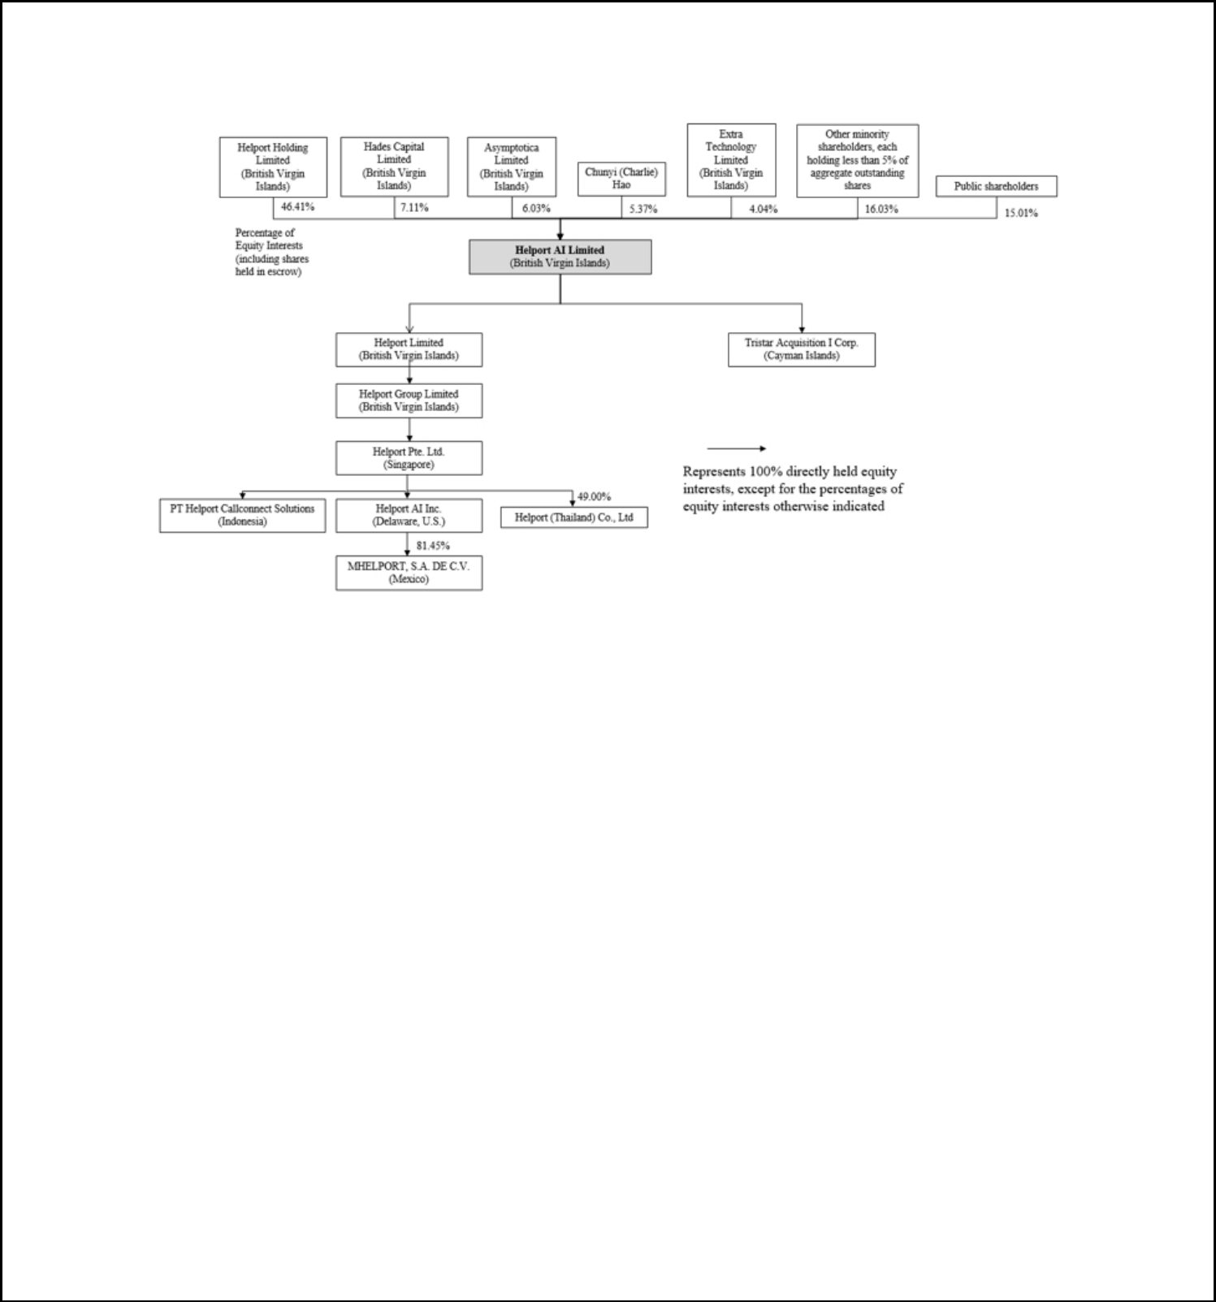
Organizational structure

The following chart illustrates the corporate structure of the Company as of the date of this prospectus.

Private Placement

On October 2, 2025, the Company entered into the Youth Spring Subscription Agreement with Youth Spring. Pursuant to the Youth Spring Subscription Agreement, Youth Spring agreed to subscribe for and purchase from the Company, and the Company agreed to issue and sell to Youth Spring, an aggregate of 125,000 Ordinary Shares of the Company, par value US$0.0001 per share, for an aggregate purchase price of $500,000, in accordance with Regulation S under the Securities Act of 1933, as amended. On March 25, 2026, the Company issued 125,000 Ordinary Shares to Youth Spring, and the transaction contemplated by the Youth Spring Subscription Agreement was consummated on the same day.

On November 15, 2025, the Company entered into the FountainX Subscription Agreement with FountainX Ltd. Pursuant to the FountainX Subscription Agreement, FountainX agreed to subscribe for and purchase from the Company, and the Company agreed to issue and sell to FountainX, 114,815 Ordinary Shares of the Company, par value US$0.0001 per share, for an aggregate purchase price of $1,240,000, in accordance with Regulation S. On March 25, 2026, the Company issued 90,942 Ordinary Shares to FountainX.

The parties to the SPAs have each made customary representations, warranties and covenants, including, among other things, (a) the Purchasers are “non-U.S. Persons” as defined in Regulation S and are acquiring the Shares for the purpose of investment, (b) the absence of any undisclosed material adverse effects, and (c) the absence of legal proceedings that affect the completion of the transaction contemplated by the SPAs.

The form of the SPAs is filed as Exhibit 4.10 to the registration statement on Form F-3, of which this prospectus forms a part. The foregoing is only a brief description of the material terms of the SPAs and does not purport to be a complete description of the rights and obligations of the parties thereunder and is qualified in its entirety by reference to such exhibit.

Summary of Risk Factors

An investment in our securities involves significant risks. Below is a summary of certain material risks we face, organized under relevant headings. These risks are discussed more fully under “Risk Factors” beginning on page 6 of this prospectus and the risk factors set forth in our most recent annual report on Form 20-F, filed on November 17, 2025 (the “2025 Annual Report”). You should carefully consider such risks before making an investment decision. Additional risks not presently known to us or that we currently deem immaterial may also impair our business operations. Our business, financial condition, results of operations or prospects could be materially and adversely affected by any of these risks.

3


Risks Related to Doing Business in the PRC

Risks and uncertainties relating to doing business in the PRC include, but are not limited to, the following:

- You may experience difficulties in effecting service of legal process, enforcing foreign judgments, or bringing actions in China against Helport AI or its management that reside outside the United States based on foreign laws. It may also be difficult for you or overseas regulators to conduct investigations or collect evidence within China (see the risk factor beginning on page 6 of this prospectus);

- Recent greater oversight by the CAC over data security could adversely impact our business (see the risk factor beginning on page 2 of our 2025 Annual Report);

- Changes in China’s economic, political, or social conditions or government policies could have a material adverse effect on our business and operations (see the risk factor beginning on page 3 of our 2025 Annual Report);

- Uncertainties in the interpretation and enforcement of PRC laws and regulations and changes in policies, rules, and regulations in China, which may be quick with little advance notice, could limit the legal protection available to you and us (see the risk factor beginning on page 4 of our 2025 Annual Report);

- Fluctuations in exchange rates could have a material and adverse effect on our results of operations and the value of your investment (see the risk factor beginning on page 4 of our 2025 Annual Report);

- Each of our customers and suppliers has entered into an Authorization for Payment Agreement with our Singapore operating entity and a third-party agent. Our financial condition and liquidity position may be subject to credit risks of the third-party agent (see the risk factor beginning on page 5 of our 2025 Annual Report); and

- If the PRC government imposes further restrictions and limitations on our PRC customers’ ability to transfer or distribute cash overseas., our business, financial condition, and results of operations could be materially adversely affected (see the risk factor beginning on page 6 of our 2025 Annual Report).

Risks Related to Our Business

Risks and uncertainties relating to our business include, but are not limited to, the following:

- Our failure to anticipate or successfully implement new technologies could render our contact-center solution services less competitive and reduce our revenue and market share (see the risk factor beginning on page 8 of this prospectus);

- Our reliance on developer partners for AI product and system development is significant. If these third parties, or their critical staff members, are unable or unwilling to continue their cooperation with us, it could have a detrimental effect on our business (see the risk factor beginning on page 7 of our 2025 Annual Report);

- The use of open-source software in our products may compromise our ability to protect the confidentiality of our proprietary information, potentially harming our business and competitive position (see the risk factor beginning on page 9 of our 2025 Annual Report);

- Our inability to use software licensed from third parties, or our use of open-source software under license terms that interfere with our proprietary rights, could disrupt our business (see the risk factor beginning on page 9 of our 2025 Annual Report);

- We are in the highly competitive AI Contact Integrated Solutions Industry, and we may not be able to compete successfully against existing or new competitors, which could reduce our market share and adversely affect our competitive position and financial performance (see the risk factor beginning on page 8 of this prospectus);

- Our business may rely on a primary supplier or a few customers that account for more than 10% of our total purchases. Interruptions in operations in such major clients or supplier may have an adverse effect on our business, financial condition, and results of operations (see the risk factor beginning on page 10 of our 2025 Annual Report); and

- We rely on third-party cloud computing platforms to develop software and store data. If we fail to maintain our relationships with these platforms, or if the service fees charged by these platforms change to our detriment, our business may be adversely affected (see the risk factor beginning on page 11 of our 2025 Annual Report).

4


Risks Related to Doing Business in Singapore

Risks and uncertainties relating to us doing business in Singapore include, but are not limited to, the following:

- We may rely on dividends and other distributions on equity paid by our subsidiary in Singapore to fund any cash and financing requirements we may have (see the risk factor beginning on page 20 of our 2025 Annual Report).

Risks Related to Our Securities

Risks and uncertainties relating to our securities include, but are not limited to, the following:

- Nasdaq has proposed a new $5 million minimum market value continued listing requirement that, if approved, could result in immediate suspension and delisting of our Ordinary Shares without any cure period or opportunity to regain compliance (see the risk factor beginning on page 14 of this prospectus).

- If we fail to implement and maintain an effective system of internal controls, we may be unable to accurately report our results of operations, meet our reporting obligations, or prevent fraud, and investor confidence and the market price of the Ordinary Shares may be materially and adversely affected (see the risk factor beginning on page 21 of our 2025 Annual Report);

- Helport AI may or may not pay cash dividends in the foreseeable future (see the risk factor beginning on page 22 of our 2025 Annual Report);

- Sales of a substantial number of our securities in the public market by our existing shareholders could cause the price of our securities to fall, and certain Selling Shareholders may earn a positive rate of return on their investment, even if certain other shareholders experience a negative rate of return (see the risk factor beginning on page 13 of this prospectus);

- Provisions in Helport AI’s Amended and Restated Memorandum and Articles of Association may inhibit a takeover of Helport AI, which could limit the price investors might be willing to pay in the future for Helport AI’s securities and could entrench management (see the risk factor beginning on page 22 of our 2025 Annual Report);

- As a “foreign private issuer” under the rules and regulations of the SEC, Helport AI is permitted to file less or different information with the SEC than a company incorporated in the United States or otherwise subject to these rules and is permitted to follow certain home-country corporate governance practices in lieu of certain Nasdaq requirements applicable to U.S. issuers (see the risk factor beginning on page 23 of our 2025 Annual Report);

- The issuance of additional our Ordinary Shares in connection with future financings, acquisitions, investments, the Incentive Plan, or otherwise will dilute all other shareholders (see the risk factor beginning on page 25 of our 2025 Annual Report);

- Our U.S. shareholders may suffer adverse tax consequences if Helport AI is classified as a “passive foreign investment company” (see the risk factor beginning on page 26 of our 2025 Annual Report); and

- Techniques employed by short sellers may drive down the market price of our Ordinary Shares (see the risk factor beginning on page 16 of this prospectus).

5

RISK FACTORS

Investing in our securities involves a high degree of risk. Before you make a decision to invest in our securities, you should consider carefully the risks described below. You should also carefully consider the risk factors set forth under “Risk Factors” described in our 2025 Annual Report, together with all other information contained or incorporated by reference in this prospectus and any applicable prospectus supplement and in any related free writing prospectus in connection with a specific offering, before making an investment decision. Each of the risk factors could materially and adversely affect our business, operating results, financial condition and prospects, as well as the value of an investment in our securities, and the occurrence of any of these risks might cause you to lose all or part of your investment.

Risks Relating to Doing Business in the PRC

You may experience difficulties in effecting service of legal process, enforcing foreign judgments, or bringing actions in China against Helport AI or its management that reside outside the United States based on foreign laws. It may also be difficult for you or overseas regulators to conduct investigations or collect evidence within China.

As a company incorporated under the laws of the British Virgin Islands, we conduct our operations through our subsidiaries, but are reliant upon customers who are based in China. In addition, three out of Helport AI’s five directors and officers;, namely Guanghai Li, Di Shen, and Xinyue (Jasmine) Geffner, reside in the PRC. A substantial portion of the assets of Helport AI’s directors and officers are located outside the United States. As a result, it may be difficult for you to effect service of process upon those persons inside mainland China. It may be difficult for you to enforce judgments obtained in U.S. courts based on civil liability provisions of the U.S. federal securities laws against Helport AI and its officers and directors who do not currently reside in the U.S. or have substantial assets in the U.S. In addition, there is uncertainty as to whether the courts of the British Virgin Islands or the PRC would recognize or enforce judgments of U.S. courts against Helport AI or such persons predicated upon the civil liability provisions of the securities laws of the U.S. or any state.

The recognition and enforcement of foreign judgments are provided for under the PRC Civil Procedures Law. PRC courts may recognize and enforce foreign judgments in accordance with the requirements of the PRC Civil Procedures Law based either on treaties between China and the country where the judgment is made or on principles of reciprocity between jurisdictions. China does not have any treaties or other forms of written arrangement with the United States that provide for the reciprocal recognition and enforcement of foreign judgments. In addition, according to the PRC Civil Procedures Law, the PRC courts will not enforce a foreign judgment against Helport AI or its directors and officers if they decide that the judgment violates the basic principles of PRC laws or national sovereignty, security, or public interest. As a result, it is uncertain whether and on what basis a PRC court would enforce a judgment rendered by a court in the United States.

It may also be difficult for you or overseas regulators to conduct investigations or collect evidence within China. For example, in China, there are significant legal and other obstacles to obtaining information needed for shareholder investigations or litigation outside China or otherwise with respect to foreign entities. Although the authorities in China may establish a regulatory cooperation mechanism with counterparts of another country or region to monitor and oversee cross border securities activities, such regulatory cooperation with the securities regulatory authorities in the United States may not be efficient in the absence of a practical cooperation mechanism. Furthermore, according to Article 177 of the PRC Securities Law (“Article 177”), which became effective in March 2020, no overseas securities regulator is allowed to directly conduct investigations or evidence collection activities within the territory of the PRC. Article 177 further provides that Chinese entities and individuals are not allowed to provide documents or materials related to securities business activities to foreign agencies without prior consent from the securities regulatory authority of the State Council and the competent departments of the State Council. While detailed interpretation of or implementing rules under Article 177 have yet to be promulgated, the inability for an overseas securities regulator to directly conduct investigations or evidence collection activities within China may further increase difficulties faced by you in protecting your interests.

6

Recent greater oversight by the CAC over data security could adversely impact our business.

On December 28, 2021, 13 governmental departments of the PRC, including the Cybersecurity Administration of China, or the CAC, jointly promulgated the Cybersecurity Review Measures, which became effective on February 15, 2022. The Cybersecurity Review Measures provide that net platform operators engaging in data processing activities that affect or may affect national security must be subject to cybersecurity review by the Cybersecurity Review Office of the PRC. On November 14, 2021, the CAC published the Draft Regulations on the Network Data Security Administration (Draft for Comments), which provides that data processing operators engaging in data processing activities that affect or may affect national security must be subject to cybersecurity review by the relevant Cyberspace Administration of the PRC.

As part of our global expansion strategy, we have engaged customers located in countries other than the PRC, which began generating revenue in the fiscal year 2024. However, for the fiscal years ended June 30, 2025 and 2024, substantially all of our revenue was still generated from customers located in the PRC, even though we have no operating entity in the PRC. Our products do not collect personal data from contact center activities, nor do we store any data from such activities. As of the date of this prospectus, neither Helport AI nor any subsidiaries thereof have received any notice from any authorities requiring Helport AI or any of its subsidiaries to undergo cybersecurity review or network data security review. However, since the use of our AI Assist software involves the collection of data and information contained in the contact center operations of our customers in the PRC, we may be subject to certain laws and regulations in China in the future. If any such new laws, regulations, rules, or implementation and interpretation come into effect, we expect to take all reasonable measures and actions to comply and to minimize the adverse effect of such laws on our operations. We cannot guarantee, however, that we will not be subject to cybersecurity review and network data security review in the future. During any such review, Helport may be required to suspend its operations or experience other disruptions to its operations. Cybersecurity review and network data security review could also result in negative publicity with respect to Helport AI, and diversion of its managerial and financial resources, which could materially and adversely affect its business, financial conditions, and results of operations.

Each of our customers and suppliers has entered into an Authorization for Payment Agreement with our Singapore and U.S. operating entity and a third- party agent. Our financial condition and liquidity position may be subject to credit risks of the third-party agent.

Since we have not yet established relevant entities or subsidiaries in the PRC, and because a significant portion of our customers and suppliers are located in the PRC, each of our customers and suppliers has entered into an Authorization for Payment Agreement (collectively, the “Agreements”) with our operating entities, Helport Singapore and Helport US, and a third party agent, Xinsheng Technology (Tianjin) Co., Ltd. (“Xinsheng”), through whom we make payments to our suppliers and receive payments from our customers. The payment amount in each of the Agreements is denoted in U.S. dollars. For details, see “ITEM 4. Information of the Company—B. Business Overview—Major Supplier” and “ITEM 4. Information of the Company—B. Business Overview—Customers, Sales, and Marketing” in our 2025 Annual Report. As of the date of this prospectus, Xinsheng has fulfilled its obligations to transfer the payments guaranteed in each of the Agreements. However, there is no assurance that, in the future, we will be able to successfully enforce Xinsheng’s guarantee, or any other such payment agents’ guarantee. Third-party agents subject to such payment agreements are subject to their own unique operational and financial risks, which are beyond our control. In the event that such agents fail to function properly or breach or terminate their cooperation with us, we may be unable to recover payment from our customers or transfer payment to our suppliers in a timely manner, or at all. This could disrupt our cash flow and lead to a breakdown of our contractual relationship with customers and suppliers. If we are unable to address these issues in a timely and cost-effective manner, our business, financial condition, and results of operations may be adversely affected.

7

Risks Related to Our Business

Our failure to anticipate or successfully implement new technologies could render our contact-center solution services less competitive and reduce our revenue and market share.

We provide data-driven AI technologies to our customers endeavoring to maximize the revenue-generation and customer-retention potential capacities of their contact centers. See “ITEM 4. Information of the Company—B. Business Overview—Competitive Strengths” in our 2025 Annual Report. As of the date of this prospectus, we have two pending patent applications in Singapore. These applications are currently awaiting approval from the authorities. We have also designed and developed effective systems of Gateways to integrate our AI Assist software into contact centers. Nonetheless, the AI Contact Integrated Solutions Industry is characterized by rapid technological advancement, constant improvement of AI products’ learning capabilities and resultant heightening of customers’ expectations, disruption by innovative entrants, and evolving business models and industry standards. This requires us to anticipate well in advance, which technologies we must implement and take advantage of to make our AI products and services competitive in the market. As such, we need to continue to invest significant financial resources in research and development to keep pace with technological advances in order to make our technologies competitive in the market, especially those relating to the intelligence and analytic capability of our core AI product. However, development activities are inherently uncertain, and our expenditures on research and development may not generate commensurate benefits. Given the fast pace with which AI technology has been and will continue to be developed, we may not be able to timely upgrade our data analytics and AI-based technologies, or the algorithm or engines required thereby in an efficient and cost-effective manner, or at all. New technologies in our industry could render the technologies and services that we are developing or expect to develop in the future obsolete or uncompetitive, thereby potentially resulting in a decline in our revenues and market share.

We are in the highly competitive AI Contact Integrated Solutions Industry, and we may not be able to compete successfully against existing or new competitors, which could reduce our market share and adversely affect our competitive position and financial performance.

The contact-center AI technology industry worldwide is competitive and rapidly evolving, with new companies increasingly joining the competition in recent years. AI products and service models in the industry are constantly evolving to adopt new technologies, improve cost efficiency, and meet customers’ rising expectations for more intelligent products. We compete with a value proposition centered on increasing customers’ profitability, enhancing managerial efficiency, and reducing agent mistakes in customers’ contact centers. These metrics are often influenced by factors such as AI efficiency, system integration abilities and industry experience. As of the date of this prospectus, we believe that we are well-positioned to effectively compete in the AI contact-center solutions industry primarily due to (i) our AI technology; (ii) our professional knowledge base; (iii) our industry experience and client base; and (iv) our business model and product offerings. See “ITEM 4. Information of the Company—B. Business Overview— Competition” in our 2025 Annual Report. Nonetheless, as advancement in AI technology is often accompanied by revolutionary effects on its application, sudden and intensive competition can take place unexpectedly in the future. The increased competition may lead to increased costs for customer acquisition and retention, which may result in reduced margins and a loss of market share for us. We compete with other competitors on the following bases:

- the effectiveness and quality of our AI solutions;

- vertical industry knowledge and domain expertise;

- operational capabilities;

- business model;

- brand recognition;

- quality of services both in the initial system installment phase and the subsequent operation maintenance phase;

- effectiveness of sales and marketing efforts; and

- hiring and retention of talented staff.

8

Our competitors may operate with different business models, have different service structures, and may be more successful or more adaptable to new regulatory, technological, and other developments. They may in the future achieve greater market acceptance and recognition and gain a greater market share. It is also possible that potential new competitors may emerge and acquire a significant market share. If existing or potential new competitors develop or offer services that provide significant performance, price, creative optimization, or other advantages over those offered by us, our business, results of operations, and financial condition could be negatively affected. Our existing and potential competitors may enjoy competitive advantages over us, such as greater brand recognition, larger customer base, and better value-added services. We may lose customers if we fail to compete successfully, which could adversely affect our financial performance and business prospects. We cannot guarantee that our strategies will remain competitive or successful in the future. Increasing competition may result in pricing pressure and loss of our market share, either of which could have a material adverse effect on our financial condition and results of operations.

Our business may rely on a primary supplier or a few customers that each account for more than 10% of our total purchases. Interruptions in operations in such major clients or supplier may have an adverse effect on our business, financial condition, and results of operations.

We rely on a few customers that each account for more than 10% of our total sales, who are all contact-center BPO companies for whom we provide our AI Assist product. For the fiscal year ended June 30, 2025, we had three significant customers, namely Beijing Baojiang Science and Technology Co., Ltd. (“Baojiang”), Shenyang Pengbosheng Network Technology Co., Ltd. (“Pengbosheng”), and Shenyang Blue Legend Information Technology Co., Ltd. (“Blue Legend”), which accounted for 27.5%, 25.8% and 16.2% of our total sales, respectively. For the fiscal year ended June 30, 2024, we had two significant customers, Baojiang and Pengbosheng, which accounted for 26.9% and 37.5% of our total sales, respectively. For the fiscal year ended June 30, 2023, we had two significant customers, Baojiang and Pengbosheng, which accounted for 28.4% and 46.3% of our total sales, respectively. No other customers accounted for more than 10% of our total sales during the fiscal years ended June 30, 2025, 2024, and 2023.

As an example of a typical transaction, in accordance with a System Information Technology Service Agreement dated February 1, 2022 between Baojiang and Helport Singapore, our Singapore operating entity, Helport Singapore is required to provide to Baojiang system functional modules for contact centers, as well as custom development and efficiency management services that accompany the modules. For details, see “ITEM 4. Information of the Company—B. Business Overview—The Business Model” in our 2025 Annual Report. The final and billable service fees will be invoiced to Baojiang every month, and the invoiced amount shall be confirmed by Baojiang within three business days.

We also rely on Youfei Shuke as our provider of AI infrastructure and developer partner, who has been our primary technology supplier for the fiscal years ended June 30, 2025, 2024, and 2023. Our partnership typically involves co-modeling and co-developing efforts based on our designs of the AI product and its expected application, and Youfei Shuke’s provision of AI infrastructure. In the fiscal year ended June 30, 2025, there were 29 service agreements between Youfei Shuke and Helport Singapore, all of which relate to the development of AI-driven products designed to enhance our existing products and systems.

Since Youfei Shuke is our primary supplier, our engagement with it may expose us to risks beyond our control. There is the risk that Youfei Shuke may breach or terminate its contracts with us or experience significant disruptions to its operations, causing our contractual relationship to end with little or no prior notice. Since we retain significant control over the development process and the core technology involved, disruptions to our business operations and development efforts in such circumstances would be limited to some extent. However, the heavy involvement of Youfei Shuke in our research and development (“R&D”) projects as our developer partner, including the technical staff it they provides, means that in the event Youfei Shuke disengages from us, we would need to find other technology suppliers as a substitute. If we cannot immediately engage alternative suppliers capable of providing and substituting all of Youfei Shuke’s functions after its potential disengagement, the process of our product development efforts could be delayed, disrupted, or even discontinued. This could render us less competitive and potentially reduce our market share and revenue. As a result, we are actively communicating with other capable suppliers with a view to diversifying our supply source.

9

In view of the above, there is no guarantee that we will not have a concentration of customers or suppliers in the future. Such customers and third-party suppliers are independent entities with their own operational and financial risks that are beyond our control. If any of these customers or suppliers breach or terminate their contracts with us, or experience significant disruptions to their operations, we will be required to find and enter into contracts with one or more customers or suppliers as replacement. It could be costly and time-consuming to find alternative customers and suppliers, and these customers or suppliers may not be available to us at reasonable terms or at all. As a result, this could harm our business and financial results and result in lost or deferred revenue.

Our business generates and processes a large amount of data, and it is required to comply with laws and regulations in multiple jurisdictions relating to data privacy and security. The improper use or disclosure of data could have a material and adverse effect on our business and prospects.

As a product for assisting contact-center agents, AI Assist only collects data from the contact center operating agents but does not collect any data from consumers who engage with the agents. Typically, the product collects data on agents’ operational activities, such as the actions they take and the length and frequency of call, and agents’ basic information, such as their name and contacts. These are common data collected for the type of business we are engaged in. Because AI Assist is installed on our customers’ own cloud database, the data collected by our product is stored on our customers’ cloud database. Our access to customers’ systems is limited, and we have no access to any of their operational data and confidential information. As a result, we do not store any customer or agent data. Data of contact center conversations is transmitted directly to providers of Automatic Speech Recognition technology such as AWS. Our technical staff in charge of assisting customers to build our AI technology into their system only operate on the premises of the customers and on their computer systems. For details, see “ITEM 4. Information of the Company—B. Business Overview—Data Privacy and Security” in our 2025 Annual Report.

On December 28, 2021, 13 governmental departments of the PRC, including the Cybersecurity Administration of China, or the CAC, jointly promulgated the Cybersecurity Review Measures, which became effective on February 15, 2022. The Cybersecurity Review Measures provide that net platform operators engaging in data processing activities that affect or may affect national security must be subject to cybersecurity review by the Cybersecurity Review Office of the PRC. On November 14, 2021, the CAC published the Draft Regulations on the Network Data Security Administration (Draft for Comments), which provides that data processing operators engaging in data processing activities that affect or may affect national security must be subject to cybersecurity review by the relevant Cyberspace Administration of the PRC.

Although we have no operating entity in the PRC, currently substantially all of our revenue is generated from customers located in the PRC. Our products do not collect personal data from contact center activities, nor do we store any data from such activities. As of the date of this prospectus, neither Helport AI nor has any subsidiaries thereof received any notice from any authorities requiring Helport AI or any of its subsidiaries to undergo any cybersecurity review or network data security review. However, since the use of our AI Assist software involves the collection of data and information contained in contact center operations of our customers in the PRC, we may be subject us to certain laws and regulations in China in the future. If any such new laws, regulations, rules, or implementation and interpretations come into effect that may impact Helport AI or any of its subsidiaries, we expect to take all reasonable measures and actions to comply and to minimize the adverse effect of such laws. We cannot guarantee, however, that such entities will not be subject to cybersecurity review and network data security review in the future. During such reviews, Helport Singapore may be required to suspend its operations or experience other disruptions to its operations. Cybersecurity review and network data security review could also result in negative publicity with respect to Helport AI and diversion of its managerial and financial resources, which could materially and adversely affect its business, financial conditions, and results of operations.

As a result of our plans for global expansion of our operations, we may be subject to a variety of laws and regulations in various jurisdictions where we operate, as well as contractual obligations, regarding data privacy, protection, and security. Some of these laws and regulations require obtaining data subjects’ consent to the collection and use of their data, honoring data subjects’ requests to delete their data or limit the processing of their data, providing notifications in the event of a data breach, and setting up the proper legal mechanisms for cross-border data transfers. Some downstream customers may refuse to provide consent to have the data of their contact-center agents collected or may restrict the use of such data. In many cases, these laws and regulations apply not only to the collection and processing of agent data from third-party downstream customers with whom we may not have any contractual relationship, but also to the sharing or transfer of information between or among us, our subsidiaries, and other third parties with which we have commercial relationships, such as our business partners and contact-center BPO customers. The regulatory framework for data privacy, protection, and security worldwide is continuously evolving and developing and, as a result, interpretation and implementation standards and enforcement practices are likely to remain uncertain for the foreseeable future.

10

The legislative and regulatory landscape for data privacy and security continues to evolve in jurisdictions worldwide, with an increasing focus on privacy and data protection issues with the potential to affect our business. In the United States, such privacy and data security laws and regulations include federal laws and regulations such as the federal Controlling the Assault of Non-Solicited Pornography and Marketing Act (“CANPAM Act”), the Telephone Consumer Protection Act, the Do-Not-Call Implementation Act, and rules and regulations promulgated under the authority of the Federal Trade Commission and state laws like the California Consumer Privacy Act (“CCPA”) and the varying data breach notification laws that have been enacted in all 50 U.S. states and the District of Columbia. Further, there currently are a number of additional proposals related to data privacy or security pending before federal, state, and foreign legislative and regulatory bodies, including in a number of U.S. states considering consumer protection laws similar to the CCPA. For example, in March 2021, Virginia enacted the Virginia Consumer Data Protection Act, and in June 2021, Colorado passed the Colorado Privacy Act, both of which are comprehensive privacy statutes that share similarities with the CCPA and CPRA and became effective on January 1, 2023 and July 1, 2023, respectively. Such legislation may add complexity, variation in requirements, restrictions, and potential legal risk, require additional investment in resources to compliance programs, may also impact strategies and availability of previously useful data, and could result in increased compliance costs and/or changes in business practices and policies.

Efforts to comply with these and other data privacy and security restrictions that may be enacted could require us to modify our data processing practices and policies and increase the cost of our operations. Failure to comply with such restrictions could subject us to criminal and civil sanctions and other penalties. In part due to the uncertainty of the legal climate, complying with regulations, and any applicable rules or guidance from regulatory authorities or self-regulatory organizations relating to privacy, data protection, information security, and consumer protection, may result in substantial costs and may necessitate changes to our business practices, which may compromise our growth strategy, adversely affect our ability to attract or retain customers, and otherwise adversely affect our business, reputation, legal exposure, financial condition and results of operations.

Any failure or perceived failure by us to comply with our standard privacy policies, our privacy-related obligations to customers or other third parties, or any other legal obligations or regulatory requirements relating to privacy, data protection, or information security may result in governmental investigations or enforcement actions, litigation, claims (including class actions), or public statements against us by consumer advocacy groups or others and could result in significant liability, cause our customers to lose trust in us, and otherwise materially and adversely affect our reputation and business. Furthermore, the costs of compliance with, and other burdens imposed by, the laws, regulations, and policies that are applicable to us may limit the adoption and use of, and reduce the overall demand for, our products. Additionally, if third parties we work with, such as our service providers or product developer partners, violate applicable laws, regulations, or agreements, such violations may put our users’ and/or employees’ data at risk, could result in governmental investigations or enforcement actions, fines, litigation, claims (including class action claims) or public statements against us by consumer advocacy groups or others and could result in significant liability, cause our customers to lose trust in us and otherwise materially and adversely affect our reputation and business. Further, public scrutiny of, or complaints about, technology companies or their data handling or data protection practices, even if unrelated to our business, industry, or operations, may lead to increased scrutiny of technology companies, including us, and may cause government agencies to enact additional regulatory requirements, or to modify their enforcement or investigation activities, which may increase our costs and risks.

In addition, in some cases, we are dependent upon our cloud computing platform providers, such as AWS, Google Could Platform and Microsoft Azure to solicit, collect, and provide us with information regarding our products that is necessary for compliance with these various types of regulations. Our business, including our ability to operate and expand internationally, could be adversely affected if laws or regulations are adopted, interpreted, or implemented in a manner that is inconsistent with our current business practices and that requires changes to these practices, the design of our products, features or our privacy policy. These platform providers may dictate rules, conduct, or technical features that do not properly comply with federal, state, local, and foreign laws, regulations, and regulatory codes and guidelines governing data privacy, data protection, and security, including with respect to the collection, storage, use, processing, transmission, sharing, and protection of personal information and other consumer data. In addition, these platforms may dictate rules, conduct, or technical features relating to the collection, storage, use, transmission, sharing, and protection of personal information and other customer data, which may result in substantial costs and may necessitate changes to our business practices, which in turn may compromise our growth strategy, adversely affect our ability to attract, monetize or retain customers, and otherwise adversely affect our business, reputation, legal exposures, financial condition and results of operations. Any failure or perceived failure by us to comply with these platform-dictated rules, conduct, or technical features may result in platform-led investigations or enforcement actions, litigation, or public statements against us, which in turn could result in significant liability or temporary or permanent suspension of our business activities with these platforms, cause our customers to lose trust in us, and otherwise compromise our growth strategy, adversely affect our ability to attract, monetize or retain customers, and otherwise adversely affect our business, reputation, legal exposures, financial condition and results of operations.

Customers we engaged are subject to our privacy policy and terms of service. If we fail to comply with our privacy policy or terms of service in service agreements, or if we fail to comply with existing privacy-related or data protection laws and regulations, it could result in complaints by data subjects or proceedings or litigation against us by governmental authorities or others, which could result in fines or judgments against us, damage our reputation, impact our financial condition, and harm our business. If regulators, the media, or consumers raise any concerns about our privacy and data protection or consumer protection practices, even if unfounded, this could also result in fines or judgments against us, damage our reputation, and negatively impact our financial condition and damage our business.

11

If we sustain cyber-attacks or other privacy or data security incidents that result in security breaches, we could be subject to increased costs, liabilities, reputational harm, or other negative consequences.

Our information technology systems and platforms may be subject to cyber-attacks, viruses, malicious software, break-ins, theft, computer hacking, phishing, employee error or malfeasance, or other security breaches. Hackers and data thieves are increasingly sophisticated and operate large-scale and complex automatic hacks. Experienced computer programmers and hackers may be able to penetrate our security controls and misappropriate or compromise sensitive proprietary or confidential information, create system disruptions, or cause shutdowns. They also may be able to develop and deploy malicious software programs that attack our systems or otherwise exploit any security vulnerabilities. Our systems and the data stored on those systems also may be vulnerable to security incidents or security attacks, acts of vandalism or theft, coordinated attacks by activist entities, misplaced or lost data, human errors, or other similar events that could negatively affect our systems and the data stored on or transmitted by those systems, including the user data of our products.

Although we have taken measures to protect sensitive data from unauthorized access, use, or disclosure, our protective measures may not be effective and our information technology may still be vulnerable to attacks. In the event of such attacks, the costs to eliminate or address the foregoing security threats and vulnerability before or after a cyber-incident could potentially be significant. our remediation efforts may not be successful and could result in interruptions or delays of services. As threats related to cyber-attacks develop and grow, we may also find it necessary to take further steps to protect our data and infrastructure, which could be costly and therefore impact our results of operations. In the event that we are unable to prevent, detect, and remediate the foregoing security threats and vulnerabilities in a timely manner, our operations could be interrupted or we could incur financial, legal, or reputational losses arising from misappropriation, misuse, leakage, falsification, or intentional or accidental release or loss of information maintained in our systems. The number and complexity of these threats continue to increase over time. Although we have not experienced any cyber-attacks or other privacy or data security incidents As of the date of this prospectus, and we inspect our systems on a regular basis to prevent these events from occurring, the possibility of these events occurring cannot be eliminated entirely.

Unauthorized use of our intellectual property by third parties and expenses incurred in protecting our intellectual property rights may adversely affect our business, reputation, and competitive edge.

As of the date of this prospectus, we own one domain name, Helport.ai, and have registered four patents in the PRC. As of the date of this prospectus, we have two pending patent applications in Singapore, for which are currently awaiting approval from the authorities. We regard our intellectual property as important to our success, and we rely on a combination of intellectual property laws and contractual arrangements, including confidentiality and non-disclosure agreements, to protect our proprietary rights. For details, please see “ITEM 4. Information of the Company—B. Business Overview—Intellectual Property” in our 2025 Annual Report.

Despite these measures, any of our intellectual property rights could be challenged, invalidated, circumvented, or misappropriated, or such intellectual property may not be sufficient to provide us with competitive advantages. Since our customers are currently mainly located in the PRC, we have also initiated the process of applying for patents in the PRC to protect our technological achievements. As of the date of this prospectus, we have applied for four patents in China, all of which have been granted. However, maintaining and enforcing intellectual property rights may be difficult in the PRC. Statutory laws and regulations are subject to judicial interpretation and enforcement and may not be applied consistently. Confidentiality, invention assignment, and non-compete agreements may be breached by counterparties, and there may not be adequate remedies available to us for any such breach. In addition, we may face challenges when defending our intellectual property rights outside Singapore and the PRC. We plan to expand our businesses to other markets across the globe, including, but not limited to, North America and Southeast Asia, and the process for applying for and registering intellectual property rights varies within each jurisdiction. We may not be able to timely protect our intellectual property rights in these jurisdictions if the expansion of our operations and ensuing intellectual property right infringements take place before we have managed to register our intellectual property rights. Accordingly, we may not be able to effectively protect our intellectual property rights or to enforce our contractual rights in all jurisdictions.

Policing unauthorized use of our proprietary technology and other intellectual property is difficult and expensive, and litigation may be necessary in the future to enforce such intellectual property rights. Future litigation could result in substantial costs and diversion of our resources and could disrupt our business, as well as materially adversely affect our financial condition and results of operations. Further, despite the potentially substantial costs, we cannot assure you that we will prevail in such litigation.

12

If we fail to attract, recruit, or retain our key personnel, including our executive officers, senior management, and key employees, our ongoing operations and growth could be affected.

Our success also depends, to a large extent, on the efforts of our key personnel, including Shuangchi He, a Doctor of Telecommunications Engineering and Operations Research and a key member of Helport Singapore’s Research and Development team, our other executive officers, senior management, and other key employees who have valuable experience, knowledge, and connection in the AI Contact Integrated Solutions Industry. There is no assurance that these key personnel will not voluntarily terminate their employment with us. We do not carry, and do not intend to procure, key person insurance on any of our senior management team. The loss of any of our key personnel could be detrimental to our ongoing operations. Our success will also depend on our ability to attract and retain qualified personnel to manage our existing operations as well as our future growth. We may not be able to successfully attract, recruit, or retain key personnel, and this could adversely impact our financial condition, operating results, and business prospects.

Risks Related to Our Securities

Sales of a substantial number of our securities in the public market by our existing shareholders could cause the price of the Ordinary Shares and Warrants to fall, and certain Selling Shareholders may earn a positive rate of return on their investment, even if certain other shareholders experience a negative rate of return.

Sales of substantial amounts of the Ordinary Shares and/or Warrants in the public market or the perception that these sales could occur, could adversely affect the market price of the Ordinary Shares and Warrants and could materially impair our ability to raise capital through equity offerings in the future.

This prospectus relates to, among other things, the issuance from time to time by us of up to $100,000,000 in the aggregate of Ordinary Shares, preferred shares, warrants to purchase Ordinary Shares or preferred shares, debt securities, rights or any combination of the foregoing, either individually or as units comprised of one or more of the other securities.

This prospectus also relates to the resale from time to time by the Selling Shareholders of 215,942 Ordinary Shares of Helport AI Limited. The Resale Shares were issued pursuant to the SPAs.

As of the date of this prospectus, we have (1) 37,646,910 Ordinary Shares and (2) 18,844,987 Warrants, issued and outstanding.

The Selling Shareholders can sell, under this prospectus, up to 215,942 Ordinary Shares, constituting approximately 0.57% of the issued and outstanding Ordinary Shares as of the date of this prospectus.

Sales of a substantial number of Ordinary Shares in the public market by the Selling Shareholders and/or by our other existing shareholders, or the perception that those sales might occur, could result in a significant decline in the public trading price of the Ordinary Shares and could impair our ability to raise capital through the sale of additional equity securities. Because the prices at which certain Selling Shareholders acquired the securities that they may sell pursuant to this prospectus may be lower than that of our public shareholders, certain Selling Shareholders may still experience a positive rate of return on the securities that they sell pursuant to this prospectus, and be incentivized to sell such shares, when our public shareholders may not experience a similar rate of return. In such event, such Selling Shareholders may have an incentive to sell their securities even if the trading price is lower than the price at which our public shareholders purchased their securities. The trading price of the Ordinary Shares have fluctuated since the closing of the Business Combination on August 2, 2024, and may continue to fluctuate. As a result, our public shareholders may not be able to achieve any positive return at all on the Ordinary Shares if they sell the Ordinary Shares in the market at the then-prevailing market prices.

13

Nasdaq has proposed a new $5 million minimum market value continued listing requirement that, if approved, could result in immediate suspension and delisting of our Ordinary Shares without any cure period or opportunity to regain compliance.

On January 13, 2026, Nasdaq proposed new listing rules requiring companies on the Nasdaq Global and Capital Markets to maintain a minimum Market Value of Listed Securities of at least $5 million. Under this proposal, if our market value falls below $5 million for 30 consecutive business days, our Ordinary Shares would be immediately suspended from trading and delisted from Nasdaq, with no cure period, no compliance period, and no stay of suspension during any appeal.

This proposed rule represents a fundamental departure from Nasdaq’s traditional approach to listing deficiencies. Unlike other continued listing requirements that provide companies with 180 days or more to regain compliance, the proposed market value requirement would result in immediate and irreversible consequences. While we could request a hearing before a Nasdaq Listing Qualifications Hearings Panel to appeal a delisting determination, such a request would not prevent the immediate suspension of our Ordinary Shares from trading. Furthermore, the Hearings Panel would have extremely limited discretion and could only reverse the delisting decision if it determines that the initial determination was in error, and the Panel could not consider evidence that we had subsequently regained compliance or grant us additional time to do so.

Nasdaq’s proposal reflects its belief that once a company’s market value falls below $5 million, the challenges facing that company are generally not temporary and are so severe that the company is unlikely to regain and sustain compliance for the long term. Nasdaq further believes it is difficult to maintain fair and orderly markets for such low-value companies. The SEC must decide on the proposal within 45 days of publication in the Federal Register, unless it extends the review period, creating uncertainty regarding whether and when this rule may become effective.

Our market value is calculated as our consolidated closing bid price multiplied by our total Listed Securities. Factors that could cause our market value to fall below the proposed threshold include continued stock price decline, lack of investor interest, adverse market conditions, negative developments in our business operations, dilutive financing transactions, or broader market volatility affecting microcap companies.

This proposal is part of a broader trend of Nasdaq tightening listing standards for smaller issuers, including recent rules granting Nasdaq discretion to deny initial listings based on susceptibility to manipulative trading and other market value-based requirements. This increasingly stringent regulatory environment creates greater challenges for microcap companies such as us to maintain public listings.

If the proposed $5 million market value continued listing requirement is approved and we subsequently fail to maintain the required market value for 30 consecutive business days, our Ordinary Shares would be immediately suspended from trading and delisted from Nasdaq without any opportunity to cure the deficiency. Such suspension and delisting would have severe adverse consequences for our business, our ability to raise capital, and the liquidity and value of our shareholders’ investments. Moreover, even if we remain in compliance with quantitative criteria, Nasdaq retains discretionary authority under Rule IM-5101-1 to suspend or terminate a company’s listing if necessary to protect investors or ensure the orderly operation of the market, which could result in similar adverse consequences even absent a failure to meet specific quantitative thresholds.

Because we are a small company, the requirements of being a public company, including compliance with the reporting requirements of the Securities Exchange Act of 1934, as amended (the “Exchange Act”), and certain requirements of the Sarbanes-Oxley Act of 2022 (the “Sarbanes-Oxley Act”) and the Dodd-Frank Wall Street Reform and Consumer Protection Act (the “Dodd-Frank Act”), may strain our resources, increase our costs and distract management, and we may be unable to comply with these requirements in a timely or cost-effective manner.

14

As a public company with listed equity securities, we must comply with the federal securities laws, rules and regulations, including certain corporate governance provisions of the Sarbanes-Oxley Act and the Dodd-Frank Act, related rules and regulations of the SEC and the Nasdaq, with which a private company is not required to comply. Complying with these laws, rules and regulations occupies a significant amount of the time of our board of directors and management and significantly increases our costs and expenses. Among other things, we must:

- maintain a system of internal control over financial reporting in compliance with the requirements of Section 404 of the Sarbanes-Oxley Act and the related rules and regulations of the SEC;

- comply with rules and regulations promulgated by the Nasdaq;

- prepare and distribute periodic public reports in compliance with our obligations under the federal securities laws;

- maintain various internal compliance and disclosures policies, such as those relating to disclosure controls and procedures and insider trading in our Ordinary Shares; and

- involve and retain to a greater degree outside counsel and accountants in the above activities.

Future sales of our Ordinary Shares, whether by us or our shareholders, could cause our share price to decline.

If our existing shareholders sell, or indicate an intent to sell, substantial amounts of our Ordinary Shares in the public market, the trading price of our Ordinary Shares could decline significantly. Similarly, the perception in the public market that our shareholders might sell of our Ordinary Shares could also depress the market price of our Ordinary Shares. A decline in the price of our Ordinary Shares might impede our ability to raise capital through the issuance of additional of our Ordinary Shares or other equity securities. In addition, the issuance and sale by us of additional of our Ordinary Shares or securities convertible into or exercisable for our Ordinary Shares, or the perception that we will issue such securities, could reduce the trading price for our Ordinary Shares as well as make future sales of equity securities by us less attractive or not feasible. The sale of Ordinary Shares issued upon the exercise of our outstanding options and Warrants could further dilute the holdings of our then existing shareholders.

Securities analysts may not cover our Ordinary Shares and this may have a negative impact on the market price of our Ordinary Shares.

The trading market for our Ordinary Shares will depend, in part, on the research and reports that securities or industry analysts publish about us or our business. We do not have any control over independent analysts (provided that we have engaged various non-independent analysts). We do not currently have and may never obtain research coverage by independent securities and industry analysts. If no independent securities or industry analysts commence coverage of us, the trading price for our Ordinary Shares would be negatively impacted. If we obtain independent securities or industry analyst coverage and if one or more of the analysts who covers us downgrades our Ordinary Shares, changes their opinion of our shares or publishes inaccurate or unfavorable research about our business, our share price would likely decline. If one or more of these analysts ceases coverage of us or fails to publish reports on us regularly, demand for our Ordinary Shares could decrease and we could lose visibility in the financial markets, which could cause our share price and trading volume to decline.

You may experience future dilution as a result of future equity offerings or other equity issuances.

We may in the future issue additional of our Ordinary Shares or other securities convertible into or exchangeable for of our Ordinary Shares. We cannot assure you that we will be able to sell of our Ordinary Shares or other securities in any other offering or other transactions at a price per share that is equal to or greater than the price per share paid by investors in this offering. The price per share at which we sell additional of our Ordinary Shares or other securities convertible into or exchangeable for our Ordinary Shares in future transactions may be higher or lower than the price per share in this offering.

15

If we fail to comply with the continued listing requirements of Nasdaq, we would face possible delisting, which would result in a limited public market for our shares and make obtaining future debt or equity financing more difficult for us.

If the Company fails to maintain compliance with other listing rules in the future, we could be subject to suspension and delisting proceedings. If our securities lose their status on the Nasdaq Capital Market, our securities would likely trade in the over-the-counter market. If our securities were to trade on the over-the-counter market, selling our securities could be more difficult because smaller quantities of securities would likely be bought and sold, transactions could be delayed, and security analysts’ coverage of us may be reduced. In addition, in the event our securities are delisted, broker-dealers have certain regulatory burdens imposed upon them, which may discourage broker-dealers from effecting transactions in our securities, further limiting the liquidity of our securities. These factors could result in lower prices and larger spreads in the bid and ask prices for our securities. Such delisting from the Nasdaq Capital Market and continued or further declines in our share price could also greatly impair our ability to raise additional necessary capital through equity or debt financing, and could significantly increase the ownership dilution to shareholders caused by our issuing equity in financing or other transactions.

Techniques employed by short sellers may drive down the market price of our Ordinary Shares.

Short selling is the practice of selling securities that the seller does not own but rather has borrowed from a third party with the intention of buying identical securities back at a later date to return to the lender. The short seller hopes to profit from a decline in the value of the securities between the sale of the borrowed securities and the purchase of the replacement shares, as the short seller expects to pay less in that purchase than it received in the sale. As it is in the short seller’s interest for the price of the security to decline, many short sellers publish, or arrange for the publication of, negative opinions regarding the relevant issuer and its business prospects in order to create negative market momentum and generate profits for themselves after selling a security short. These short attacks have, in the past, led to selling of shares in the market.

Public companies listed in the United States that have a substantial majority of their operations in China have been the subject of short selling. Much of the scrutiny and negative publicity has centered on allegations of a lack of effective internal control over financial reporting resulting in financial and accounting irregularities and mistakes, inadequate corporate governance policies or a lack of adherence thereto and, in many cases, allegations of fraud. As a result, many of these companies are now conducting internal and external investigations into the allegations and, in the interim, are subject to shareholder lawsuits and/or SEC enforcement actions.

We may in the future be, the subject of unfavorable allegations made by short sellers. Any such allegations may be followed by periods of instability in the market price of our Ordinary Shares and negative publicity. If and when we become the subject of any unfavorable allegations, whether such allegations are proven to be true or untrue, we could have to expend a significant amount of resources to investigate such allegations and/or defend ourselves. While we would strongly defend against any such short seller attacks, we may be constrained in the manner in which we can proceed against the relevant short seller by principles of freedom of speech, applicable federal or state law or issues of commercial confidentiality. Such a situation could be costly and time-consuming and could distract our management from growing our business. Even if such allegations are ultimately proven to be groundless, allegations against us could severely impact our business operations and shareholder’s equity, and the value of any investment in our securities could be greatly reduced or rendered worthless.

16

USE OF PROCEEDS

We intend to use the net proceeds from the sale of the securities we offer as indicated in the applicable prospectus supplement, information incorporated by reference, or free writing prospectus.

We will not receive any proceeds from the sale of any of the Resale Shares by the Selling Shareholders described herein and identified in the supplements to this prospectus. The Selling Shareholders will pay any underwriting discounts and commissions and expenses incurred by the Selling Shareholders for brokerage or legal services or any other expenses incurred by the Selling Shareholders in disposing of the Resale Shares offered hereby. We will bear all other costs, fees and expenses incurred in effecting the registration of the securities covered by this prospectus, including all registration and filing fees and fees and expenses of our counsel and accountants.

DILUTION

Because the Selling Shareholders who offer and sell Resale Shares covered by this prospectus may do so at various times, at prices and at terms then prevailing or at prices related to the then current market rate, or in negotiated terms, we have not included in this prospectus information about the dilution (if any) to the public arising from these sales.

If required, we will set forth in a prospectus supplement the following information regarding any material dilution of the equity interests of investors purchasing securities in an offering under this prospectus:

- the net tangible book value per share of our equity securities before and after the offering;

- the amount of the increase in such net tangible book value per share attributable to the cash payments made by purchasers in the offering; and

- the amount of the immediate dilution from the public offering price which will be absorbed by such purchasers.

17

DESCRIPTION OF THE SECURITIES WE MAY OFFER

We may offer, from time to time, our Ordinary Shares, preferred shares, debt securities, warrants to purchase Ordinary Shares, rights to purchase Ordinary Shares or a combination of these securities, or units consisting of a combination of any or all of these securities, in amounts we will determine from time to time, under this prospectus at prices and on terms to be determined by market conditions at the time of offering. While the terms we have summarized below will apply generally to any future Ordinary Shares, preferred shares, debt securities, warrants to purchase Ordinary Shares, rights to purchase any of the foregoing or a combination of these securities, or units consisting of a combination of any or all of these securities that we may offer, we will describe the particular terms of any class or series of these securities in more detail in the applicable prospectus supplement. For the complete terms of our Ordinary Shares and preferred shares, please refer to our Amended and Restated Memorandum and Articles of Association (“Amended and Restated Memorandum and Articles”), that is incorporated by reference into the registration statement of which this prospectus is a part or may be incorporated by reference in this prospectus or any applicable prospectus supplement. The terms of these securities may also be affected by British Virgin Islands law. The summary below and that contained in any applicable prospectus supplement or any related free writing prospectus are qualified in their entirety by reference to our Amended and Restated Memorandum and Articles, as in effect at the time of any offering of securities under this prospectus. For information on how to obtain copies of our Amended and Restated Memorandum and Articles, see “Where You Can Find More Information.”

We, directly or through agents, dealers or underwriters designated from time to time, may offer, issue and sell, together or separately, up to $100,000,000 in the aggregate of:

- Ordinary Shares;

- preferred shares;

- secured or unsecured debt securities consisting of notes, debentures or other evidences of indebtedness which may be senior debt securities, senior subordinated debt securities or subordinated debt securities, each of which may be convertible into equity securities;

- warrants to purchase our securities;

- rights to purchase our securities; or

- units comprised of, or other combinations of, the foregoing securities.

We may issue the debt securities as exchangeable for or convertible into Ordinary Shares, preferred shares or other securities. The preferred shares may also be exchangeable for and/or convertible into Ordinary Shares, another series of preferred shares or other securities. The debt securities, the preferred shares, the Ordinary Shares and the warrants are collectively referred to in this prospectus as the “securities.” When a particular series of securities is offered, a supplement to this prospectus will be delivered with this prospectus, which will set forth the terms of the offering and sale of the offered securities.

18

Description of Ordinary Shares

The following description of our Ordinary Shares, together with any additional information we include in any applicable prospectus supplement or any related free writing prospectus, summarizes the material terms and provisions of our Ordinary Shares and the preferred shares that we may offer under this prospectus. While the terms we have summarized below will apply generally to any future Ordinary Shares or preferred shares that we may offer, we will describe the particular terms of any class or series of these securities in more detail in the applicable prospectus supplement. For the complete terms of our Ordinary Shares and preferred shares, please refer to our Amended and Restated Memorandum and Articles that is incorporated by reference into the registration statement of which this prospectus is a part or may be incorporated by reference in this prospectus or any applicable prospectus supplement. The terms of these securities may also be affected by British Virgin Islands law. The summary below and that contained in any applicable prospectus supplement or any related free writing prospectus are qualified in their entirety by reference to our Amended and Restated Memorandum and Articles, as in effect at the time of any offering of securities under this prospectus. For information on how to obtain copies of our Amended and Restated Memorandum and Articles, see “Where You Can Find More Information.”

We are authorized to issue a maximum of 500,000,000 Ordinary Shares, par value $0.0001 each. 37,646,910 Ordinary Shares of the Company are issued and outstanding as of the date of this prospectus. Each Ordinary Share has the right to one vote at a meeting of shareholders or on any resolution of shareholders, the right to an equal share in any dividend paid by us, and the right to an equal share in the distribution of surplus assets on our liquidation. We may by a resolution of the board of directors redeem our shares for such consideration as the board of directors determines.

If, at any time, our authorized number of shares is divided into different classes of shares, the rights attached to any class (unless otherwise provided by the terms of issue of the shares of that class) may, whether or not we are being wound-up, be varied with the resolution of members of that class entitled to vote thereon the approval of which requires the affirmative vote of a majority of the members of that class present at the meeting who voted.

No less than fifteen calendar days’ written notice of a meeting shall be given to each shareholder entitled to attend and vote thereat, stating the date, place, and time at which the meeting is to be held, and if different, the record date for determining shareholders entitled to attend and vote at the meeting, and the general nature of the business to be conducted at the meeting. A meeting shall, notwithstanding the fact that it is called on shorter notice than otherwise required, be deemed to have been properly called if it is attended, or such notice is waived, by 90% of the shareholders entitled to attend and vote thereat, or all members holding shares entitled to vote on all or any matters to be considered at the meeting, have waived notice of the meeting. The inadvertent failure to give notice of a meeting to, or the non-receipt of a notice of a meeting by, any person entitled to receive notice shall not invalidate the proceedings at that meeting.

There are no limitations on the rights to own our securities, or limitations on the rights of non-resident or foreign shareholders to hold or exercise voting rights on our securities, contained in our Amended and Restated Memorandum and Articles (or under British Virgin Islands law).

Description of Preferred Shares

As all our current authorized shares are designated as Ordinary Shares, a resolution of board of directors (the “Board”) or shareholders resolution will be needed to amend the Company’s Amended and Restated Memorandum and Articles to alter its authorized number of shares if the Company decides to issue preferred shares and following such amendment to the Company’s Amended and Restated Memorandum and Articles, a copy must be filed with the Registrar of Corporate Affairs of the British Virgin Islands. After such resolution and amendment to the Company’s Amended and Restated Memorandum and Articles in accordance with and following filing of the amended and restated memorandum and articles of association with the Registrar of Corporate Affairs of the British Virgin Islands, the Board is empowered to allot and/or issue (with or without rights of renunciation), grant options over, offer or otherwise deal with or dispose of any unissued shares of the Company (whether forming part of the original or any increased number of shares), either at a premium or at par, with or without preferred, deferred or other special rights or restrictions, whether in regard to dividend, voting, return of capital or otherwise and to such persons, on such terms and conditions, and at such times as the Board may decide and they may allot or otherwise dispose of them to such persons (including any director of the Board) on such terms and conditions and at such time as the Board may determine.

19

You should refer to the prospectus supplement relating to the series of preferred shares being offered for the specific terms of that series, including:

- title of the series and the number of shares in the series;

- the price at which the preferred shares will be offered;

- the dividend rate or rates or method of calculating the rates, the dates on which the dividends will be payable, whether or not dividends will be cumulative or noncumulative and, if cumulative, the dates from which dividends on the preferred shares being offered will cumulate;

- the voting rights, if any, of the holders of preferred shares being offered;

- the provisions for a sinking fund, if any, and the provisions for redemption, if applicable, of the preferred shares being offered, including any restrictions on the foregoing as a result of arrearage in the payment of dividends or sinking fund installments;

- the liquidation preference per share;

- the terms and conditions, if applicable, upon which the preferred shares being offered will be convertible into our Ordinary Shares, including the conversion price, or the manner of calculating the conversion price, and the conversion period;

- the terms and conditions, if applicable, upon which the preferred shares being offered will be exchangeable for debt securities, including the exchange price, or the manner of calculating the exchange price, and the exchange period;

- any listing of the preferred shares being offered on any securities exchange;

- a discussion of any material federal income tax considerations applicable to the preferred shares being offered;

- any preemptive rights;

- the relative ranking and preferences of the preferred shares being offered as to dividend rights and rights upon liquidation, dissolution or the winding up of our affairs;

- any limitations on the issuance of any class or series of preferred shares ranking senior or equal to the series of preferred shares being offered as to dividend rights and rights upon liquidation, dissolution or the winding up of our affairs; and

- any additional rights, preferences, qualifications, limitations and restrictions of the series.

Upon issuance, the preferred shares will be fully paid and non-assessable, which means that its holders will have paid their purchase price in full and we may not require them to pay additional funds.

Any preferred share terms selected by the Board could decrease the amount of earnings and assets available for distribution to holders of our Ordinary Shares or adversely affect the rights and power, including voting rights, of the holders of our Ordinary Shares without any further vote or action by the shareholders. The rights of holders of our Ordinary Shares may be subject to, and may be adversely affected by, the rights of the holders of any preferred shares that may be issued by us in the future. The issuance of preferred shares could also have the effect of delaying or preventing a change in control of our company or make removal of management more difficult.

20

Description of Warrants

General

We may issue warrants for the purchase of Ordinary Shares or preferred shares. Warrants may be offered independently or together with Ordinary Shares or preferred shares offered by any prospectus supplement and may be attached to or separate from those securities. While the terms we have summarized below will apply generally to any warrants that we may offer under this prospectus, we will describe in particular the terms of any series of warrants that we may offer in more detail in the applicable prospectus supplement and any applicable free writing prospectus. The terms of any warrants offered under a prospectus supplement may differ from the terms described below.

We will file as an exhibit to the registration statement of which this prospectus is a part, or will incorporate by reference from another report that we file with the SEC, the form of warrant and/or warrant agreement, which may include a form of warrant certificate, as applicable, that describes the terms of the particular series of warrants we may offer before the issuance of the related series of warrants. We may issue the warrants under a warrant agreement that we will enter into with a warrant agent to be selected by us. The warrant agent will act solely as our agent in connection with the warrants and will not assume any obligation or relationship of agency or trust for or with any registered holders of warrants or beneficial owners of warrants. The following summary of material provisions of the warrants and warrant agreements is subject to, and qualified in its entirety by reference to, all the provisions of the form of warrant and/or warrant agreement and warrant certificate applicable to a particular series of warrants. We urge you to read the applicable prospectus supplement and any related free writing prospectus, as well as the complete form of warrant and/or the warrant agreement and warrant certificate, as applicable, that contain the terms of the warrants.

The particular terms of any issue of warrants will be described in the prospectus supplement relating to the issue. Those terms may include:

- the title of such warrants;

- the aggregate number of such warrants;

- the price or prices at which such warrants will be issued;

- the currency or currencies (including composite currencies) in which the price of such warrants may be payable;

- the terms of the securities purchasable upon exercise of such warrants and the procedures and conditions relating to the exercise of such warrants;

- the price at which the securities purchasable upon exercise of such warrants may be purchased;

- the date on which the right to exercise such warrants will commence and the date on which such right shall expire;

- any provisions for adjustment of the number or amount of securities receivable upon exercise of the warrants or the exercise price of the warrants;

- if applicable, the minimum or maximum amount of such warrants that may be exercised at any one time;

- if applicable, the designation and terms of the securities with which such warrants are issued and the number of such warrants issued with each such security;

- if applicable, the date on and after which such warrants and the related securities will be separately transferable;

- information with respect to book-entry procedures, if any;

21

- the terms of any rights to redeem or call the warrants;

- United States federal income tax consequences of holding or exercising the warrants, if material; and

- any other terms of such warrants, including terms, procedures and limitations relating to the exchange or exercise of such warrants.

Each warrant will entitle its holder to purchase the number of Ordinary Shares or preferred shares of the relevant class or series at the exercise price set forth in, or calculable as set forth in, the applicable prospectus supplement. The warrants may be exercised as set forth in the prospectus supplement relating to the warrants offered. Unless we otherwise specify in the applicable prospectus supplement, warrants may be exercised at any time up to the close of business on the expiration date set forth in the prospectus supplement relating to the warrants offered thereby. After the close of business on the expiration date, unexercised warrants will become void.

We will specify the place or places where, and the manner in which, warrants may be exercised in the form of warrant, warrant agreement or warrant certificate and applicable prospectus supplement. Upon receipt of payment and the warrant or warrant certificate, as applicable, properly completed and duly executed at the corporate trust office of the warrant agent, if any, or any other office, including ours, indicated in the prospectus supplement, we will, as soon as practicable, issue and deliver the securities purchasable upon such exercise. If less than all of the warrants (or the warrants represented by such warrant certificate) are exercised, a new warrant or a new warrant certificate, as applicable, upon the request of the holders thereof, will be issued for the remaining amount of warrants. If we so indicate in the applicable prospectus supplement, holders of the warrants may surrender securities as all or part of the exercise price for warrants.

Prior to the exercise of any warrants to purchase Ordinary Shares or preferred shares of the relevant class or series, holders of the warrants will not have any of the rights of holders of Ordinary Shares or preferred shares purchasable upon exercise, including the right to vote or to receive any payments of dividends or payments upon our liquidation, dissolution or winding up on the Ordinary Shares or preferred shares purchasable upon exercise, if any.

Outstanding Warrants

As of the date of this prospectus, there were 18,844,987 outstanding Warrants to purchase Ordinary Shares.

Description of Debt Securities

As used in this prospectus, the term “debt securities” means the debentures, notes, bonds and other evidences of indebtedness that we may issue from time to time. The debt securities will either be senior debt securities, senior subordinated debt or subordinated debt securities. We may also issue convertible debt securities. Debt securities issued under an indenture (which we refer to herein as an Indenture) will be entered into between us and a trustee to be named therein. It is likely that convertible debt securities will not be issued under an Indenture.

The Indenture or forms of Indentures, if any, will be filed as exhibits to the registration statement of which this prospectus is a part.

As you read this section, please remember that for each series of debt securities, the specific terms of your debt security as described in the applicable prospectus supplement will supplement and, if applicable, may modify or replace the general terms described in the summary below. The statement we make in this section may not apply to your debt security.

22

Events of Default Under the Indenture

Unless we provide otherwise in the prospectus supplement or free writing prospectus applicable to a particular series of debt securities, the following are events of default under the indentures with respect to any series of debt securities that we may issue:

- if we fail to pay the principal or premium, if any, when due and payable at maturity, upon redemption or repurchase or otherwise;

- if we fail to pay interest when due and payable and our failure continues for certain days;

- if we fail to observe or perform any other covenant contained in the Securities of a Series or in this Indenture, and our failure continues for certain days after we receive written notice from the trustee or holders of at least certain percentage in aggregate principal amount of the outstanding debt securities of the applicable series. The written notice must specify the Default, demand that it be remedied and state that the notice is a “Notice of Default”;

- if specified events of bankruptcy, insolvency or reorganization occur; and

- if any other event of default provided with respect to securities of that series, which is specified in a Board Resolution, a supplemental indenture hereto or an Officers’ Certificate as defined in the Form of Indenture.

We covenant in the Form of Indenture to deliver a certificate to the trustee annually, within certain days after the close of the fiscal year, to show that we are in compliance with the terms of the indenture and that we have not defaulted under the indenture.

Nonetheless, if we issue debt securities, the terms of the debt securities and the final form of indenture will be provided in a prospectus supplement. Please refer to the prospectus supplement and the form of indenture attached thereto for the terms and conditions of the offered debt securities. The terms and conditions may or may not include whether or not we must furnish periodic evidence showing that an event of default does not exist or that we are in compliance with the terms of the indenture.

The statements and descriptions in this prospectus or in any prospectus supplement regarding provisions of the Indentures and debt securities are summaries thereof, do not purport to be complete and are subject to, and are qualified in their entirety by reference to, all of the provisions of the Indentures (and any amendments or supplements we may enter into from time to time which are permitted under each Indenture) and the debt securities, including the definitions therein of certain terms.

General

Unless otherwise specified in a prospectus supplement, the debt securities will be direct secured or unsecured obligations of our company. The senior debt securities will rank equally with any of our other unsecured senior and unsubordinated debt. The subordinated debt securities will be subordinate and junior in right of payment to any senior indebtedness.

We may issue debt securities from time to time in one or more series, in each case with the same or various maturities, at par or at a discount. Unless indicated in a prospectus supplement, we may issue additional debt securities of a particular series without the consent of the holders of the debt securities of such series outstanding at the time of the issuance. Any such additional debt securities, together with all other outstanding debt securities of that series, will constitute a single series of debt securities under the applicable Indenture and will be equal in ranking.

Should an indenture relate to unsecured indebtedness, in the event of a bankruptcy or other liquidation event involving a distribution of assets to satisfy our outstanding indebtedness or an event of default under a loan agreement relating to secured indebtedness of our company or its subsidiaries, the holders of such secured indebtedness, if any, would be entitled to receive payment of principal and interest prior to payments on the senior indebtedness issued under an Indenture.

23

Prospectus Supplement

Each prospectus supplement will describe the terms relating to the specific series of debt securities being offered. These terms will include some or all of the following:

- the title of debt securities and whether they are subordinated, senior subordinated or senior debt securities;

- any limit on the aggregate principal amount of debt securities of such series;

- the percentage of the principal amount at which the debt securities of any series will be issued;

- the ability to issue additional debt securities of the same series;

- the purchase price for the debt securities and the denominations of the debt securities;

- the specific designation of the series of debt securities being offered;

- the maturity date or dates of the debt securities and the date or dates upon which the debt securities are payable and the rate or rates at which the debt securities of the series shall bear interest, if any, which may be fixed or variable, or the method by which such rate shall be determined;

- the basis for calculating interest if other than 360-day year or twelve 30-day months;

- the date or dates from which any interest will accrue or the method by which such date or dates will be determined;

- the duration of any deferral period, including the maximum consecutive period during which interest payment periods may be extended;

- whether the amount of payments of principal of (and premium, if any) or interest on the debt securities may be determined with reference to any index, formula or other method, such as one or more currencies, commodities, equity indices or other indices, and the manner of determining the amount of such payments;

- the dates on which we will pay interest on the debt securities and the regular record date for determining who is entitled to the interest payable on any interest payment date;

- the place or places where the principal of (and premium, if any) and interest on the debt securities will be payable, where any securities may be surrendered for registration of transfer, exchange or conversion, as applicable, and notices and demands may be delivered to or upon us pursuant to the applicable Indenture;

- the rate or rates of amortization of the debt securities;

- if we possess the option to do so, the periods within which and the prices at which we may redeem the debt securities, in whole or in part, pursuant to optional redemption provisions, and the other terms and conditions of any such provisions;

- our obligation or discretion, if any, to redeem, repay or purchase debt securities by making periodic payments to a sinking fund or through an analogous provision or at the option of holders of the debt securities, and the period or periods within which and the price or prices at which we will redeem, repay or purchase the debt securities, in whole or in part, pursuant to such obligation, and the other terms and conditions of such obligation;

- the terms and conditions, if any, regarding the option or mandatory conversion or exchange of debt securities;

- the period or periods within which, the price or prices at which and the terms and conditions upon which any debt securities of the series may be redeemed, in whole or in part at our option and, if other than by a board resolution, the manner in which any election by us to redeem the debt securities shall be evidenced;

24

- any restriction or condition on the transferability of the debt securities of a particular series;

- the portion, or methods of determining the portion, of the principal amount of the debt securities which we must pay upon the acceleration of the maturity of the debt securities in connection with any event of default if other than the full principal amount;

- the currency or currencies in which the debt securities will be denominated and in which principal, any premium and any interest will or may be payable or a description of any units based on or relating to a currency or currencies in which the debt securities will be denominated;

- provisions, if any, granting special rights to holders of the debt securities upon the occurrence of specified events;

- any deletions from, modifications of or additions to the events of default or our covenants with respect to the applicable series of debt securities, and whether or not such events of default or covenants are consistent with those contained in the applicable Indenture;

- any limitation on our ability to incur debt, redeem stock, sell our assets or other restrictions;

- the application, if any, of the terms of the applicable Indenture relating to defeasance and covenant defeasance (which terms are described below) to the debt securities;

- what subordination provisions will apply to the debt securities;

- the terms, if any, upon which the holders may convert or exchange the debt securities into or for our Ordinary Shares, preferred shares or other securities or property;

- whether we are issuing the debt securities in whole or in part in global form;

- any change in the right of the trustee or the requisite holders of debt securities to declare the principal amount thereof due and payable because of an event of default;

- the depositary for global or certificated debt securities, if any;

- any material federal income tax consequences applicable to the debt securities, including any debt securities denominated and made payable, as described in the prospectus supplements, in foreign currencies, or units based on or related to foreign currencies;

- any right we may have to satisfy, discharge and defease our obligations under the debt securities, or terminate or eliminate restrictive covenants or events of default in the Indentures, by depositing money or U.S. government obligations with the trustee of the Indentures;

- the names of any trustees, depositories, authenticating or paying agents, transfer agents or registrars or other agents with respect to the debt securities;

- to whom any interest on any debt security shall be payable, if other than the person in whose name the security is registered, on the record date for such interest, the extent to which, or the manner in which, any interest payable on a temporary global debt security will be paid if other than in the manner provided in the applicable Indenture;

- if the principal of or any premium or interest on any debt securities is to be payable in one or more currencies or currency units other than as stated, the currency, currencies or currency units in which it shall be paid and the periods within and terms and conditions upon which such election is to be made and the amounts payable (or the manner in which such amount shall be determined);

25

- the portion of the principal amount of any debt securities which shall be payable upon declaration of acceleration of the maturity of the debt securities pursuant to the applicable Indenture if other than the entire principal amount;

- if the principal amount payable at the stated maturity of any debt security of the series will not be determinable as of any one or more dates prior to the stated maturity, the amount which shall be deemed to be the principal amount of such debt securities as of any such date for any purpose, including the principal amount thereof which shall be due and payable upon any maturity other than the stated maturity or which shall be deemed to be outstanding as of any date prior to the stated maturity (or, in any such case, the manner in which such amount deemed to be the principal amount shall be determined); and

- any other specific terms of the debt securities, including any modifications to the events of default under the debt securities and any other terms which may be required by or advisable under applicable laws or regulations.

Unless otherwise specified in the applicable prospectus supplement, the debt securities will not be listed on any securities exchange. Holders of the debt securities may present registered debt securities for exchange or transfer in the manner described in the applicable prospectus supplement. Except as limited by the applicable Indenture, we will provide these services without charge, other than any tax or other governmental charge payable in connection with the exchange or transfer.

Debt securities may bear interest at a fixed rate or a variable rate as specified in the prospectus supplement. In addition, if specified in the prospectus supplement, we may sell debt securities bearing no interest or interest at a rate that at the time of issuance is below the prevailing market rate, or at a discount below their stated principal amount. We will describe in the applicable prospectus supplement any special federal income tax considerations applicable to these discounted debt securities.

We may issue debt securities with the principal amount payable on any principal payment date, or the amount of interest payable on any interest payment date, to be determined by referring to one or more currency exchange rates, commodity prices, equity indices or other factors. Holders of such debt securities may receive a principal amount on any principal payment date, or interest payments on any interest payment date, that are greater or less than the amount of principal or interest otherwise payable on such dates, depending upon the value on such dates of applicable currency, commodity, equity index or other factors. The applicable prospectus supplement will contain information as to how we will determine the amount of principal or interest payable on any date, as well as the currencies, commodities, equity indices or other factors to which the amount payable on that date relates and certain additional tax considerations.

Description of Rights

We may issue rights to purchase our securities. The rights may or may not be transferable by the persons purchasing or receiving the rights. In connection with any rights offering, we may enter into a standby underwriting or other arrangement with one or more underwriters or other persons pursuant to which such underwriters or other persons would purchase any offered securities remaining unsubscribed for after such rights offering. Each series of rights will be issued under a separate rights agent agreement to be entered into between us and one or more banks, trust companies or other financial institutions, as rights agent, that we will name in the applicable prospectus supplement. The rights agent will act solely as our agent in connection with the rights and will not assume any obligation or relationship of agency or trust for or with any holders of rights certificates or beneficial owners of rights.

The prospectus supplement relating to any rights that we offer will include specific terms relating to the offering, including, among other matters:

- the date of determining the security holders entitled to the rights distribution; 26

- the aggregate number of rights issued and the aggregate amount of securities purchasable upon exercise of the rights;

- the exercise price;

- the conditions to completion of the rights offering;

- the date on which the right to exercise the rights will commence and the date on which the rights will expire; and

- any applicable federal income tax considerations.

Each right would entitle the holder of the rights to purchase for cash the principal amount of securities at the exercise price set forth in the applicable prospectus supplement. Rights may be exercised at any time up to the close of business on the expiration date for the rights provided in the applicable prospectus supplement. After the close of business on the expiration date, all unexercised rights will become void.

If less than all of the rights issued in any rights offering are exercised, we may offer any unsubscribed securities directly to persons other than our security holders, to or through agents, underwriters or dealers or through a combination of such methods, including pursuant to standby arrangements, as described in the applicable prospectus supplement.

Description of Units

The following description, together with the additional information we may include in any applicable prospectus supplement, summarizes the material terms and provisions of the units that we may offer under this prospectus. While the terms we have summarized below will apply generally to any units that we may offer under this prospectus, we will describe the particular terms of any series of units in more detail in the applicable prospectus supplement and any related free writing prospectus. The terms of any units offered under a prospectus supplement may differ from the terms described below. However, no prospectus supplement will fundamentally change the terms that are set forth in this prospectus or offer a security that is not registered and described in this prospectus at the time of its effectiveness.

We will file as an exhibit to the registration statement of which this prospectus is a part, or will incorporate by reference from another report we file with the SEC, the form of unit agreement that describes the terms of the series of units we may offer under this prospectus, and any supplemental agreements, before the issuance of the related series of units. The following summaries of material terms and provisions of the units are subject to, and qualified in their entirety by reference to, all the provisions of the unit agreement and any supplemental agreements applicable to a particular series of units. We urge you to read the applicable prospectus supplement and any related free writing prospectus, as well as the complete unit agreement and any supplemental agreements that contain the terms of the units.

We may issue units consisting of any combination of the other types of securities offered under this prospectus in one or more series. We may evidence each series of units by unit certificates that we may issue under a separate agreement. We may enter into unit agreements with a unit agent. Each unit agent, if any, may be a bank or trust company that we select. We will indicate the name and address of the unit agent, if any, in the applicable prospectus supplement relating to a particular series of units. Specific unit agreements, if any, will contain additional important terms and provisions. We will file as an exhibit to the registration statement of which this prospectus is a part, or will incorporate by reference from a current report that we file with the SEC, the form of unit and the form of each unit agreement, if any, relating to units offered under this prospectus.

27

If we offer any units, certain terms of that series of units will be described in the applicable prospectus supplement, including, without limitation, the following, as applicable:

- the title of the series of units;

- identification and description of the separate constituent securities comprising the units;

- the price or prices at which the units will be issued;

- the date, if any, on and after which the constituent securities comprising the units will be separately transferable;

- a discussion of certain United States federal income tax considerations applicable to the units; and

- any other material terms of the units and their constituent securities.

The provisions described in this section, as well as those described under “— Description of Ordinary Shares,” “— Description of Preferred Shares,” and “— Description of Warrants” will apply to each unit and to any Ordinary Shares, preferred shares or warrant included in each unit, respectively.

Issuance in Series

We may issue units in such amounts and in numerous distinct series as we determine.

Transfer Agent and Registrar

The transfer agent and registrar for our Ordinary Shares and Warrants is Continental Stock Transfer & Trust Company, with a mailing address of 1 State Street, 30th Floor, New York, New York 10004.

Nasdaq Capital Market Listing

Our Ordinary Shares and Warrants are listed on the Nasdaq Capital Market under the symbols “HPAI” and “HPAIW,” respectively.

28

SELLING SHAREHOLDERS

This prospectus covers the offering for resale of up to 215,942 Ordinary Shares (the “Resale Shares”), in one or more offerings, from time to time, held by the Selling Shareholders as specified in the table below. We will not receive any of the proceeds from the sale of the Resale Shares by the Selling Shareholders. The Resale Shares were issued to the Selling Shareholders pursuant to the SPAs.

We have prepared the table, the paragraph immediately following this paragraph, and the related notes based on information supplied to us by the Selling Shareholders and such information is as of March 25, 2026 (except otherwise noted). We have not sought to verify such information. We believe, based on information supplied by the Selling Shareholders, that except as may otherwise be indicated in the footnote to the table below, the Selling Shareholders have sole voting and dispositive power with respect to the Resale Shares.

Because the Selling Shareholders identified in the table may sell some or all of the Resale Shares which are included in this prospectus, and because there are currently no agreements, arrangements or understandings with respect to the sale of any of them, no estimate can be given as to the number of the Resale Shares available for resale. We have, therefore, assumed for the purpose of the following table, that the Selling Shareholders will sell all of the Resale Shares covered by this prospectus. The Selling Shareholders are not obligated to sell any of the Resale Shares offered by this prospectus.

Except for disclosure in this section, the Selling Shareholders have not had any material relationship with us within the past three years.

 |  |  |  | Maximum
 |  |  |  | Number of |  | Number of |  | Percentage of
 |  | Number of |  | Ordinary |  |  |  | Outstanding
 |  | Ordinary |  | Shares to be |  | Ordinary |  | Ordinary
 |  | Shares Owned |  | Sold Pursuant |  | Shares |  | Shares
 |  | Prior to |  | to this |  | Owned After |  | Owned After
Name of Selling Shareholder |  | Resale |  | Prospectus |  | Resale ⁽³⁾ |  | Resale
Youth Spring Limited⁽¹⁾ |  | 125,000 |  | 125,000 |  | 0 |  | 0%
FountainX⁽²⁾ |  | 90,942 |  | 90,942 |  | 0 |  | 0%

- Represents 125,000 Ordinary Shares held by Youth Spring Limited, a Samoa company wholly owned by Jinghua Cai, who has voting and dispositive control over the securities owned by Youth Spring Limited. The principal address of Youth Spring Limited is Vistra Corporate Services Centre, Ground Floor NPF Building, Beach Road, Apia, Samoa.

- Represents 90,942 Ordinary Shares held by FountainX, a British Virgin Islands company wholly owned by Xuran Cheng, who has voting and dispositive control over the securities owned by FountainX. The principal address of FountainX is Sea Meadow House, P.O. Box 116, Road Town, Tortola, British Virgin Islands.

- Represents the amount of Ordinary Shares that will be held by the Selling Shareholders after the resale of the Resale Shares, based on the assumptions that (a) all the Resale Shares will be sold, and (b) no other Ordinary Shares will be acquired or sold by the Selling Shareholders prior to the resale of the Resale Shares. However, the Selling Shareholders may sell all, some or none of the Resale Shares offered pursuant to this prospectus and may sell other Ordinary Shares that they may own pursuant to another registration statement under the Securities Act or sell some or all of their Ordinary Shares pursuant to an exemption from the registration provisions of the Securities Act, including under Rule 144.

29

PLAN OF DISTRIBUTION

We and the Selling Shareholders described herein and identified in supplements to this prospectus may sell the securities offered through this prospectus (i) to or through underwriters or dealers, (ii) directly to purchasers, including our affiliates, (iii) through agents, or (iv) through a combination of any these methods. The securities may be distributed at a fixed price or prices, which may be changed, market prices prevailing at the time of sale, prices related to the prevailing market prices, or negotiated prices. The prospectus supplement will include the following information:

- the terms of the offering;

- the names of any underwriters or agents;

- the name or names of any managing underwriter or underwriters;

- the purchase price of the securities;

- any over-allotment options under which underwriters may purchase additional securities from us;

- the net proceeds from the sale of the securities;

- any delayed delivery arrangements;

- any underwriting discounts, commissions and other items constituting underwriters’ compensation;

- any initial public offering price;

- any discounts or concessions allowed or reallowed or paid to dealers;

- any commissions paid to agents; and

- any securities exchange or market on which the securities may be listed.

Sale Through Underwriters or Dealers

Only underwriters named in the prospectus supplement are underwriters of the securities offered by the prospectus supplement. If underwriters are used in the sale, the underwriters will acquire the securities for their own account, including through underwriting, purchase, security lending or repurchase agreements with us. The underwriters may resell the securities from time to time in one or more transactions, including negotiated transactions. Underwriters may sell the securities in order to facilitate transactions in any of our other securities (described in this prospectus or otherwise), including other public or private transactions and short sales. Underwriters may offer securities to the public either through underwriting syndicates represented by one or more managing underwriters or directly by one or more firms acting as underwriters. Unless otherwise indicated in the prospectus supplement, the obligations of the underwriters to purchase the securities will be subject to certain conditions, and the underwriters will be obligated to purchase all the offered securities if they purchase any of them. The underwriters may change from time to time any public offering price and any discounts or concessions allowed or reallowed or paid to dealers.

30

If dealers are used in the sale of securities offered through this prospectus, we will sell the securities to them as principals. They may then resell those securities to the public at varying prices determined by the dealers at the time of resale. The prospectus supplement will include the names of the dealers and the terms of the transaction.

We will provide in the applicable prospectus supplement any compensation we will pay to underwriters, dealers or agents in connection with the offering of the securities, and any discounts, concessions or commissions allowed by underwriters to participating dealers.

Direct Sales and Sales Through Agents

We and the Selling Shareholders may sell the securities offered through this prospectus directly. In such case, no underwriters or agents would be involved. Such securities may also be sold through agents designated from time to time. The prospectus supplement will name any agent involved in the offer or sale of the offered securities and will describe any commissions payable to the agent. Unless otherwise indicated in the prospectus supplement, any agent will agree to use its reasonable best efforts to solicit purchases for the period of its appointment.

We and the Selling Shareholders may sell the securities directly to institutional investors or others who may be deemed to be underwriters within the meaning of the Securities Act with respect to any sale of those securities. The terms of any such sales will be described in the prospectus supplement.

Delayed Delivery Contracts

If the prospectus supplement indicates, we may authorize agents, underwriters or dealers to solicit offers from certain types of institutions to purchase securities at the public offering price under delayed delivery contracts. These contracts would provide for payment and delivery on a specified date in the future. The contracts would be subject only to those conditions described in the prospectus supplement. The applicable prospectus supplement will describe the commission payable for solicitation of those contracts.

Market Making, Stabilization and Other Transactions

Unless the applicable prospectus supplement states otherwise, other than our Ordinary Shares, all securities we offer under this prospectus will be a new issue and will have no established trading market. We may elect to list offered securities on an exchange or in the over-the-counter market. Any underwriters that we use in the sale of offered securities may make a market in such securities, but may discontinue such market making at any time without notice. Therefore, we cannot assure you that the securities will have a liquid trading market.

Any underwriter may also engage in stabilizing transactions, syndicate covering transactions and penalty bids in accordance with Rule 104 under the Securities Exchange Act. Stabilizing transactions involve bids to purchase the underlying security in the open market for the purpose of pegging, fixing or maintaining the price of the securities. Syndicate covering transactions involve purchases of the securities in the open market after the distribution has been completed in order to cover syndicate short positions.

Penalty bids permit the underwriters to reclaim a selling concession from a syndicate member when the securities originally sold by the syndicate member are purchased in a syndicate covering transaction to cover syndicate short positions. Stabilizing transactions, syndicate covering transactions and penalty bids may cause the price of the securities to be higher than it would be in the absence of the transactions. The underwriters may, if they commence these transactions, discontinue them at any time.

General Information

Agents, underwriters, and dealers may be entitled, under agreements entered into with us, to indemnification by us against certain liabilities, including liabilities under the Securities Act. Our agents, underwriters, and dealers, or their affiliates, may be customers of, engage in transactions with or perform services for us, in the ordinary course of business.

31

LEGAL MATTERS

Except as otherwise set forth in the applicable prospectus supplement, certain legal matters in connection with the securities offered pursuant to this prospectus will be passed upon for us by Hunter Taubman Fischer & Li LLC to the extent governed by the laws of the State of New York, and by Ogier to the extent governed by the laws of the British Virgin Islands. If legal matters in connection with offerings made pursuant to this prospectus are passed upon by counsel to underwriters, dealers or agents, such counsel will be named in the applicable prospectus supplement relating to any such offering.

EXPERTS

The consolidated financial statements of Helport AI Limited as of and for the years ended June 30, 2025, 2024 and 2023 appearing in our most recent annual report on Form 20-F, filed on November 17, 2025, have been audited by Enrome LLP, our current independent registered public accounting firm, as set forth in the 2025 Annual Report, and are included in reliance upon such report given on the authority of such firm as experts in accounting and auditing.

The office of Enrome LLP is located at 143 Cecil Street, #19-03/04 GB Building, Singapore 069542.

FINANCIAL INFORMATION

Our audited consolidated financial statements of Helport AI Limited as of June 30, 2025, 2024 and 2023 are included in our 2025 Annual Report, which are incorporated by reference into this prospectus.

32

INFORMATION INCORPORATED BY REFERENCE

The SEC allows us to “incorporate by reference” into this prospectus the information we file with the SEC. This means that we can disclose important information to you by referring you to those documents. Any statement contained in a document incorporated by reference in this prospectus shall be deemed to be modified or superseded for purposes of this prospectus to the extent that a statement contained herein, or in any subsequently filed document, which also is incorporated by reference herein, modifies or supersedes such earlier statement. Any such statement so modified or superseded shall not be deemed, except as so modified or superseded, to constitute a part of this prospectus.

We hereby incorporate by reference into this prospectus the following documents that we have filed with the SEC under the Exchange Act:

- the Company’s Annual Report on Form 20-F for the fiscal year ended June 30, 2025, filed with the SEC on November 17, 2025.

- the description of our Ordinary Shares and Warrants incorporated by reference in our registration statement on Form 8-A, as amended (File No. 001-42205) filed with the Commission on August 2, 2024 including any amendment and report subsequently filed for the purpose of updating that description.

All documents that we file with the SEC pursuant to Section 13(a), 13(c), 14 or 15(d) of the Exchange Act (and in the case of a Report on Form 6-K, so long as they state that they are incorporated by reference into this prospectus, and other than Reports on Form 6-K, or portions thereof, furnished under Form 6-K) (i) after the initial filing date of the registration statement of which this prospectus forms a part and prior to the effectiveness of such registration statement and (ii) after the date of this prospectus and prior to the termination of the offering shall be deemed to be incorporated by reference in this prospectus from the date of filing of the documents, unless we specifically provide otherwise. Information that we file with the SEC will automatically update and may replace information previously filed with the SEC. To the extent that any information contained in any Current Report on Form 6-K or any exhibit thereto, was or is furnished to, rather than filed with the SEC, such information or exhibit is specifically not incorporated by reference.

Upon request, we will provide, without charge, to each person who receives this prospectus, a copy of any or all of the documents incorporated by reference (other than exhibits to the documents that are not specifically incorporated by reference in the documents). Please direct written or oral requests for copies to us at Attn: Mr. Guanghai Li, Chief Executive Officer, 9 Temasek Boulevard #07-00, Suntec Tower Two, Singapore 038989, at +65 82336584.

33

WHERE YOU CAN FIND MORE INFORMATION

As permitted by SEC rules, this prospectus omits certain information and exhibits that are included in the registration statement of which this prospectus forms a part. Since this prospectus may not contain all of the information that you may find important, you should review the full text of these documents. If we have filed a contract, agreement or other document as an exhibit to the registration statement of which this prospectus forms a part, you should read the exhibit for a more complete understanding of the document or matter involved. Each statement in this prospectus, including statements incorporated by reference as discussed above, regarding a contract, agreement or other document is qualified in its entirety by reference to the actual document.

We are subject to the information reporting requirements of the Exchange Act that are applicable to foreign private issuers, and, in accordance with these requirements, we file annual and current reports and other information with the SEC. The SEC maintains an internet website at www.sec.gov that contains our filed reports and other information that we file electronically with the SEC.

We maintain a corporate website at https://www.helport.ai. Information contained on, or that can be accessed through, our website does not constitute a part of this prospectus.

ENFORCEABILITY OF CIVIL LIABILITIES

British Virgin Islands

The Company was incorporated in the British Virgin Islands in order to enjoy the following benefits:

- political and economic stability;

- an effective judicial system;

- a favorable tax system;

- the absence of exchange control or currency restrictions; and

- the availability of professional and support services.

However, certain disadvantages accompany incorporation in the British Virgin Islands. These disadvantages include, but are not limited to, the following:

- the British Virgin Islands has a less developed body of securities laws as compared to the United States and these securities laws provide significantly less protection to investors; and

34

- British Virgin Islands companies may not have standing to sue before the federal courts of the United States.

Our Amended and Restated Memorandum and Articles do not contain provisions requiring that disputes, including those arising under the securities laws of the United States, between us, our officers, directors and shareholders, be arbitrated.

A majority of our Company’s operations are conducted outside the United States, and a majority of our Company’s assets are located outside the United States. A majority of our Company’s directors and officers are nationals or residents of jurisdictions other than the United States and a substantial portion of their assets are located outside the United States. As a result, it may be difficult for a shareholder to effect service of process within the United States upon these persons, or to enforce against our Company or them judgments obtained in United States courts, including judgments predicated upon the civil liability provisions of the securities laws of the United States or any state in the United States.

Ogier, our British Virgin Islands counsel, has informed us that the BVI does not have a treaty providing for reciprocal recognition and enforcement of judgments of courts of the United States in civil and commercial matters and that a final judgment for the payment of money rendered by any general or state court in the United States based on civil liability, whether or not predicated solely upon the U.S. federal securities laws, would not be enforceable in the BVI. We have also been advised that a final and conclusive judgment obtained in U.S. federal or state courts under which a sum of money is payable as compensatory damages (i.e., not being a sum claimed by a revenue authority for taxes or other charges of a similar nature by a governmental authority, or in respect of a fine or penalty or multiple or punitive damages) may be the subject of an action on a debt in the court of the BVI under the common law doctrine of obligation.

Ogier has further advised us that that there is currently no statutory enforcement or treaty between the United States and the British Virgin Islands providing for enforcement of judgments. A judgment obtained in the United States, however, may be recognized and enforced in the courts of the British Virgin Islands at common law, without any re-examination on the merits of the underlying dispute, by an action commenced on the foreign judgment debt in the Commercial Division of the Eastern Caribbean Supreme Court in the British Virgin Islands, provided such judgment: (i) is given by a foreign court of competent jurisdiction; (ii) is final; (iii) is not in respect of taxes, a fine or a penalty; and (iv) was not obtained in a manner and is not of a kind the enforcement of which is contrary to natural justice or public policy of the British Virgin Islands. Furthermore, it is uncertain that British Virgin Islands courts would enforce: (1) judgments of U.S. courts obtained in actions against us or other persons that are predicated upon the civil liability provisions of the U.S. federal securities laws; or (2) original actions brought against us or other persons predicated upon the Securities Act. Our British Virgin Islands counsel has informed us that there is uncertainty with regard to British Virgin Islands law relating to whether a judgment obtained from the U.S. courts under civil liability provisions of the securities laws will be determined by the courts of the British Virgin Islands as penal or punitive in nature.

35

Singapore

In general, the judgment creditor is responsible for enforcing the order or judgment in all civil claims under Singapore law, and the Singapore Courts will not be responsible for the commencement of enforcement proceedings. A judgment creditor may enforce an order or judgment through writ of possession, writ of seizure and sale, writ of delivery and garnishee proceedings. If a party subject to a judgment does not comply with a court order, the Singapore court may commence committal proceedings, through which the court can determine penalties against such party. Where a foreign judgment is obtained in a court of law outside of Singapore, the party seeking enforcement may have to register the foreign judgment with the High Court of Singapore before it can be enforced in Singapore.

With respect to the registration of a foreign judgment, it is noted that Singapore does not have treaties providing for the reciprocal recognition and enforcement of judgments of courts with United States. Further, it is unclear if extradition treaties currently in effect between the United States and Singapore would permit enforcement of criminal penalties of U.S. federal securities laws. In this case, the judgment creditor may be required to commence an action for the recovery of judgment debt in the Singapore courts under common laws to recognize and enforce the judgment.

As a general matter, the interpretation and enforcement of laws and regulations in Singapore involve a certain degree of uncertainty. As local administrative and court authorities and in certain cases, independent organizations, have significant discretion in interpreting and implementing statutory provisions and contractual terms, it may be difficult to evaluate the outcome of administrative and court proceedings and the level of legal protection that our Company and its subsidiaries may enjoy in the locations that they operate in. Moreover, the local courts may have broad discretion to reject enforcement of foreign awards. These uncertainties may affect our Company and its subsidiaries’ judgment on the relevance of legal requirements and their ability to enforce contractual rights or tort claims. In addition, the regulatory uncertainties may be exploited through unmerited or frivolous legal actions or threats in attempts to exact payments or benefits from our Company and its subsidiaries.

INDEMNIFICATION FOR SECURITIES ACT LIABILITIES

Insofar as indemnification for liabilities arising under the Securities Act may be permitted to our directors, officers and controlling persons pursuant to the foregoing provisions, or otherwise, we have been informed that in the opinion of the SEC such indemnification is against public policy as expressed in the Securities Act and is, therefore, unenforceable.

36

PART II

INFORMATION NOT REQUIRED IN PROSPECTUS

Item 8. Indemnification of Directors and Officers

Our Amended and Restated Memorandum and Articles, the BVI Business Companies Act, 2004, as amended, and the common law of the British Virgin Islands allow us to indemnify our officers and directors from certain liabilities. Our Amended and Restated Memorandum and Articles provide that we may indemnify, hold harmless and exonerate against all direct and indirect costs, fees and expenses of any type or nature whatsoever, any person who

- is or was a party or is threatened to be made a party to any proceeding by reason of the fact that such person is or was a director, officer, key employee, adviser of the Company or who at the request of the Company; or (b) is or was, at the request of the Company, serving as a director of, or in any other capacity is or was acting for, another company.

The Company will only indemnify the individual in question if the relevant indemnitee acted honestly and in good faith with a view to the best interests of the Company and, in the case of criminal proceedings, the indemnitee had no reasonable cause to believe that his conduct was unlawful. The decision of the Board as to whether an indemnitee acted honestly and in good faith and with a view to the best interests of the Company and as to whether such indemnitee had no reasonable cause to believe that his conduct was unlawful is, in the absence of fraud, sufficient for the purposes of our Memorandum and Articles of Association, unless a question of law is involved.

The termination of any proceedings by any judgment, order, settlement, conviction or the entering of a nolle prosequi does not, by itself, create a presumption that the relevant indemnitee did not act honestly and in good faith and with a view to the best interests of the Company or that such indemnitee had reasonable cause to believe that his conduct was unlawful.

The Company may purchase and maintain insurance, purchase or furnish similar protection or make other arrangements including, but not limited to, providing a trust fund, letter of credit, or surety bond in relation to any indemnitee or who at the request of the Company is or was serving as a director, officer or liquidator of, or in any other capacity is or was acting for, another company, against any liability asserted against the person and incurred by him in that capacity, whether or not the Company has or would have had the power to indemnify him against the liability as provided in our Amended and Restated Memorandum and Articles.

Insofar as indemnification for liabilities arising under the Securities Act may be permitted to our directors, officers or persons controlling us under the foregoing provisions, we have been informed that in the opinion of the SEC, such indemnification is against public policy as expressed in the Securities Act and is therefore unenforceable.

II-1

Item 9. Exhibits

Exhibit No. |  | Description
1.1 |  | Form of Underwriting Agreement**
4.1 |  | Specimen Ordinary Share Certificate*
4.2 |  | Form of Preferred Shares Certificate**
4.3 |  | Form of Warrant Certificate**
4.4 |  | Form of Warrant Agreement**
4.5 |  | Form of Unit Agreement and Unit Certificate**
4.6 |  | Form of Right Agreement and Right Certificate**
4.7 |  | Form of indenture with respect to senior debt securities, to be entered into between registrant and a trustee acceptable to the registrant, if
 |  | any.
4.8 |  | Form of indenture with respect to subordinated debt securities, to be entered into between registrant and a trustee acceptable to the
 |  | registrant, if any.
4.9 |  | Form of Debt Securities**
5.1 |  | Opinion of Ogier
10.1 |  | Subscription Agreement dated October 2, 2025 by and between Helport AI Limited and Youth Spring Limited***
10.2 |  | Subscription Agreement dated November 15, 2025 by and between Helport AI Limited and FountainX
23.1 |  | Consent of Enrome LLP
23.2 |  | Consent of Ogier (included in Exhibit 5.1)
24.1 |  | Power of Attorney (included on signature page of this registration statement)
25.1 |  | Form T-1 Statement of Eligibility under the Trust Indenture Act of 1939 of the Trustee under the Senior Debt Securities Indenture#
25.2 |  | Form T-1 Statement of Eligibility under the Trust Indenture Act of 1939 of the Trustee under the Subordinated Debt Securities Indenture#
- Filing Fee Table

- To be filed by amendment or as an exhibit to a filing with the SEC under Section 13 or 15(d) of the Securities Exchange Act of 1934 and incorporated by reference in connection with the offering of securities to the extent required for any such offering.

- Incorporated by reference to our Registration Statement Filed on Form F-1 on December 23, 2024.

*** Filed previously as exhibits to that certain current report on Form 6-K filed on October 23, 2025 with the SEC.

- To be filed in accordance with the requirements of Section 305(b)(2) of the Trust Indenture Act of 1939 and Rule 5b-3 thereunder. II-2

Item 10 Undertakings

- The undersigned registrant hereby undertakes:

  - To file, during any period in which offers or sales are being made, a post-effective amendment to this registration statement:

    - To include any prospectus required by Section 10(a)(3) of the Securities Act of 1933;

    - To reflect in the prospectus any facts or events arising after the effective date of the registration statement (or the most recent post-effective amendment thereof) which, individually or in the aggregate, represent a fundamental change in the information set forth in the registration statement. Notwithstanding the foregoing, any increase or decrease in volume of securities offered (if the total dollar value of securities offered would not exceed that which was registered) and any deviation from the low or high end of the estimated maximum offering range may be reflected in the form of prospectus filed with the Commission pursuant to Rule 424(b) if, in the aggregate, the changes in volume and price represent no more than 20 percent change in the maximum aggregate offering price set forth in the “Calculation of Registration Fee” table in the effective registration statement.

    - To include any material information with respect to the plan of distribution not previously disclosed in the registration statement or any material change to such information in the registration statement.

provided, however, that paragraphs (a)(1)(i), (a)(1)(ii) and (a)(1)(iii) of this section do not apply if the information required to be included in a post-effective amendment by those paragraphs is contained in reports filed with or furnished to the Securities and Exchange Commission by the registrant pursuant to Section 13 or 15(d) of the Securities Exchange Act of 1934 that are incorporated by reference in the registration statement, or is contained in a form of prospectus filed pursuant to Rule 424(b).

- That, for the purpose of determining any liability under the Securities Act of 1933, each such post-effective amendment shall be deemed to be a new registration statement relating to the securities offered therein, and the offering of such securities at that time shall be deemed to be the initial bona fide offering thereof.

- To remove from registration by means of a post-effective amendment any of the securities being registered which remain unsold at the termination of the offering.

- That, for the purpose of determining liability under the Securities Act of 1933 to any purchaser:

  - Each prospectus filed by the registrant pursuant to Rule 424(b)(3) shall be deemed to be part of the registration statement as of the date the filed prospectus was deemed part of and included in the registration statement; and

  - Each prospectus required to be filed pursuant to Rule 424(b)(2), (b)(5), or (b)(7) as part of a registration statement in reliance on Rule 430B relating to an offering made pursuant to Rule 415(a)(1)(i), (vii), or (x) for the purpose of providing the information required by Section 10(a) of the Securities Act of 1933 shall be deemed to be part of and included in the registration statement as of the earlier of the date such form of prospectus is first used after effectiveness or the date of the first contract of sale of securities in the offering described in the prospectus. As provided in Rule 430B, for liability purposes of the issuer and any person that is at that date an underwriter, such date shall be deemed to be a new effective date of the registration statement relating to the securities in the registration statement to which that prospectus relates, and the offering of such securities at that time shall be deemed to be the initial bona fide offering thereof. Provided, however, that no statement made in a registration statement or prospectus that is part of the registration statement or made in a document incorporated or deemed incorporated by reference into the registration statement or prospectus that is part of the registration statement will, as to a purchaser with a time of contract of sale prior to such effective date, supersede or modify any statement that was made in the registration statement or prospectus that was part of the registration statement or made in any such document immediately prior to such effective date.

II-3

  - That, for the purpose of determining liability of the registrant under the Securities Act of 1933 to any purchaser in the initial distribution of the securities: The undersigned registrant undertakes that in a primary offering of securities of the undersigned registrant pursuant to this registration statement, regardless of the underwriting method used to sell the securities to the purchaser, if the securities are offered or sold to such purchaser by means of any of the following communications, the undersigned registrant will be a seller to the purchaser and will be considered to offer or sell such securities to such purchaser:

    - Any preliminary prospectus or prospectus of the undersigned registrant relating to the offering required to be filed pursuant to Rule 424;

    - Any free writing prospectus relating to the offering prepared by or on behalf of the undersigned registrant or used or referred to by the undersigned registrant;

    - The portion of any other free writing prospectus relating to the offering containing material information about the undersigned registrant or its securities provided by or on behalf of the undersigned registrant; and

    - Any other communication that is an offer in the offering made by the undersigned registrant to the purchaser.

- That, for purposes of determining any liability under the Securities Act of 1933, each filing of the registrant’s annual report pursuant to section 13(a) or section 15(d) of the Securities Exchange Act of 1934 (and, where applicable, each filing of an employee benefit plan’s annual report pursuant to section 15(d) of the Securities Exchange Act of 1934) that is incorporated by reference in the registration statement shall be deemed to be a new registration statement relating to the securities offered therein, and the offering of such securities at that time shall be deemed to be the initial bona fide offering thereof.

- Insofar as indemnification for liabilities arising under the Securities Act of 1933 may be permitted to directors, officers and controlling persons of the registrant pursuant to the foregoing provisions, or otherwise, the registrant has been advised that in the opinion of the Securities and Exchange Commission such indemnification is against public policy as expressed in the Act and is, therefore, unenforceable. In the event that a claim for indemnification against such liabilities (other than the payment by the registrant of expenses incurred or paid by a director, officer or controlling person of the registrant in the successful defense of any action, suit or proceeding) is asserted by such director, officer or controlling person in connection with the securities being registered, the registrant will, unless in the opinion of its counsel the matter has been settled by controlling precedent, submit to a court of appropriate jurisdiction the question whether such indemnification by it is against public policy as expressed in the Act and will be governed by the final adjudication of such issue.

II-4

SIGNATURES

Pursuant to the requirements of the Securities Act of 1933, as amended, the registrant certifies that it has reasonable grounds to believe that it meets all of the requirements for filing on Form F-3 and has duly caused this registration statement to be signed on its behalf by the undersigned, thereunto duly authorized, in Singapore on March 26, 2026.

HELPORT AI LIMITED

By: /s/ Guanghai Li

Name: | Guanghai Li
Title: | Chief Executive Officer Director, and
 | Chairman of the Board of Directors
 | (Principal Executive Officer)

POWER OF ATTORNEY

Each person whose signature appears below hereby constitutes and appoints Guanghai Li as his or her true and lawful attorneys-in-fact and agents, with full power of substitution and resubstitution, in his or her name, place and stead, in any and all capacities (including his capacity as a director and/or officer of the registrant), to sign any and all amendments and post-effective amendments and supplements to this registration statement, and including any registration statement for the same offering that is to be effective upon filing pursuant to Rule 462(b) under the U.S. Securities Act of 1933, as amended, and to file the same, with all exhibits thereto and other documents in connection therewith, with the SEC, granting unto said attorneys-in-fact and agents, and each of them, full power and authority to do and perform each and every act and thing requisite and necessary to be done in and about the premises, as fully to all intents and purposes as he might or could do in person, hereby ratifying and confirming all that said attorneys-in-fact and agents or any of them, or his substitute, may lawfully do or cause to be done by virtue hereof.

Pursuant to the requirements of the U.S. Securities Act of 1933, as amended, this Form F-3 registration statement has been signed by the following persons in the capacities and on the date indicated.

Signature |  | Title |  | Date
/s/ Guanghai Li | Chief Executive Officer, Director, and
/s/ Guanghai Li | Chairman of the Board of Directors |  |  | March 26, 2026
Guanghai Li | (Principal Executive Officer)
/s/ Di Shen | Interim Chief Financial Officer and Director |  |  | March 26, 2026
Di Shen
/s/ Geoffrey Bonnycastle | (Principal Accounting and Financial Officer) Director |  |  | March 26, 2026
Geoffrey Bonnycastle
/s/ Xiaoma (Sherman) Lu | Director |  |  | March 26, 2026
Xiaoma (Sherman) Lu
/s/ Xinyue (Jasmine) Geffner | Director |  |  | March 26, 2026
Xinyue (Jasmine) Geffner
 |  | II-5

SIGNATURE OF AUTHORIZED REPRESENTATIVE IN THE UNITED STATES

Pursuant to the Securities Act of 1933, the undersigned, the duly authorized representative in the United States of the Company has signed this Registration Statement or amendment thereto in San Diego, California on March 26, 2026.

Helport AI, Inc.

Authorized U.S. Representative

By: | /s/ Tailin Song
Name: | Tailin Song
Title: | Director of Helport AI, Inc.

II-6

Exhibit 4.7

HELPORT AI LIMITED

(the “Issuer”)

AND

[TRUSTEE]

(the “Trustee”)

INDENTURE

Dated as of [●], 20[●]

Senior Debt Securities

 | TABLE OF CONTENTS
 |  | Page
ARTICLE 1 DEFINITIONS |  | 1
Section 1.01 | Definitions of Terms | 1
ARTICLE 2 ISSUE, DESCRIPTION, TERMS, EXECUTION, REGISTRATION AND EXCHANGE OF SECURITIES |  | 5
Section 2.01 | Designation and Terms of Securities | 5
Section 2.02 | Form of Securities and Trustee’s Certificate | 7
Section 2.03 | Denominations: Provisions for Payment | 7
Section 2.04 | Execution and Authentication | 9
Section 2.05 | Registration of Transfer and Exchange | 10
Section 2.06 | Temporary Securities | 11
Section 2.07 | Mutilated, Destroyed, Lost or Stolen Securities | 11
Section 2.08 | Cancellation | 12
Section 2.09 | Benefits of Indenture | 12
Section 2.10 | Authenticating Agent | 12
Section 2.11 | Global Securities | 13
ARTICLE 3 REDEMPTION OF SECURITIES AND SINKING FUND PROVISIONS |  | 14
Section 3.01 | Redemption | 14
Section 3.02 | Notice of Redemption | 14
Section 3.03 | Payment Upon Redemption | 15
Section 3.04 | Sinking Fund | 15
Section 3.05 | Satisfaction of Sinking Fund Payments with Securities | 15
Section 3.06 | Redemption of Securities for Sinking Fund | 15
ARTICLE 4 COVENANTS |  | 16
Section 4.01 | Payment of Principal, Premium and Interest | 16

i

 | TABLE OF CONTENTS
 |  | Page
Section 4.02 | Maintenance of Office or Agency | 16
Section 4.03 | Paying Agents | 16
Section 4.04 | Appointment to Fill Vacancy in Office of Trustee | 17
Section 4.05 | Compliance with Consolidation Provisions | 17
ARTICLE 5 SECURITYHOLDERS’ LISTS AND REPORTS BY THE COMPANY AND THE TRUSTEE |  | 17
Section 5.01 | Company to Furnish Trustee Names and Addresses of Securityholders | 17
Section 5.02 | Preservation of Information; Communications with Securityholders | 17
Section 5.03 | Reports by the Company | 18
Section 5.04 | Reports by the Trustee | 18
ARTICLE 6 REMEDIES OF THE TRUSTEE AND SECURITYHOLDERS ON EVENT OF DEFAULT |  | 18
Section 6.01 | Events of Default | 18
Section 6.02 | Collection of Indebtedness and Suits for Enforcement by Trustee | 20
Section 6.03 | Application of Moneys or Property Collected | 22
Section 6.04 | Limitation on Suits | 22
Section 6.05 | Rights and Remedies Cumulative; Delay or Omission Not Waiver | 23
Section 6.06 | Control by Securityholders | 23
Section 6.07 | Undertaking to Pay Costs | 23
ARTICLE 7 CONCERNING THE TRUSTEE |  | 24
Section 7.01 | Certain Duties and Responsibilities of Trustee | 24
Section 7.02 | Certain Rights of Trustee | 24
Section 7.03 | Trustee Not Responsible for Recitals or Issuance or Securities | 26

ii

 | TABLE OF CONTENTS
 |  | Page
Section 7.04 | May Hold Securities | 26
Section 7.05 | Moneys Held in Trust | 26
Section 7.06 | Compensation and Reimbursement | 26
Section 7.07 | Reliance on Officers’ Certificate | 27
Section 7.08 | Disqualification; Conflicting Interests | 27
Section 7.09 | Corporate Trustee Required; Eligibility | 27
Section 7.10 | Resignation and Removal; Appointment of Successor | 28
Section 7.11 | Acceptance of Appointment by Successor | 29
Section 7.12 | Merger, Conversion, Consolidation or Succession to Business | 29
Section 7.13 | Preferential Collection of Claims Against the Company | 30
Section 7.14 | Notice of Default | 30
ARTICLE 8 CONCERNING THE SECURITYHOLDERS |  | 30
Section 8.01 | Evidence of Action by Securityholders | 30
Section 8.02 | Proof of Execution by Securityholders | 31
Section 8.03 | Who May be Deemed Owners | 31
Section 8.04 | Certain Securities Owned by Company Disregarded | 31
Section 8.05 | Actions Binding on Future Securityholders | 31
ARTICLE 9 SUPPLEMENTAL INDENTURES |  | 32
Section 9.01 | Supplemental Indentures without the Consent of Securityholders | 32
Section 9.02 | Supplemental Indentures with Consent of Securityholders | 33
Section 9.03 | Effect of Supplemental Indentures | 33
Section 9.04 | Securities Affected by Supplemental Indentures | 33
Section 9.05 | Execution of Supplemental Indentures | 34

iii

 | TABLE OF CONTENTS
 |  | Page
ARTICLE 10 SUCCESSOR ENTITY |  | 34
Section 10.01 | Company May Consolidate, Etc. | 34
Section 10.02 | Successor Entity Substituted | 35
Section 10.03 | Evidence of Consolidation, Etc. to Trustee | 35
ARTICLE 11 SATISFACTION AND DISCHARGE |  | 35
Section 11.01 | Satisfaction and Discharge of Indenture | 35
Section 11.02 | Discharge of Obligations | 36
Section 11.03 | Deposited Moneys to be Held in Trust | 36
Section 11.04 | Payment of Moneys Held by Paying Agents | 36
Section 11.05 | Repayment to Company | 36
ARTICLE 12 IMMUNITY OF INCORPORATORS, SHAREHOLDERS, OFFICERS AND DIRECTORS |  | 37
Section 12.01 | No Recourse | 37
ARTICLE 13 MISCELLANEOUS PROVISIONS |  | 37
Section 13.01 | Effect on Successors and Assigns | 37
Section 13.02 | Actions by Successor | 37
Section 13.03 | Surrender of Company Powers | 37
Section 13.04 | Notices | 37
Section 13.05 | Governing Law | 37
Section 13.06 | Treatment of Securities as Debt | 38
Section 13.07 | Certificates and Opinions as to Conditions Precedent | 38
Section 13.08 | Payments on Business Days | 38
Section 13.09 | Conflict with Trust Indenture Act | 38
Section 13.10 | Indenture and Securities Solely Corporate Obligations | 39
Section 13.11 | Counterparts | 39
Section 13.12 | Separability | 39
Section 13.13 | Compliance Certificates | 39

- This Table of Contents does not constitute part of the Indenture and shall not have any bearing on the interpretation of any of its terms or provisions.

iv

INDENTURE

INDENTURE, dated as of [●], 20[●], among Helport AI Limited, a British Virgin Islands company (the “Company”), and [TRUSTEE], as trustee (the “Trustee”).

WHEREAS, for its lawful corporate purposes, the Company has duly authorized the execution and delivery of this Indenture to provide for the issuance of debt securities (hereinafter referred to as the “Securities”), in an unlimited aggregate principal amount to be issued from time to time in one or more series as in this Indenture provided, as registered Securities without coupons, to be authenticated by the certificate of the Trustee;

WHEREAS, to provide the terms and conditions upon which the Securities are to be authenticated, issued and delivered, the Company has duly authorized the execution of this Indenture; and

WHEREAS, all things necessary to make this Indenture a valid agreement of the Company, in accordance with its terms, have been done.

NOW, THEREFORE, in consideration of the premises and the purchase of the Securities by the holders thereof, it is mutually covenanted and agreed as follows for the equal and ratable benefit of the holders of Securities:

ARTICLE 1

DEFINITIONS

Section 1.01 Definitions of Terms.

The terms defined in this Section (except as in this Indenture or any indenture supplemental hereto otherwise expressly provided or unless the context otherwise requires) for all purposes of this Indenture and of any indenture supplemental hereto shall have the respective meanings specified in this Section and shall include the plural as well as the singular. All other terms used in this Indenture that are defined in the Trust Indenture Act of 1939, as amended, or that are by reference in such Act defined in the Securities Act of 1933, as amended (except as herein or any indenture supplemental hereto otherwise expressly provided or unless the context otherwise requires), shall have the meanings assigned to such terms in said Trust Indenture Act and in said Securities Act as in force at the date of the execution of this instrument.

“Authenticating Agent” means an authenticating agent with respect to all or any of the series of Securities appointed by the Trustee pursuant to Section 2.10.

“Bankruptcy Law” means Title 11, U.S. Code, or any similar federal or state law for the relief of debtors.

“Board of Directors” means the Board of Directors of the Company or any duly authorized committee of such Board.

1

“Board Resolution” means a copy of a resolution certified by any director of the Company to have been duly adopted by the Board of Directors and to be in full force and effect on the date of such certification.

“Business Day” means, with respect to any series of Securities, any day other than a day on which federal or state banking institutions in the Borough of Manhattan, the City of New York, or in the city of the Corporate Trust Office of the Trustee, are authorized or obligated by law, executive order or regulation to close.

“Certificate” means a certificate signed by any Officer. The Certificate need not comply with the provisions of Section 13.07.

“Company” means Helport AI Limited, a British Virgin Islands company, and, subject to the provisions of Article Ten, shall also include its successors and assigns.

“Corporate Trust Office” means the office of the Trustee at which, at any particular time, its corporate trust business shall be principally administered, which office at the date hereof is located at [ ].

“Custodian” means any receiver, trustee, assignee, liquidator or similar official under any Bankruptcy Law.

“Default” means any event, act or condition that with notice or lapse of time, or both, would constitute an Event of Default.

“Depositary” means, with respect to Securities of any series for which the Company shall determine that such Securities will be issued as a Global Security, The Depository Trust Company, New York, New York, another clearing agency, or any successor registered as a clearing agency under the Securities and Exchange Act of 1934, as amended (the “Exchange Act”), or other applicable statute or regulation, which, in each case, shall be designated by the Company pursuant to either Section 2.01 or 2.11.

“Event of Default” means, with respect to Securities of a particular series, any event specified in Section 6.01, continued for the period of time, if any, therein designated.

“Global Security” means, with respect to any series of Securities, a Security executed by the Company and delivered by the Trustee to the Depositary or pursuant to the Depositary’s instruction, all in accordance with the Indenture, which shall be registered in the name of the Depositary or its nominee.

“Governmental Obligations” means securities that are (a) direct obligations of the United States of America for the payment of which its full faith and credit is pledged or (b) obligations of a Person controlled or supervised by and acting as an agency or instrumentality of the United States of America, the payment of which is unconditionally guaranteed as a full faith and credit obligation by the United States of America that, in either case, are not callable or redeemable at the option of the issuer thereof at any time prior to the stated maturity of the Securities, and shall also include a depositary receipt issued by a bank or trust company as custodian with respect to any such Governmental Obligation or a specific payment of principal of or interest on any such Governmental Obligation held by such custodian for the account of the holder of such depositary receipt; provided, however, that (except as required by law) such custodian is not authorized to make any deduction from the amount payable to the holder of such depositary receipt from any amount received by the custodian in respect of the Governmental Obligation or the specific payment of principal of or interest on the Governmental Obligation evidenced by such depositary receipt.

2

“herein”, “hereof” and “hereunder”, and other words of similar import, refer to this Indenture as a whole and not to any particular Article, Section or other subdivision.

“Indenture” means this instrument as originally executed or as it may from time to time be supplemented or amended by one or more indentures supplemental hereto entered into in accordance with the terms hereof.

“Interest Payment Date”, when used with respect to any installment of interest on a Security of a particular series, means the date specified in such Security or in a Board Resolution or in an indenture supplemental hereto with respect to such series as the fixed date on which an installment of interest with respect to Securities of that series is due and payable.

“Officer” means, with respect to the Company, the chairman of the Board of Directors, a chief executive officer, a president, a chief financial officer, chief operating officer, any executive vice president, any senior vice president, any vice president, the treasurer or any assistant treasurer, the controller or any assistant controller or the secretary or any assistant secretary.

“Officers’ Certificate” means a certificate signed by any two Officers. Each such certificate shall include the statements provided for in Section 13.07, if and to the extent required by the provisions thereof.

“Opinion of Counsel” means an opinion in writing subject to customary exceptions of legal counsel, who may be an employee of or counsel for the Company, that is delivered to the Trustee in accordance with the terms hereof. Each such opinion shall include the statements provided for in Section 13.07, if and to the extent required by the provisions thereof.

“Outstanding”, when used with reference to Securities of any series, means, subject to the provisions of Section 8.04, as of any particular time, all Securities of that series theretofore authenticated and delivered by the Trustee under this Indenture, except (a) Securities theretofore canceled by the Trustee or any paying agent, or delivered to the Trustee or any paying agent for cancellation or that have previously been canceled; (b) Securities or portions thereof for the payment or redemption of which moneys or Governmental Obligations in the necessary amount shall have been deposited in trust with the Trustee or with any paying agent (other than the Company) or shall have been set aside and segregated in trust by the Company (if the Company shall act as its own paying agent); provided, however, that if such Securities or portions of such Securities are to be redeemed prior to the maturity thereof, notice of such redemption shall have been given as in Article Three provided, or provision satisfactory to the Trustee shall have been made for giving such notice; and (c) Securities in lieu of or in substitution for which other Securities shall have been authenticated and delivered pursuant to the terms of Section 2.07.

3

“Person” means any individual, corporation, partnership, joint venture, joint-stock company, limited liability company, association, trust, unincorporated organization, any other entity or organization, including a government or political subdivision or an agency or instrumentality thereof.

“Predecessor Security” of any particular Security means every previous Security evidencing all or a portion of the same debt as that evidenced by such particular Security; and, for the purposes of this definition, any Security authenticated and delivered under Section 2.07 in lieu of a lost, destroyed or stolen Security shall be deemed to evidence the same debt as the lost, destroyed or stolen Security.

“Responsible Officer” when used with respect to the Trustee means the chairman of its board of directors, the chief executive officer, the president, any vice president, the secretary, the treasurer, any trust officer, any corporate trust officer or any other officer or assistant officer of the Trustee customarily performing functions similar to those performed by the Persons who at the time shall be such officers, respectively, or to whom any corporate trust matter is referred because of his or her knowledge of and familiarity with the particular subject.

“Securities” means the debt Securities authenticated and delivered under this Indenture.

“Securityholder”, “holder of Securities”, “registered holder”, or other similar term, means the Person or Persons in whose name or names a particular Security shall be registered on the books of the Company kept for that purpose in accordance with the terms of this Indenture.

“Security Register” and “Security Registrar” shall have the meanings as set forth in Section 2.05.

“Subsidiary” means, with respect to any Person, (i) any corporation at least a majority of whose outstanding Voting Stock shall at the time be owned, directly or indirectly, by such Person or by one or more of its Subsidiaries or by such Person and one or more of its Subsidiaries, (ii) any general partnership, joint venture or similar entity, at least a majority of whose outstanding partnership or similar interests shall at the time be owned by such Person, or by one or more of its Subsidiaries, or by such Person and one or more of its Subsidiaries and (iii) any limited partnership of which such Person or any of its Subsidiaries is a general partner.

“Trustee” means [TRUSTEE], and, subject to the provisions of Article Seven, shall also include its successors and assigns, and, if at any time there is more than one Person acting in such capacity hereunder, “Trustee” shall mean each such Person. The term “Trustee” as used with respect to a particular series of the Securities shall mean the trustee with respect to that series.

“Trust Indenture Act” means the Trust Indenture Act of 1939, as amended.

“Voting Stock”, as applied to stock of any Person, means shares, interests, participations or other equivalents in the equity interest (however designated) in such Person having ordinary voting power for the election of a majority of the directors (or the equivalent) of such Person, other than shares, interests, participations or other equivalents having such power only by reason of the occurrence of a contingency.

4

ARTICLE 2

ISSUE, DESCRIPTION, TERMS, EXECUTION, REGISTRATION AND EXCHANGE OF SECURITIES

Section 2.01 Designation and Terms of Securities.

- The aggregate principal amount of Securities that may be authenticated and delivered under this Indenture is unlimited. The Securities may be issued in one or more series up to the aggregate principal amount of Securities of that series from time to time authorized by or pursuant to a Board Resolution or pursuant to one or more indentures supplemental hereto. Prior to the initial issuance of Securities of any series, there shall be established in or pursuant to a Board Resolution, and set forth in an Officers’ Certificate, or established in one or more indentures supplemental hereto:

  - the title of the Securities of the series (which shall distinguish the Securities of that series from all other Securities);

  - any limit upon the aggregate principal amount of the Securities of that series that may be authenticated and delivered under this Indenture (except for Securities authenticated and delivered upon registration of transfer of, or in exchange for, or in lieu of, other Securities of that series);

  - the date or dates on which the principal of the Securities of the series is payable, any original issue discount that may apply to the Securities of that series upon their issuance, the principal amount due at maturity, and the place(s) of payment;

  - the rate or rates at which the Securities of the series shall bear interest or the manner of calculation of such rate or rates, if any;

  - the date or dates from which such interest shall accrue, the Interest Payment Dates on which such interest will be payable or the manner of determination of such Interest Payment Dates, the place(s) of payment, and the record date for the determination of holders to whom interest is payable on any such Interest Payment Dates or the manner of determination of such record dates;

  - the right, if any, to extend the interest payment periods and the duration of such extension;

  - the period or periods within which, the price or prices at which and the terms and conditions upon which Securities of the series may be redeemed, in whole or in part, at the option of the Company;

  - the obligation, if any, of the Company to redeem or purchase Securities of the series pursuant to any sinking fund, mandatory redemption, or analogous provisions (including payments made in cash in satisfaction of future sinking fund obligations) or at the option of a holder thereof and the period or periods within which, the price or prices at which, and the terms and conditions upon which, Securities of the series shall be redeemed or purchased, in whole or in part, pursuant to such obligation;

5

- the form of the Securities of the series including the form of the Certificate of Authentication for such series;

- if other than denominations of one thousand U.S. dollars ($1,000) or any integral multiple thereof, the denominations in which the Securities of the series shall be issuable;

- any and all other terms (including terms, to the extent applicable, relating to any auction or remarketing of the Securities of that series and any security for the obligations of the Company with respect to such Securities) with respect to such series (which terms shall not be inconsistent with the terms of this Indenture, as amended by any supplemental indenture) including any terms which may be required by or advisable under United States laws or regulations or advisable in connection with the marketing of Securities of that series;

- whether the Securities are issuable as a Global Security and, in such case, the terms and the identity of the Depositary for such

series;

- whether the Securities will be convertible into or exchangeable for ordinary shares or other securities of the Company or any other Person and, if so, the terms and conditions upon which such Securities will be so convertible or exchangeable, including the conversion or exchange price, as applicable, or how it will be calculated and may be adjusted, any mandatory or optional (at the Company’s option or the holders’ option) conversion or exchange features, and the applicable conversion or exchange period;

- if other than the principal amount thereof, the portion of the principal amount of Securities of the series which shall be payable upon declaration of acceleration of the maturity thereof pursuant to Section 6.01;

- any additional or different Events of Default or restrictive covenants (which may include, among other restrictions, restrictions on the Company’s ability or the ability of the Company’s Subsidiaries to: incur additional indebtedness; issue additional securities; create liens; pay dividends or make distributions in respect of their capital stock; redeem capital stock; place restrictions on such Subsidiaries placing restrictions on their ability to pay dividends, make distributions or transfer assets; make investments or other restricted payments; sell or otherwise dispose of assets; enter into sale-leaseback transactions; engage in transactions with shareholders and affiliates; issue or sell shares of their Subsidiaries; or effect a consolidation or merger) or financial covenants (which may include, among other financial covenants, financial covenants that require the Company and its Subsidiaries to maintain specified interest coverage, fixed charge, cash flow-based or asset-based ratios) provided for with respect to the Securities of the series;

- if other than dollars, the coin or currency in which the Securities of the series are denominated (including, but not limited to, foreign

currency);

6

- the terms and conditions, if any, upon which the Company shall pay amounts in addition to the stated interest, premium, if any and principal amounts of the Securities of the series to any Securityholder that is not a “United States person” for federal tax purposes; and

- any restrictions on transfer, sale or assignment of the Securities of the series.

All Securities of any one series shall be substantially identical except as to denomination and except as may otherwise be provided in or pursuant to any such Board Resolution or in any indentures supplemental hereto.

If any of the terms of the series are established by action taken pursuant to a Board Resolution of the Company, a copy of an appropriate record of such action shall be certified by the secretary or an assistant secretary of the Company and delivered to the Trustee at or prior to the delivery of the Officers’ Certificate of the Company setting forth the terms of the series.

Securities of any particular series may be issued at various times, with different dates on which the principal or any installment of principal is payable, with different rates of interest, if any, or different methods by which rates of interest may be determined, with different dates on which such interest may be payable and with different redemption dates.

Section 2.02 Form of Securities and Trustee’s Certificate.

The Securities of any series and the Trustee’s certificate of authentication to be borne by such Securities shall be substantially of the tenor and purport as set forth in one or more indentures supplemental hereto or as provided in a Board Resolution, and set forth in an Officers’ Certificate, and they may have such letters, numbers or other marks of identification or designation and such legends or endorsements printed, lithographed or engraved thereon as the Company may deem appropriate and as are not inconsistent with the provisions of this Indenture, or as may be required to comply with any law or with any rule or regulation made pursuant thereto or with any rule or regulation of any securities exchange on which Securities of that series may be listed, or to conform to usage.

Section 2.03 Denominations: Provisions for Payment.

The Securities shall be issuable as registered Securities and in the denominations of one thousand U.S. dollars ($1,000) or any integral multiple thereof, subject to Section 2.01(a)(10). The Securities of a particular series shall bear interest payable on the dates and at the rate specified with respect to that series. Subject to Section 2.01(a)(16), the principal of and the interest on the Securities of any series, as well as any premium thereon in case of redemption thereof prior to maturity, shall be payable in the coin or currency of the United States of America that at the time is legal tender for public and private debt, at the office or agency of the Company maintained for that purpose in the Borough of Manhattan, the City and State of New York. Each Security shall be dated the date of its authentication. Interest on the Securities shall be computed on the basis of a 360-day year composed of twelve 30-day months.

7

The interest installment on any Security that is payable, and is punctually paid or duly provided for, on any Interest Payment Date for Securities of that series shall be paid to the Person in whose name said Security (or one or more Predecessor Securities) is registered at the close of business on the regular record date for such interest installment. In the event that any Security of a particular series or portion thereof is called for redemption and the redemption date is subsequent to a regular record date with respect to any Interest Payment Date and prior to such Interest Payment Date, interest on such Security will be paid upon presentation and surrender of such Security as provided in Section 3.03.

Any interest on any Security that is payable, but is not punctually paid or duly provided for, on any Interest Payment Date for Securities of the same series (herein called “Defaulted Interest”) shall forthwith cease to be payable to the registered holder on the relevant regular record date by virtue of having been such holder; and such Defaulted Interest shall be paid by the Company, at its election, as provided in clause (1) or clause (2) below:

- The Company may make payment of any Defaulted Interest on Securities to the Persons in whose names such Securities (or their respective Predecessor Securities) are registered at the close of business on a special record date for the payment of such Defaulted Interest, which shall be fixed in the following manner: the Company shall notify the Trustee in writing of the amount of Defaulted Interest proposed to be paid on each such Security and the date of the proposed payment, and at the same time the Company shall deposit with the Trustee an amount of money equal to the aggregate amount proposed to be paid in respect of such Defaulted Interest or shall make arrangements satisfactory to the Trustee for such deposit prior to the date of the proposed payment, such money when deposited to be held in trust for the benefit of the Persons entitled to such Defaulted Interest as in this clause provided. Thereupon the Trustee shall fix a special record date for the payment of such Defaulted Interest which shall not be more than 15 nor less than 10 days prior to the date of the proposed payment and not less than 10 days after the receipt by the Trustee of the notice of the proposed payment. The Trustee shall promptly notify the Company of such special record date and, in the name and at the expense of the Company, shall cause notice of the proposed payment of such Defaulted Interest and the special record date therefor to be mailed, first class postage prepaid, to each Securityholder at his or her address as it appears in the Security Register (as hereinafter defined), not less than 10 days prior to such special record date. Notice of the proposed payment of such Defaulted Interest and the special record date therefor having been mailed as aforesaid, such Defaulted Interest shall be paid to the Persons in whose names such Securities (or their respective Predecessor Securities) are registered on such special record date.

- The Company may make payment of any Defaulted Interest on any Securities in any other lawful manner not inconsistent with the requirements of any securities exchange on which such Securities may be listed, and upon such notice as may be required by such exchange, if, after notice given by the Company to the Trustee of the proposed payment pursuant to this clause, such manner of payment shall be deemed practicable by the Trustee.

8

Unless otherwise set forth in a Board Resolution or one or more indentures supplemental hereto establishing the terms of any series of Securities pursuant to Section 2.01 hereof, the term “regular record date” as used in this Section with respect to a series of Securities and any Interest Payment Date for such series shall mean either the fifteenth day of the month immediately preceding the month in which an Interest Payment Date established for such series pursuant to Section 2.01 hereof shall occur, if such Interest Payment Date is the first day of a month, or the first day of the month in which an Interest Payment Date established for such series pursuant to Section 2.01 hereof shall occur, if such Interest Payment Date is the fifteenth day of a month, whether or not such date is a Business Day.

Subject to the foregoing provisions of this Section, each Security of a series delivered under this Indenture upon transfer of or in exchange for or in lieu of any other Security of such series shall carry the rights to interest accrued and unpaid, and to accrue, that were carried by such other Security.

Section 2.04 Execution and Authentication.

The Securities shall be signed on behalf of the Company by one of its Directors. Signatures may be in the form of a manual or facsimile signature.

The Company may use the facsimile signature of any Person who shall have been an Officer, notwithstanding the fact that at the time the Securities shall be authenticated and delivered or disposed of such Person shall have ceased to be such an officer of the Company. The Securities may contain such notations, legends or endorsements required by law, stock exchange rule or usage. Each Security shall be dated the date of its authentication by the Trustee.

A Security shall not be valid until authenticated manually by an authorized signatory of the Trustee, or by an Authenticating Agent. Such signature shall be conclusive evidence that the Security so authenticated has been duly authenticated and delivered hereunder and that the holder is entitled to the benefits of this Indenture. At any time and from time to time after the execution and delivery of this Indenture, the Company may deliver Securities of any series executed by the Company to the Trustee for authentication, together with a written order of the Company for the authentication and delivery of such Securities, signed by an Officer, and the Trustee in accordance with such written order shall authenticate and deliver such Securities.

In authenticating such Securities and accepting the additional responsibilities under this Indenture in relation to such Securities, the Trustee shall be entitled to receive, and (subject to Section 7.01) shall be fully protected in relying upon, an Opinion of Counsel stating that the form and terms thereof have been established in conformity with the provisions of this Indenture.

The Trustee shall not be required to authenticate such Securities if the issue of such Securities pursuant to this Indenture will affect the Trustee’s own rights, duties or immunities under the Securities and this Indenture or otherwise in a manner that is not reasonably acceptable to the Trustee.

9

Section 2.05 Registration of Transfer and Exchange.

- Securities of any series may be exchanged upon presentation thereof at the office or agency of the Company designated for such purpose in the Borough of Manhattan, the City and State of New York, for other Securities of such series of authorized denominations, and for a like aggregate principal amount, upon payment of a sum sufficient to cover any tax or other governmental charge in relation thereto, all as provided in this Section. In respect of any Securities so surrendered for exchange, the Company shall execute, the Trustee shall authenticate and such office or agency shall deliver in exchange therefor the Security or Securities of the same series that the Securityholder making the exchange shall be entitled to receive, bearing numbers not contemporaneously outstanding.

- The Company shall keep, or cause to be kept, at its office or agency designated for such purpose in the Borough of Manhattan, the City and State of New York, or such other location designated by the Company, a register or registers (herein referred to as the “Security Register”) in which, subject to such reasonable regulations as it may prescribe, the Company shall register the Securities and the transfers of Securities as in this Article provided and which at all reasonable times shall be open for inspection by the Trustee. The registrar for the purpose of registering Securities and transfer of Securities as herein provided shall be appointed as authorized by Board Resolution (the “Security Registrar”).

Upon surrender for transfer of any Security at the office or agency of the Company designated for such purpose, the Company shall execute, the Trustee shall authenticate and such office or agency shall deliver in the name of the transferee or transferees a new Security or Securities of the same series as the Security presented for a like aggregate principal amount.

All Securities presented or surrendered for exchange or registration of transfer, as provided in this Section, shall be accompanied (if so required by the Company or the Security Registrar) by a written instrument or instruments of transfer, in form satisfactory to the Company or the Security Registrar, duly executed by the registered holder or by such holder’s duly authorized attorney in writing.

- Except as provided pursuant to Section 2.01 pursuant to a Board Resolution, and set forth in an Officers’ Certificate, or established in one or more indentures supplemental to this Indenture, no service charge shall be made for any exchange or registration of transfer of Securities, or issue of new Securities in case of partial redemption of any series, but the Company may require payment of a sum sufficient to cover any tax or other governmental charge in relation thereto, other than exchanges pursuant to Section 2.06, Section 3.03(b) and Section 9.04 not involving any transfer.

- The Company shall not be required (i) to issue, exchange or register the transfer of any Securities during a period beginning at the opening of business 15 days before the day of the mailing of a notice of redemption of less than all the Outstanding Securities of the same series and ending at the close of business on the day of such mailing, nor (ii) to register the transfer of or exchange any Securities of any series or portions thereof called for redemption, other than the unredeemed portion of any such Securities being redeemed in part. The provisions of this Section 2.05 are, with respect to any Global Security, subject to Section 2.11 hereof.

10

Section 2.06 Temporary Securities.

Pending the preparation of definitive Securities of any series, the Company may execute, and the Trustee shall authenticate and deliver, temporary Securities (printed, lithographed or typewritten) of any authorized denomination. Such temporary Securities shall be substantially in the form of the definitive Securities in lieu of which they are issued, but with such omissions, insertions and variations as may be appropriate for temporary Securities, all as may be determined by the Company. Every temporary Security of any series shall be executed by the Company and be authenticated by the Trustee upon the same conditions and in substantially the same manner, and with like effect, as the definitive Securities of such series. Without unnecessary delay the Company will execute and will furnish definitive Securities of such series and thereupon any or all temporary Securities of such series may be surrendered in exchange therefor (without charge to the holders), at the office or agency of the Company designated for the purpose in the Borough of Manhattan, the City and State of New York, and the Trustee shall authenticate and such office or agency shall deliver in exchange for such temporary Securities an equal aggregate principal amount of definitive Securities of such series, unless the Company advises the Trustee to the effect that definitive Securities need not be executed and furnished until further notice from the Company. Until so exchanged, the temporary Securities of such series shall be entitled to the same benefits under this Indenture as definitive Securities of such series authenticated and delivered hereunder.

Section 2.07 Mutilated, Destroyed, Lost or Stolen Securities.

In case any temporary or definitive Security shall become mutilated or be destroyed, lost or stolen, the Company (subject to the next succeeding sentence) shall execute, and upon the Company’s request the Trustee (subject as aforesaid) shall authenticate and deliver, a new Security of the same series, bearing a number not contemporaneously outstanding, in exchange and substitution for the mutilated Security, or in lieu of and in substitution for the Security so destroyed, lost or stolen. In every case the applicant for a substituted Security shall furnish to the Company and the Trustee such security or indemnity as may be required by them to save each of them harmless, and, in every case of destruction, loss or theft, the applicant shall also furnish to the Company and the Trustee evidence to their satisfaction of the destruction, loss or theft of the applicant’s Security and of the ownership thereof. The Trustee may authenticate any such substituted Security and deliver the same upon the written request or authorization of any officer of the Company. Upon the issuance of any substituted Security, the Company may require the payment of a sum sufficient to cover any tax or other governmental charge that may be imposed in relation thereto and any other expenses (including the fees and expenses of the Trustee) connected therewith.

In case any Security that has matured or is about to mature shall become mutilated or be destroyed, lost or stolen, the Company may, instead of issuing a substitute Security, pay or authorize the payment of the same (without surrender thereof except in the case of a mutilated Security) if the applicant for such payment shall furnish to the Company and the Trustee such security or indemnity as they may require to save them harmless, and, in case of destruction, loss or theft, evidence to the satisfaction of the Company and the Trustee of the destruction, loss or theft of such Security and of the ownership thereof.

11

Every replacement Security issued pursuant to the provisions of this Section shall constitute an additional contractual obligation of the Company whether or not the mutilated, destroyed, lost or stolen Security shall be found at any time, or be enforceable by anyone, and shall be entitled to all the benefits of this Indenture equally and proportionately with any and all other Securities of the same series duly issued hereunder. All Securities shall be held and owned upon the express condition that the foregoing provisions are exclusive with respect to the replacement or payment of mutilated, destroyed, lost or stolen Securities, and shall preclude (to the extent lawful) any and all other rights or remedies, notwithstanding any law or statute existing or hereafter enacted to the contrary with respect to the replacement or payment of negotiable instruments or other securities without their surrender.

Section 2.08 Cancellation.

All Securities surrendered for the purpose of payment, redemption, exchange or registration of transfer shall, if surrendered to the Company or any paying agent, be delivered to the Trustee for cancellation, or, if surrendered to the Trustee, shall be cancelled by it, and no Securities shall be issued in lieu thereof except as expressly required or permitted by any of the provisions of this Indenture. In the absence of such request the Trustee may dispose of canceled Securities in accordance with its standard procedures and deliver a certificate of disposition to the Company. If the Company shall otherwise acquire any of the Securities, however, such acquisition shall not operate as a redemption or satisfaction of the indebtedness represented by such Securities unless and until the same are delivered to the Trustee for cancellation.

Section 2.09 Benefits of Indenture.

Nothing in this Indenture or in the Securities, express or implied, shall give or be construed to give to any Person, other than the parties hereto and the holders of the Securities any legal or equitable right, remedy or claim under or in respect of this Indenture, or under any covenant, condition or provision herein contained; all such covenants, conditions and provisions being for the sole benefit of the parties hereto and of the holders of the Securities.

Section 2.10 Authenticating Agent.

So long as any of the Securities of any series remain Outstanding there may be an Authenticating Agent for any or all such series of Securities which the Trustee shall have the right to appoint. Said Authenticating Agent shall be authorized to act on behalf of the Trustee to authenticate Securities of such series issued upon exchange, transfer or partial redemption thereof, and Securities so authenticated shall be entitled to the benefits of this Indenture and shall be valid and obligatory for all purposes as if authenticated by the Trustee hereunder. All references in this Indenture to the authentication of Securities by the Trustee shall be deemed to include authentication by an Authenticating Agent for such series. Each Authenticating Agent shall be acceptable to the Company and shall be a corporation that has a combined capital and surplus, as most recently reported or determined by it, sufficient under the laws of any jurisdiction under which it is organized or in which it is doing business to conduct a trust business, and that is otherwise authorized under such laws to conduct such business and is subject to supervision or examination by federal or state authorities. If at any time any Authenticating Agent shall cease to be eligible in accordance with these provisions, it shall resign immediately.

12

Any Authenticating Agent may at any time resign by giving written notice of resignation to the Trustee and to the Company. The Trustee may at any time (and upon request by the Company shall) terminate the agency of any Authenticating Agent by giving written notice of termination to such Authenticating Agent and to the Company. Upon resignation, termination or cessation of eligibility of any Authenticating Agent, the Trustee may appoint an eligible successor Authenticating Agent acceptable to the Company. Any successor Authenticating Agent, upon acceptance of its appointment hereunder, shall become vested with all the rights, powers and duties of its predecessor hereunder as if originally named as an Authenticating Agent pursuant hereto.

Section 2.11 Global Securities.

- If the Company shall establish pursuant to Section 2.01 that the Securities of a particular series are to be issued as a Global Security, then the Company shall execute and the Trustee shall, in accordance with Section 2.04, authenticate and deliver, a Global Security that (i) shall represent, and shall be denominated in an amount equal to the aggregate principal amount of, all of the Outstanding Securities of such series, (ii) shall be registered in the name of the Depositary or its nominee, (iii) shall be delivered by the Trustee to the Depositary or pursuant to the Depositary’s instruction and (iv) shall bear a legend substantially to the following effect: “Except as otherwise provided in Section 2.11 of the Indenture, this Security may be transferred, in whole but not in part, only to another nominee of the Depositary or to a successor Depositary or to a nominee of such successor Depositary.”

- Notwithstanding the provisions of Section 2.05, the Global Security of a series may be transferred, in whole but not in part and in the manner provided in Section 2.05, only to another nominee of the Depositary for such series, or to a successor Depositary for such series selected or approved by the Company or to a nominee of such successor Depositary.

- If at any time the Depositary for a series of the Securities notifies the Company that it is unwilling or unable to continue as Depositary for such series or if at any time the Depositary for such series shall no longer be registered or in good standing under the Exchange Act, or other applicable statute or regulation, and a successor Depositary for such series is not appointed by the Company within 90 days after the Company receives such notice or becomes aware of such condition, as the case may be, or if an Event of Default has occurred and is continuing and the Company has received a request from the Depositary, this Section 2.11 shall no longer be applicable to the Securities of such series and the Company will execute, and subject to Section 2.04, the Trustee will authenticate and deliver the Securities of such series in definitive registered form without coupons, in authorized denominations, and in an aggregate principal amount equal to the principal amount of the Global Security of such series in exchange for such Global Security. In addition, the Company may at any time determine that the Securities of any series shall no longer be represented by a Global Security and that the provisions of this Section 2.11 shall no longer apply to the Securities of such series. In such event the Company will execute and, subject to Section 2.04, the Trustee, upon receipt of an Officers’ Certificate evidencing such determination by the Company, will authenticate and deliver the Securities of such series in definitive registered form without coupons, in authorized denominations, and in an aggregate principal amount equal to the principal amount of the Global Security of such series in exchange for such Global Security. Upon the exchange of the Global Security for such Securities in definitive registered form without coupons, in authorized denominations, the Global Security shall be canceled by the Trustee. Such Securities in definitive registered form issued in exchange for the Global Security pursuant to this Section 2.11(c) shall be registered in such names and in such authorized denominations as the Depositary, pursuant to instructions from its direct or indirect participants or otherwise, shall instruct the Trustee. The Trustee shall deliver such Securities to the Depositary for delivery to the Persons in whose names such Securities are so registered.

13

ARTICLE 3

REDEMPTION OF SECURITIES AND SINKING FUND PROVISIONS

Section 3.01 Redemption.

The Company may redeem the Securities of any series issued hereunder on and after the dates and in accordance with the terms established for such series pursuant to Section 2.01 hereof.

Section 3.02 Notice of Redemption.

- In case the Company shall desire to exercise such right to redeem all or, as the case may be, a portion of the Securities of any series in accordance with any right the Company reserved for itself to do so pursuant to Section 2.01 hereof, the Company shall, or shall cause the Trustee to, give notice of such redemption to holders of the Securities of such series to be redeemed by mailing, first class postage prepaid, a notice of such redemption not less than 30 days and not more than 90 days before the date fixed for redemption of that series to such holders at their last addresses as they shall appear upon the Security Register, unless a shorter period is specified in the Securities to be redeemed. Any notice that is mailed in the manner herein provided shall be conclusively presumed to have been duly given, whether or not the registered holder receives the notice. In any case, failure duly to give such notice to the holder of any Security of any series designated for redemption in whole or in part, or any defect in the notice, shall not affect the validity of the proceedings for the redemption of any other Securities of such series or any other series. In the case of any redemption of Securities prior to the expiration of any restriction on such redemption provided in the terms of such Securities or elsewhere in this Indenture, the Company shall furnish the Trustee with an Officers’ Certificate evidencing compliance with any such restriction.

Each such notice of redemption shall specify the date fixed for redemption and the redemption price at which Securities of that series are to be redeemed, and shall state that payment of the redemption price of such Securities to be redeemed will be made at the office or agency of the Company in the Borough of Manhattan, the City and State of New York, upon presentation and surrender of such Securities, that interest accrued to the date fixed for redemption will be paid as specified in said notice, that from and after said date interest will cease to accrue and that the redemption is for a sinking fund, if such is the case. If less than all the Securities of a series are to be redeemed, the notice to the holders of Securities of that series to be redeemed in part shall specify the particular Securities to be so redeemed.

In case any Security is to be redeemed in part only, the notice that relates to such Security shall state the portion of the principal amount thereof to be redeemed, and shall state that on and after the redemption date, upon surrender of such Security, a new Security or Securities of such series in principal amount equal to the unredeemed portion thereof will be issued.

- If less than all the Securities of a series are to be redeemed, the Company shall give the Trustee at least 45 days’ notice (unless a shorter notice shall be satisfactory to the Trustee) in advance of the date fixed for redemption as to the aggregate principal amount of Securities of the series to be redeemed, and thereupon the Trustee shall select, by lot or in such other manner as it shall deem appropriate and fair in its discretion and that may provide for the selection of a portion or portions (equal to one thousand U.S. dollars ($1,000) or any integral multiple thereof) of the principal amount of such Securities of a denomination larger than $1,000, the Securities to be redeemed and shall thereafter promptly notify the Company in writing of the numbers of the Securities to be redeemed, in whole or in part. The Company may, if and whenever it shall so elect, by delivery of instructions signed on its behalf by an Officer, instruct the Trustee or any paying agent to call all or any part of the Securities of a particular series for redemption and to give notice of redemption in the manner set forth in this Section, such notice to be in the name of the Company or its own name as the Trustee or such paying agent may deem advisable. In any case in which notice of redemption is to be given by the Trustee or any such paying agent, the Company shall deliver or cause to be delivered to, or permit to remain with, the Trustee or such paying agent, as the case may be, such Security Register, transfer books or other records, or suitable copies or extracts therefrom, sufficient to enable the Trustee or such paying agent to give any notice by mail that may be required under the provisions of this Section.

14

Section 3.03 Payment Upon Redemption.

- If the giving of notice of redemption shall have been completed as above provided, the Securities or portions of Securities of the series to be redeemed specified in such notice shall become due and payable on the date and at the place stated in such notice at the applicable redemption price, together with interest accrued to the date fixed for redemption and interest on such Securities or portions of Securities shall cease to accrue on and after the date fixed for redemption, unless the Company shall default in the payment of such redemption price and accrued interest with respect to any such Security or portion thereof. On presentation and surrender of such Securities on or after the date fixed for redemption at the place of payment specified in the notice, said Securities shall be paid and redeemed at the applicable redemption price for such series, together with interest accrued thereon to the date fixed for redemption (but if the date fixed for redemption is an interest payment date, the interest installment payable on such date shall be payable to the registered holder at the close of business on the applicable record date pursuant to Section 2.03).

- Upon presentation of any Security of such series that is to be redeemed in part only, the Company shall execute and the Trustee shall authenticate and the office or agency where the Security is presented shall deliver to the holder thereof, at the expense of the Company, a new Security of the same series of authorized denominations in principal amount equal to the unredeemed portion of the Security so presented.

Section 3.04 Sinking Fund.

The provisions of Sections 3.04, 3.05 and 3.06 shall be applicable to any sinking fund for the retirement of Securities of a series, except as otherwise specified as contemplated by Section 2.01 for Securities of such series.

The minimum amount of any sinking fund payment provided for by the terms of Securities of any series is herein referred to as a “mandatory sinking fund payment,” and any payment in excess of such minimum amount provided for by the terms of Securities of any series is herein referred to as an “optional sinking fund payment”. If provided for by the terms of Securities of any series, the cash amount of any sinking fund payment may be subject to reduction as provided in Section 3.05. Each sinking fund payment shall be applied to the redemption of Securities of any series as provided for by the terms of Securities of such series.

Section 3.05 Satisfaction of Sinking Fund Payments with Securities.

The Company (i) may deliver Outstanding Securities of a series and (ii) may apply as a credit Securities of a series that have been redeemed either at the election of the Company pursuant to the terms of such Securities or through the application of permitted optional sinking fund payments pursuant to the terms of such Securities, in each case in satisfaction of all or any part of any sinking fund payment with respect to the Securities of such series required to be made pursuant to the terms of such Securities as provided for by the terms of such series, provided that such Securities have not been previously so credited. Such Securities shall be received and credited for such purpose by the Trustee at the redemption price specified in such Securities for redemption through operation of the sinking fund and the amount of such sinking fund payment shall be reduced accordingly.

Section 3.06 Redemption of Securities for Sinking Fund.

Not less than 45 days prior to each sinking fund payment date for any series of Securities (unless a shorter period shall be satisfactory to the Trustee), the Company will deliver to the Trustee an Officers’ Certificate specifying the amount of the next ensuing sinking fund payment for that series pursuant to the terms of the series, the portion thereof, if any, that is to be satisfied by delivering and crediting Securities of that series pursuant to Section 3.05 and the basis for such credit and will, together with such Officers’ Certificate, deliver to the Trustee any Securities to be so delivered. Not less than 30 days before each such sinking fund payment date the Trustee shall select the Securities to be redeemed upon such sinking fund payment date in the manner specified in Section 3.02 and cause notice of the redemption thereof to be given in the name of and at the expense of the Company in the manner provided in Section 3.02. Such notice having been duly given, the redemption of such Securities shall be made upon the terms and in the manner stated in Section 3.03.

15

ARTICLE 4

COVENANTS

Section 4.01 Payment of Principal, Premium and Interest.

The Company will duly and punctually pay or cause to be paid the principal of (and premium, if any) and interest on the Securities of that series at the time and place and in the manner provided herein and established with respect to such Securities.

Section 4.02 Maintenance of Office or Agency.

So long as any series of the Securities remain Outstanding, the Company agrees to maintain an office or agency in the Borough of Manhattan, the City and State of New York, with respect to each such series and at such other location or locations as may be designated as provided in this Section 4.02, where (i) Securities of that series may be presented for payment, (ii) Securities of that series may be presented as herein above authorized for registration of transfer and exchange, and (iii) notices and demands to or upon the Company in respect of the Securities of that series and this Indenture may be given or served, such designation to continue with respect to such office or agency until the Company shall, by written notice signed by any officer authorized to sign an Officers’ Certificate and delivered to the Trustee, designate some other office or agency for such purposes or any of them. If at any time the Company shall fail to maintain any such required office or agency or shall fail to furnish the Trustee with the address thereof, such presentations, notices and demands may be made or served at the Corporate Trust Office of the Trustee, and the Company hereby appoints the Trustee as its agent to receive all such presentations, notices and demands. The Company initially appoints the Corporate Trust Office of the Trustee located in the Borough of Manhattan, the City of New York as its paying agent with respect to the Securities.

Section 4.03 Paying Agents.

- If the Company shall appoint one or more paying agents for all or any series of the Securities, other than the Trustee, the Company will cause each such paying agent to execute and deliver to the Trustee an instrument in which such agent shall agree with the Trustee, subject to the provisions of this Section:

  - that it will hold all sums held by it as such agent for the payment of the principal of (and premium, if any) or interest on the Securities of that series (whether such sums have been paid to it by the Company or by any other obligor of such Securities) in trust for the benefit of the Persons entitled thereto;

  - that it will give the Trustee notice of any failure by the Company (or by any other obligor of such Securities) to make any payment of the principal of (and premium, if any) or interest on the Securities of that series when the same shall be due and payable;

  - that it will, at any time during the continuance of any failure referred to in the preceding paragraph (a)(2) above, upon the written request of the Trustee, forthwith pay to the Trustee all sums so held in trust by such paying agent; and

  - that it will perform all other duties of paying agent as set forth in this Indenture.

16

- If the Company shall act as its own paying agent with respect to any series of the Securities, it will on or before each due date of the principal of (and premium, if any) or interest on Securities of that series, set aside, segregate and hold in trust for the benefit of the Persons entitled thereto a sum sufficient to pay such principal (and premium, if any) or interest so becoming due on Securities of that series until such sums shall be paid to such Persons or otherwise disposed of as herein provided and will promptly notify the Trustee of such action, or any failure (by it or any other obligor on such Securities) to take such action. Whenever the Company shall have one or more paying agents for any series of Securities, it will, prior to each due date of the principal of (and premium, if any) or interest on any Securities of that series, deposit with the paying agent a sum sufficient to pay the principal (and premium, if any) or interest so becoming due, such sum to be held in trust for the benefit of the Persons entitled to such principal, premium or interest, and (unless such paying agent is the Trustee) the Company will promptly notify the Trustee of this action or failure so to act.

- Notwithstanding anything in this Section to the contrary, (i) the agreement to hold sums in trust as provided in this Section is subject to the provisions of Section 11.05, and (ii) the Company may at any time, for the purpose of obtaining the satisfaction and discharge of this Indenture or for any other purpose, pay, or direct any paying agent to pay, to the Trustee all sums held in trust by the Company or such paying agent, such sums to be held by the Trustee upon the same terms and conditions as those upon which such sums were held by the Company or such paying agent; and, upon such payment by the Company or any paying agent to the Trustee, the Company or such paying agent shall be released from all further liability with respect to such money.

Section 4.04 Appointment to Fill Vacancy in Office of Trustee.

The Company, whenever necessary to avoid or fill a vacancy in the office of Trustee, will appoint, in the manner provided in Section 7.10, a Trustee, so that there shall at all times be a Trustee hereunder.

Section 4.05 Compliance with Consolidation Provisions.

The Company will not, while any of the Securities remain Outstanding, consolidate with or merge into any other Person, in either case where the Company is not the survivor of such transaction, or sell or convey all or substantially all of its property to any other Person unless the provisions of Article Ten hereof are complied with.

ARTICLE 5

SECURITYHOLDERS’ LISTS AND REPORTS BY THE COMPANY AND THE TRUSTEE

Section 5.01 Company to Furnish Trustee Names and Addresses of Securityholders.

The Company will furnish or cause to be furnished to the Trustee (a) within 15 days after each regular record date (as defined in Section 2.03) a list, in such form as the Trustee may reasonably require, of the names and addresses of the holders of each series of Securities as of such regular record date, provided that the Company shall not be obligated to furnish or cause to furnish such list at any time that the list shall not differ in any respect from the most recent list furnished to the Trustee by the Company and (b) at such other times as the Trustee may request in writing within 30 days after the receipt by the Company of any such request, a list of similar form and content as of a date not more than 15 days prior to the time such list is furnished; provided, however, that, in either case, no such list need be furnished for any series for which the Trustee shall be the Security Registrar.

Section 5.02 Preservation of Information; Communications with Securityholders.

- The Trustee shall preserve, in as current a form as is reasonably practicable, all information as to the names and addresses of the holders of Securities contained in the most recent list furnished to it as provided in Section 5.01 and as to the names and addresses of holders of Securities received by the Trustee in its capacity as Security Registrar (if acting in such capacity).

- The Trustee may destroy any list furnished to it as provided in Section 5.01 upon receipt of a new list so furnished.

- Securityholders may communicate as provided in Section 312(b) of the Trust Indenture Act with other Securityholders with respect to their rights under this Indenture or under the Securities, and, in connection with any such communications, the Trustee shall satisfy its obligations under Section 312(b) of the Trust Indenture Act in accordance with the provisions of Section 312(b) of the Trust Indenture Act.

17

Section 5.03 Reports by the Company.

The Company covenants and agrees to provide a copy to the Trustee, after the Company files the same with the U.S. Securities and Exchange Commission, copies of the annual reports and of the information, documents and other reports (or copies of such portions of any of the foregoing as the U.S. Securities and Exchange Commission may from time to time by rules and regulations prescribe) that the Company files with the U.S. Securities and Exchange Commission pursuant to Section 13 or Section 15(d) of the Exchange Act; provided, however, the Company shall not be required to deliver to the Trustee any materials for which the Company has sought and received confidential treatment by the SEC. The Company shall also comply with the requirements of Section 314 of the Trust Indenture Act, but only to the extent then applicable to the Company.

Section 5.04 Reports by the Trustee.

- On or before July 1 in each year in which any of the Securities are Outstanding, the Trustee shall transmit by mail, first class postage prepaid, to the Securityholders, as their names and addresses appear upon the Security Register, a brief report dated as of the preceding May 1, if and to the extent required under Section 313(a) of the Trust Indenture Act.

- The Trustee shall comply with Section 313(b) and 313(c) of the Trust Indenture Act.

- A copy of each such report shall, at the time of such transmission to Securityholders, be filed by the Trustee with the Company, with each securities exchange upon which any Securities are listed (if so listed) and also with the U.S. Securities and Exchange Commission. The Company agrees to notify the Trustee when any Securities become listed on any securities exchange.

ARTICLE 6

REMEDIES OF THE TRUSTEE AND SECURITYHOLDERS ON EVENT OF DEFAULT

Section 6.01 Events of Default.

- Whenever used herein with respect to Securities of a particular series, “Event of Default” means any one or more of the following events that has occurred and is continuing:

  - the Company defaults in the payment of any installment of interest upon any of the Securities of that series, as and when the same shall become due and payable, and such default continues for a period of 90 days; provided, however, that a valid extension of an interest payment period by the Company in accordance with the terms of any indenture supplemental hereto shall not constitute a default in the payment of interest for this purpose;

18

  - the Company defaults in the payment of the principal of (or premium, if any, on) any of the Securities of that series as and when the same shall become due and payable whether at maturity, upon redemption, by declaration or otherwise, or in any payment required by any sinking or analogous fund established with respect to that series; provided, however, that a valid extension of the maturity of such Securities in accordance with the terms of any indenture supplemental hereto shall not constitute a default in the payment of principal or premium, if any;

  - the Company fails to observe or perform any other of its covenants or agreements with respect to that series contained in this Indenture or otherwise established with respect to that series of Securities pursuant to Section 2.01 hereof (other than a covenant or agreement that has been expressly included in this Indenture solely for the benefit of one or more series of Securities other than such series) for a period of 90 days after the date on which written notice of such failure, requiring the same to be remedied and stating that such notice is a “Notice of Default” hereunder, shall have been given to the Company by the Trustee, by registered or certified mail, or to the Company and the Trustee by the holders of at least 25% in principal amount of the Securities of that series at the time Outstanding;

  - the Company pursuant to or within the meaning of any Bankruptcy Law (i) commences a voluntary case, (ii) consents to the entry of an order for relief against it in an involuntary case, (iii) consents to the appointment of a Custodian of it or for all or substantially all of its property or (iv) makes a general assignment for the benefit of its creditors; or

  - a court of competent jurisdiction enters an order under any Bankruptcy Law that (i) is for relief against the Company in an involuntary case, (ii) appoints a Custodian of the Company for all or substantially all of its property or (iii) orders the liquidation of the Company, and the order or decree remains unstayed and in effect for 90 days.

- In each and every such case (other than an Event of Default specified in clause (4) or clause (5) above), unless the principal of all the Securities of that series shall have already become due and payable, either the Trustee or the holders of not less than 25% in aggregate principal amount of the Securities of that series then Outstanding hereunder, by notice in writing to the Company (and to the Trustee if given by such Securityholders), may declare the principal of (and premium, if any, on) and accrued and unpaid interest on all the Securities of that series to be due and payable immediately, and upon any such declaration the same shall become and shall be immediately due and payable. If an Event of Default specified in clause (4) or clause (5) above occurs, the principal of and accrued and unpaid interest on all the Securities of that series shall automatically be immediately due and payable without any declaration or other act on the part of the Trustee or the holders of the Securities.

19

- At any time after the principal of (and premium, if any, on) and accrued and unpaid interest on the Securities of that series shall have been so declared due and payable, and before any judgment or decree for the payment of the moneys due shall have been obtained or entered as hereinafter provided, the holders of a majority in aggregate principal amount of the Securities of that series then Outstanding hereunder, by written notice to the Company and the Trustee, may rescind and annul such declaration and its consequences if: (i) the Company has paid or deposited with the Trustee a sum sufficient to pay all matured installments of interest upon all the Securities of that series and the principal of (and premium, if any, on) any and all Securities of that series that shall have become due otherwise than by acceleration (with interest upon such principal and premium, if any, and, to the extent that such payment is enforceable under applicable law, upon overdue installments of interest, at the rate per annum expressed in the Securities of that series to the date of such payment or deposit) and the amount payable to the Trustee under Section 7.06, and (ii) any and all Events of Default under the Indenture with respect to such series, other than the nonpayment of principal on (and premium, if any, on) and accrued and unpaid interest on Securities of that series that shall not have become due by their terms, shall have been remedied or waived as provided in Section 6.06.

No such rescission and annulment shall extend to or shall affect any subsequent default or impair any right consequent thereon.

- In case the Trustee shall have proceeded to enforce any right with respect to Securities of that series under this Indenture and such proceedings shall have been discontinued or abandoned because of such rescission or annulment or for any other reason or shall have been determined adversely to the Trustee, then and in every such case, subject to any determination in such proceedings, the Company and the Trustee shall be restored respectively to their former positions and rights hereunder, and all rights, remedies and powers of the Company and the Trustee shall continue as though no such proceedings had been taken.

Section 6.02 Collection of Indebtedness and Suits for Enforcement by Trustee.

- The Company covenants that (i) in case it shall default in the payment of any installment of interest on any of the Securities of a series, or in any payment required by any sinking or analogous fund established with respect to that series as and when the same shall have become due and payable, and such default shall have continued for a period of 90 Business Days, or (ii) in case it shall default in the payment of the principal of (or premium, if any, on) any of the Securities of a series when the same shall have become due and payable, whether upon maturity of the Securities of a series or upon redemption or upon declaration or otherwise then, upon demand of the Trustee, the Company will pay to the Trustee, for the benefit of the holders of the Securities of that series, the whole amount that then shall have been become due and payable on all such Securities for principal (and premium, if any) or interest, or both, as the case may be, with interest upon the overdue principal (and premium, if any) and (to the extent that payment of such interest is enforceable under applicable law) upon overdue installments of interest at the rate per annum expressed in the Securities of that series; and, in addition thereto, such further amount as shall be sufficient to cover the costs and expenses of collection, and the amount payable to the Trustee under Section 7.06.

- If the Company shall fail to pay such amounts forthwith upon such demand, the Trustee, in its own name and as trustee of an express trust, shall be entitled and empowered to institute any action or proceedings at law or in equity for the collection of the sums so due and unpaid, and may prosecute any such action or proceeding to judgment or final decree, and may enforce any such judgment or final decree against the Company or other obligor upon the Securities of that series and collect the moneys adjudged or decreed to be payable in the manner provided by law or equity out of the property of the Company or other obligor upon the Securities of that series, wherever situated.

20

- In case of any receivership, insolvency, liquidation, bankruptcy, reorganization, readjustment, arrangement, composition or judicial proceedings affecting the Company, or its creditors or property, the Trustee shall have power to intervene in such proceedings and take any action therein that may be permitted by the court and shall (except as may be otherwise provided by law) be entitled to file such proofs of claim and other papers and documents as may be necessary or advisable in order to have the claims of the Trustee and of the holders of Securities of such series allowed for the entire amount due and payable by the Company under the Indenture at the date of institution of such proceedings and for any additional amount that may become due and payable by the Company after such date, and to collect and receive any moneys or other property payable or deliverable on any such claim, and to distribute the same after the deduction of the amount payable to the Trustee under Section 7.06; and any receiver, assignee or trustee in bankruptcy or reorganization is hereby authorized by each of the holders of Securities of such series to make such payments to the Trustee, and, in the event that the Trustee shall consent to the making of such payments directly to such Securityholders, to pay to the Trustee any amount due it under Section 7.06.

- All rights of action and of asserting claims under this Indenture, or under any of the terms established with respect to Securities of that series, may be enforced by the Trustee without the possession of any of such Securities, or the production thereof at any trial or other proceeding relative thereto, and any such suit or proceeding instituted by the Trustee shall be brought in its own name as trustee of an express trust, and any recovery of judgment shall, after provision for payment to the Trustee of any amounts due under Section 7.06, be for the ratable benefit of the holders of the Securities of such series.

In case of an Event of Default hereunder, the Trustee may in its discretion proceed to protect and enforce the rights vested in it by this Indenture by such appropriate judicial proceedings as the Trustee shall deem most effectual to protect and enforce any of such rights, either at law or in equity or in bankruptcy or otherwise, whether for the specific enforcement of any covenant or agreement contained in the Indenture or in aid of the exercise of any power granted in this Indenture, or to enforce any other legal or equitable right vested in the Trustee by this Indenture or by law.

Nothing contained herein shall be deemed to authorize the Trustee to authorize or consent to or accept or adopt on behalf of any Securityholder any plan of reorganization, arrangement, adjustment or composition affecting the Securities of that series or the rights of any holder thereof or to authorize the Trustee to vote in respect of the claim of any Securityholder in any such proceeding.

21

Section 6.03 Application of Moneys or Property Collected.

Any moneys or property collected by the Trustee pursuant to this Article with respect to a particular series of Securities shall be applied in the following order, at the date or dates fixed by the Trustee and, in case of the distribution of such moneys or property on account of principal (or premium, if any) or interest, upon presentation of the Securities of that series, and notation thereon of the payment, if only partially paid, and upon surrender thereof if fully paid:

FIRST: To the payment of reasonable costs and expenses of collection and of all amounts payable to the Trustee under Section 7.06;

SECOND: To the payment of the amounts then due and unpaid upon Securities of such series for principal (and premium, if any) and interest, in respect of which or for the benefit of which such money has been collected, ratably, without preference or priority of any kind, according to the amounts due and payable on such Securities for principal (and premium, if any) and interest, respectively; and

THIRD: To the payment of the remainder, if any, to the Company or any other Person lawfully entitled thereto as requested by the Company.

Section 6.04 Limitation on Suits.

No holder of any Security of any series shall have any right by virtue or by availing of any provision of this Indenture to institute any suit, action or proceeding in equity or at law upon or under or with respect to this Indenture or for the appointment of a receiver or trustee, or for any other remedy hereunder, unless (i) such holder previously shall have given to the Trustee written notice of an Event of Default and of the continuance thereof with respect to the Securities of such series specifying such Event of Default, as hereinbefore provided; (ii) the holders of not less than 25% in aggregate principal amount of the Securities of such series then Outstanding shall have made written request upon the Trustee to institute such action, suit or proceeding in its own name as Trustee hereunder; (iii) such holder or holders shall have offered to the Trustee such reasonable indemnity as it may require against the costs, expenses and liabilities to be incurred therein or thereby; (iv) the Trustee for 90 days after its receipt of such notice, request and offer of indemnity, shall have failed to institute any such action, suit or proceeding and (v) during such 90 day period, the holders of a majority in principal amount of the Securities of that series do not give the Trustee a direction inconsistent with the request.

Notwithstanding anything contained herein to the contrary or any other provisions of this Indenture, the right of any holder of any Security to receive payment of the principal of (and premium, if any) and interest on such Security, as therein provided, on or after the respective due dates expressed in such Security (or in the case of redemption, on the redemption date), or to institute suit for the enforcement of any such payment on or after such respective dates or redemption date, shall not be impaired or affected without the consent of such holder and by accepting a Security hereunder it is expressly understood, intended and covenanted by the taker and holder of every Security of such series with every other such taker and holder and the Trustee, that no one or more holders of Securities of such series shall have any right in any manner whatsoever by virtue or by availing of any provision of this Indenture to affect, disturb or prejudice the rights of the holders of any other of such Securities, or to obtain or seek to obtain priority over or preference to any other such holder, or to enforce any right under this Indenture, except in the manner herein provided and for the equal, ratable and common benefit of all holders of Securities of such series. For the protection and enforcement of the provisions of this Section, each and every Securityholder and the Trustee shall be entitled to such relief as can be given either at law or in equity.

22

Section 6.05 Rights and Remedies Cumulative; Delay or Omission Not Waiver.

- Except as otherwise provided in Section 2.07, all powers and remedies given by this Article to the Trustee or to the Securityholders shall, to the extent permitted by law, be deemed cumulative and not exclusive of any other powers and remedies available to the Trustee or the holders of the Securities, by judicial proceedings or otherwise, to enforce the performance or observance of the covenants and agreements contained in this Indenture or otherwise established with respect to such Securities.

- No delay or omission of the Trustee or of any holder of any of the Securities to exercise any right or power accruing upon any Event of Default occurring and continuing as aforesaid shall impair any such right or power, or shall be construed to be a waiver of any such default or an acquiescence therein; and, subject to the provisions of Section 6.04, every power and remedy given by this Article or by law to the Trustee or the Securityholders may be exercised from time to time, and as often as shall be deemed expedient, by the Trustee or by the Securityholders.

Section 6.06 Control by Securityholders.

The holders of a majority in aggregate principal amount of the Securities of any series at the time Outstanding, determined in accordance with Section 8.04, shall have the right to direct the time, method and place of conducting any proceeding for any remedy available to the Trustee, or exercising any trust or power conferred on the Trustee with respect to such series; provided, however, that such direction shall not be in conflict with any rule of law or with this Indenture. Subject to the provisions of Section 7.01, the Trustee shall have the right to decline to follow any such direction if the Trustee in good faith shall, by a Responsible Officer or officers of the Trustee, determine that the proceeding so directed, subject to the Trustee’s duties under the Trust Indenture Act, would involve the Trustee in personal liability or might be unduly prejudicial to the Securityholders not involved in the proceeding. The holders of a majority in aggregate principal amount of the Securities of any series at the time Outstanding affected thereby, determined in accordance with Section 8.04, may on behalf of the holders of all of the Securities of such series waive any past default in the performance of any of the covenants contained herein or established pursuant to Section 2.01 with respect to such series and its consequences, except a default in the payment of the principal of, or premium, if any, or interest on, any of the Securities of that series as and when the same shall become due by the terms of such Securities otherwise than by acceleration (unless such default has been cured and a sum sufficient to pay all matured installments of interest and principal and any premium has been deposited with the Trustee (in accordance with Section 6.01(c)). Upon any such waiver, the default covered thereby shall be deemed to be cured for all purposes of this Indenture and the Company, the Trustee and the holders of the Securities of such series shall be restored to their former positions and rights hereunder, respectively; but no such waiver shall extend to any subsequent or other default or impair any right consequent thereon.

Section 6.07 Undertaking to Pay Costs.

All parties to this Indenture agree, and each holder of any Securities by such holder’s acceptance thereof shall be deemed to have agreed, that any court may in its discretion require, in any suit for the enforcement of any right or remedy under this Indenture, or in any suit against the Trustee for any action taken or omitted by it as Trustee, the filing by any party litigant in such suit of an undertaking to pay the costs of such suit, and that such court may in its discretion assess reasonable costs, including reasonable attorneys’ fees, against any party litigant in such suit, having due regard to the merits and good faith of the claims or defenses made by such party litigant; but the provisions of this Section shall not apply to any suit instituted by the Trustee, to any suit instituted by any Securityholder, or group of Securityholders, holding more than 10% in aggregate principal amount of the Outstanding Securities of any series, or to any suit instituted by any Securityholder for the enforcement of the payment of the principal of (or premium, if any) or interest on any Security of such series, on or after the respective due dates expressed in such Security or established pursuant to this Indenture.

23

ARTICLE 7

CONCERNING THE TRUSTEE

Section 7.01 Certain Duties and Responsibilities of Trustee.

- The Trustee, prior to the occurrence of an Event of Default with respect to the Securities of a series and after the curing of all Events of Default with respect to the Securities of that series that may have occurred, shall undertake to perform with respect to the Securities of such series such duties and only such duties as are specifically set forth in this Indenture, and no implied covenants shall be read into this Indenture against the Trustee. In case an Event of Default with respect to the Securities of a series has occurred (that has not been cured or waived), the Trustee shall exercise with respect to Securities of that series such of the rights and powers vested in it by this Indenture, and use the same degree of care and skill in their exercise, as a prudent man would exercise or use under the circumstances in the conduct of his own affairs.

- No provision of this Indenture shall be construed to relieve the Trustee from liability for its own negligent action, its own negligent failure to act, or its own willful misconduct, except that:

    - prior to the occurrence of an Event of Default with respect to the Securities of a series and after the curing or waiving of all such Events of Default with respect to that series that may have occurred:

  - the duties and obligations of the Trustee shall with respect to the Securities of such series be determined solely by the express provisions of this Indenture, and the Trustee shall not be liable with respect to the Securities of such series except for the performance of such duties and obligations as are specifically set forth in this Indenture, and no implied covenants or obligations shall be read into this Indenture against the Trustee; and

  - in the absence of bad faith on the part of the Trustee, the Trustee may with respect to the Securities of such series conclusively rely, as to the truth of the statements and the correctness of the opinions expressed therein, upon any certificates or opinions furnished to the Trustee and conforming to the requirements of this Indenture; but in the case of any such certificates or opinions that by any provision hereof are specifically required to be furnished to the Trustee, the Trustee shall be under a duty to examine the same to determine whether or not they conform to the requirement of this Indenture;

    - the Trustee shall not be liable for any error of judgment made in good faith by a Responsible Officer or Responsible Officers of the Trustee, unless it shall be proved that the Trustee was negligent in ascertaining the pertinent facts;

    - the Trustee shall not be liable with respect to any action taken or omitted to be taken by it in good faith in accordance with the direction of the holders of not less than a majority in principal amount of the Securities of any series at the time Outstanding relating to the time, method and place of conducting any proceeding for any remedy available to the Trustee, or exercising any trust or power conferred upon the Trustee under this Indenture with respect to the Securities of that series; and

    - None of the provisions contained in this Indenture shall require the Trustee to expend or risk its own funds or otherwise incur personal financial liability in the performance of any of its duties or in the exercise of any of its rights or powers if there is reasonable ground for believing that the repayment of such funds or liability is not reasonably assured to it under the terms of this Indenture or adequate indemnity against such risk is not reasonably assured to it.

Section 7.02 Certain Rights of Trustee.

Except as otherwise provided in Section 7.01:

- The Trustee may rely conclusively and shall be protected in acting or refraining from acting upon any resolution, certificate, statement, instrument, opinion, report, notice, request, consent, order, approval, bond, security or other paper or document believed by it to be genuine and to have been signed or presented by the proper party or parties;

24

- Any request, direction, order or demand of the Company mentioned herein shall be sufficiently evidenced by a Board Resolution or an instrument signed in the name of the Company by any authorized officer of the Company (unless other evidence in respect thereof is specifically prescribed herein);

- The Trustee may consult with counsel and the written advice of such counsel or any Opinion of Counsel shall be full and complete authorization and protection in respect of any action taken or suffered or omitted hereunder in good faith and in reliance thereon;

- The Trustee shall be under no obligation to exercise any of the rights or powers vested in it by this Indenture at the request, order or direction of any of the Securityholders pursuant to the provisions of this Indenture, unless such Securityholders shall have offered to the Trustee reasonable security or indemnity against the costs, expenses and liabilities that may be incurred therein or thereby; nothing contained herein shall, however, relieve the Trustee of the obligation, upon the occurrence of an Event of Default with respect to a series of the Securities (that has not been cured or waived), to exercise with respect to Securities of that series such of the rights and powers vested in it by this Indenture, and to use the same degree of care and skill in their exercise, as a prudent man would exercise or use under the circumstances in the conduct of his own affairs;

- The Trustee shall not be liable for any action taken or omitted to be taken by it in good faith and believed by it to be authorized or within the discretion or rights or powers conferred upon it by this Indenture;

- The Trustee shall not be bound to make any investigation into the facts or matters stated in any resolution, certificate, statement, instrument, opinion, report, notice, request, consent, order, approval, bond, security, or other papers or documents, unless requested in writing so to do by the holders of not less than a majority in principal amount of the Outstanding Securities of the particular series affected thereby (determined as provided in Section 8.04); provided, however, that if the payment within a reasonable time to the Trustee of the costs, expenses or liabilities likely to be incurred by it in the making of such investigation is, in the opinion of the Trustee, not reasonably assured to the Trustee by the security afforded to it by the terms of this Indenture, the Trustee may require reasonable indemnity against such costs, expenses or liabilities as a condition to so proceeding. The reasonable expense of every such examination shall be paid by the Company or, if paid by the Trustee, shall be repaid by the Company upon demand; and

- The Trustee may execute any of the trusts or powers hereunder or perform any duties hereunder either directly or by or through agents or attorneys and the Trustee shall not be responsible for any misconduct or negligence on the part of any agent or attorney appointed with due care by it hereunder.

In addition, the Trustee shall not be deemed to have knowledge of any Default or Event of Default except (1) any Event of Default occurring pursuant to Sections 6.01(a)(1), 6.01(a)(2) and 4.01 hereof or (2) any Default or Event of Default of which the Trustee shall have received written notification in the manner set forth in this Indenture or a Responsible Officer of the Trustee shall have obtained actual knowledge. Delivery of reports, information and documents to the Trustee under Section 5.03 is for informational purposes only and the information and the Trustee’s receipt of the foregoing shall not constitute constructive notice of any information contained therein, or determinable from information contained therein including the Company’s compliance with any of their covenants thereunder (as to which the Trustee is entitled to rely conclusively on an Officers’ Certificate).

25

Section 7.03 Trustee Not Responsible for Recitals or Issuance or Securities.

- The recitals contained herein and in the Securities shall be taken as the statements of the Company, and the Trustee assumes no responsibility for the correctness of the same.

- The Trustee makes no representations as to the validity or sufficiency of this Indenture or of the Securities.

- The Trustee shall not be accountable for the use or application by the Company of any of the Securities or of the proceeds of such Securities, or for the use or application of any moneys paid over by the Trustee in accordance with any provision of this Indenture or established pursuant to Section 2.01, or for the use or application of any moneys received by any paying agent other than the Trustee.

Section 7.04 May Hold Securities.

The Trustee or any paying agent or Security Registrar, in its individual or any other capacity, may become the owner or pledgee of Securities with the same rights it would have if it were not Trustee, paying agent or Security Registrar.

Section 7.05 Moneys Held in Trust.

Subject to the provisions of Section 11.05, all moneys received by the Trustee shall, until used or applied as herein provided, be held in trust for the purposes for which they were received, but need not be segregated from other funds except to the extent required by law. The Trustee shall be under no liability for interest on any moneys received by it hereunder except such as it may agree with the Company to pay thereon.

Section 7.06 Compensation and Reimbursement.

- The Company covenants and agrees to pay to the Trustee, and the Trustee shall be entitled to, such reasonable compensation (which shall not be limited by any provision of law in regard to the compensation of a trustee of an express trust) as the Company and the Trustee may from time to time agree in writing, for all services rendered by it in the execution of the trusts hereby created and in the exercise and performance of any of the powers and duties hereunder of the Trustee, and, except as otherwise expressly provided herein, the Company will pay or reimburse the Trustee upon its request for all reasonable expenses, disbursements and advances incurred or made by the Trustee in accordance with any of the provisions of this Indenture (including the reasonable compensation and the expenses and disbursements of its counsel and of all Persons not regularly in its employ), except any such expense, disbursement or advance as may arise from its negligence or bad faith and except as the Company and Trustee may from time to time agree in writing. The Company also covenants to indemnify the Trustee (and its officers, agents, directors and employees) for, and to hold it harmless against, any loss, liability or expense incurred without negligence or bad faith on the part of the Trustee and arising out of or in connection with the acceptance or administration of this trust, including the reasonable costs and expenses of defending itself against any claim of liability in the premises.

26

- The obligations of the Company under this Section to compensate and indemnify the Trustee and to pay or reimburse the Trustee for reasonable expenses, disbursements and advances shall constitute additional indebtedness hereunder. Such additional indebtedness shall be secured by a lien prior to that of the Securities upon all property and funds held or collected by the Trustee as such, except funds held in trust for the benefit of the holders of particular Securities.

Section 7.07 Reliance on Officers’ Certificate.

Except as otherwise provided in Section 7.01, whenever in the administration of the provisions of this Indenture the Trustee shall deem it reasonably necessary or desirable that a matter be proved or established prior to taking or suffering or omitting to take any action hereunder, such matter (unless other evidence in respect thereof be herein specifically prescribed) may, in the absence of negligence or bad faith on the part of the Trustee, be deemed to be conclusively proved and established by an Officers’ Certificate delivered to the Trustee and such certificate, in the absence of negligence or bad faith on the part of the Trustee, shall be full warrant to the Trustee for any action taken, suffered or omitted to be taken by it under the provisions of this Indenture upon the faith thereof.

Section 7.08 Disqualification; Conflicting Interests.

If the Trustee has or shall acquire any “conflicting interest” within the meaning of Section 310(b) of the Trust Indenture Act, the Trustee and the Company shall in all respects comply with the provisions of Section 310(b) of the Trust Indenture Act.

Section 7.09 Corporate Trustee Required; Eligibility.

There shall at all times be a Trustee with respect to the Securities issued hereunder which shall at all times be a corporation organized and doing business under the laws of the United States of America or any state or territory thereof or of the District of Columbia, or a corporation or other Person permitted to act as trustee by the U.S. Securities and Exchange Commission, authorized under such laws to exercise corporate trust powers, having a combined capital and surplus of at least fifty million U.S. dollars ($50,000,000), and subject to supervision or examination by federal, state, territorial, or District of Columbia authority.

If such corporation or other Person publishes reports of condition at least annually, pursuant to law or to the requirements of the aforesaid supervising or examining authority, then for the purposes of this Section, the combined capital and surplus of such corporation or other Person shall be deemed to be its combined capital and surplus as set forth in its most recent report of condition so published. The Company may not, nor may any Person directly or indirectly controlling, controlled by, or under common control with the Company, serve as Trustee. In case at any time the Trustee shall cease to be eligible in accordance with the provisions of this Section, the Trustee shall resign immediately in the manner and with the effect specified in Section 7.10.

27

Section 7.10 Resignation and Removal; Appointment of Successor.

- The Trustee or any successor hereafter appointed may at any time resign with respect to the Securities of one or more series by giving written notice thereof to the Company and by transmitting notice of resignation by mail, first class postage prepaid, to the Securityholders of such series, as their names and addresses appear upon the Security Register.

Upon receiving such notice of resignation, the Company shall promptly appoint a successor trustee with respect to Securities of such series by written instrument, in duplicate, executed by order of the Board of Directors, one copy of which instrument shall be delivered to the resigning Trustee and one copy to the successor trustee. If no successor trustee shall have been so appointed and have accepted appointment within 30 days after the mailing of such notice of resignation, the resigning Trustee may petition any court of competent jurisdiction for the appointment of a successor trustee with respect to Securities of such series, or any Securityholder of that series who has been a bona fide holder of a Security or Securities for at least six months may on behalf of himself and all others similarly situated, petition any such court for the appointment of a successor trustee. Such court may thereupon after such notice, if any, as it may deem proper and prescribe, appoint a successor trustee.

- In case at any time any one of the following shall occur:

  - the Trustee shall fail to comply with the provisions of Section 7.08 after written request therefor by the Company or by any Securityholder who has been a bona fide holder of a Security or Securities for at least six months; or

  - the Trustee shall cease to be eligible in accordance with the provisions of Section 7.09 and shall fail to resign after written request therefor by the Company or by any such Securityholder; or

  - the Trustee shall become incapable of acting, or shall be adjudged a bankrupt or insolvent, or commence a voluntary bankruptcy proceeding, or a receiver of the Trustee or of its property shall be appointed or consented to, or any public officer shall take charge or control of the Trustee or of its property or affairs for the purpose of rehabilitation, conservation or liquidation; then, in any such case, the Company may remove the Trustee with respect to all Securities and appoint a successor trustee by written instrument, in duplicate, executed by order of the Board of Directors, one copy of which instrument shall be delivered to the Trustee so removed and one copy to the successor trustee, or any Securityholder who has been a bona fide holder of a Security or Securities for at least six months may, on behalf of that holder and all others similarly situated, petition any court of competent jurisdiction for the removal of the Trustee and the appointment of a successor trustee. Such court may thereupon after such notice, if any, as it may deem proper and prescribe, remove the Trustee and appoint a successor trustee.

- The holders of a majority in aggregate principal amount of the Securities of any series at the time Outstanding may at any time remove the Trustee with respect to such series by so notifying the Trustee and the Company and may appoint a successor Trustee for such series with the consent of the Company.

- Any resignation or removal of the Trustee and appointment of a successor trustee with respect to the Securities of a series pursuant to any of the provisions of this Section shall become effective upon acceptance of appointment by the successor trustee as provided in Section 7.11.

- Any successor trustee appointed pursuant to this Section may be appointed with respect to the Securities of one or more series or all of such series, and at any time there shall be only one Trustee with respect to the Securities of any particular series.

28

Section 7.11 Acceptance of Appointment by Successor.

- In case of the appointment hereunder of a successor trustee with respect to all Securities, every such successor trustee so appointed shall execute, acknowledge and deliver to the Company and to the retiring Trustee an instrument accepting such appointment, and thereupon the resignation or removal of the retiring Trustee shall become effective and such successor trustee, without any further act, deed or conveyance, shall become vested with all the rights, powers, trusts and duties of the retiring Trustee; but, on the request of the Company or the successor trustee, such retiring Trustee shall, upon payment of its charges, execute and deliver an instrument transferring to such successor trustee all the rights, powers, and trusts of the retiring Trustee and shall duly assign, transfer and deliver to such successor trustee all property and money held by such retiring Trustee hereunder.

- In case of the appointment hereunder of a successor trustee with respect to the Securities of one or more (but not all) series, the Company, the retiring Trustee and each successor trustee with respect to the Securities of one or more series shall execute and deliver an indenture supplemental hereto wherein each successor trustee shall accept such appointment and which (i) shall contain such provisions as shall be necessary or desirable to transfer and confirm to, and to vest in, each successor trustee all the rights, powers, trusts and duties of the retiring Trustee with respect to the Securities of that or those series to which the appointment of such successor trustee relates, (ii) shall contain such provisions as shall be deemed necessary or desirable to confirm that all the rights, powers, trusts and duties of the retiring Trustee with respect to the Securities of that or those series as to which the retiring Trustee is not retiring shall continue to be vested in the retiring Trustee, and (iii) shall add to or change any of the provisions of this Indenture as shall be necessary to provide for or facilitate the administration of the trusts hereunder by more than one Trustee, it being understood that nothing herein or in such supplemental indenture shall constitute such Trustees co-trustees of the same trust, that each such Trustee shall be trustee of a trust or trusts hereunder separate and apart from any trust or trusts hereunder administered by any other such Trustee and that no Trustee shall be responsible for any act or failure to act on the part of any other Trustee hereunder; and upon the execution and delivery of such supplemental indenture the resignation or removal of the retiring Trustee shall become effective to the extent provided therein, such retiring Trustee shall with respect to the Securities of that or those series to which the appointment of such successor trustee relates have no further responsibility for the exercise of rights and powers or for the performance of the duties and obligations vested in the Trustee under this Indenture, and each such successor trustee, without any further act, deed or conveyance, shall become vested with all the rights, powers, trusts and duties of the retiring Trustee with respect to the Securities of that or those series to which the appointment of such successor trustee relates; but, on request of the Company or any successor trustee, such retiring Trustee shall duly assign, transfer and deliver to such successor trustee, to the extent contemplated by such supplemental indenture, the property and money held by such retiring Trustee hereunder with respect to the Securities of that or those series to which the appointment of such successor trustee relates.

- Upon request of any such successor trustee, the Company shall execute any and all instruments for more fully and certainly vesting in and confirming to such successor trustee all such rights, powers and trusts referred to in paragraph (a) or (b) of this Section, as the case may be.

- No successor trustee shall accept its appointment unless at the time of such acceptance such successor trustee shall be qualified and eligible under this Article.

- Upon acceptance of appointment by a successor trustee as provided in this Section, the Company shall transmit notice of the succession of such trustee hereunder by mail, first class postage prepaid, to the Securityholders, as their names and addresses appear upon the Security Register. If the Company fails to transmit such notice within ten days after acceptance of appointment by the successor trustee, the successor trustee shall cause such notice to be transmitted at the expense of the Company.

Section 7.12 Merger, Conversion, Consolidation or Succession to Business.

Any corporation into which the Trustee may be merged or converted or with which it may be consolidated, or any corporation resulting from any merger, conversion or consolidation to which the Trustee shall be a party, or any corporation succeeding to the corporate trust business of the Trustee, shall be the successor of the Trustee hereunder, provided that such corporation shall be qualified under the provisions of Section 7.08 and eligible under the provisions of Section 7.09, without the execution or filing of any paper or any further act on the part of any of the parties hereto, anything herein to the contrary notwithstanding. In case any Securities shall have been authenticated, but not delivered, by the Trustee then in office, any successor by merger, conversion or consolidation to such authenticating Trustee may adopt such authentication and deliver the Securities so authenticated with the same effect as if such successor Trustee had itself authenticated such Securities.

29

Section 7.13 Preferential Collection of Claims Against the Company.

The Trustee shall comply with Section 311(a) of the Trust Indenture Act, excluding any creditor relationship described in Section 311(b) of the Trust Indenture Act. A Trustee who has resigned or been removed shall be subject to Section 311(a) of the Trust Indenture Act to the extent included therein.

Section 7.14 Notice of Default

If any Default or any Event of Default occurs and is continuing and if such Default or Event of Default is known to a Responsible Officer of the Trustee, the Trustee shall mail to each Securityholder in the manner and to the extent provided in Section 313(c) of the Trust Indenture Act notice of the Default or Event of Default within 45 days after it occurs and becomes known to the Trustee, unless such Default or Event of Default has been cured; provided, however, that, except in the case of a default in the payment of the principal of (or premium, if any) or interest on any Security, the Trustee shall be protected in withholding such notice if and so long as the board of directors, the executive committee or a trust committee of directors and/or Responsible

Officers of the Trustee in good faith determine that the withholding of such notice is in the interest of the Securityholders.

ARTICLE 8

CONCERNING THE SECURITYHOLDERS

Section 8.01 Evidence of Action by Securityholders.

Whenever in this Indenture it is provided that the holders of a majority or specified percentage in aggregate principal amount of the Securities of a particular series may take any action (including the making of any demand or request, the giving of any notice, consent or waiver or the taking of any other action), the fact that at the time of taking any such action the holders of such majority or specified percentage of that series have joined therein may be evidenced by any instrument or any number of instruments of similar tenor executed by such holders of Securities of that series in person or by agent or proxy appointed in writing.

If the Company shall solicit from the Securityholders of any series any request, demand, authorization, direction, notice, consent, waiver or other action, the Company may, at its option, as evidenced by an Officers’ Certificate, fix in advance a record date for such series for the determination of Securityholders entitled to give such request, demand, authorization, direction, notice, consent, waiver or other action, but the Company shall have no obligation to do so. If such a record date is fixed, such request, demand, authorization, direction, notice, consent, waiver or other action may be given before or after the record date, but only the Securityholders of record at the close of business on the record date shall be deemed to be Securityholders for the purposes of determining whether Securityholders of the requisite proportion of Outstanding Securities of that series have authorized or agreed or consented to such request, demand, authorization, direction, notice, consent, waiver or other action, and for that purpose the Outstanding Securities of that series shall be computed as of the record date; provided, however, that no such authorization, agreement or consent by such Securityholders on the record date shall be deemed effective unless it shall become effective pursuant to the provisions of this Indenture not later than six months after the record date.

30

Section 8.02 Proof of Execution by Securityholders.

Subject to the provisions of Section 7.01, proof of the execution of any instrument by a Securityholder (such proof will not require notarization) or his agent or proxy and proof of the holding by any Person of any of the Securities shall be sufficient if made in the following manner:

- The fact and date of the execution by any such Person of any instrument may be proved in any reasonable manner acceptable to the Trustee.

- The ownership of Securities shall be proved by the Security Register of such Securities or by a certificate of the Security Registrar thereof.

The Trustee may require such additional proof of any matter referred to in this Section as it shall deem necessary.

Section 8.03 Who May be Deemed Owners.

Prior to the due presentment for registration of transfer of any Security, the Company, the Trustee, any paying agent and any Security Registrar may deem and treat the Person in whose name such Security shall be registered upon the books of the Company as the absolute owner of such Security (whether or not such Security shall be overdue and notwithstanding any notice of ownership or writing thereon made by anyone other than the Security Registrar) for the purpose of receiving payment of or on account of the principal of, premium, if any, and (subject to Section 2.03) interest on such Security and for all other purposes; and neither the Company nor the Trustee nor any paying agent nor any Security Registrar shall be affected by any notice to the contrary.

Section 8.04 Certain Securities Owned by Company Disregarded.

In determining whether the holders of the requisite aggregate principal amount of Securities of a particular series have concurred in any direction, consent or waiver under this Indenture, the Securities of that series that are owned by the Company or any other obligor on the Securities of that series or by any Person directly or indirectly controlling or controlled by or under common control with the Company or any other obligor on the Securities of that series shall be disregarded and deemed not to be Outstanding for the purpose of any such determination, except that for the purpose of determining whether the Trustee shall be protected in relying on any such direction, consent or waiver, only Securities of such series that the Trustee actually knows are so owned shall be so disregarded. The Securities so owned that have been pledged in good faith may be regarded as Outstanding for the purposes of this Section, if the pledgee shall establish to the satisfaction of the Trustee the pledgee’s right so to act with respect to such Securities and that the pledgee is not a Person directly or indirectly controlling or controlled by or under direct or indirect common control with the Company or any such other obligor. In case of a dispute as to such right, any decision by the Trustee taken upon the advice of counsel shall be full protection to the Trustee.

Section 8.05 Actions Binding on Future Securityholders.

At any time prior to (but not after) the evidencing to the Trustee, as provided in Section 8.01, of the taking of any action by the holders of the majority or percentage in aggregate principal amount of the Securities of a particular series specified in this Indenture in connection with such action, any holder of a Security of that series that is shown by the evidence to be included in the Securities the holders of which have consented to such action may, by filing written notice with the Trustee, and upon proof of holding as provided in Section 8.02, revoke such action so far as concerns such Security. Except as aforesaid any such action taken by the holder of any Security shall be conclusive and binding upon such holder and upon all future holders and owners of such Security, and of any Security issued in exchange therefor, on registration of transfer thereof or in place thereof, irrespective of whether or not any notation in regard thereto is made upon such Security. Any action taken by the holders of the majority or percentage in aggregate principal amount of the Securities of a particular series specified in this Indenture in connection with such action shall be conclusively binding upon the Company, the Trustee and the holders of all the Securities of that series.

31

ARTICLE 9

SUPPLEMENTAL INDENTURES

Section 9.01 Supplemental Indentures Without the Consent of Securityholders.

In addition to any supplemental indenture otherwise authorized by this Indenture, the Company and the Trustee may from time to time and at any time enter into an indenture or indentures supplemental hereto (which shall conform to the provisions of the Trust Indenture Act as then in effect), without the consent of the Securityholders, for one or more of the following purposes:

- to cure any ambiguity, defect, or inconsistency herein or in the Securities of any series;

- to comply with Article Ten;

- to provide for uncertificated Securities in addition to or in place of certificated Securities and to make all appropriate changes for such purpose;

- to add to the covenants, restrictions, conditions or provisions relating to the Company for the benefit of the holders of all or any series of Securities (and if such covenants, restrictions, conditions or provisions are to be for the benefit of less than all series of Securities, stating that such covenants, restrictions, conditions or provisions are expressly being included solely for the benefit of such series), to make the occurrence, or the occurrence and the continuance, of a default in any such additional covenants, restrictions, conditions or provisions an Event of Default, or to surrender any right or power herein conferred upon the Company;

- to add to, delete from, or revise the conditions, limitations, and restrictions on the authorized amount, terms, or purposes of issue, authentication, and delivery of Securities, as herein set forth;

- to make any change that does not adversely affect the rights of any Securityholder in any material respect;

- to provide for the issuance of and establish the form and terms and conditions of the Securities of any series as provided in Section 2.01, to establish the form of any certifications required to be furnished pursuant to the terms of this Indenture or any series of Securities, or to add to the rights of the holders of any series of Securities;

- to evidence and provide for the acceptance of appointment hereunder by a successor trustee; or

- to comply with any requirements of the U.S. Securities and Exchange Commission or any successor in connection with the qualification of this Indenture under the Trust Indenture Act.

The Trustee is hereby authorized to join with the Company in the execution of any such supplemental indenture, and to make any further appropriate agreements and stipulations that may be therein contained, but the Trustee shall not be obligated to enter into any such supplemental indenture that affects the Trustee’s own rights, duties or immunities under this Indenture or otherwise.

Any supplemental indenture authorized by the provisions of this Section may be executed by the Company and the Trustee without the consent of the holders of any of the Securities at the time Outstanding, notwithstanding any of the provisions of Section 9.02.

32

Section 9.02 Supplemental Indentures with Consent of Securityholders.

With the consent (evidenced as provided in Section 8.01) of the holders of not less than a majority in aggregate principal amount of the Securities of each series affected by such supplemental indenture or indentures at the time Outstanding, the Company, when authorized by a Board Resolution, and the Trustee may from time to time and at any time enter into an indenture or indentures supplemental hereto (which shall conform to the provisions of the Trust Indenture Act as then in effect) for the purpose of adding any provisions to or changing in any manner or eliminating any of the provisions of this Indenture or of any supplemental indenture or of modifying in any manner not covered by Section 9.01 the rights of the holders of the Securities of such series under this Indenture; provided, however, that no such supplemental indenture shall, without the consent of the holders of each Security then Outstanding and affected thereby, (a) extend the fixed maturity of any Securities of any series, or reduce the principal amount thereof, or reduce the rate or extend the time of payment of interest thereon, or reduce any premium payable upon the redemption thereof or (b) reduce the aforesaid percentage of Securities, the holders of which are required to consent to any such supplemental indenture.

It shall not be necessary for the consent of the Securityholders of any series affected thereby under this Section to approve the particular form of any proposed supplemental indenture, but it shall be sufficient if such consent shall approve the substance thereof.

Section 9.03 Effect of Supplemental Indentures.

Upon the execution of any supplemental indenture pursuant to the provisions of this Article or of Section 10.01, this Indenture shall, with respect to such series, be and be deemed to be modified and amended in accordance therewith and the respective rights, limitations of rights, obligations, duties and immunities under this Indenture of the Trustee, the Company and the holders of Securities of the series affected thereby shall thereafter be determined, exercised and enforced hereunder subject in all respects to such modifications and amendments, and all the terms and conditions of any such supplemental indenture shall be and be deemed to be part of the terms and conditions of this Indenture for any and all purposes.

Section 9.04 Securities Affected by Supplemental Indentures.

Securities of any series affected by a supplemental indenture, authenticated and delivered after the execution of such supplemental indenture pursuant to the provisions of this Article or of Section 10.01, may bear a notation in form approved by the Company, provided such form meets the requirements of any securities exchange upon which such series may be listed, as to any matter provided for in such supplemental indenture. If the Company shall so determine, new Securities of that series so modified as to conform, in the opinion of the Board of Directors, to any modification of this Indenture contained in any such supplemental indenture may be prepared by the Company, authenticated by the Trustee and delivered in exchange for the Securities of that series then Outstanding.

33

Section 9.05 Execution of Supplemental Indentures.

Upon the request of the Company, accompanied by its Board Resolutions authorizing the execution of any such supplemental indenture, and upon the filing with the Trustee of evidence of the consent of Securityholders required to consent thereto as aforesaid, the Trustee shall join with the Company in the execution of such supplemental indenture unless such supplemental indenture affects the Trustee’s own rights, duties or immunities under this Indenture or otherwise, in which case the Trustee may in its discretion but shall not be obligated to enter into such supplemental indenture. The Trustee, subject to the provisions of Section 7.01, will be entitled to receive and will be fully protected in relying upon an Officers’ Certificate and an Opinion of Counsel stating that any supplemental indenture executed pursuant to this Article is authorized or permitted by, and conforms to, the terms of this Article and that it is proper for the Trustee under the provisions of this Article to join in the execution thereof; provided, however, that such Officers’ Certificate or Opinion of Counsel need not be provided in connection with the execution of a supplemental indenture that establishes the terms of a series of Securities pursuant to Section 2.01 hereof.

Promptly after the execution by the Company and the Trustee of any supplemental indenture pursuant to the provisions of this Section, the Trustee shall transmit by mail, first class postage prepaid, a notice, setting forth in general terms the substance of such supplemental indenture, to the Securityholders of all series affected thereby as their names and addresses appear upon the Security Register. Any failure of the Trustee to mail such notice, or any defect therein, shall not, however, in any way impair or affect the validity of any such supplemental indenture.

ARTICLE 10

SUCCESSOR ENTITY

Section 10.01 Company May Consolidate, Etc.

Except as provided pursuant to Section 2.01 pursuant to a Board Resolution, and set forth in an Officers’ Certificate, or established in one or more indentures supplemental to this Indenture, nothing contained in this Indenture shall prevent any consolidation or merger of the Company with or into any other Person (whether or not affiliated with the Company) or successive consolidations or mergers in which the Company or its successor or successors shall be a party or parties, or shall prevent any sale, conveyance, transfer or other disposition of the property of the Company or its successor or successors as an entirety, or substantially as an entirety, to any other corporation (whether or not affiliated with the Company or its successor or successors) authorized to acquire and operate the same; provided, however, the Company hereby covenants and agrees that, upon any such consolidation or merger (in each case, if the Company is not the survivor of such transaction), sale, conveyance, transfer or other disposition, the due and punctual payment of the principal of (premium, if any) and interest on all of the Securities of all series in accordance with the terms of each series, according to their tenor, and the due and punctual performance and observance of all the covenants and conditions of this Indenture with respect to each series or established with respect to such series pursuant to Section 2.01 to be kept or performed by the Company shall be expressly assumed, by supplemental indenture (which shall conform to the provisions of the Trust Indenture Act, as then in effect) reasonably satisfactory in form to the Trustee executed and delivered to the Trustee by the entity formed by such consolidation, or into which the Company shall have been merged, or by the entity which shall have acquired such property.

34

Section 10.02 Successor Entity Substituted.

- In case of any such consolidation, merger, sale, conveyance, transfer or other disposition and upon the assumption by the successor entity by supplemental indenture, executed and delivered to the Trustee and satisfactory in form to the Trustee, of the obligations set forth under Section 10.01 on all of the Securities of all series Outstanding, such successor entity shall succeed to and be substituted for the Company with the same effect as if it had been named as the Company herein, and thereupon the predecessor corporation shall be relieved of all obligations and covenants under this Indenture and the Securities.

- In case of any such consolidation, merger, sale, conveyance, transfer or other disposition, such changes in phraseology and form (but not in substance) may be made in the Securities thereafter to be issued as may be appropriate.

- Nothing contained in this Article shall require any action by the Company in the case of a consolidation or merger of any Person into the Company where the Company is the survivor of such transaction, or the acquisition by the Company, by purchase or otherwise, of all or any part of the property of any other Person (whether or not affiliated with the Company).

Section 10.03 Evidence of Consolidation, Etc. to Trustee.

The Trustee, subject to the provisions of Section 7.01, may receive an Officers’ Certificate or an Opinion of Counsel as conclusive evidence that any such consolidation, merger, sale, conveyance, transfer or other disposition, and any such assumption, comply with the provisions of this Article.

ARTICLE 11

SATISFACTION AND DISCHARGE

Section 11.01 Satisfaction and Discharge of Indenture.

If at any time: (a) the Company shall have delivered to the Trustee for cancellation all Securities of a series theretofore authenticated and not delivered to the Trustee for cancellation (other than any Securities that shall have been destroyed, lost or stolen and that shall have been replaced or paid as provided in Section 2.07 and Securities for whose payment money or Governmental Obligations have theretofore been deposited in trust or segregated and held in trust by the Company and thereupon repaid to the Company or discharged from such trust, as provided in Section 11.05); or (b) all such Securities of a particular series not theretofore delivered to the Trustee for cancellation shall have become due and payable, or are by their terms to become due and payable within one year or are to be called for redemption within one year under arrangements satisfactory to the Trustee for the giving of notice of redemption, and the Company shall deposit or cause to be deposited with the Trustee as trust funds the entire amount in moneys or Governmental Obligations or a combination thereof, sufficient in the opinion of a nationally recognized firm of independent public accountants expressed in a written certification thereof delivered to the Trustee, to pay at maturity or upon redemption all Securities of that series not theretofore delivered to the Trustee for cancellation, including principal (and premium, if any) and interest due or to become due to such date of maturity or date fixed for redemption, as the case may be, and if the Company shall also pay or cause to be paid all other sums payable hereunder with respect to such series by the Company then this Indenture shall thereupon cease to be of further effect with respect to such series except for the provisions of Sections 2.03, 2.05, 2.07, 4.01, 4.02, 4.03 and 7.10, that shall survive until the date of maturity or redemption date, as the case may be, and Sections 7.06 and 11.05, that shall survive to such date and thereafter, and the Trustee, on demand of the Company and at the cost and expense of the Company shall execute proper instruments acknowledging satisfaction of and discharging this Indenture with respect to such series.

35

Section 11.02 Discharge of Obligations.

If at any time all such Securities of a particular series not heretofore delivered to the Trustee for cancellation or that have not become due and payable as described in Section 11.01 shall have been paid by the Company by depositing irrevocably with the Trustee as trust funds moneys or an amount of Governmental Obligations sufficient to pay at maturity or upon redemption all such Securities of that series not theretofore delivered to the Trustee for cancellation, including principal (and premium, if any) and interest due or to become due to such date of maturity or date fixed for redemption, as the case may be, and if the Company shall also pay or cause to be paid all other sums payable hereunder by the Company with respect to such series, then after the date such moneys or Governmental Obligations, as the case may be, are deposited with the Trustee the obligations of the Company under this Indenture with respect to such series shall cease to be of further effect except for the provisions of Sections 2.03, 2.05, 2.07, 4,01, 4.02, 4,03, 7.05, 7.10 and 11.05 hereof that shall survive until such Securities shall mature and be paid.

Thereafter, Sections 7.06 and 11.05 shall survive.

Section 11.03 Deposited Moneys to be Held in Trust.

All moneys or Governmental Obligations deposited with the Trustee pursuant to Sections 11.01 or 11.02 shall be held in trust and shall be available for payment as due, either directly or through any paying agent (including the Company acting as its own paying agent), to the holders of the particular series of Securities for the payment or redemption of which such moneys or Governmental Obligations have been deposited with the Trustee.

Section 11.04 Payment of Moneys Held by Paying Agents.

In connection with the satisfaction and discharge of this Indenture all moneys or Governmental Obligations then held by any paying agent under the provisions of this Indenture shall, upon demand of the Company, be paid to the Trustee and thereupon such paying agent shall be released from all further liability with respect to such moneys or Governmental Obligations.

Section 11.05 Repayment to Company.

Any moneys or Governmental Obligations deposited with any paying agent or the Trustee, or then held by the Company, in trust for payment of principal of or premium, if any, or interest on the Securities of a particular series that are not applied but remain unclaimed by the holders of such Securities for at least two years after the date upon which the principal of (and premium, if any) or interest on such Securities shall have respectively become due and payable, or such other shorter period set forth in applicable escheat or abandoned or unclaimed property law, shall be repaid to the Company on May 31 of each year or upon the Company’s request or (if then held by the Company) shall be discharged from such trust; and thereupon the paying agent and the Trustee shall be released from all further liability with respect to such moneys or Governmental Obligations, and the holder of any of the Securities entitled to receive such payment shall thereafter, as a general creditor, look only to the Company for the payment thereof.

36

ARTICLE 12

IMMUNITY OF INCORPORATORS, SHAREHOLDERS, OFFICERS AND DIRECTORS

Section 12.01 No Recourse.

No recourse under or upon any obligation, covenant or agreement of this Indenture, or of any Security, or for any claim based thereon or otherwise in respect thereof, shall be had against any incorporator, shareholder, officer or director, past, present or future as such, of the Company or of any predecessor or successor corporation, either directly or through the Company or any such predecessor or successor corporation, whether by virtue of any constitution, statute or rule of law, or by the enforcement of any assessment or penalty or otherwise; it being expressly understood that this Indenture and the obligations issued hereunder are solely corporate obligations, and that no such personal liability whatever shall attach to, or is or shall be incurred by, the incorporators, shareholders, officers or directors as such, of the Company or of any predecessor or successor corporation, or any of them, because of the creation of the indebtedness hereby authorized, or under or by reason of the obligations, covenants or agreements contained in this Indenture or in any of the Securities or implied therefrom; and that any and all such personal liability of every name and nature, either at common law or in equity or by constitution or statute, of, and any and all such rights and claims against, every such incorporator, shareholder, officer or director as such, because of the creation of the indebtedness hereby authorized, or under or by reason of the obligations, covenants or agreements contained in this Indenture or in any of the Securities or implied therefrom, are hereby expressly waived and released as a condition of, and as a consideration for, the execution of this Indenture and the issuance of such Securities.

ARTICLE 13

MISCELLANEOUS PROVISIONS

Section 13.01 Effect on Successors and Assigns.

All the covenants, stipulations, promises and agreements in this Indenture made by or on behalf of the Company shall bind its successors and assigns, whether so expressed or not.

Section 13.02 Actions by Successor.

Any act or proceeding by any provision of this Indenture authorized or required to be done or performed by any board, committee or officer of the Company shall and may be done and performed with like force and effect by the corresponding board, committee or officer of any corporation that shall at the time be the lawful successor of the Company.

Section 13.03 Surrender of Company Powers.

The Company by instrument in writing executed by authority of its Board of Directors and delivered to the Trustee may surrender any of the powers reserved to the Company, and thereupon such power so surrendered shall terminate both as to the Company and as to any successor corporation.

Section 13.04 Notices.

Except as otherwise expressly provided herein, any notice, request or demand that by any provision of this Indenture is required or permitted to be given, made or served by the Trustee or by the holders of Securities or by any other Person pursuant to this Indenture to or on the Company may be given or served by being deposited in first class mail, postage prepaid, addressed (until another address is filed in writing by the Company with the Trustee), as follows: 99 Temasek Boulevard #07-00, Suntec Tower Two, Singapore 038989, with a copy to Hunter Taubman Fischer & Li LLC, 950 Third Avenue, 19th

Floor, New York, NY 10022, Attn: Ying Li, Esq. Any notice, election, request or demand by the Company or any Securityholder or by any other Person pursuant to this Indenture to or upon the Trustee shall be deemed to have been sufficiently given or made, for all purposes, if given or made in writing at the Corporate Trust Office of the Trustee.

Section 13.05 Governing Law.

This Indenture and each Security shall be deemed to be a contract made under the internal laws of the State of New York, and for all purposes shall be construed in accordance with the laws of said State, except to the extent that the Trust Indenture Act is applicable.

37

Section 13.06 Treatment of Securities as Debt.

It is intended that the Securities will be treated as indebtedness and not as equity for federal income tax purposes. The provisions of this Indenture shall be interpreted to further this intention.

Section 13.07 Certificates and Opinions as to Conditions Precedent.

- Upon any application or demand by the Company to the Trustee to take any action under any of the provisions of this Indenture, the Company shall furnish to the Trustee an Officers’ Certificate stating that all conditions precedent provided for in this Indenture (other than the certificate to be delivered pursuant to Section 13.13) relating to the proposed action have been complied with and an Opinion of Counsel stating that in the opinion of such counsel all such conditions precedent have been complied with, except that in the case of any such application or demand as to which the furnishing of such documents is specifically required by any provision of this Indenture relating to such particular application or demand, no additional certificate or opinion need be furnished.

- Each certificate or opinion provided for in this Indenture and delivered to the Trustee with respect to compliance with a condition or covenant in this Indenture shall include (i) a statement that the Person making such certificate or opinion has read such covenant or condition; (ii) a brief statement as to the nature and scope of the examination or investigation upon which the statements or opinions contained in such certificate or opinion are based; (iii) a statement that, in the opinion of such Person, he has made such examination or investigation as is reasonably necessary to enable him to express an informed opinion as to whether or not such covenant or condition has been complied with; and (iv) a statement as to whether or not, in the opinion of such Person, such condition or covenant has been complied with.

Section 13.08 Payments on Business Days.

Except as provided pursuant to Section 2.01 pursuant to a Board Resolution, and set forth in an Officers’ Certificate, or established in one or more indentures supplemental to this Indenture, in any case where the date of maturity of interest or principal of any Security or the date of redemption of any Security shall not be a Business Day, then payment of interest or principal (and premium, if any) may be made on the next succeeding Business Day with the same force and effect as if made on the nominal date of maturity or redemption, and no interest shall accrue for the period after such nominal date.

Section 13.09 Conflict with Trust Indenture Act.

If and to the extent that any provision of this Indenture limits, qualifies or conflicts with the duties imposed by Sections 310 to 317, inclusive, of the Trust Indenture Act, such imposed duties shall control.

38

Section 13.10 Indenture and Securities Solely Corporate Obligations.

No recourse for the payment of the principal of, premium, if any, or interest on any Securities, or for any claim based thereon or otherwise in respect thereof, and no recourse under or upon any obligation, covenant or agreement of the Company in this Indenture or in any supplemental indenture or in any Security, or because of the creation of any indebtedness represented thereby, shall be had against any incorporator, shareholder, employee, agent, officer, director or subsidiary, as such, past, present or future, of the Company or of any successor entity, either directly or through the Company or any successor entity, whether by virtue of any constitution, statute, or rule of law, or by the enforcement of any assessment or penalty or otherwise; it being expressly understood that all such liability is hereby expressly waived and released as a condition of, and as a consideration for, the execution of this Indenture and the issuance of the Securities.

Section 13.11 Counterparts.

This Indenture may be executed in any number of counterparts, each of which shall be an original, but such counterparts shall together constitute but one and the same instrument.

Section 13.12 Separability.

In case any one or more of the provisions contained in this Indenture or in the Securities of any series shall for any reason be held to be invalid, illegal or unenforceable in any respect, such invalidity, illegality or unenforceability shall not affect any other provisions of this Indenture or of such Securities, but this Indenture and such Securities shall be construed as if such invalid or illegal or unenforceable provision had never been contained herein or therein.

Section 13.13 Compliance Certificates.

The Company shall deliver to the Trustee, within 120 days after the end of each fiscal year during which any Securities of any series were outstanding, a compliance certificate stating whether or not the signer knows of any Default or Event of Default that occurred during such fiscal year. Such certificate shall contain a certification from the principal executive officer, principal financial officer or principal accounting officer of the Company that a review has been conducted of the activities of the Company and the Company’s performance under this Indenture and that the Company has complied with all conditions and covenants under this Indenture. For purposes of this Section 13.13, such compliance shall be determined without regard to any period of grace or requirement of notice provided under this Indenture. If the officer of the Company signing such certificate has knowledge of such a Default or Event of Default, the certificate shall describe any such Default or Event of Default and its status.

39

IN WITNESS WHEREOF, the parties hereto have caused this Indenture to be duly executed all as of the day and year first above written.

HELPORT AI LIMITED

By:

Name:

Title:

[TRUSTEE], as Trustee

By:

Name:

Title:

40

CROSS-REFERENCE TABLE (1)
Section of Trust Indenture Act of 1939, as Amended |  | Section of Indenture
310(a) |  | 7.09
310(b) |  | 7.08
 |  | 7.10
310(c) |  | Inapplicable
311(a) |  | 7.13
311(b) |  | 7.13
311(c) |  | Inapplicable
312(a) |  | 5.01
 |  | 5.02(a)
312(b) |  | 5.02(c)
312(c) |  | 5.02(c)
313(a) |  | 5.04(a)
313(b) |  | 5.04(b)
313(c) |  | 5.04(a)
 |  | 5.04(b)
313(d) |  | 5.04(c)
314(a) |  | 5.03
 |  | 13.12
314(b) |  | Inapplicable
314(c) |  | 13.07(a)
314(d) |  | Inapplicable
314(e) |  | 13.07(b)
314(f) |  | Inapplicable
315(a) |  | 7.01(a)
 |  | 7.01(b)
315(b) |  | 7.14
315(c) |  | 7.01
315(d) |  | 7.01(b)
315(e) |  | 6.07
316(a) |  | 6.06
 |  | 8.04
316(b) |  | 6.04
316(c) |  | 8.01
317(a) |  | 6.02
317(b) |  | 4.03
318(a) |  | 13.09

- This Cross-Reference Table does not constitute part of the Indenture and shall not have any bearing on the interpretation of any of its terms or provisions.

41

Exhibit 4.8

HELPORT AI LIMITED

(the “Issuer”)

AND

[TRUSTEE]

(the “Trustee”)

INDENTURE

Dated as of [●], 20[●]

Subordinated Debt Securities

 | TABLE OF CONTENTS
ARTICLE 1 DEFINITIONS |  | 1
Section 1.01 | Definitions of Terms | 1
ARTICLE 2 ISSUE, DESCRIPTION, TERMS, EXECUTION, REGISTRATION AND EXCHANGE OF SECURITIES |  | 4
Section 2.01 | Designation and Terms of Securities | 4
Section 2.02 | Form of Securities and Trustee’s Certificate | 6
Section 2.03 | Denominations: Provisions for Payment | 6
Section 2.04 | Execution and Authentication | 8
Section 2.05 | Registration of Transfer and Exchange | 8
Section 2.06 | Temporary Securities. | 9
Section 2.07 | Mutilated, Destroyed, Lost or Stolen Securities | 10
Section 2.08 | Cancellation | 10
Section 2.09 | Benefits of Indenture | 10
Section 2.10 | Authenticating Agent | 11
Section 2.11 | Global Securities | 11
ARTICLE 3 REDEMPTION OF SECURITIES AND SINKING FUND PROVISIONS |  | 12
Section 3.01 | Redemption | 12
Section 3.02 | Notice of Redemption | 12
Section 3.03 | Payment Upon Redemption | 13
Section 3.04 | Sinking Fund | 14
Section 3.05 | Satisfaction of Sinking Fund Payments with Securities | 14
Section 3.06 | Redemption of Securities for Sinking Fund | 14
ARTICLE 4 COVENANTS |  | 14
Section 4.01 | Payment of Principal, Premium and Interest | 14
Section 4.02 | Maintenance of Office or Agency | 15
Section 4.03 | Paying Agents | 15
Section 4.04 | Appointment to Fill Vacancy in Office of Trustee | 16
Section 4.05 | Compliance with Consolidation Provisions | 16
ARTICLE 5 SECURITYHOLDERS’ LISTS AND REPORTS BY THE COMPANY AND THE TRUSTEE |  | 16
Section 5.01 | Company to Furnish Trustee Names and Addresses of Securityholders | 16
Section 5.02 | Preservation of Information; Communications with Securityholders | 16
Section 5.03 | Reports by the Company | 17
Section 5.04 | Reports by the Trustee | 17

i

ARTICLE 6 REMEDIES OF THE TRUSTEE AND SECURITYHOLDERS ON EVENT OF DEFAULT |  | 17
Section 6.01 | Events of Default | 17
Section 6.02 | Collection of Indebtedness and Suits for Enforcement by Trustee | 19
Section 6.03 | Application of Moneys or Property Collected | 20
Section 6.04 | Limitation on Suits | 20
Section 6.05 | Rights and Remedies Cumulative; Delay or Omission Not Waiver | 21
Section 6.06 | Control by Securityholders | 21
Section 6.07 | Undertaking to Pay Costs | 22
ARTICLE 7 CONCERNING THE TRUSTEE |  | 22
Section 7.01 | Certain Duties and Responsibilities of Trustee | 22
Section 7.02 | Certain Rights of Trustee | 23
Section 7.03 | Trustee Not Responsible for Recitals or Issuance or Securities | 24
Section 7.04 | May Hold Securities | 24
Section 7.05 | Moneys Held in Trust | 25
Section 7.06 | Compensation and Reimbursement | 25
Section 7.07 | Reliance on Officers’ Certificate | 25
Section 7.08 | Disqualification; Conflicting Interests | 25
Section 7.09 | Corporate Trustee Required; Eligibility | 26
Section 7.10 | Resignation and Removal; Appointment of Successor | 26
Section 7.11 | Acceptance of Appointment by Successor | 27
Section 7.12 | Merger, Conversion, Consolidation or Succession to Business | 28
Section 7.13 | Preferential Collection of Claims Against the Company | 28
Section 7.14 | Notice of Default | 28
ARTICLE 8 CONCERNING THE SECURITYHOLDERS |  | 29
Section 8.01 | Evidence of Action by Securityholders | 29
Section 8.02 | Proof of Execution by Securityholders | 29
Section 8.03 | Who May be Deemed Owners | 29
Section 8.04 | Certain Securities Owned by Company Disregarded | 30
Section 8.05 | Actions Binding on Future Securityholders | 30
ARTICLE 9 SUPPLEMENTAL INDENTURES |  | 30
Section 9.01 | Supplemental Indentures Without the Consent of Securityholders | 30
Section 9.02 | Supplemental Indentures With Consent of Securityholders | 31
Section 9.03 | Effect of Supplemental Indentures | 32
Section 9.04 | Securities Affected by Supplemental Indentures | 32
Section 9.05 | Execution of Supplemental Indentures | 32
ARTICLE 10 SUCCESSOR ENTITY |  | 33
Section 10.01 | Company May Consolidate, Etc | 33
Section 10.02 | Successor Entity Substituted | 33
Section 10.03 | Evidence of Consolidation, Etc. to Trustee | 33
ARTICLE 11 SATISFACTION AND DISCHARGE |  | 34
Section 11.01 | Satisfaction and Discharge of Indenture | 34
Section 11.02 | Discharge of Obligations | 34
Section 11.03 | Deposited Moneys to be Held in Trust | 34
Section 11.04 | Payment of Moneys Held by Paying Agents | 35
Section 11.05 | Repayment to Company | 35

ii

ARTICLE 12 IMMUNITY OF INCORPORATORS, SHAREHOLDERS, OFFICERS AND DIRECTORS |  | 35
Section 12.01 | No Recourse | 35
ARTICLE 13 MISCELLANEOUS PROVISIONS |  | 36
Section 13.01 | Effect on Successors and Assigns | 36
Section 13.02 | Actions by Successor | 36
Section 13.03 | Surrender of Company Powers | 36
Section 13.04 | Notices | 36
Section 13.05 | Governing Law | 36
Section 13.06 | Treatment of Securities as Debt | 36
Section 13.07 | Certificates and Opinions as to Conditions Precedent | 37
Section 13.08 | Payments on Business Days | 37
Section 13.09 | Conflict with Trust Indenture Act | 37
Section 13.10 | Indenture and Securities Solely Corporate Obligations | 37
Section 13.11 | Counterparts | 38
Section 13.12 | Separability | 38
Section 13.13 | Compliance Certificates | 38
ARTICLE 14 SUBORDINATION OF SECURITIES |  | 38
Section 14.01 | Subordination Terms | 38

- This Table of Contents does not constitute part of the Indenture and shall not have any bearing on the interpretation of any of its terms or provisions.

iii

INDENTURE

INDENTURE, dated as of [●], 20[●], among Helport AI Limited, a British Virgin Islands company (the “Company”), and [TRUSTEE], as trustee (the “Trustee”).

WHEREAS, for its lawful corporate purposes, the Company has duly authorized the execution and delivery of this Indenture to provide for the issuance of subordinated debt securities (hereinafter referred to as the “Securities”), in an unlimited aggregate principal amount to be issued from time to time in one or more series as in this Indenture provided, as registered Securities without coupons, to be authenticated by the certificate of the Trustee;

WHEREAS, to provide the terms and conditions upon which the Securities are to be authenticated, issued and delivered, the Company has duly authorized the execution of this Indenture; and

WHEREAS, all things necessary to make this Indenture a valid agreement of the Company, in accordance with its terms, have been done.

NOW, THEREFORE, in consideration of the premises and the purchase of the Securities by the holders thereof, it is mutually covenanted and agreed as follows for the equal and ratable benefit of the holders of Securities:

ARTICLE 1

DEFINITIONS

Section 1.01 Definitions of Terms.

The terms defined in this Section (except as in this Indenture or any indenture supplemental hereto otherwise expressly provided or unless the context otherwise requires) for all purposes of this Indenture and of any indenture supplemental hereto shall have the respective meanings specified in this Section and shall include the plural as well as the singular. All other terms used in this Indenture that are defined in the Trust Indenture Act of 1939, as amended, or that are by reference in such Act defined in the Securities Act of 1933, as amended (except as herein or any indenture supplemental hereto otherwise expressly provided or unless the context otherwise requires), shall have the meanings assigned to such terms in said Trust Indenture Act and in said Securities Act as in force at the date of the execution of this instrument.

“Authenticating Agent” means an authenticating agent with respect to all or any of the series of Securities appointed by the Trustee pursuant to Section 2.10.

“Bankruptcy Law” means Title 11, U.S. Code, or any similar federal or state law for the relief of debtors.

“Board of Directors” means the Board of Directors of the Company or any duly authorized committee of such Board.

“Board Resolution” means a copy of a resolution certified by any director of the Company to have been duly adopted by the Board of Directors and to be in full force and effect on the date of such certification.

“Business Day” means, with respect to any series of Securities, any day other than a day on which federal or state banking institutions in the Borough of Manhattan, the City of New York, or in the city of the Corporate Trust Office of the Trustee, are authorized or obligated by law, executive order or regulation to close.

1

“Certificate” means a certificate signed by any Officer. The Certificate need not comply with the provisions of Section 13.07.

“Company” means Helport AI Limited, a British Virgin Islands company, and, subject to the provisions of Article Ten, shall also include its successors and assigns.

“Corporate Trust Office” means the office of the Trustee at which, at any particular time, its corporate trust business shall be principally administered, which office at the date hereof is located at [ ].

“Custodian” means any receiver, trustee, assignee, liquidator or similar official under any Bankruptcy Law.

“Default” means any event, act or condition that with notice or lapse of time, or both, would constitute an Event of Default.

“Depositary” means, with respect to Securities of any series for which the Company shall determine that such Securities will be issued as a Global Security, The Depository Trust Company, New York, New York, another clearing agency, or any successor registered as a clearing agency under the Securities and Exchange Act of 1934, as amended (the “Exchange Act”), or other applicable statute or regulation, which, in each case, shall be designated by the Company pursuant to either Section 2.01 or 2.11.

“Event of Default” means, with respect to Securities of a particular series, any event specified in Section 6.01, continued for the period of time, if any, therein designated.

“Global Security” means, with respect to any series of Securities, a Security executed by the Company and delivered by the Trustee to the Depositary or pursuant to the Depositary’s instruction, all in accordance with the Indenture, which shall be registered in the name of the Depositary or its nominee.

“Governmental Obligations” means securities that are (a) direct obligations of the United States of America for the payment of which its full faith and credit is pledged or (b) obligations of a Person controlled or supervised by and acting as an agency or instrumentality of the United States of America, the payment of which is unconditionally guaranteed as a full faith and credit obligation by the United States of America that, in either case, are not callable or redeemable at the option of the issuer thereof at any time prior to the stated maturity of the Securities, and shall also include a depositary receipt issued by a bank or trust company as custodian with respect to any such Governmental Obligation or a specific payment of principal of or interest on any such Governmental Obligation held by such custodian for the account of the holder of such depositary receipt; provided, however, that (except as required by law) such custodian is not authorized to make any deduction from the amount payable to the holder of such depositary receipt from any amount received by the custodian in respect of the Governmental Obligation or the specific payment of principal of or interest on the Governmental Obligation evidenced by such depositary receipt.

“herein”, “hereof” and “hereunder”, and other words of similar import, refer to this Indenture as a whole and not to any particular Article, Section or other subdivision.

“Indenture” means this instrument as originally executed or as it may from time to time be supplemented or amended by one or more indentures supplemental hereto entered into in accordance with the terms hereof.

2

“Interest Payment Date”, when used with respect to any installment of interest on a Security of a particular series, means the date specified in such Security or in a Board Resolution or in an indenture supplemental hereto with respect to such series as the fixed date on which an installment of interest with respect to Securities of that series is due and payable.

“Officer” means, with respect to the Company, the chairman of the Board of Directors, a chief executive officer, a president, a chief financial officer, chief operating officer, any executive vice president, any senior vice president, any vice president, the treasurer or any assistant treasurer, the controller or any assistant controller or the secretary or any assistant secretary.

“Officers’ Certificate” means a certificate signed by any two Officers. Each such certificate shall include the statements provided for in Section 13.07, if and to the extent required by the provisions thereof.

“Opinion of Counsel” means an opinion in writing subject to customary exceptions of legal counsel, who may be an employee of or counsel for the Company, that is delivered to the Trustee in accordance with the terms hereof. Each such opinion shall include the statements provided for in Section 13.07, if and to the extent required by the provisions thereof.

“Outstanding”, when used with reference to Securities of any series, means, subject to the provisions of Section 8.04, as of any particular time, all Securities of that series theretofore authenticated and delivered by the Trustee under this Indenture, except (a) Securities theretofore canceled by the Trustee or any paying agent, or delivered to the Trustee or any paying agent for cancellation or that have previously been canceled; (b) Securities or portions thereof for the payment or redemption of which moneys or Governmental Obligations in the necessary amount shall have been deposited in trust with the Trustee or with any paying agent (other than the Company) or shall have been set aside and segregated in trust by the Company (if the Company shall act as its own paying agent); provided, however, that if such Securities or portions of such Securities are to be redeemed prior to the maturity thereof, notice of such redemption shall have been given as in Article Three provided, or provision satisfactory to the Trustee shall have been made for giving such notice; and (c) Securities in lieu of or in substitution for which other Securities shall have been authenticated and delivered pursuant to the terms of Section 2.07.

“Person” means any individual, corporation, partnership, joint venture, joint-stock company, limited liability company, association, trust, unincorporated organization, any other entity or organization, including a government or political subdivision or an agency or instrumentality thereof.

“Predecessor Security” of any particular Security means every previous Security evidencing all or a portion of the same debt as that evidenced by such particular Security; and, for the purposes of this definition, any Security authenticated and delivered under Section 2.07 in lieu of a lost, destroyed or stolen Security shall be deemed to evidence the same debt as the lost, destroyed or stolen Security.

“Responsible Officer” when used with respect to the Trustee means the chairman of its board of directors, the chief executive officer, the president, any vice president, the secretary, the treasurer, any trust officer, any corporate trust officer or any other officer or assistant officer of the Trustee customarily performing functions similar to those performed by the Persons who at the time shall be such officers, respectively, or to whom any corporate trust matter is referred because of his or her knowledge of and familiarity with the particular subject.

“Securities” means the debt Securities authenticated and delivered under this Indenture.

3

“Securityholder”, “holder of Securities”, “registered holder”, or other similar term, means the Person or Persons in whose name or names a particular Security shall be registered on the books of the Company kept for that purpose in accordance with the terms of this Indenture.

“Security Register” and “Security Registrar” shall have the meanings as set forth in Section 2.05.

“Subsidiary” means, with respect to any Person, (i) any corporation at least a majority of whose outstanding Voting Stock shall at the time be owned, directly or indirectly, by such Person or by one or more of its Subsidiaries or by such Person and one or more of its Subsidiaries, (ii) any general partnership, joint venture or similar entity, at least a majority of whose outstanding partnership or similar interests shall at the time be owned by such Person, or by one or more of its Subsidiaries, or by such Person and one or more of its Subsidiaries and (iii) any limited partnership of which such Person or any of its Subsidiaries is a general partner.

“Trustee” means [TRUSTEE], and, subject to the provisions of Article Seven, shall also include its successors and assigns, and, if at any time there is more than one Person acting in such capacity hereunder, “Trustee” shall mean each such Person. The term “Trustee” as used with respect to a particular series of the Securities shall mean the trustee with respect to that series.

“Trust Indenture Act” means the Trust Indenture Act of 1939, as amended.

“Voting Stock”, as applied to stock of any Person, means shares, interests, participations or other equivalents in the equity interest (however designated) in such Person having ordinary voting power for the election of a majority of the directors (or the equivalent) of such Person, other than shares, interests, participations or other equivalents having such power only by reason of the occurrence of a contingency.

ARTICLE 2

ISSUE, DESCRIPTION, TERMS, EXECUTION, REGISTRATION AND EXCHANGE OF SECURITIES

Section 2.01 Designation and Terms of Securities.

- The aggregate principal amount of Securities that may be authenticated and delivered under this Indenture is unlimited. The Securities may be issued in one or more series up to the aggregate principal amount of Securities of that series from time to time authorized by or pursuant to a Board Resolution or pursuant to one or more indentures supplemental hereto. Prior to the initial issuance of Securities of any series, there shall be established in or pursuant to a Board Resolution, and set forth in an Officers’ Certificate, or established in one or more indentures supplemental hereto:

  - the title of the Securities of the series (which shall distinguish the Securities of that series from all other Securities);

  - any limit upon the aggregate principal amount of the Securities of that series that may be authenticated and delivered under this Indenture (except for Securities authenticated and delivered upon registration of transfer of, or in exchange for, or in lieu of, other Securities of that series);

  - the date or dates on which the principal of the Securities of the series is payable, any original issue discount that may apply to the Securities of that series upon their issuance, the principal amount due at maturity, and the place(s) of payment;

4

- the rate or rates at which the Securities of the series shall bear interest or the manner of calculation of such rate or rates, if any;

- the date or dates from which such interest shall accrue, the Interest Payment Dates on which such interest will be payable or the manner of determination of such Interest Payment Dates, the place(s) of payment, and the record date for the determination of holders to whom interest is payable on any such Interest Payment Dates or the manner of determination of such record dates;

- the right, if any, to extend the interest payment periods and the duration of such extension;

- the period or periods within which, the price or prices at which and the terms and conditions upon which Securities of the series may be redeemed, in whole or in part, at the option of the Company;

- the obligation, if any, of the Company to redeem or purchase Securities of the series pursuant to any sinking fund, mandatory redemption, or analogous provisions (including payments made in cash in satisfaction of future sinking fund obligations) or at the option of a holder thereof and the period or periods within which, the price or prices at which, and the terms and conditions upon which, Securities of the series shall be redeemed or purchased, in whole or in part, pursuant to such obligation;

- the form of the Securities of the series including the form of the Certificate of Authentication for such series;

- if other than denominations of one thousand U.S. dollars ($1,000) or any integral multiple thereof, the denominations in which the Securities of the series shall be issuable;

- any and all other terms (including terms, to the extent applicable, relating to any auction or remarketing of the Securities of that series and any security for the obligations of the Company with respect to such Securities) with respect to such series (which terms shall not be inconsistent with the terms of this Indenture, as amended by any supplemental indenture) including any terms which may be required by or advisable under United States laws or regulations or advisable in connection with the marketing of Securities of that series;

- whether the Securities are issuable as a Global Security and, in such case, the terms and the identity of the Depositary for such

series;

- whether the Securities will be convertible into or exchangeable for ordinary shares or other securities of the Company or any other Person and, if so, the terms and conditions upon which such Securities will be so convertible or exchangeable, including the conversion or exchange price, as applicable, or how it will be calculated and may be adjusted, any mandatory or optional (at the Company’s option or the holders’ option) conversion or exchange features, and the applicable conversion or exchange period;

- if other than the principal amount thereof, the portion of the principal amount of Securities of the series which shall be payable upon declaration of acceleration of the maturity thereof pursuant to Section 6.01;

5

- any additional or different Events of Default or restrictive covenants (which may include, among other restrictions, restrictions on the Company’s ability or the ability of the Company’s Subsidiaries to: incur additional indebtedness; issue additional securities; create liens; pay dividends or make distributions in respect of their capital stock; redeem capital stock; place restrictions on such Subsidiaries placing restrictions on their ability to pay dividends, make distributions or transfer assets; make investments or other restricted payments; sell or otherwise dispose of assets; enter into sale-leaseback transactions; engage in transactions with shareholders and affiliates; issue or sell shares of their Subsidiaries; or effect a consolidation or merger) or financial covenants (which may include, among other financial covenants, financial covenants that require the Company and its Subsidiaries to maintain specified interest coverage, fixed charge, cash flow-based or asset-based ratios) provided for with respect to the Securities of the series;

- if other than dollars, the coin or currency in which the Securities of the series are denominated (including, but not limited to, foreign

currency);

- the terms and conditions, if any, upon which the Company shall pay amounts in addition to the stated interest, premium, if any and principal amounts of the Securities of the series to any Securityholder that is not a “United States person” for federal tax purposes;

- any restrictions on transfer, sale or assignment of the Securities of the series; and

- the subordination terms of the Securities of the series.

All Securities of any one series shall be substantially identical except as to denomination and except as may otherwise be provided in or pursuant to any such Board Resolution or in any indentures supplemental hereto.

If any of the terms of the series are established by action taken pursuant to a Board Resolution of the Company, a copy of an appropriate record of such action shall be certified by the secretary or an assistant secretary of the Company and delivered to the Trustee at or prior to the delivery of the Officers’ Certificate of the Company setting forth the terms of the series.

Securities of any particular series may be issued at various times, with different dates on which the principal or any installment of principal is payable, with different rates of interest, if any, or different methods by which rates of interest may be determined, with different dates on which such interest may be payable and with different redemption dates.

Section 2.02 Form of Securities and Trustee’s Certificate.

The Securities of any series and the Trustee’s certificate of authentication to be borne by such Securities shall be substantially of the tenor and purport as set forth in one or more indentures supplemental hereto or as provided in a Board Resolution, and set forth in an Officers’ Certificate, and they may have such letters, numbers or other marks of identification or designation and such legends or endorsements printed, lithographed or engraved thereon as the Company may deem appropriate and as are not inconsistent with the provisions of this Indenture, or as may be required to comply with any law or with any rule or regulation made pursuant thereto or with any rule or regulation of any securities exchange on which Securities of that series may be listed, or to conform to usage.

Section 2.03 Denominations: Provisions for Payment.

The Securities shall be issuable as registered Securities and in the denominations of one thousand U.S. dollars ($1,000) or any integral multiple thereof, subject to Section 2.01(a)(10). The Securities of a particular series shall bear interest payable on the dates and at the rate specified with respect to that series. Subject to Section 2.01(a)(16), the principal of and the interest on the Securities of any series, as well as any premium thereon in case of redemption thereof prior to maturity, shall be payable in the coin or currency of the United States of America that at the time is legal tender for public and private debt, at the office or agency of the Company maintained for that purpose in the Borough of Manhattan, the City and State of New York. Each Security shall be dated the date of its authentication. Interest on the Securities shall be computed on the basis of a 360-day year composed of twelve 30-day months.

6

The interest installment on any Security that is payable, and is punctually paid or duly provided for, on any Interest Payment Date for Securities of that series shall be paid to the Person in whose name said Security (or one or more Predecessor Securities) is registered at the close of business on the regular record date for such interest installment. In the event that any Security of a particular series or portion thereof is called for redemption and the redemption date is subsequent to a regular record date with respect to any Interest Payment Date and prior to such Interest Payment Date, interest on such Security will be paid upon presentation and surrender of such Security as provided in Section 3.03.

Any interest on any Security that is payable, but is not punctually paid or duly provided for, on any Interest Payment Date for Securities of the same series (herein called “Defaulted Interest”) shall forthwith cease to be payable to the registered holder on the relevant regular record date by virtue of having been such holder; and such Defaulted Interest shall be paid by the Company, at its election, as provided in clause (1) or clause (2) below:

- The Company may make payment of any Defaulted Interest on Securities to the Persons in whose names such Securities (or their respective Predecessor Securities) are registered at the close of business on a special record date for the payment of such Defaulted Interest, which shall be fixed in the following manner: the Company shall notify the Trustee in writing of the amount of Defaulted Interest proposed to be paid on each such Security and the date of the proposed payment, and at the same time the Company shall deposit with the Trustee an amount of money equal to the aggregate amount proposed to be paid in respect of such Defaulted Interest or shall make arrangements satisfactory to the Trustee for such deposit prior to the date of the proposed payment, such money when deposited to be held in trust for the benefit of the Persons entitled to such Defaulted Interest as in this clause provided. Thereupon the Trustee shall fix a special record date for the payment of such Defaulted Interest which shall not be more than 15 nor less than 10 days prior to the date of the proposed payment and not less than 10 days after the receipt by the Trustee of the notice of the proposed payment. The Trustee shall promptly notify the Company of such special record date and, in the name and at the expense of the Company, shall cause notice of the proposed payment of such Defaulted Interest and the special record date therefor to be mailed, first class postage prepaid, to each Securityholder at his or her address as it appears in the Security Register (as hereinafter defined), not less than 10 days prior to such special record date. Notice of the proposed payment of such Defaulted Interest and the special record date therefor having been mailed as aforesaid, such Defaulted Interest shall be paid to the Persons in whose names such Securities (or their respective Predecessor Securities) are registered on such special record date.

- The Company may make payment of any Defaulted Interest on any Securities in any other lawful manner not inconsistent with the requirements of any securities exchange on which such Securities may be listed, and upon such notice as may be required by such exchange, if, after notice given by the Company to the Trustee of the proposed payment pursuant to this clause, such manner of payment shall be deemed practicable by the Trustee.

Unless otherwise set forth in a Board Resolution or one or more indentures supplemental hereto establishing the terms of any series of Securities pursuant to Section 2.01 hereof, the term “regular record date” as used in this Section with respect to a series of Securities and any Interest Payment Date for such series shall mean either the fifteenth day of the month immediately preceding the month in which an Interest Payment Date established for such series pursuant to Section 2.01 hereof shall occur, if such Interest Payment Date is the first day of a month, or the first day of the month in which an Interest Payment Date established for such series pursuant to Section 2.01 hereof shall occur, if such Interest Payment Date is the fifteenth day of a month, whether or not such date is a Business Day.

7

Subject to the foregoing provisions of this Section, each Security of a series delivered under this Indenture upon transfer of or in exchange for or in lieu of any other Security of such series shall carry the rights to interest accrued and unpaid, and to accrue, that were carried by such other Security.

Section 2.04 Execution and Authentication.

The Securities shall be signed on behalf of the Company by one of its Directors. Signatures may be in the form of a manual or facsimile signature.

The Company may use the facsimile signature of any Person who shall have been an Officer, notwithstanding the fact that at the time the Securities shall be authenticated and delivered or disposed of such Person shall have ceased to be such an officer of the Company. The Securities may contain such notations, legends or endorsements required by law, stock exchange rule or usage. Each Security shall be dated the date of its authentication by the Trustee.

A Security shall not be valid until authenticated manually by an authorized signatory of the Trustee, or by an Authenticating Agent. Such signature shall be conclusive evidence that the Security so authenticated has been duly authenticated and delivered hereunder and that the holder is entitled to the benefits of this Indenture. At any time and from time to time after the execution and delivery of this Indenture, the Company may deliver Securities of any series executed by the Company to the Trustee for authentication, together with a written order of the Company for the authentication and delivery of such Securities, signed by an Officer, and the Trustee in accordance with such written order shall authenticate and deliver such Securities.

In authenticating such Securities and accepting the additional responsibilities under this Indenture in relation to such Securities, the Trustee shall be entitled to receive, and (subject to Section 7.01) shall be fully protected in relying upon, an Opinion of Counsel stating that the form and terms thereof have been established in conformity with the provisions of this Indenture.

The Trustee shall not be required to authenticate such Securities if the issue of such Securities pursuant to this Indenture will affect the Trustee’s own rights, duties or immunities under the Securities and this Indenture or otherwise in a manner that is not reasonably acceptable to the Trustee.

Section 2.05 Registration of Transfer and Exchange.

- Securities of any series may be exchanged upon presentation thereof at the office or agency of the Company designated for such purpose in the Borough of Manhattan, the City and State of New York, for other Securities of such series of authorized denominations, and for a like aggregate principal amount, upon payment of a sum sufficient to cover any tax or other governmental charge in relation thereto, all as provided in this Section. In respect of any Securities so surrendered for exchange, the Company shall execute, the Trustee shall authenticate and such office or agency shall deliver in exchange therefor the Security or Securities of the same series that the Securityholder making the exchange shall be entitled to receive, bearing numbers not contemporaneously outstanding.

- The Company shall keep, or cause to be kept, at its office or agency designated for such purpose in the Borough of Manhattan, the City and State of New York, or such other location designated by the Company, a register or registers (herein referred to as the “Security Register”) in which, subject to such reasonable regulations as it may prescribe, the Company shall register the Securities and the transfers of Securities as in this Article provided and which at all reasonable times shall be open for inspection by the Trustee. The registrar for the purpose of registering Securities and transfer of Securities as herein provided shall be appointed as authorized by Board Resolution (the “Security Registrar”).

8

Upon surrender for transfer of any Security at the office or agency of the Company designated for such purpose, the Company shall execute, the Trustee shall authenticate and such office or agency shall deliver in the name of the transferee or transferees a new Security or Securities of the same series as the Security presented for a like aggregate principal amount.

All Securities presented or surrendered for exchange or registration of transfer, as provided in this Section, shall be accompanied (if so required by the Company or the Security Registrar) by a written instrument or instruments of transfer, in form satisfactory to the Company or the Security Registrar, duly executed by the registered holder or by such holder’s duly authorized attorney in writing.

- Except as provided pursuant to Section 2.01 pursuant to a Board Resolution, and set forth in an Officers’ Certificate, or established in one or more indentures supplemental to this Indenture, no service charge shall be made for any exchange or registration of transfer of Securities, or issue of new Securities in case of partial redemption of any series, but the Company may require payment of a sum sufficient to cover any tax or other governmental charge in relation thereto, other than exchanges pursuant to Section 2.06, Section 3.03(b) and Section 9.04 not involving any transfer.

- The Company shall not be required (i) to issue, exchange or register the transfer of any Securities during a period beginning at the opening of business 15 days before the day of the mailing of a notice of redemption of less than all the Outstanding Securities of the same series and ending at the close of business on the day of such mailing, nor (ii) to register the transfer of or exchange any Securities of any series or portions thereof called for redemption, other than the unredeemed portion of any such Securities being redeemed in part. The provisions of this Section 2.05 are, with respect to any Global Security, subject to Section 2.11 hereof.

Section 2.06 Temporary Securities.

Pending the preparation of definitive Securities of any series, the Company may execute, and the Trustee shall authenticate and deliver, temporary Securities (printed, lithographed or typewritten) of any authorized denomination. Such temporary Securities shall be substantially in the form of the definitive Securities in lieu of which they are issued, but with such omissions, insertions and variations as may be appropriate for temporary Securities, all as may be determined by the Company. Every temporary Security of any series shall be executed by the Company and be authenticated by the Trustee upon the same conditions and in substantially the same manner, and with like effect, as the definitive Securities of such series. Without unnecessary delay the Company will execute and will furnish definitive Securities of such series and thereupon any or all temporary Securities of such series may be surrendered in exchange therefor (without charge to the holders), at the office or agency of the Company designated for the purpose in the Borough of Manhattan, the City and State of New York, and the Trustee shall authenticate and such office or agency shall deliver in exchange for such temporary Securities an equal aggregate principal amount of definitive Securities of such series, unless the Company advises the Trustee to the effect that definitive Securities need not be executed and furnished until further notice from the Company. Until so exchanged, the temporary Securities of such series shall be entitled to the same benefits under this Indenture as definitive Securities of such series authenticated and delivered hereunder.

9

Section 2.07 Mutilated, Destroyed, Lost or Stolen Securities.

In case any temporary or definitive Security shall become mutilated or be destroyed, lost or stolen, the Company (subject to the next succeeding sentence) shall execute, and upon the Company’s request the Trustee (subject as aforesaid) shall authenticate and deliver, a new Security of the same series, bearing a number not contemporaneously outstanding, in exchange and substitution for the mutilated Security, or in lieu of and in substitution for the Security so destroyed, lost or stolen. In every case the applicant for a substituted Security shall furnish to the Company and the Trustee such security or indemnity as may be required by them to save each of them harmless, and, in every case of destruction, loss or theft, the applicant shall also furnish to the Company and the Trustee evidence to their satisfaction of the destruction, loss or theft of the applicant’s Security and of the ownership thereof. The Trustee may authenticate any such substituted Security and deliver the same upon the written request or authorization of any officer of the Company. Upon the issuance of any substituted Security, the Company may require the payment of a sum sufficient to cover any tax or other governmental charge that may be imposed in relation thereto and any other expenses (including the fees and expenses of the Trustee) connected therewith.

In case any Security that has matured or is about to mature shall become mutilated or be destroyed, lost or stolen, the Company may, instead of issuing a substitute Security, pay or authorize the payment of the same (without surrender thereof except in the case of a mutilated Security) if the applicant for such payment shall furnish to the Company and the Trustee such security or indemnity as they may require to save them harmless, and, in case of destruction, loss or theft, evidence to the satisfaction of the Company and the Trustee of the destruction, loss or theft of such Security and of the ownership thereof.

Every replacement Security issued pursuant to the provisions of this Section shall constitute an additional contractual obligation of the Company whether or not the mutilated, destroyed, lost or stolen Security shall be found at any time, or be enforceable by anyone, and shall be entitled to all the benefits of this Indenture equally and proportionately with any and all other Securities of the same series duly issued hereunder. All Securities shall be held and owned upon the express condition that the foregoing provisions are exclusive with respect to the replacement or payment of mutilated, destroyed, lost or stolen Securities, and shall preclude (to the extent lawful) any and all other rights or remedies, notwithstanding any law or statute existing or hereafter enacted to the contrary with respect to the replacement or payment of negotiable instruments or other securities without their surrender.

Section 2.08 Cancellation.

All Securities surrendered for the purpose of payment, redemption, exchange or registration of transfer shall, if surrendered to the Company or any paying agent, be delivered to the Trustee for cancellation, or, if surrendered to the Trustee, shall be cancelled by it, and no Securities shall be issued in lieu thereof except as expressly required or permitted by any of the provisions of this Indenture. In the absence of such request the Trustee may dispose of canceled Securities in accordance with its standard procedures and deliver a certificate of disposition to the Company. If the Company shall otherwise acquire any of the Securities, however, such acquisition shall not operate as a redemption or satisfaction of the indebtedness represented by such Securities unless and until the same are delivered to the Trustee for cancellation.

Section 2.09 Benefits of Indenture.

Nothing in this Indenture or in the Securities, express or implied, shall give or be construed to give to any Person, other than the parties hereto and the holders of the Securities (and, with respect to the provisions of Article Fourteen, the holders of any indebtedness of the Company to which the Securities of any series are subordinated) any legal or equitable right, remedy or claim under or in respect of this Indenture, or under any covenant, condition or provision herein contained; all such covenants, conditions and provisions being for the sole benefit of the parties hereto and of the holders of the Securities (and, with respect to the provisions of Article Fourteen, the holders of any indebtedness of the Company to which the Securities of any series are subordinated).

10

Section 2.10 Authenticating Agent.

So long as any of the Securities of any series remain Outstanding there may be an Authenticating Agent for any or all such series of Securities which the Trustee shall have the right to appoint. Said Authenticating Agent shall be authorized to act on behalf of the Trustee to authenticate Securities of such series issued upon exchange, transfer or partial redemption thereof, and Securities so authenticated shall be entitled to the benefits of this Indenture and shall be valid and obligatory for all purposes as if authenticated by the Trustee hereunder. All references in this Indenture to the authentication of Securities by the Trustee shall be deemed to include authentication by an Authenticating Agent for such series. Each Authenticating Agent shall be acceptable to the Company and shall be a corporation that has a combined capital and surplus, as most recently reported or determined by it, sufficient under the laws of any jurisdiction under which it is organized or in which it is doing business to conduct a trust business, and that is otherwise authorized under such laws to conduct such business and is subject to supervision or examination by federal or state authorities. If at any time any Authenticating Agent shall cease to be eligible in accordance with these provisions, it shall resign immediately.

Any Authenticating Agent may at any time resign by giving written notice of resignation to the Trustee and to the Company. The Trustee may at any time (and upon request by the Company shall) terminate the agency of any Authenticating Agent by giving written notice of termination to such Authenticating Agent and to the Company. Upon resignation, termination or cessation of eligibility of any Authenticating Agent, the Trustee may appoint an eligible successor Authenticating Agent acceptable to the Company. Any successor Authenticating Agent, upon acceptance of its appointment hereunder, shall become vested with all the rights, powers and duties of its predecessor hereunder as if originally named as an Authenticating Agent pursuant hereto.

Section 2.11 Global Securities.

- If the Company shall establish pursuant to Section 2.01 that the Securities of a particular series are to be issued as a Global Security, then the Company shall execute and the Trustee shall, in accordance with Section 2.04, authenticate and deliver, a Global Security that (i) shall represent, and shall be denominated in an amount equal to the aggregate principal amount of, all of the Outstanding Securities of such series, (ii) shall be registered in the name of the Depositary or its nominee, (iii) shall be delivered by the Trustee to the Depositary or pursuant to the Depositary’s instruction and (iv) shall bear a legend substantially to the following effect: “Except as otherwise provided in Section 2.11 of the Indenture, this Security may be transferred, in whole but not in part, only to another nominee of the Depositary or to a successor Depositary or to a nominee of such successor Depositary.”

- Notwithstanding the provisions of Section 2.05, the Global Security of a series may be transferred, in whole but not in part and in the manner provided in Section 2.05, only to another nominee of the Depositary for such series, or to a successor Depositary for such series selected or approved by the Company or to a nominee of such successor Depositary.

11

- If at any time the Depositary for a series of the Securities notifies the Company that it is unwilling or unable to continue as Depositary for such series or if at any time the Depositary for such series shall no longer be registered or in good standing under the Exchange Act, or other applicable statute or regulation, and a successor Depositary for such series is not appointed by the Company within 90 days after the Company receives such notice or becomes aware of such condition, as the case may be, or if an Event of Default has occurred and is continuing and the Company has received a request from the Depositary, this Section 2.11 shall no longer be applicable to the Securities of such series and the Company will execute, and subject to Section 2.04, the Trustee will authenticate and deliver the Securities of such series in definitive registered form without coupons, in authorized denominations, and in an aggregate principal amount equal to the principal amount of the Global Security of such series in exchange for such Global Security. In addition, the Company may at any time determine that the Securities of any series shall no longer be represented by a Global Security and that the provisions of this Section 2.11 shall no longer apply to the Securities of such series. In such event the Company will execute and, subject to Section 2.04, the Trustee, upon receipt of an Officers’ Certificate evidencing such determination by the Company, will authenticate and deliver the Securities of such series in definitive registered form without coupons, in authorized denominations, and in an aggregate principal amount equal to the principal amount of the Global Security of such series in exchange for such Global Security. Upon the exchange of the Global Security for such Securities in definitive registered form without coupons, in authorized denominations, the Global Security shall be canceled by the Trustee. Such Securities in definitive registered form issued in exchange for the Global Security pursuant to this Section 2.11(c) shall be registered in such names and in such authorized denominations as the Depositary, pursuant to instructions from its direct or indirect participants or otherwise, shall instruct the Trustee. The Trustee shall deliver such Securities to the Depositary for delivery to the Persons in whose names such Securities are so registered.

ARTICLE 3

REDEMPTION OF SECURITIES AND SINKING FUND PROVISIONS

Section 3.01 Redemption.

The Company may redeem the Securities of any series issued hereunder on and after the dates and in accordance with the terms established for such series pursuant to Section 2.01 hereof.

Section 3.02 Notice of Redemption.

- In case the Company shall desire to exercise such right to redeem all or, as the case may be, a portion of the Securities of any series in accordance with any right the Company reserved for itself to do so pursuant to Section 2.01 hereof, the Company shall, or shall cause the Trustee to, give notice of such redemption to holders of the Securities of such series to be redeemed by mailing, first class postage prepaid, a notice of such redemption not less than 30 days and not more than 90 days before the date fixed for redemption of that series to such holders at their last addresses as they shall appear upon the Security Register, unless a shorter period is specified in the Securities to be redeemed. Any notice that is mailed in the manner herein provided shall be conclusively presumed to have been duly given, whether or not the registered holder receives the notice. In any case, failure duly to give such notice to the holder of any Security of any series designated for redemption in whole or in part, or any defect in the notice, shall not affect the validity of the proceedings for the redemption of any other Securities of such series or any other series. In the case of any redemption of Securities prior to the expiration of any restriction on such redemption provided in the terms of such Securities or elsewhere in this Indenture, the Company shall furnish the Trustee with an Officers’ Certificate evidencing compliance with any such restriction.

Each such notice of redemption shall specify the date fixed for redemption and the redemption price at which Securities of that series are to be redeemed, and shall state that payment of the redemption price of such Securities to be redeemed will be made at the office or agency of the Company in the Borough of Manhattan, the City and State of New York, upon presentation and surrender of such Securities, that interest accrued to the date fixed for redemption will be paid as specified in said notice, that from and after said date interest will cease to accrue and that the redemption is for a sinking fund, if such is the case. If less than all the Securities of a series are to be redeemed, the notice to the holders of Securities of that series to be redeemed in part shall specify the particular Securities to be so redeemed.

12

In case any Security is to be redeemed in part only, the notice that relates to such Security shall state the portion of the principal amount thereof to be redeemed, and shall state that on and after the redemption date, upon surrender of such Security, a new Security or Securities of such series in principal amount equal to the unredeemed portion thereof will be issued.

- If less than all the Securities of a series are to be redeemed, the Company shall give the Trustee at least 45 days’ notice (unless a shorter notice shall be satisfactory to the Trustee) in advance of the date fixed for redemption as to the aggregate principal amount of Securities of the series to be redeemed, and thereupon the Trustee shall select, by lot or in such other manner as it shall deem appropriate and fair in its discretion and that may provide for the selection of a portion or portions (equal to one thousand U.S. dollars ($1,000) or any integral multiple thereof) of the principal amount of such Securities of a denomination larger than $1,000, the Securities to be redeemed and shall thereafter promptly notify the Company in writing of the numbers of the Securities to be redeemed, in whole or in part. The Company may, if and whenever it shall so elect, by delivery of instructions signed on its behalf by an Officer, instruct the Trustee or any paying agent to call all or any part of the Securities of a particular series for redemption and to give notice of redemption in the manner set forth in this Section, such notice to be in the name of the Company or its own name as the Trustee or such paying agent may deem advisable. In any case in which notice of redemption is to be given by the Trustee or any such paying agent, the Company shall deliver or cause to be delivered to, or permit to remain with, the Trustee or such paying agent, as the case may be, such Security Register, transfer books or other records, or suitable copies or extracts therefrom, sufficient to enable the Trustee or such paying agent to give any notice by mail that may be required under the provisions of this Section.

Section 3.03 Payment Upon Redemption.

- If the giving of notice of redemption shall have been completed as above provided, the Securities or portions of Securities of the series to be redeemed specified in such notice shall become due and payable on the date and at the place stated in such notice at the applicable redemption price, together with interest accrued to the date fixed for redemption and interest on such Securities or portions of Securities shall cease to accrue on and after the date fixed for redemption, unless the Company shall default in the payment of such redemption price and accrued interest with respect to any such Security or portion thereof. On presentation and surrender of such Securities on or after the date fixed for redemption at the place of payment specified in the notice, said Securities shall be paid and redeemed at the applicable redemption price for such series, together with interest accrued thereon to the date fixed for redemption (but if the date fixed for redemption is an interest payment date, the interest installment payable on such date shall be payable to the registered holder at the close of business on the applicable record date pursuant to Section 2.03).

- Upon presentation of any Security of such series that is to be redeemed in part only, the Company shall execute and the Trustee shall authenticate and the office or agency where the Security is presented shall deliver to the holder thereof, at the expense of the Company, a new Security of the same series of authorized denominations in principal amount equal to the unredeemed portion of the Security so presented.

13

Section 3.04 Sinking Fund.

The provisions of Sections 3.04, 3.05 and 3.06 shall be applicable to any sinking fund for the retirement of Securities of a series, except as otherwise specified as contemplated by Section 2.01 for Securities of such series.

The minimum amount of any sinking fund payment provided for by the terms of Securities of any series is herein referred to as a “mandatory sinking fund payment,” and any payment in excess of such minimum amount provided for by the terms of Securities of any series is herein referred to as an “optional sinking fund payment”. If provided for by the terms of Securities of any series, the cash amount of any sinking fund payment may be subject to reduction as provided in Section 3.05. Each sinking fund payment shall be applied to the redemption of Securities of any series as provided for by the terms of Securities of such series.

Section 3.05 Satisfaction of Sinking Fund Payments with Securities.

The Company (i) may deliver Outstanding Securities of a series and (ii) may apply as a credit Securities of a series that have been redeemed either at the election of the Company pursuant to the terms of such Securities or through the application of permitted optional sinking fund payments pursuant to the terms of such Securities, in each case in satisfaction of all or any part of any sinking fund payment with respect to the Securities of such series required to be made pursuant to the terms of such Securities as provided for by the terms of such series, provided that such Securities have not been previously so credited. Such Securities shall be received and credited for such purpose by the Trustee at the redemption price specified in such Securities for redemption through operation of the sinking fund and the amount of such sinking fund payment shall be reduced accordingly.

Section 3.06 Redemption of Securities for Sinking Fund.

Not less than 45 days prior to each sinking fund payment date for any series of Securities (unless a shorter period shall be satisfactory to the Trustee), the Company will deliver to the Trustee an Officers’ Certificate specifying the amount of the next ensuing sinking fund payment for that series pursuant to the terms of the series, the portion thereof, if any, that is to be satisfied by delivering and crediting Securities of that series pursuant to Section 3.05 and the basis for such credit and will, together with such Officers’ Certificate, deliver to the Trustee any Securities to be so delivered. Not less than 30 days before each such sinking fund payment date the Trustee shall select the Securities to be redeemed upon such sinking fund payment date in the manner specified in Section 3.02 and cause notice of the redemption thereof to be given in the name of and at the expense of the Company in the manner provided in Section 3.02. Such notice having been duly given, the redemption of such Securities shall be made upon the terms and in the manner stated in Section 3.03.

ARTICLE 4

COVENANTS

Section 4.01 Payment of Principal, Premium and Interest.

The Company will duly and punctually pay or cause to be paid the principal of (and premium, if any) and interest on the Securities of that series at the time and place and in the manner provided herein and established with respect to such Securities.

14

Section 4.02 Maintenance of Office or Agency.

So long as any series of the Securities remain Outstanding, the Company agrees to maintain an office or agency in the Borough of Manhattan, the City and State of New York, with respect to each such series and at such other location or locations as may be designated as provided in this Section 4.02, where (i) Securities of that series may be presented for payment, (ii) Securities of that series may be presented as herein above authorized for registration of transfer and exchange, and (iii) notices and demands to or upon the Company in respect of the Securities of that series and this Indenture may be given or served, such designation to continue with respect to such office or agency until the Company shall, by written notice signed by any officer authorized to sign an Officers’ Certificate and delivered to the Trustee, designate some other office or agency for such purposes or any of them. If at any time the Company shall fail to maintain any such required office or agency or shall fail to furnish the Trustee with the address thereof, such presentations, notices and demands may be made or served at the Corporate Trust Office of the Trustee, and the Company hereby appoints the Trustee as its agent to receive all such presentations, notices and demands. The Company initially appoints the Corporate Trust Office of the Trustee located in the Borough of Manhattan, the City of New York as its paying agent with respect to the Securities.

Section 4.03 Paying Agents.

- If the Company shall appoint one or more paying agents for all or any series of the Securities, other than the Trustee, the Company will cause each such paying agent to execute and deliver to the Trustee an instrument in which such agent shall agree with the Trustee, subject to the provisions of this Section:

  - that it will hold all sums held by it as such agent for the payment of the principal of (and premium, if any) or interest on the Securities of that series (whether such sums have been paid to it by the Company or by any other obligor of such Securities) in trust for the benefit of the Persons entitled thereto;

  - that it will give the Trustee notice of any failure by the Company (or by any other obligor of such Securities) to make any payment of the principal of (and premium, if any) or interest on the Securities of that series when the same shall be due and payable;

  - that it will, at any time during the continuance of any failure referred to in the preceding paragraph (a)(2) above, upon the written request of the Trustee, forthwith pay to the Trustee all sums so held in trust by such paying agent; and

  - that it will perform all other duties of paying agent as set forth in this Indenture.

- If the Company shall act as its own paying agent with respect to any series of the Securities, it will on or before each due date of the principal of (and premium, if any) or interest on Securities of that series, set aside, segregate and hold in trust for the benefit of the Persons entitled thereto a sum sufficient to pay such principal (and premium, if any) or interest so becoming due on Securities of that series until such sums shall be paid to such Persons or otherwise disposed of as herein provided and will promptly notify the Trustee of such action, or any failure (by it or any other obligor on such Securities) to take such action. Whenever the Company shall have one or more paying agents for any series of Securities, it will, prior to each due date of the principal of (and premium, if any) or interest on any Securities of that series, deposit with the paying agent a sum sufficient to pay the principal (and premium, if any) or interest so becoming due, such sum to be held in trust for the benefit of the Persons entitled to such principal, premium or interest, and (unless such paying agent is the Trustee) the Company will promptly notify the Trustee of this action or failure so to act.

15

- Notwithstanding anything in this Section to the contrary, (i) the agreement to hold sums in trust as provided in this Section is subject to the provisions of Section 11.05, and (ii) the Company may at any time, for the purpose of obtaining the satisfaction and discharge of this Indenture or for any other purpose, pay, or direct any paying agent to pay, to the Trustee all sums held in trust by the Company or such paying agent, such sums to be held by the Trustee upon the same terms and conditions as those upon which such sums were held by the Company or such paying agent; and, upon such payment by the Company or any paying agent to the Trustee, the Company or such paying agent shall be released from all further liability with respect to such money.

Section 4.04 Appointment to Fill Vacancy in Office of Trustee.

The Company, whenever necessary to avoid or fill a vacancy in the office of Trustee, will appoint, in the manner provided in Section 7.10, a Trustee, so that there shall at all times be a Trustee hereunder.

Section 4.05 Compliance with Consolidation Provisions.

The Company will not, while any of the Securities remain Outstanding, consolidate with or merge into any other Person, in either case where the Company is not the survivor of such transaction, or sell or convey all or substantially all of its property to any other Person unless the provisions of Article Ten hereof are complied with.

ARTICLE 5

SECURITYHOLDERS’ LISTS AND REPORTS BY THE COMPANY AND THE TRUSTEE

Section 5.01 Company to Furnish Trustee Names and Addresses of Securityholders.

The Company will furnish or cause to be furnished to the Trustee (a) within 15 days after each regular record date (as defined in Section 2.03) a list, in such form as the Trustee may reasonably require, of the names and addresses of the holders of each series of Securities as of such regular record date, provided that the Company shall not be obligated to furnish or cause to furnish such list at any time that the list shall not differ in any respect from the most recent list furnished to the Trustee by the Company and (b) at such other times as the Trustee may request in writing within 30 days after the receipt by the Company of any such request, a list of similar form and content as of a date not more than 15 days prior to the time such list is furnished; provided, however, that, in either case, no such list need be furnished for any series for which the Trustee shall be the Security Registrar .

Section 5.02 Preservation of Information; Communications with Securityholders.

- The Trustee shall preserve, in as current a form as is reasonably practicable, all information as to the names and addresses of the holders of Securities contained in the most recent list furnished to it as provided in Section 5.01 and as to the names and addresses of holders of Securities received by the Trustee in its capacity as Security Registrar (if acting in such capacity).

- The Trustee may destroy any list furnished to it as provided in Section 5.01 upon receipt of a new list so furnished.

- Securityholders may communicate as provided in Section 312(b) of the Trust Indenture Act with other Securityholders with respect to their rights under this Indenture or under the Securities, and, in connection with any such communications, the Trustee shall satisfy its obligations under Section 312(b) of the Trust Indenture Act in accordance with the provisions of Section 312(b) of the Trust Indenture Act.

16

Section 5.03 Reports by the Company.

The Company covenants and agrees to provide a copy to the Trustee, after the Company files the same with the U.S. Securities and Exchange Commission, copies of the annual reports and of the information, documents and other reports (or copies of such portions of any of the foregoing as the U.S. Securities and Exchange Commission may from time to time by rules and regulations prescribe) that the Company files with the U.S. Securities and Exchange Commission pursuant to Section 13 or Section 15(d) of the Exchange Act; provided, however, the Company shall not be required to deliver to the Trustee any materials for which the Company has sought and received confidential treatment by the SEC. The Company shall also comply with the requirements of Section 314 of the Trust Indenture Act, but only to the extent then applicable to the Company.

Section 5.04 Reports by the Trustee.

- On or before July 1 in each year in which any of the Securities are Outstanding, the Trustee shall transmit by mail, first class postage prepaid, to the Securityholders, as their names and addresses appear upon the Security Register, a brief report dated as of the preceding May 1, if and to the extent required under Section 313(a) of the Trust Indenture Act.

- The Trustee shall comply with Section 313(b) and 313(c) of the Trust Indenture Act.

- A copy of each such report shall, at the time of such transmission to Securityholders, be filed by the Trustee with the Company, with each securities exchange upon which any Securities are listed (if so listed) and also with the U.S. Securities and Exchange Commission. The Company agrees to notify the Trustee when any Securities become listed on any securities exchange.

ARTICLE 6

REMEDIES OF THE TRUSTEE AND SECURITYHOLDERS ON EVENT OF DEFAULT

Section 6.01 Events of Default.

- Whenever used herein with respect to Securities of a particular series, “Event of Default” means any one or more of the following events that has occurred and is continuing:

  - the Company defaults in the payment of any installment of interest upon any of the Securities of that series, as and when the same shall become due and payable, and such default continues for a period of 90 days; provided, however, that a valid extension of an interest payment period by the Company in accordance with the terms of any indenture supplemental hereto shall not constitute a default in the payment of interest for this purpose;

  - the Company defaults in the payment of the principal of (or premium, if any, on) any of the Securities of that series as and when the same shall become due and payable whether at maturity, upon redemption, by declaration or otherwise, or in any payment required by any sinking or analogous fund established with respect to that series; provided, however, that a valid extension of the maturity of such Securities in accordance with the terms of any indenture supplemental hereto shall not constitute a default in the payment of principal or premium, if any;

17

  - the Company fails to observe or perform any other of its covenants or agreements with respect to that series contained in this Indenture or otherwise established with respect to that series of Securities pursuant to Section 2.01 hereof (other than a covenant or agreement that has been expressly included in this Indenture solely for the benefit of one or more series of Securities other than such series) for a period of 90 days after the date on which written notice of such failure, requiring the same to be remedied and stating that such notice is a “Notice of Default” hereunder, shall have been given to the Company by the Trustee, by registered or certified mail, or to the Company and the Trustee by the holders of at least 25% in principal amount of the Securities of that series at the time Outstanding;

  - the Company pursuant to or within the meaning of any Bankruptcy Law (i) commences a voluntary case, (ii) consents to the entry of an order for relief against it in an involuntary case, (iii) consents to the appointment of a Custodian of it or for all or substantially all of its property or (iv) makes a general assignment for the benefit of its creditors; or

  - a court of competent jurisdiction enters an order under any Bankruptcy Law that (i) is for relief against the Company in an involuntary case, (ii) appoints a Custodian of the Company for all or substantially all of its property or (iii) orders the liquidation of the Company, and the order or decree remains unstayed and in effect for 90 days.

- In each and every such case (other than an Event of Default specified in clause (4) or clause (5) above), unless the principal of all the Securities of that series shall have already become due and payable, either the Trustee or the holders of not less than 25% in aggregate principal amount of the Securities of that series then Outstanding hereunder, by notice in writing to the Company (and to the Trustee if given by such Securityholders), may declare the principal of (and premium, if any, on) and accrued and unpaid interest on all the Securities of that series to be due and payable immediately, and upon any such declaration the same shall become and shall be immediately due and payable. If an Event of Default specified in clause (4) or clause (5) above occurs, the principal of and accrued and unpaid interest on all the Securities of that series shall automatically be immediately due and payable without any declaration or other act on the part of the Trustee or the holders of the Securities.

- At any time after the principal of (and premium, if any, on) and accrued and unpaid interest on the Securities of that series shall have been so declared due and payable, and before any judgment or decree for the payment of the moneys due shall have been obtained or entered as hereinafter provided, the holders of a majority in aggregate principal amount of the Securities of that series then Outstanding hereunder, by written notice to the Company and the Trustee, may rescind and annul such declaration and its consequences if: (i) the Company has paid or deposited with the Trustee a sum sufficient to pay all matured installments of interest upon all the Securities of that series and the principal of (and premium, if any, on) any and all Securities of that series that shall have become due otherwise than by acceleration (with interest upon such principal and premium, if any, and, to the extent that such payment is enforceable under applicable law, upon overdue installments of interest, at the rate per annum expressed in the Securities of that series to the date of such payment or deposit) and the amount payable to the Trustee under Section 7.06, and (ii) any and all Events of Default under the Indenture with respect to such series, other than the nonpayment of principal on (and premium, if any, on) and accrued and unpaid interest on Securities of that series that shall not have become due by their terms, shall have been remedied or waived as provided in Section 6.06.

No such rescission and annulment shall extend to or shall affect any subsequent default or impair any right consequent thereon.

- In case the Trustee shall have proceeded to enforce any right with respect to Securities of that series under this Indenture and such proceedings shall have been discontinued or abandoned because of such rescission or annulment or for any other reason or shall have been determined adversely to the Trustee, then and in every such case, subject to any determination in such proceedings, the Company and the Trustee shall be restored respectively to their former positions and rights hereunder, and all rights, remedies and powers of the Company and the Trustee shall continue as though no such proceedings had been taken.

18

Section 6.02 Collection of Indebtedness and Suits for Enforcement by Trustee.

- The Company covenants that (i) in case it shall default in the payment of any installment of interest on any of the Securities of a series, or in any payment required by any sinking or analogous fund established with respect to that series as and when the same shall have become due and payable, and such default shall have continued for a period of 90 Business Days, or (ii) in case it shall default in the payment of the principal of (or premium, if any, on) any of the Securities of a series when the same shall have become due and payable, whether upon maturity of the Securities of a series or upon redemption or upon declaration or otherwise then, upon demand of the Trustee, the Company will pay to the Trustee, for the benefit of the holders of the Securities of that series, the whole amount that then shall have been become due and payable on all such Securities for principal (and premium, if any) or interest, or both, as the case may be, with interest upon the overdue principal (and premium, if any) and (to the extent that payment of such interest is enforceable under applicable law) upon overdue installments of interest at the rate per annum expressed in the Securities of that series; and, in addition thereto, such further amount as shall be sufficient to cover the costs and expenses of collection, and the amount payable to the Trustee under Section 7.06.

- If the Company shall fail to pay such amounts forthwith upon such demand, the Trustee, in its own name and as trustee of an express trust, shall be entitled and empowered to institute any action or proceedings at law or in equity for the collection of the sums so due and unpaid, and may prosecute any such action or proceeding to judgment or final decree, and may enforce any such judgment or final decree against the Company or other obligor upon the Securities of that series and collect the moneys adjudged or decreed to be payable in the manner provided by law or equity out of the property of the Company or other obligor upon the Securities of that series, wherever situated.

- In case of any receivership, insolvency, liquidation, bankruptcy, reorganization, readjustment, arrangement, composition or judicial proceedings affecting the Company, or its creditors or property, the Trustee shall have power to intervene in such proceedings and take any action therein that may be permitted by the court and shall (except as may be otherwise provided by law) be entitled to file such proofs of claim and other papers and documents as may be necessary or advisable in order to have the claims of the Trustee and of the holders of Securities of such series allowed for the entire amount due and payable by the Company under the Indenture at the date of institution of such proceedings and for any additional amount that may become due and payable by the Company after such date, and to collect and receive any moneys or other property payable or deliverable on any such claim, and to distribute the same after the deduction of the amount payable to the Trustee under Section 7.06; and any receiver, assignee or trustee in bankruptcy or reorganization is hereby authorized by each of the holders of Securities of such series to make such payments to the Trustee, and, in the event that the Trustee shall consent to the making of such payments directly to such Securityholders, to pay to the Trustee any amount due it under Section 7.06.

- All rights of action and of asserting claims under this Indenture, or under any of the terms established with respect to Securities of that series, may be enforced by the Trustee without the possession of any of such Securities, or the production thereof at any trial or other proceeding relative thereto, and any such suit or proceeding instituted by the Trustee shall be brought in its own name as trustee of an express trust, and any recovery of judgment shall, after provision for payment to the Trustee of any amounts due under Section 7.06, be for the ratable benefit of the holders of the Securities of such series.

19

In case of an Event of Default hereunder, the Trustee may in its discretion proceed to protect and enforce the rights vested in it by this Indenture by such appropriate judicial proceedings as the Trustee shall deem most effectual to protect and enforce any of such rights, either at law or in equity or in bankruptcy or otherwise, whether for the specific enforcement of any covenant or agreement contained in the Indenture or in aid of the exercise of any power granted in this Indenture, or to enforce any other legal or equitable right vested in the Trustee by this Indenture or by law.

Nothing contained herein shall be deemed to authorize the Trustee to authorize or consent to or accept or adopt on behalf of any Securityholder any plan of reorganization, arrangement, adjustment or composition affecting the Securities of that series or the rights of any holder thereof or to authorize the Trustee to vote in respect of the claim of any Securityholder in any such proceeding.

Section 6.03 Application of Moneys or Property Collected.

Any moneys or property collected by the Trustee pursuant to this Article with respect to a particular series of Securities shall be applied in the following order, at the date or dates fixed by the Trustee and, in case of the distribution of such moneys or property on account of principal (or premium, if any) or interest, upon presentation of the Securities of that series, and notation thereon of the payment, if only partially paid, and upon surrender thereof if fully paid:

FIRST: To the payment of reasonable costs and expenses of collection and of all amounts payable to the Trustee under Section 7.06;

SECOND: To the payment of all indebtedness of the Company to which such series of Securities is subordinated to the extent required by Section 7.06 and Article Fourteen;

THIRD: To the payment of the amounts then due and unpaid upon Securities of such series for principal (and premium, if any) and interest, in respect of which or for the benefit of which such money has been collected, ratably, without preference or priority of any kind, according to the amounts due and payable on such Securities for principal (and premium, if any) and interest, respectively; and

FOURTH: To the payment of the remainder, if any, to the Company or any other Person lawfully entitled thereto, as requested by the Company.

Section 6.04 Limitation on Suits.

No holder of any Security of any series shall have any right by virtue or by availing of any provision of this Indenture to institute any suit, action or proceeding in equity or at law upon or under or with respect to this Indenture or for the appointment of a receiver or trustee, or for any other remedy hereunder, unless (i) such holder previously shall have given to the Trustee written notice of an Event of Default and of the continuance thereof with respect to the Securities of such series specifying such Event of Default, as hereinbefore provided; (ii) the holders of not less than 25% in aggregate principal amount of the Securities of such series then Outstanding shall have made written request upon the Trustee to institute such action, suit or proceeding in its own name as Trustee hereunder; (iii) such holder or holders shall have offered to the Trustee such reasonable indemnity as it may require against the costs, expenses and liabilities to be incurred therein or thereby; (iv) the Trustee for 90 days after its receipt of such notice, request and offer of indemnity, shall have failed to institute any such action, suit or proceeding and (v) during such 90 day period, the holders of a majority in principal amount of the Securities of that series do not give the Trustee a direction inconsistent with the request.

20

Notwithstanding anything contained herein to the contrary or any other provisions of this Indenture, the right of any holder of any Security to receive payment of the principal of (and premium, if any) and interest on such Security, as therein provided, on or after the respective due dates expressed in such Security (or in the case of redemption, on the redemption date), or to institute suit for the enforcement of any such payment on or after such respective dates or redemption date, shall not be impaired or affected without the consent of such holder and by accepting a Security hereunder it is expressly understood, intended and covenanted by the taker and holder of every Security of such series with every other such taker and holder and the Trustee, that no one or more holders of Securities of such series shall have any right in any manner whatsoever by virtue or by availing of any provision of this Indenture to affect, disturb or prejudice the rights of the holders of any other of such Securities, or to obtain or seek to obtain priority over or preference to any other such holder, or to enforce any right under this Indenture, except in the manner herein provided and for the equal, ratable and common benefit of all holders of Securities of such series. For the protection and enforcement of the provisions of this Section, each and every Securityholder and the Trustee shall be entitled to such relief as can be given either at law or in equity.

Section 6.05 Rights and Remedies Cumulative; Delay or Omission Not Waiver.

- Except as otherwise provided in Section 2.07, all powers and remedies given by this Article to the Trustee or to the Securityholders shall, to the extent permitted by law, be deemed cumulative and not exclusive of any other powers and remedies available to the Trustee or the holders of the Securities, by judicial proceedings or otherwise, to enforce the performance or observance of the covenants and agreements contained in this Indenture or otherwise established with respect to such Securities.

- No delay or omission of the Trustee or of any holder of any of the Securities to exercise any right or power accruing upon any Event of Default occurring and continuing as aforesaid shall impair any such right or power, or shall be construed to be a waiver of any such default or an acquiescence therein; and, subject to the provisions of Section 6.04, every power and remedy given by this Article or by law to the Trustee or the Securityholders may be exercised from time to time, and as often as shall be deemed expedient, by the Trustee or by the Securityholders.

Section 6.06 Control by Securityholders.

The holders of a majority in aggregate principal amount of the Securities of any series at the time Outstanding, determined in accordance with Section 8.04, shall have the right to direct the time, method and place of conducting any proceeding for any remedy available to the Trustee, or exercising any trust or power conferred on the Trustee with respect to such series; provided, however, that such direction shall not be in conflict with any rule of law or with this Indenture. Subject to the provisions of Section 7.01, the Trustee shall have the right to decline to follow any such direction if the Trustee in good faith shall, by a Responsible Officer or officers of the Trustee, determine that the proceeding so directed, subject to the Trustee’s duties under the Trust Indenture Act, would involve the Trustee in personal liability or might be unduly prejudicial to the Securityholders not involved in the proceeding. The holders of a majority in aggregate principal amount of the Securities of any series at the time Outstanding affected thereby, determined in accordance with Section 8.04, may on behalf of the holders of all of the Securities of such series waive any past default in the performance of any of the covenants contained herein or established pursuant to Section 2.01 with respect to such series and its consequences, except a default in the payment of the principal of, or premium, if any, or interest on, any of the Securities of that series as and when the same shall become due by the terms of such Securities otherwise than by acceleration (unless such default has been cured and a sum sufficient to pay all matured installments of interest and principal and any premium has been deposited with the Trustee (in accordance with Section 6.01(c)). Upon any such waiver, the default covered thereby shall be deemed to be cured for all purposes of this Indenture and the Company, the Trustee and the holders of the Securities of such series shall be restored to their former positions and rights hereunder, respectively; but no such waiver shall extend to any subsequent or other default or impair any right consequent thereon.

21

Section 6.07 Undertaking to Pay Costs.

All parties to this Indenture agree, and each holder of any Securities by such holder’s acceptance thereof shall be deemed to have agreed, that any court may in its discretion require, in any suit for the enforcement of any right or remedy under this Indenture, or in any suit against the Trustee for any action taken or omitted by it as Trustee, the filing by any party litigant in such suit of an undertaking to pay the costs of such suit, and that such court may in its discretion assess reasonable costs, including reasonable attorneys’ fees, against any party litigant in such suit, having due regard to the merits and good faith of the claims or defenses made by such party litigant; but the provisions of this Section shall not apply to any suit instituted by the Trustee, to any suit instituted by any Securityholder, or group of Securityholders, holding more than 10% in aggregate principal amount of the Outstanding Securities of any series, or to any suit instituted by any Securityholder for the enforcement of the payment of the principal of (or premium, if any) or interest on any Security of such series, on or after the respective due dates expressed in such Security or established pursuant to this Indenture.

ARTICLE 7

CONCERNING THE TRUSTEE

Section 7.01 Certain Duties and Responsibilities of Trustee.

- The Trustee, prior to the occurrence of an Event of Default with respect to the Securities of a series and after the curing of all Events of Default with respect to the Securities of that series that may have occurred, shall undertake to perform with respect to the Securities of such series such duties and only such duties as are specifically set forth in this Indenture, and no implied covenants shall be read into this Indenture against the Trustee. In case an Event of Default with respect to the Securities of a series has occurred (that has not been cured or waived), the Trustee shall exercise with respect to Securities of that series such of the rights and powers vested in it by this Indenture, and use the same degree of care and skill in their exercise, as a prudent man would exercise or use under the circumstances in the conduct of his own affairs.

- No provision of this Indenture shall be construed to relieve the Trustee from liability for its own negligent action, its own negligent failure to act, or its own willful misconduct, except that:

  - prior to the occurrence of an Event of Default with respect to the Securities of a series and after the curing or waiving of all such Events of Default with respect to that series that may have occurred:

    - the duties and obligations of the Trustee shall with respect to the Securities of such series be determined solely by the express provisions of this Indenture, and the Trustee shall not be liable with respect to the Securities of such series except for the performance of such duties and obligations as are specifically set forth in this Indenture, and no implied covenants or obligations shall be read into this Indenture against the Trustee; and

22

  - in the absence of bad faith on the part of the Trustee, the Trustee may with respect to the Securities of such series conclusively rely, as to the truth of the statements and the correctness of the opinions expressed therein, upon any certificates or opinions furnished to the Trustee and conforming to the requirements of this Indenture; but in the case of any such certificates or opinions that by any provision hereof are specifically required to be furnished to the Trustee, the Trustee shall be under a duty to examine the same to determine whether or not they conform to the requirement of this Indenture;

- the Trustee shall not be liable for any error of judgment made in good faith by a Responsible Officer or Responsible Officers of the Trustee, unless it shall be proved that the Trustee was negligent in ascertaining the pertinent facts;

- the Trustee shall not be liable with respect to any action taken or omitted to be taken by it in good faith in accordance with the direction of the holders of not less than a majority in principal amount of the Securities of any series at the time Outstanding relating to the time, method and place of conducting any proceeding for any remedy available to the Trustee, or exercising any trust or power conferred upon the Trustee under this Indenture with respect to the Securities of that series; and

- None of the provisions contained in this Indenture shall require the Trustee to expend or risk its own funds or otherwise incur personal financial liability in the performance of any of its duties or in the exercise of any of its rights or powers if there is reasonable ground for believing that the repayment of such funds or liability is not reasonably assured to it under the terms of this Indenture or adequate indemnity against such risk is not reasonably assured to it.

Section 7.02 Certain Rights of Trustee.

Except as otherwise provided in Section 7.01:

- The Trustee may rely conclusively and shall be protected in acting or refraining from acting upon any resolution, certificate, statement, instrument, opinion, report, notice, request, consent, order, approval, bond, security or other paper or document believed by it to be genuine and to have been signed or presented by the proper party or parties;

- Any request, direction, order or demand of the Company mentioned herein shall be sufficiently evidenced by a Board Resolution or an instrument signed in the name of the Company by any authorized officer of the Company (unless other evidence in respect thereof is specifically prescribed herein);

- The Trustee may consult with counsel and the written advice of such counsel or any Opinion of Counsel shall be full and complete authorization and protection in respect of any action taken or suffered or omitted hereunder in good faith and in reliance thereon;

- The Trustee shall be under no obligation to exercise any of the rights or powers vested in it by this Indenture at the request, order or direction of any of the Securityholders pursuant to the provisions of this Indenture, unless such Securityholders shall have offered to the Trustee reasonable security or indemnity against the costs, expenses and liabilities that may be incurred therein or thereby; nothing contained herein shall, however, relieve the Trustee of the obligation, upon the occurrence of an Event of Default with respect to a series of the Securities (that has not been cured or waived), to exercise with respect to Securities of that series such of the rights and powers vested in it by this Indenture, and to use the same degree of care and skill in their exercise, as a prudent man would exercise or use under the circumstances in the conduct of his own affairs;

- The Trustee shall not be liable for any action taken or omitted to be taken by it in good faith and believed by it to be authorized or within the discretion or rights or powers conferred upon it by this Indenture;

23

- The Trustee shall not be bound to make any investigation into the facts or matters stated in any resolution, certificate, statement, instrument, opinion, report, notice, request, consent, order, approval, bond, security, or other papers or documents, unless requested in writing so to do by the holders of not less than a majority in principal amount of the Outstanding Securities of the particular series affected thereby (determined as provided in Section 8.04); provided, however, that if the payment within a reasonable time to the Trustee of the costs, expenses or liabilities likely to be incurred by it in the making of such investigation is, in the opinion of the Trustee, not reasonably assured to the Trustee by the security afforded to it by the terms of this Indenture, the Trustee may require reasonable indemnity against such costs, expenses or liabilities as a condition to so proceeding. The reasonable expense of every such examination shall be paid by the Company or, if paid by the Trustee, shall be repaid by the Company upon demand; and

- The Trustee may execute any of the trusts or powers hereunder or perform any duties hereunder either directly or by or through agents or attorneys and the Trustee shall not be responsible for any misconduct or negligence on the part of any agent or attorney appointed with due care by it hereunder.

In addition, the Trustee shall not be deemed to have knowledge of any Default or Event of Default except (1) any Event of Default occurring pursuant to Sections 6.01(a)(1), 6.01(a)(2) and 4.01 hereof or (2) any Default or Event of Default of which the Trustee shall have received written notification in the manner set forth in this Indenture or a Responsible Officer of the Trustee shall have obtained actual knowledge. Delivery of reports, information and documents to the Trustee under Section 5.03 is for informational purposes only and the information and the Trustee’s receipt of the foregoing shall not constitute constructive notice of any information contained therein, or determinable from information contained therein including the Company’s compliance with any of their covenants thereunder (as to which the Trustee is entitled to rely conclusively on an Officers’ Certificate).

Section 7.03 Trustee Not Responsible for Recitals or Issuance or Securities.

- The recitals contained herein and in the Securities shall be taken as the statements of the Company, and the Trustee assumes no responsibility for the correctness of the same.

- The Trustee makes no representations as to the validity or sufficiency of this Indenture or of the Securities.

- The Trustee shall not be accountable for the use or application by the Company of any of the Securities or of the proceeds of such Securities, or for the use or application of any moneys paid over by the Trustee in accordance with any provision of this Indenture or established pursuant to Section 2.01, or for the use or application of any moneys received by any paying agent other than the Trustee.

Section 7.04 May Hold Securities.

The Trustee or any paying agent or Security Registrar, in its individual or any other capacity, may become the owner or pledgee of Securities with the same rights it would have if it were not Trustee, paying agent or Security Registrar.

24

Section 7.05 Moneys Held in Trust.

Subject to the provisions of Section 11.05, all moneys received by the Trustee shall, until used or applied as herein provided, be held in trust for the purposes for which they were received, but need not be segregated from other funds except to the extent required by law. The Trustee shall be under no liability for interest on any moneys received by it hereunder except such as it may agree with the Company to pay thereon.

Section 7.06 Compensation and Reimbursement.

- The Company covenants and agrees to pay to the Trustee, and the Trustee shall be entitled to, such reasonable compensation (which shall not be limited by any provision of law in regard to the compensation of a trustee of an express trust) as the Company and the Trustee may from time to time agree in writing, for all services rendered by it in the execution of the trusts hereby created and in the exercise and performance of any of the powers and duties hereunder of the Trustee, and, except as otherwise expressly provided herein, the Company will pay or reimburse the Trustee upon its request for all reasonable expenses, disbursements and advances incurred or made by the Trustee in accordance with any of the provisions of this Indenture (including the reasonable compensation and the expenses and disbursements of its counsel and of all Persons not regularly in its employ), except any such expense, disbursement or advance as may arise from its negligence or bad faith and except as the Company and Trustee may from time to time agree in writing. The Company also covenants to indemnify the Trustee (and its officers, agents, directors and employees) for, and to hold it harmless against, any loss, liability or expense incurred without negligence or bad faith on the part of the Trustee and arising out of or in connection with the acceptance or administration of this trust, including the reasonable costs and expenses of defending itself against any claim of liability in the premises.

- The obligations of the Company under this Section to compensate and indemnify the Trustee and to pay or reimburse the Trustee for reasonable expenses, disbursements and advances shall constitute indebtedness of the Company to which the Securities are subordinated. Such additional indebtedness shall be secured by a lien prior to that of the Securities upon all property and funds held or collected by the Trustee as such, except funds held in trust for the benefit of the holders of particular Securities.

Section 7.07 Reliance on Officers’ Certificate.

Except as otherwise provided in Section 7.01, whenever in the administration of the provisions of this Indenture the Trustee shall deem it reasonably necessary or desirable that a matter be proved or established prior to taking or suffering or omitting to take any action hereunder, such matter (unless other evidence in respect thereof be herein specifically prescribed) may, in the absence of negligence or bad faith on the part of the Trustee, be deemed to be conclusively proved and established by an Officers’ Certificate delivered to the Trustee and such certificate, in the absence of negligence or bad faith on the part of the Trustee, shall be full warrant to the Trustee for any action taken, suffered or omitted to be taken by it under the provisions of this Indenture upon the faith thereof.

Section 7.08 Disqualification; Conflicting Interests.

If the Trustee has or shall acquire any “conflicting interest” within the meaning of Section 310(b) of the Trust Indenture Act, the Trustee and the Company shall in all respects comply with the provisions of Section 310(b) of the Trust Indenture Act.

25

Section 7.09 Corporate Trustee Required; Eligibility.

There shall at all times be a Trustee with respect to the Securities issued hereunder which shall at all times be a corporation organized and doing business under the laws of the United States of America or any state or territory thereof or of the District of Columbia, or a corporation or other Person permitted to act as trustee by the U.S. Securities and Exchange Commission, authorized under such laws to exercise corporate trust powers, having a combined capital and surplus of at least fifty million U.S. dollars ($50,000,000), and subject to supervision or examination by federal, state, territorial, or District of Columbia authority.

If such corporation or other Person publishes reports of condition at least annually, pursuant to law or to the requirements of the aforesaid supervising or examining authority, then for the purposes of this Section, the combined capital and surplus of such corporation or other Person shall be deemed to be its combined capital and surplus as set forth in its most recent report of condition so published. The Company may not, nor may any Person directly or indirectly controlling, controlled by, or under common control with the Company, serve as Trustee. In case at any time the Trustee shall cease to be eligible in accordance with the provisions of this Section, the Trustee shall resign immediately in the manner and with the effect specified in Section 7.10.

Section 7.10 Resignation and Removal; Appointment of Successor.

- The Trustee or any successor hereafter appointed may at any time resign with respect to the Securities of one or more series by giving written notice thereof to the Company and by transmitting notice of resignation by mail, first class postage prepaid, to the Securityholders of such series, as their names and addresses appear upon the Security Register. Upon receiving such notice of resignation, the Company shall promptly appoint a successor trustee with respect to Securities of such series by written instrument, in duplicate, executed by order of the Board of Directors, one copy of which instrument shall be delivered to the resigning Trustee and one copy to the successor trustee. If no successor trustee shall have been so appointed and have accepted appointment within 30 days after the mailing of such notice of resignation, the resigning Trustee may petition any court of competent jurisdiction for the appointment of a successor trustee with respect to Securities of such series, or any Securityholder of that series who has been a bona fide holder of a Security or Securities for at least six months may on behalf of himself and all others similarly situated, petition any such court for the appointment of a successor trustee. Such court may thereupon after such notice, if any, as it may deem proper and prescribe, appoint a successor trustee.

- In case at any time any one of the following shall occur:

  - the Trustee shall fail to comply with the provisions of Section 7.08 after written request therefor by the Company or by any Securityholder who has been a bona fide holder of a Security or Securities for at least six months; or

  - the Trustee shall cease to be eligible in accordance with the provisions of Section 7.09 and shall fail to resign after written request therefor by the Company or by any such Securityholder; or

  - the Trustee shall become incapable of acting, or shall be adjudged a bankrupt or insolvent, or commence a voluntary bankruptcy proceeding, or a receiver of the Trustee or of its property shall be appointed or consented to, or any public officer shall take charge or control of the Trustee or of its property or affairs for the purpose of rehabilitation, conservation or liquidation;

then, in any such case, the Company may remove the Trustee with respect to all Securities and appoint a successor trustee by written instrument, in duplicate, executed by order of the Board of Directors, one copy of which instrument shall be delivered to the Trustee so removed and one copy to the successor trustee, or any Securityholder who has been a bona fide holder of a Security or Securities for at least six months may, on behalf of that holder and all others similarly situated, petition any court of competent jurisdiction for the removal of the Trustee and the appointment of a successor trustee. Such court may thereupon after such notice, if any, as it may deem proper and prescribe, remove the Trustee and appoint a successor trustee.

26

- The holders of a majority in aggregate principal amount of the Securities of any series at the time Outstanding may at any time remove the Trustee with respect to such series by so notifying the Trustee and the Company and may appoint a successor Trustee for such series with the consent of the Company.

- Any resignation or removal of the Trustee and appointment of a successor trustee with respect to the Securities of a series pursuant to any of the provisions of this Section shall become effective upon acceptance of appointment by the successor trustee as provided in Section 7.11.

- Any successor trustee appointed pursuant to this Section may be appointed with respect to the Securities of one or more series or all of such series, and at any time there shall be only one Trustee with respect to the Securities of any particular series.

Section 7.11 Acceptance of Appointment by Successor.

- In case of the appointment hereunder of a successor trustee with respect to all Securities, every such successor trustee so appointed shall execute, acknowledge and deliver to the Company and to the retiring Trustee an instrument accepting such appointment, and thereupon the resignation or removal of the retiring Trustee shall become effective and such successor trustee, without any further act, deed or conveyance, shall become vested with all the rights, powers, trusts and duties of the retiring Trustee; but, on the request of the Company or the successor trustee, such retiring Trustee shall, upon payment of its charges, execute and deliver an instrument transferring to such successor trustee all the rights, powers, and trusts of the retiring Trustee and shall duly assign, transfer and deliver to such successor trustee all property and money held by such retiring Trustee hereunder.

- In case of the appointment hereunder of a successor trustee with respect to the Securities of one or more (but not all) series, the Company, the retiring Trustee and each successor trustee with respect to the Securities of one or more series shall execute and deliver an indenture supplemental hereto wherein each successor trustee shall accept such appointment and which (i) shall contain such provisions as shall be necessary or desirable to transfer and confirm to, and to vest in, each successor trustee all the rights, powers, trusts and duties of the retiring Trustee with respect to the Securities of that or those series to which the appointment of such successor trustee relates, (ii) shall contain such provisions as shall be deemed necessary or desirable to confirm that all the rights, powers, trusts and duties of the retiring Trustee with respect to the Securities of that or those series as to which the retiring Trustee is not retiring shall continue to be vested in the retiring Trustee, and (iii) shall add to or change any of the provisions of this Indenture as shall be necessary to provide for or facilitate the administration of the trusts hereunder by more than one Trustee, it being understood that nothing herein or in such supplemental indenture shall constitute such Trustees co-trustees of the same trust, that each such Trustee shall be trustee of a trust or trusts hereunder separate and apart from any trust or trusts hereunder administered by any other such Trustee and that no Trustee shall be responsible for any act or failure to act on the part of any other Trustee hereunder; and upon the execution and delivery of such supplemental indenture the resignation or removal of the retiring Trustee shall become effective to the extent provided therein, such retiring Trustee shall with respect to the Securities of that or those series to which the appointment of such successor trustee relates have no further responsibility for the exercise of rights and powers or for the performance of the duties and obligations vested in the Trustee under this Indenture, and each such successor trustee, without any further act, deed or conveyance, shall become vested with all the rights, powers, trusts and duties of the retiring Trustee with respect to the Securities of that or those series to which the appointment of such successor trustee relates; but, on request of the Company or any successor trustee, such retiring Trustee shall duly assign, transfer and deliver to such successor trustee, to the extent contemplated by such supplemental indenture, the property and money held by such retiring Trustee hereunder with respect to the Securities of that or those series to which the appointment of such successor trustee relates.

27

- Upon request of any such successor trustee, the Company shall execute any and all instruments for more fully and certainly vesting in and confirming to such successor trustee all such rights, powers and trusts referred to in paragraph (a) or (b) of this Section, as the case may be.

- No successor trustee shall accept its appointment unless at the time of such acceptance such successor trustee shall be qualified and eligible under this Article.

- Upon acceptance of appointment by a successor trustee as provided in this Section, the Company shall transmit notice of the succession of such trustee hereunder by mail, first class postage prepaid, to the Securityholders, as their names and addresses appear upon the Security Register. If the Company fails to transmit such notice within ten days after acceptance of appointment by the successor trustee, the successor trustee shall cause such notice to be transmitted at the expense of the Company.

Section 7.12 Merger, Conversion, Consolidation or Succession to Business.

Any corporation into which the Trustee may be merged or converted or with which it may be consolidated, or any corporation resulting from any merger, conversion or consolidation to which the Trustee shall be a party, or any corporation succeeding to the corporate trust business of the Trustee, shall be the successor of the Trustee hereunder, provided that such corporation shall be qualified under the provisions of Section 7.08 and eligible under the provisions of Section 7.09, without the execution or filing of any paper or any further act on the part of any of the parties hereto, anything herein to the contrary notwithstanding. In case any Securities shall have been authenticated, but not delivered, by the Trustee then in office, any successor by merger, conversion or consolidation to such authenticating Trustee may adopt such authentication and deliver the Securities so authenticated with the same effect as if such successor Trustee had itself authenticated such Securities.

Section 7.13 Preferential Collection of Claims Against the Company.

The Trustee shall comply with Section 311(a) of the Trust Indenture Act, excluding any creditor relationship described in Section 311(b) of the Trust Indenture Act. A Trustee who has resigned or been removed shall be subject to Section 311(a) of the Trust Indenture Act to the extent included therein.

Section 7.14 Notice of Default

If any Default or any Event of Default occurs and is continuing and if such Default or Event of Default is known to a Responsible Officer of the Trustee, the Trustee shall mail to each Securityholder in the manner and to the extent provided in Section 313(c) of the Trust Indenture Act notice of the Default or Event of Default within 45 days after it occurs and becomes known to the Trustee, unless such Default or Event of Default has been cured; provided, however, that, except in the case of a default in the payment of the principal of (or premium, if any) or interest on any Security, the Trustee shall be protected in withholding such notice if and so long as the board of directors, the executive committee or a trust committee of directors and/or Responsible Officers of the Trustee in good faith determine that the withholding of such notice is in the interest of the Securityholders.

28

ARTICLE 8

CONCERNING THE SECURITYHOLDERS

Section 8.01 Evidence of Action by Securityholders.

Whenever in this Indenture it is provided that the holders of a majority or specified percentage in aggregate principal amount of the Securities of a particular series may take any action (including the making of any demand or request, the giving of any notice, consent or waiver or the taking of any other action), the fact that at the time of taking any such action the holders of such majority or specified percentage of that series have joined therein may be evidenced by any instrument or any number of instruments of similar tenor executed by such holders of Securities of that series in person or by agent or proxy appointed in writing.

If the Company shall solicit from the Securityholders of any series any request, demand, authorization, direction, notice, consent, waiver or other action, the Company may, at its option, as evidenced by an Officers’ Certificate, fix in advance a record date for such series for the determination of Securityholders entitled to give such request, demand, authorization, direction, notice, consent, waiver or other action, but the Company shall have no obligation to do so. If such a record date is fixed, such request, demand, authorization, direction, notice, consent, waiver or other action may be given before or after the record date, but only the Securityholders of record at the close of business on the record date shall be deemed to be Securityholders for the purposes of determining whether Securityholders of the requisite proportion of Outstanding Securities of that series have authorized or agreed or consented to such request, demand, authorization, direction, notice, consent, waiver or other action, and for that purpose the Outstanding Securities of that series shall be computed as of the record date; provided, however, that no such authorization, agreement or consent by such Securityholders on the record date shall be deemed effective unless it shall become effective pursuant to the provisions of this Indenture not later than six months after the record date.

Section 8.02 Proof of Execution by Securityholders.

Subject to the provisions of Section 7.01, proof of the execution of any instrument by a Securityholder (such proof will not require notarization) or his agent or proxy and proof of the holding by any Person of any of the Securities shall be sufficient if made in the following manner:

- The fact and date of the execution by any such Person of any instrument may be proved in any reasonable manner acceptable to the Trustee.

- The ownership of Securities shall be proved by the Security Register of such Securities or by a certificate of the Security Registrar thereof. The Trustee may require such additional proof of any matter referred to in this Section as it shall deem necessary.

Section 8.03 Who May be Deemed Owners.

Prior to the due presentment for registration of transfer of any Security, the Company, the Trustee, any paying agent and any Security Registrar may deem and treat the Person in whose name such Security shall be registered upon the books of the Company as the absolute owner of such Security (whether or not such Security shall be overdue and notwithstanding any notice of ownership or writing thereon made by anyone other than the Security Registrar) for the purpose of receiving payment of or on account of the principal of, premium, if any, and (subject to Section 2.03) interest on such Security and for all other purposes; and neither the Company nor the Trustee nor any paying agent nor any Security Registrar shall be affected by any notice to the contrary.

29

Section 8.04 Certain Securities Owned by Company Disregarded.

In determining whether the holders of the requisite aggregate principal amount of Securities of a particular series have concurred in any direction, consent or waiver under this Indenture, the Securities of that series that are owned by the Company or any other obligor on the Securities of that series or by any Person directly or indirectly controlling or controlled by or under common control with the Company or any other obligor on the Securities of that series shall be disregarded and deemed not to be Outstanding for the purpose of any such determination, except that for the purpose of determining whether the Trustee shall be protected in relying on any such direction, consent or waiver, only Securities of such series that the Trustee actually knows are so owned shall be so disregarded. The Securities so owned that have been pledged in good faith may be regarded as Outstanding for the purposes of this Section, if the pledgee shall establish to the satisfaction of the Trustee the pledgee’s right so to act with respect to such Securities and that the pledgee is not a Person directly or indirectly controlling or controlled by or under direct or indirect common control with the Company or any such other obligor. In case of a dispute as to such right, any decision by the Trustee taken upon the advice of counsel shall be full protection to the Trustee.

Section 8.05 Actions Binding on Future Securityholders.

At any time prior to (but not after) the evidencing to the Trustee, as provided in Section 8.01, of the taking of any action by the holders of the majority or percentage in aggregate principal amount of the Securities of a particular series specified in this Indenture in connection with such action, any holder of a Security of that series that is shown by the evidence to be included in the Securities the holders of which have consented to such action may, by filing written notice with the Trustee, and upon proof of holding as provided in Section 8.02, revoke such action so far as concerns such Security. Except as aforesaid any such action taken by the holder of any Security shall be conclusive and binding upon such holder and upon all future holders and owners of such Security, and of any Security issued in exchange therefor, on registration of transfer thereof or in place thereof, irrespective of whether or not any notation in regard thereto is made upon such Security. Any action taken by the holders of the majority or percentage in aggregate principal amount of the Securities of a particular series specified in this Indenture in connection with such action shall be conclusively binding upon the Company, the Trustee and the holders of all the Securities of that series.

ARTICLE 9

SUPPLEMENTAL INDENTURES

Section 9.01 Supplemental Indentures Without the Consent of Securityholders.

In addition to any supplemental indenture otherwise authorized by this Indenture, the Company and the Trustee may from time to time and at any time enter into an indenture or indentures supplemental hereto (which shall conform to the provisions of the Trust Indenture Act as then in effect), without the consent of the Securityholders, for one or more of the following purposes:

- to cure any ambiguity, defect, or inconsistency herein or in the Securities of any series;

- to comply with Article Ten;

30

- to provide for uncertificated Securities in addition to or in place of certificated Securities and to make all appropriate changes for such purpose;

- to add to the covenants, restrictions, conditions or provisions relating to the Company for the benefit of the holders of all or any series of Securities (and if such covenants, restrictions, conditions or provisions are to be for the benefit of less than all series of Securities, stating that such covenants, restrictions, conditions or provisions are expressly being included solely for the benefit of such series), to make the occurrence, or the occurrence and the continuance, of a default in any such additional covenants, restrictions, conditions or provisions an Event of Default, or to surrender any right or power herein conferred upon the Company;

- to add to, delete from, or revise the conditions, limitations, and restrictions on the authorized amount, terms, or purposes of issue, authentication, and delivery of Securities, as herein set forth;

- to make any change that does not adversely affect the rights of any Securityholder in any material respect;

- to provide for the issuance of and establish the form and terms and conditions of the Securities of any series as provided in Section 2.01, to establish the form of any certifications required to be furnished pursuant to the terms of this Indenture or any series of Securities, or to add to the rights of the holders of any series of Securities;

- to evidence and provide for the acceptance of appointment hereunder by a successor trustee; or

- to comply with any requirements of the U.S. Securities and Exchange Commission or any successor in connection with the qualification of this Indenture under the Trust Indenture Act.

The Trustee is hereby authorized to join with the Company in the execution of any such supplemental indenture, and to make any further appropriate agreements and stipulations that may be therein contained, but the Trustee shall not be obligated to enter into any such supplemental indenture that affects the Trustee’s own rights, duties or immunities under this Indenture or otherwise.

Any supplemental indenture authorized by the provisions of this Section may be executed by the Company and the Trustee without the consent of the holders of any of the Securities at the time Outstanding, notwithstanding any of the provisions of Section 9.02.

Section 9.02 Supplemental Indentures with Consent of Securityholders.

With the consent (evidenced as provided in Section 8.01) of the holders of not less than a majority in aggregate principal amount of the Securities of each series affected by such supplemental indenture or indentures at the time Outstanding, the Company, when authorized by a Board Resolution, and the Trustee may from time to time and at any time enter into an indenture or indentures supplemental hereto (which shall conform to the provisions of the Trust Indenture Act as then in effect) for the purpose of adding any provisions to or changing in any manner or eliminating any of the provisions of this Indenture or of any supplemental indenture or of modifying in any manner not covered by Section 9.01 the rights of the holders of the Securities of such series under this Indenture; provided, however, that no such supplemental indenture shall, without the consent of the holders of each Security then Outstanding and affected thereby, (a) extend the fixed maturity of any Securities of any series, or reduce the principal amount thereof, or reduce the rate or extend the time of payment of interest thereon, or reduce any premium payable upon the redemption thereof or (b) reduce the aforesaid percentage of Securities, the holders of which are required to consent to any such supplemental indenture.

31

It shall not be necessary for the consent of the Securityholders of any series affected thereby under this Section to approve the particular form of any proposed supplemental indenture, but it shall be sufficient if such consent shall approve the substance thereof.

Section 9.03 Effect of Supplemental Indentures.

Upon the execution of any supplemental indenture pursuant to the provisions of this Article or of Section 10.01, this Indenture shall, with respect to such series, be and be deemed to be modified and amended in accordance therewith and the respective rights, limitations of rights, obligations, duties and immunities under this Indenture of the Trustee, the Company and the holders of Securities of the series affected thereby shall thereafter be determined, exercised and enforced hereunder subject in all respects to such modifications and amendments, and all the terms and conditions of any such supplemental indenture shall be and be deemed to be part of the terms and conditions of this Indenture for any and all purposes.

Section 9.04 Securities Affected by Supplemental Indentures.

Securities of any series affected by a supplemental indenture, authenticated and delivered after the execution of such supplemental indenture pursuant to the provisions of this Article or of Section 10.01, may bear a notation in form approved by the Company, provided such form meets the requirements of any securities exchange upon which such series may be listed, as to any matter provided for in such supplemental indenture. If the Company shall so determine, new Securities of that series so modified as to conform, in the opinion of the Board of Directors, to any modification of this Indenture contained in any such supplemental indenture may be prepared by the Company, authenticated by the Trustee and delivered in exchange for the Securities of that series then Outstanding.

Section 9.05 Execution of Supplemental Indentures.

Upon the request of the Company, accompanied by its Board Resolutions authorizing the execution of any such supplemental indenture, and upon the filing with the Trustee of evidence of the consent of Securityholders required to consent thereto as aforesaid, the Trustee shall join with the Company in the execution of such supplemental indenture unless such supplemental indenture affects the Trustee’s own rights, duties or immunities under this Indenture or otherwise, in which case the Trustee may in its discretion but shall not be obligated to enter into such supplemental indenture. The Trustee, subject to the provisions of Section 7.01, will be entitled to receive and will be fully protected in relying upon an Officers’ Certificate and an Opinion of Counsel stating that any supplemental indenture executed pursuant to this Article is authorized or permitted by, and conforms to, the terms of this Article and that it is proper for the Trustee under the provisions of this Article to join in the execution thereof; provided, however, that such Officers’ Certificate or Opinion of Counsel need not be provided in connection with the execution of a supplemental indenture that establishes the terms of a series of Securities pursuant to Section 2.01 hereof.

Promptly after the execution by the Company and the Trustee of any supplemental indenture pursuant to the provisions of this Section, the Trustee shall transmit by mail, first class postage prepaid, a notice, setting forth in general terms the substance of such supplemental indenture, to the Securityholders of all series affected thereby as their names and addresses appear upon the Security Register. Any failure of the Trustee to mail such notice, or any defect therein, shall not, however, in any way impair or affect the validity of any such supplemental indenture.

32

ARTICLE 10

SUCCESSOR ENTITY

Section 10.01 Company May Consolidate, Etc.

Except as provided pursuant to Section 2.01 pursuant to a Board Resolution, and set forth in an Officers’ Certificate, or established in one or more indentures supplemental to this Indenture, nothing contained in this Indenture shall prevent any consolidation or merger of the Company with or into any other Person (whether or not affiliated with the Company) or successive consolidations or mergers in which the Company or its successor or successors shall be a party or parties, or shall prevent any sale, conveyance, transfer or other disposition of the property of the Company or its successor or successors as an entirety, or substantially as an entirety, to any other corporation (whether or not affiliated with the Company or its successor or successors) authorized to acquire and operate the same; provided, however, the Company hereby covenants and agrees that, upon any such consolidation or merger (in each case, if the Company is not the survivor of such transaction), sale, conveyance, transfer or other disposition, the due and punctual payment of the principal of (premium, if any) and interest on all of the Securities of all series in accordance with the terms of each series, according to their tenor, and the due and punctual performance and observance of all the covenants and conditions of this Indenture with respect to each series or established with respect to such series pursuant to Section 2.01 to be kept or performed by the Company shall be expressly assumed, by supplemental indenture (which shall conform to the provisions of the Trust Indenture Act, as then in effect) reasonably satisfactory in form to the Trustee executed and delivered to the Trustee by the entity formed by such consolidation, or into which the Company shall have been merged, or by the entity which shall have acquired such property.

Section 10.02 Successor Entity Substituted.

- In case of any such consolidation, merger, sale, conveyance, transfer or other disposition and upon the assumption by the successor entity by supplemental indenture, executed and delivered to the Trustee and satisfactory in form to the Trustee, of the obligations set forth under Section 10.01 on all of the Securities of all series Outstanding, such successor entity shall succeed to and be substituted for the Company with the same effect as if it had been named as the Company herein, and thereupon the predecessor corporation shall be relieved of all obligations and covenants under this Indenture and the Securities.

- In case of any such consolidation, merger, sale, conveyance, transfer or other disposition, such changes in phraseology and form (but not in substance) may be made in the Securities thereafter to be issued as may be appropriate.

- Nothing contained in this Article shall require any action by the Company in the case of a consolidation or merger of any Person into the Company where the Company is the survivor of such transaction, or the acquisition by the Company, by purchase or otherwise, of all or any part of the property of any other Person (whether or not affiliated with the Company).

Section 10.03 Evidence of Consolidation, Etc. to Trustee.

The Trustee, subject to the provisions of Section 7.01, may receive an Officers’ Certificate or an Opinion of Counsel as conclusive evidence that any such consolidation, merger, sale, conveyance, transfer or other disposition, and any such assumption, comply with the provisions of this Article.

33

ARTICLE 11

SATISFACTION AND DISCHARGE

Section 11.01 Satisfaction and Discharge of Indenture.

If at any time: (a) the Company shall have delivered to the Trustee for cancellation all Securities of a series theretofore authenticated and not delivered to the Trustee for cancellation (other than any Securities that shall have been destroyed, lost or stolen and that shall have been replaced or paid as provided in Section 2.07 and Securities for whose payment money or Governmental Obligations have theretofore been deposited in trust or segregated and held in trust by the Company and thereupon repaid to the Company or discharged from such trust, as provided in Section 11.05); or (b) all such Securities of a particular series not theretofore delivered to the Trustee for cancellation shall have become due and payable, or are by their terms to become due and payable within one year or are to be called for redemption within one year under arrangements satisfactory to the Trustee for the giving of notice of redemption, and the Company shall deposit or cause to be deposited with the Trustee as trust funds the entire amount in moneys or Governmental Obligations or a combination thereof, sufficient in the opinion of a nationally recognized firm of independent public accountants expressed in a written certification thereof delivered to the Trustee, to pay at maturity or upon redemption all Securities of that series not theretofore delivered to the Trustee for cancellation, including principal (and premium, if any) and interest due or to become due to such date of maturity or date fixed for redemption, as the case may be, and if the Company shall also pay or cause to be paid all other sums payable hereunder with respect to such series by the Company then this Indenture shall thereupon cease to be of further effect with respect to such series except for the provisions of Sections 2.03, 2.05, 2.07, 4.01, 4.02, 4.03 and 7.10, that shall survive until the date of maturity or redemption date, as the case may be, and Sections 7.06 and 11.05, that shall survive to such date and thereafter, and the Trustee, on demand of the Company and at the cost and expense of the Company shall execute proper instruments acknowledging satisfaction of and discharging this Indenture with respect to such series.

Section 11.02 Discharge of Obligations.

If at any time all such Securities of a particular series not heretofore delivered to the Trustee for cancellation or that have not become due and payable as described in Section 11.01 shall have been paid by the Company by depositing irrevocably with the Trustee as trust funds moneys or an amount of Governmental Obligations sufficient to pay at maturity or upon redemption all such Securities of that series not theretofore delivered to the Trustee for cancellation, including principal (and premium, if any) and interest due or to become due to such date of maturity or date fixed for redemption, as the case may be, and if the Company shall also pay or cause to be paid all other sums payable hereunder by the Company with respect to such series, then after the date such moneys or Governmental Obligations, as the case may be, are deposited with the Trustee the obligations of the Company under this Indenture with respect to such series shall cease to be of further effect except for the provisions of Sections 2.03, 2.05, 2.07, 4,01, 4.02, 4,03, 7.05, 7.10 and 11.05 hereof that shall survive until such Securities shall mature and be paid.

Thereafter, Sections 7.06 and 11.05 shall survive.

Section 11.03 Deposited Moneys to be Held in Trust.

All moneys or Governmental Obligations deposited with the Trustee pursuant to Sections 11.01 or 11.02 shall be held in trust and shall be available for payment as due, either directly or through any paying agent (including the Company acting as its own paying agent), to the holders of the particular series of Securities for the payment or redemption of which such moneys or Governmental Obligations have been deposited with the Trustee.

34

Section 11.04 Payment of Moneys Held by Paying Agents.

In connection with the satisfaction and discharge of this Indenture all moneys or Governmental Obligations then held by any paying agent under the provisions of this Indenture shall, upon demand of the Company, be paid to the Trustee and thereupon such paying agent shall be released from all further liability with respect to such moneys or Governmental Obligations.

Section 11.05 Repayment to Company.

Any moneys or Governmental Obligations deposited with any paying agent or the Trustee, or then held by the Company, in trust for payment of principal of or premium, if any, or interest on the Securities of a particular series that are not applied but remain unclaimed by the holders of such Securities for at least two years after the date upon which the principal of (and premium, if any) or interest on such Securities shall have respectively become due and payable, or such other shorter period set forth in applicable escheat or abandoned or unclaimed property law, shall be repaid to the Company on May 31 of each year or upon the Company’s request or (if then held by the Company) shall be discharged from such trust; and thereupon the paying agent and the Trustee shall be released from all further liability with respect to such moneys or Governmental Obligations, and the holder of any of the Securities entitled to receive such payment shall thereafter, as a general creditor, look only to the Company for the payment thereof.

ARTICLE 12

IMMUNITY OF INCORPORATORS, SHAREHOLDERS, OFFICERS AND DIRECTORS

Section 12.01 No Recourse.

No recourse under or upon any obligation, covenant or agreement of this Indenture, or of any Security, or for any claim based thereon or otherwise in respect thereof, shall be had against any incorporator, shareholder, officer or director, past, present or future as such, of the Company or of any predecessor or successor corporation, either directly or through the Company or any such predecessor or successor corporation, whether by virtue of any constitution, statute or rule of law, or by the enforcement of any assessment or penalty or otherwise; it being expressly understood that this Indenture and the obligations issued hereunder are solely corporate obligations, and that no such personal liability whatever shall attach to, or is or shall be incurred by, the incorporators, shareholders, officers or directors as such, of the Company or of any predecessor or successor corporation, or any of them, because of the creation of the indebtedness hereby authorized, or under or by reason of the obligations, covenants or agreements contained in this Indenture or in any of the Securities or implied therefrom; and that any and all such personal liability of every name and nature, either at common law or in equity or by constitution or statute, of, and any and all such rights and claims against, every such incorporator, shareholder, officer or director as such, because of the creation of the indebtedness hereby authorized, or under or by reason of the obligations, covenants or agreements contained in this Indenture or in any of the Securities or implied therefrom, are hereby expressly waived and released as a condition of, and as a consideration for, the execution of this Indenture and the issuance of such Securities.

35

ARTICLE 13

MISCELLANEOUS PROVISIONS

Section 13.01 Effect on Successors and Assigns.

All the covenants, stipulations, promises and agreements in this Indenture made by or on behalf of the Company shall bind its successors and assigns, whether so expressed or not.

Section 13.02 Actions by Successor.

Any act or proceeding by any provision of this Indenture authorized or required to be done or performed by any board, committee or officer of the Company shall and may be done and performed with like force and effect by the corresponding board, committee or officer of any corporation that shall at the time be the lawful successor of the Company.

Section 13.03 Surrender of Company Powers.

The Company by instrument in writing executed by authority of its Board of Directors and delivered to the Trustee may surrender any of the powers reserved to the Company, and thereupon such power so surrendered shall terminate both as to the Company and as to any successor corporation.

Section 13.04 Notices.

Except as otherwise expressly provided herein, any notice, request or demand that by any provision of this Indenture is required or permitted to be given, made or served by the Trustee or by the holders of Securities or by any other Person pursuant to this Indenture to or on the Company may be given or served by being deposited in first class mail, postage prepaid, addressed (until another address is filed in writing by the Company with the Trustee), as follows: 9 Temasek Boulevard #07-00, Suntec Tower Two, Singapore 038989, with a copy to Hunter Taubman Fischer & Li LLC, 950 Third Avenue, 19th

Floor, New York, NY 10022, Attn: Ying Li, Esq. Any notice, election, request or demand by the Company or any Securityholder or by any other Person pursuant to this Indenture to or upon the Trustee shall be deemed to have been sufficiently given or made, for all purposes, if given or made in writing at the Corporate Trust Office of the Trustee.

Section 13.05 Governing Law.

This Indenture and each Security shall be deemed to be a contract made under the internal laws of the State of New York, and for all purposes shall be construed in accordance with the laws of said State, except to the extent that the Trust Indenture Act is applicable.

Section 13.06 Treatment of Securities as Debt.

It is intended that the Securities will be treated as indebtedness and not as equity for federal income tax purposes. The provisions of this Indenture shall be interpreted to further this intention.

36

Section 13.07 Certificates and Opinions as to Conditions Precedent.

- Upon any application or demand by the Company to the Trustee to take any action under any of the provisions of this Indenture, the Company shall furnish to the Trustee an Officers’ Certificate stating that all conditions precedent provided for in this Indenture (other than the certificate to be delivered pursuant to Section 13.13) relating to the proposed action have been complied with and an Opinion of Counsel stating that in the opinion of such counsel all such conditions precedent have been complied with, except that in the case of any such application or demand as to which the furnishing of such documents is specifically required by any provision of this Indenture relating to such particular application or demand, no additional certificate or opinion need be furnished.

- Each certificate or opinion provided for in this Indenture and delivered to the Trustee with respect to compliance with a condition or covenant in this Indenture shall include (i) a statement that the Person making such certificate or opinion has read such covenant or condition; (ii) a brief statement as to the nature and scope of the examination or investigation upon which the statements or opinions contained in such certificate or opinion are based; (iii) a statement that, in the opinion of such Person, he has made such examination or investigation as is reasonably necessary to enable him to express an informed opinion as to whether or not such covenant or condition has been complied with; and (iv) a statement as to whether or not, in the opinion of such Person, such condition or covenant has been complied with.

Section 13.08 Payments on Business Days.

Except as provided pursuant to Section 2.01 pursuant to a Board Resolution, and set forth in an Officers’ Certificate, or established in one or more indentures supplemental to this Indenture, in any case where the date of maturity of interest or principal of any Security or the date of redemption of any Security shall not be a Business Day, then payment of interest or principal (and premium, if any) may be made on the next succeeding Business Day with the same force and effect as if made on the nominal date of maturity or redemption, and no interest shall accrue for the period after such nominal date.

Section 13.09 Conflict with Trust Indenture Act.

If and to the extent that any provision of this Indenture limits, qualifies or conflicts with the duties imposed by Sections 310 to 317, inclusive, of the Trust Indenture Act, such imposed duties shall control.

Section 13.10 Indenture and Securities Solely Corporate Obligations.

No recourse for the payment of the principal of, premium, if any, or interest on any Securities, or for any claim based thereon or otherwise in respect thereof, and no recourse under or upon any obligation, covenant or agreement of the Company in this Indenture or in any supplemental indenture or in any Security, or because of the creation of any indebtedness represented thereby, shall be had against any incorporator, shareholder, employee, agent, officer, director or subsidiary, as such, past, present or future, of the Company or of any successor entity, either directly or through the Company or any successor entity, whether by virtue of any constitution, statute, or rule of law, or by the enforcement of any assessment or penalty or otherwise; it being expressly understood that all such liability is hereby expressly waived and released as a condition of, and as a consideration for, the execution of this Indenture and the issuance of the Securities.

37

Section 13.11 Counterparts.

This Indenture may be executed in any number of counterparts, each of which shall be an original, but such counterparts shall together constitute but one and the same instrument.

Section 13.12 Separability.

In case any one or more of the provisions contained in this Indenture or in the Securities of any series shall for any reason be held to be invalid, illegal or unenforceable in any respect, such invalidity, illegality or unenforceability shall not affect any other provisions of this Indenture or of such Securities, but this Indenture and such Securities shall be construed as if such invalid or illegal or unenforceable provision had never been contained herein or therein.

Section 13.13 Compliance Certificates.

The Company shall deliver to the Trustee, within 120 days after the end of each fiscal year during which any Securities of any series were outstanding, a compliance certificate stating whether or not the signer knows of any Default or Event of Default that occurred during such fiscal year. Such certificate shall contain a certification from the principal executive officer, principal financial officer or principal accounting officer of the Company that a review has been conducted of the activities of the Company and the Company’s performance under this Indenture and that the Company has complied with all conditions and covenants under this Indenture. For purposes of this Section 13.13, such compliance shall be determined without regard to any period of grace or requirement of notice provided under this Indenture. If the officer of the Company signing such certificate has knowledge of such a Default or Event of Default, the certificate shall describe any such Default or Event of Default and its status.

ARTICLE 14

SUBORDINATION OF SECURITIES

Section 14.01 Subordination Terms.

The payment by the Company of the principal of, premium, if any, and interest on any series of securities issued hereunder shall be subordinated to the extent set forth in an indenture supplemental hereto relating to such Securities.

38

IN WITNESS WHEREOF, the parties hereto have caused this Indenture to be duly executed all as of the day and year first above written.

HELPORT AI LIMITED

By:

Name:

Title:

[TRUSTEE], as Trustee

By:

Name:

Title:

39

CROSS-REFERENCE TABLE (1)
Section of Trust Indenture Act Of 1939, as Amended |  | Section of Indenture
310(a) |  | 7.09
310(b) |  | 7.08
 |  | 7.10
310(c) |  | Inapplicable
311(a) |  | 7.13
311(b) |  | 7.13
311(c) |  | Inapplicable
312(a) |  | 5.01
 |  | 5.02(a)
312(b) |  | 5.02(c)
312(c) |  | 5.02(c)
313(a) |  | 5.04(a)
313(b) |  | 5.04(b)
313(c) |  | 5.04(a)
 |  | 5.04(b)
313(d) |  | 5.04(c)
314(a) |  | 5.03
 |  | 13.12
314(b) |  | Inapplicable
314(c) |  | 13.07(a)
314(d) |  | Inapplicable
314(e) |  | 13.07(b)
314(f) |  | Inapplicable
315(a) |  | 7.01(a)
 |  | 7.01(b)
315(b) |  | 7.14
315(c) |  | 7.01
315(d) |  | 7.01(b)
315(e) |  | 6.07
316(a) |  | 6.06
 |  | 8.04
316(b) |  | 6.04
316(c) |  | 8.01
317(a) |  | 6.02
317(b) |  | 4.03
318(a) |  | 13.09

- This Cross-Reference Table does not constitute part of the Indenture and shall not have any bearing on the interpretation of any of its terms or provisions.

40

Exhibit 5.1


Helport AI Limited

D +852 3656 6054

E nathan.powell@ogier.com

D +852 3656 6010

E cecilia.li@ogier.com

Reference: NMP/RYH/510506.00001

25 March 2026

Helport AI Limited (the Company)

We have been requested to provide you with an opinion on matters of British Virgin Islands law in connection with the Company’s registration statement on Form F-3, including all amendments or supplements thereto (including its exhibits, the Registration Statement), to be filed by the Company with the United States Securities and Exchange Commission (the Commission) under the United States Securities Act of 1933, as amended (the Act) to date relating to the registration of up to US$100,000,000 of the following securities to be issued by the Company from time to time (together with the Resale Shares (as defined below), the Securities):

- ordinary shares of par value US$0.0001 each of the Company, including the underlying ordinary shares issuable upon the conversion, exchange, redemption, repurchase or exercise (as the case may be) of any Non-Equity Securities (as defined below) (the Ordinary Shares);

- preferred shares to be designated by the Company, including the underlying preferred shares issuable upon the conversion, exchange, redemption, repurchase or exercise (as the case may be) of any Non-Equity Securities (the Preferred Shares, together with the Ordinary Shares, the Equity Securities);

- warrants to purchase Ordinary Shares or Preferred Shares (the Warrants) issuable pursuant to the terms of a warrant agreement or similar agreement to be entered into between the Company and a warrant agent for such Warrants thereunder, if any (the Warrant Document);

- debt securities (the Debt Securities) to be issued pursuant to the applicable indenture or similar agreement to be entered into by the Company (the Debt Document);

Ogier
Providing advice on British Virgin Islands,
Cayman Islands and Guernsey laws

Floor 11 Central Tower | Partners | Yuki Yan
28 Queen’s Road Central | Nicholas Plowman | Yuki Yan
Central | Nathan Powell | David Lin
Hong Kong | Anthony Oakes | Alan Wong
 | Oliver Payne | Janice Chu
 | Kate Hodson | Zhao Rong Ooi
 | David Nelson | Rachel Huang**
T +852 3656 6000 | Justin Davis | Florence Chan*‡
F +852 3656 6001 | Joanne Collett | Richard Bennett**‡ | * admitted in New Zealand
ogier.com | Dennis Li | James Bergstrom‡ | ** admitted in England and Wales
 | Cecilia Li | James Bergstrom‡ | ‡ not ordinarily resident in Hong Kong

- rights to purchase Ordinary Shares, Preferred Shares, Debt Securities or other securities of the Company (the Rights) to be issued under a rights agreement or similar agreement to be entered into between the Company and one or more rights agent, if any (the Rights Document); and/or

- units comprising any combination of Ordinary Shares, Preferred Shares, Warrants, Debt Securities, Rights or other securities of the Company (the Units) to be issued under a unit agreement or similar agreement between the Company and a unit agent to be specified therein, if any (the Unit Document).

The Registration Statement also relates to the resale by certain selling shareholders (the Selling Shareholders) described therein of an aggregate of 215,942 Ordinary Shares (the Resale Shares). The Resale Shares were issued pursuant to two subscription agreements dated 2 October 2025 and 15 November 2025, respectively (together, the Subscription Agreements).

The Warrant Document, Debt Document, Rights Document and Unit Document are referred to herein collectively as Governing Documents.

The Warrants, the Debt Securities, the Rights and the Units are collectively referred to herein as the Non-Equity Securities.

We have been advised that the Securities are to be offered on a delayed basis pursuant to Rule 415 under the Act, as set forth in the Registration Statement, and that this opinion is required to be furnished in accordance with the requirements of Item 601 (b)(5) of Regulation S-K under the Act. No opinion is expressed herein as to any matter pertaining to the contents of the Registration Statement other than as expressly stated herein with respect to the issue of the Securities.

Unless a contrary intention appears, all capitalised terms used in this opinion have the respective meanings set forth in the Documents. A reference to a Schedule is a reference to a schedule to this opinion and the headings herein are for convenience only and do not affect the construction of this opinion.

- Documents examined

For the purposes of giving this opinion, we have examined originals, copies or drafts of the documents set out below (the Documents). In addition, we have examined the corporate and other documents and conducted the searches listed below. We have not made any searches or enquiries concerning, and have not examined any documents entered into by or affecting the Company or any other person, save for the searches, enquiries and examinations expressly referred to below:

  - the constitutional documents and public records of the Company obtained from the Registry of Corporate Affairs in the British Virgin Islands on 21 November 2024 (the Company Registry Records);

  - the public information revealed from a search of the electronic records of the Civil Division and the Commercial Division of the Registry of the High Court and of the Court of Appeal (Virgin Islands) Register, each from 1 January 2000, as maintained on the Judicial Enforcement Management System (the High Court Database) by the Registry of the High Court of the Virgin Islands on 21 November 2024 (the Court Records);

2

- the Company Registry Records and the Court Records each as updated by update searches on 25 March 2026 (the Company Registry Records and the Court Records together, and as updated, the Public Records);

- a certificate of incumbency in respect of the Company dated 25 March 2026 (the Certificate of Incumbency) issued by the registered agent of the Company;

- a certificate of good standing dated 24 March 2026 (the Good Standing Certificate) issued by the Registry of Corporate Affairs in the British Virgin Islands in respect of the Company;

- the register of directors of the Company provided to us on 19 March 2026 (the Register);

- the written resolutions of all the directors of the Company passed on 14 November 2025 and 19 March 2026 (together, the Board Resolutions);

- the Registration Statement; and

- the Subscription Agreements.

- Assumptions

In giving this opinion we have relied upon the assumptions set forth in Schedule 1 without having carried out any independent investigation or verification in respect of those assumptions.

- Opinions

On the basis of the examinations and assumptions referred to above and subject to the qualifications set forth in Schedule 2 and the limitations set forth below, we are of the opinion that:

Corporate status

- The Company is a company duly incorporated with limited liability under the BVI Business Companies Act, 2004 (the BCA) on 3 October 2023, and is validly existing and, based solely on the Good Standing Certificate, is in good standing under the laws of the British Virgin Islands. It is a separate legal entity and subject to suit in its own name and has the capacity to sue in its own name.

Issuance of shares

- With respect to the Ordinary Shares, when:

  - the board of directors of the Company (the Board) has taken all necessary corporate actions to approve the issuance and allotment of the Ordinary Shares, the terms of the offering of the Ordinary Shares and all related matters;

3

- either (A) the provisions of the applicable definitive purchase, underwriting or similar agreement approved by the Board have been satisfied and payment of the consideration specified therein (being not less than the par value of the Ordinary Shares) has been made, or (B) if such Ordinary Shares are issuable upon conversion, exchange, redemption, repurchase or exercise of any other security, the terms of such security, the memorandum and articles of association of the Company (the Memorandum and Articles) or the instrument governing such security providing for such conversion, exchange, redemption, repurchase or exercise for Ordinary Shares, as approved by the Board, have been satisfied and the consideration approved by the Board (being not less than the par value of the Ordinary Shares) received; and

- valid entry has been made in the register of members of the Company reflecting such issuance of Ordinary Shares, in each case in accordance with the Memorandum and Articles,

the Ordinary Shares will be recognised as having been duly authorised and validly issued, fully paid and non-assessable.

- With respect to the Preferred Shares, when:

  - the Board or the shareholders of the Company have taken all necessary corporate actions to approve the creation, issuance and the terms of the Preferred Shares, the terms of the offering of the Preferred Shares and all related matters;

  - either (A) the provisions of the applicable definitive purchase, underwriting or similar agreement approved by the Board have been satisfied and payment of the consideration specified therein (being not less than the par value of the Preferred Shares) has been made, or (B) if such Preferred Shares are issuable upon conversion, exchange, redemption, repurchase or exercise of any other security, the terms of such security, the Memorandum and Articles or the instrument governing such security providing for such conversion, exchange, redemption, repurchase or exercise for Preferred Shares, as approved by the Board, have been satisfied and the consideration approved by the Board (being not less than the par value of the Preferred Shares) received;

  - valid entry has been made in the register of members of the Company reflecting such issuance of Preferred Shares, in each case in accordance with the Memorandum and Articles,

the Preferred Shares will be recognised as having been duly authorised and validly issued, fully paid and non-assessable.

- With respect to the Resale Shares, the issue and allotment of the Resale Shares offered and sold by the Selling Shareholders pursuant to the provisions of the Subscription Agreements (as applicable) have been duly authorised, and the Resale Shares as issued by the Company are validly issued, fully paid and non-assessable.

4

Valid Issuance of Warrants

- With respect to the Warrants to be issued, when:

  - the Board has taken all necessary corporate actions to authorise and approve the creation and terms of the Warrants and to approve the issue thereof, the terms of the offering thereof and all related matters;

  - a Warrant Document relating to the Warrants shall have been duly authorized and validly executed and unconditionally delivered by the Company and the warrant agent thereunder; and

  - the certificates representing the Warrants have been duly executed, countersigned, registered and delivered in accordance with the Warrant Document relating to the Warrants and the applicable definitive purchase, underwriting or similar agreement approved by the Board upon payment of the consideration therefor provided therein,

the Warrants will be duly authorized and validly issued and will constitute legal, valid and binding obligations of the Company.

Issuance of Debt Securities

- With respect to the Debt Securities to be issued, when:

  - the Board has taken all necessary corporate actions to authorise and approve the creation and terms of the Debt Securities and to approve the issue thereof, the terms of the offering thereof and all related matters;

  - the Debt Document relating to the Debt Securities shall have been duly authorized and validly executed and unconditionally delivered by and on behalf of the Company and all the relevant parties thereunder; and

  - the Debt Securities issued thereunder have been duly executed and delivered on behalf of the Company and authenticated in the manner set forth in the applicable Debt Document relating to such issue of Debt Securities and delivered against due payment therefor pursuant to, and in accordance with, the terms of the Registration Statement and any relevant prospectus supplement,

the Debt Securities will have been duly executed, issued and delivered.

Valid Issuance of Rights

- With respect to the Rights to be issued, when:

  - the Board has taken all necessary corporate actions to authorise and approve the creation and terms of the Rights and to approve the issue thereof, the terms of the offering thereof and all related matters;

  - a Rights Document relating to the Rights shall have been duly authorised and validly executed and unconditionally delivered by the Company and the financial institution designated as rights agent thereunder; and

  - the certificates representing the Rights shall have been duly executed, countersigned, issued, registered and delivered in accordance with the Rights Document relating to the Rights, and the applicable definitive purchase, underwriting or similar agreement approved by the Board upon payment of the consideration therefor provided therein,

the Rights will be duly authorised and validly issued and will constitute legal, valid and binding obligations of the Company.

5

Valid Issuance of Units

- With respect to each issue of Units, when:

  - the Board has taken all necessary corporate actions to authorise and approve the creation and terms of the Units and to approve the issue of the Securities which are components thereof, the terms of the offering thereof and all related matters;

  - a Unit Document relating to the Units shall have been duly authorised and validly executed and unconditionally delivered by the Company and the financial institution designated as unit agent thereunder;

  - in respect of any Warrants which are components of the Units, a Warrant Document shall have been duly authorized and validly executed and unconditionally delivered by the Company and the warrant agent thereunder, if any, in respect of any Warrants which are components of the Units;

  - in respect of any Debt Securities which are components of the Units, the Debt Document shall have been duly authorized and validly executed and unconditionally delivered by the Company and all relevant parties thereunder;

  - in respect of any Equity Securities which are components of the Units, valid entry has been made in the register of members of the Company reflecting such issuance of the Equity Securities, in each case in accordance with the Memorandum and Articles; and

  - the Units and any Securities which are components of the Units shall have been duly executed, countersigned, authenticated, issued, registered and delivered (in each case, as and when applicable), in accordance with the provisions of (A) the applicable Unit Document relating to the Units, (B) the applicable Warrant Document relating to any Warrants which are components of the Units, (C) the applicable Debt Document relating to any Debt Securities which are components of the Units, (D) the Memorandum and Articles and (E) the applicable definitive purchase, underwriting or similar agreement approved by the Board, and upon payment of the consideration therefor provided therein (being, in respect of the Equity Securities which are components of the Units, not less than the par value of such Equity Securities),

the Units will be duly authorised and validly issued and will constitute legal, valid and binding obligations of the Company.

6

- Limitations

4.1 We offer no opinion:

- in relation to the laws of any jurisdiction other than the laws of the British Virgin Islands, and we have not, for the purposes of this opinion, made any investigation into such laws of any other jurisdiction and we express no opinion as to the meaning, validity, or effect of references in the Documents to statutes, rules, regulations, codes or judicial authority of any jurisdiction other than the British Virgin Islands;

- in relation to any representation or warranty made or given by the Company in the Documents or, save as expressly set out herein, as to whether the Company will be able to perform its obligations under the Documents;

- as to the commercial terms of the Documents (or as to how the commercial terms of the Documents reflect the intentions of the parties) or, except to the extent that this opinion expressly provides otherwise, the validity, enforceability or effect of the Documents, the accuracy of representations, the fulfilment of warranties or conditions, the occurrence of events of default or terminating events or the existence of any conflicts or inconsistencies among the Documents and any other agreements into which the Company may have entered or any other documents, unless this opinion expressly provides otherwise;

- as to whether the acceptance, execution or performance of the obligations of the Company under the Documents will result in the breach of or infringe any other agreement, deed or document (other than the Memorandum and Articles) entered into by or binding on the Company; or

- as to the rights, title or interest of the Company to or in, or the existence of, any property or assets that are the subject of the Documents.

- Governing law of this opinion

5.1 This opinion is:

- governed by, and shall be construed in accordance with, the laws of the British Virgin Islands;

- limited to the matters expressly stated in it; and

- confined to, and given on the basis of, the laws and practice in the British Virgin Islands at the date of this opinion.

5.2 Unless otherwise indicated, a reference to any specific British Virgin Islands legislation is a reference to that legislation as amended to, and as in force at, the date of this opinion.

- Consent

We hereby consent to the filing of this opinion as an exhibit to the Registration Statement and to the reference to our firm under the headings “Enforceability of Civil Liabilities” and “Legal Matters” of the Registration Statement.

This opinion may be used only in connection with the offer and sale of the Securities while the Registration Statement is effective. In giving our consent, we do not thereby admit that we are in the category of persons whose consent is required under Section 7 of the Act or the Rules and Regulations of the Commission thereunder.

Yours faithfully

/s/ Ogier

Ogier

7

SCHEDULE 1

Assumptions

- All original documents examined by us are authentic and complete.

- All copy documents examined by us (whether in facsimile, electronic or other form) conform to the originals and those originals are authentic and complete.

- All signatures, seals, dates, stamps and markings (whether on original or copy documents) are genuine.

- Each of the Good Standing Certificate, the Certificate of Incumbency and the Register is accurate and complete as at the date of this opinion.

- Each of the parties to the Governing Documents other than the Company is duly incorporated, formed or organised (as applicable), validly existing and in good standing under all relevant laws. Any individuals who are parties to the Governing Documents, or who sign or have signed documents or give information on which we rely, have the legal capacity under all relevant laws (including the laws of the British Virgin Islands) to enter into and perform their obligations under such Governing Document, sign such documents and give such information.

- Each Governing Document and the Non-Equity Securities have been, or will be, duly authorised, executed and unconditionally delivered by or on behalf of all relevant parties in accordance with all relevant laws and, in respect of the Company, in the manner authorised by the Board.

- In authorising the execution and delivery of the Documents and the Governing Documents by the Company, the exercise of its rights and performance of its obligations under such documents, each of the directors of the Company has acted in good faith with a view to the best interests of the Company and has exercised the standard of care, diligence and skill that is required of him or her.

- The applicable Governing Documents will be governed by and construed in accordance with the laws of New York and will be legal, valid, binding and enforceable against all relevant parties in accordance with its terms under the laws of New York and all other relevant laws. If an obligation is to be performed in a jurisdiction outside the British Virgin Islands, its performance will not be contrary to an official directive, impossible or illegal under the laws of that jurisdiction.

- The choice of the laws of the State of New York as the governing law of the Governing Documents has, or will have, been made in good faith and would be regarded as a valid and binding selection which will be upheld by the courts of the State of New York and any other relevant jurisdiction (other than the British Virgin Islands) as a matter of the laws of the State of New York and all other relevant laws (other than the laws of the British Virgin Islands).

- The Non-Equity Securities will respectively be issued and authenticated as required in accordance with the provisions of a duly authorised, executed and delivered applicable Governing Document and the Non-Equity Securities will be legal, valid, binding and enforceable against all relevant parties in accordance with their terms under the laws of the State of New York and all other relevant laws (other than, with respect to the Company, the laws of the British Virgin Islands).

8

- The form and terms of any and all Securities, the issuance and sale thereof by the Company, and the Company’s incurrence and performance of its obligations thereunder or in respect thereof (including, without limitation, its obligations under any related agreement, indenture or supplement thereto) in accordance with the terms thereof will not violate the memorandum and articles of association of the Company then in effect nor any applicable law, regulation, order or decree in the British Virgin Islands.

- None of the opinions expressed herein will be adversely affected by the laws or public policies of any jurisdiction other than the British Virgin Islands. In particular, but without limitation to the previous sentence:

  - the laws or public policies of any jurisdiction other than the British Virgin Islands will not adversely affect the capacity or authority of the Company; and

  - neither the execution or delivery of the Governing Documents nor the exercise by any party to the Governing Documents of its rights or the performance of its obligations under them contravene those laws or public policies.

- There are no agreements, documents or arrangements (other than the documents expressly referred to in this opinion as having been examined by us) that materially affect or modify the Governing Documents or the transactions contemplated by Governing Documents or restrict the powers and authority of the Company in any way from entering into and performing its obligations under a duly authorised, executed and delivered Governing Documents.

- The Company has obtained, or will obtain prior to execution, all consents, licences, approvals and authorisations of any governmental or regulatory authority or agency or of any other person that it is required to obtain pursuant to the laws of all relevant jurisdictions (other than those of the British Virgin Islands) to ensure the legality, validity, enforceability, proper performance and admissibility in evidence of the Governing Documents. Any conditions to which such consents, licences, approvals and authorisations are subject have been, and will continue to be, satisfied or waived by the parties entitled to the benefit of them.

- All necessary corporate action will be taken to authorise and approve any issuance of Securities and the terms of the offering of such Securities thereof and other related matters and that the applicable definitive purchase, underwriting or similar agreement will be duly approved, executed and delivered by or on behalf of the Company and all other parties thereto.

9

SCHEDULE 2

Qualifications

Good standing

- Under the BCA an annual fee must be paid in respect of the Company to the Registry of Corporate Affairs. Failure to pay the annual fees by the relevant due date will render the Company liable to a penalty fee in addition to the amount of the outstanding fees. If the license fee and/or any penalty fee remains unpaid from the due date, the Company will be liable to be struck off and dissolved from the Register of Companies in the British Virgin Islands.

- Under the BCA, a copy of the Company’s register of directors which is complete must be filed by the Company at the Registry of Corporate Affairs. Failure to make this filing will render the Company liable to a penalty fee and if the filing is not made within the requisite time period or any penalty fee remains unpaid from the due date, the Company will be liable to be struck off and dissolved from the Register of Companies.

- Under the BCA, an annual financial return, in the prescribed form, must be filed by the Company with its registered agent in respect of each year for which one is due within the timeframe prescribed by the BCA for that year (unless the Company is within one of the statutory exceptions to the obligation to file). Failure to make this filing when due will render the Company liable to a penalty fee and where the Company is liable to the maximum penalty and has not filed its annual return, the Company will be liable to be struck off and dissolved from the Register of Companies.

- Under the BCA, unless the Company is within one of the statutory exceptions to the obligation to file and is compliant with any conditions for the relevant exception(s) to apply, a copy of the Company’s register of members which is complete and certain prescribed beneficial ownership information for the Company must be filed by the Company at the Registry of Corporate Affairs. Failure to make these filings will render the Company liable to penalty fees and if the filings are not made within the requisite time period or any penalty fee remains unpaid from the due date, the Company will be liable to be struck off and dissolved from the Register of Companies.

- For the purposes of this opinion “in good standing” means only that the Registrar of Corporate Affairs is satisfied that the Company is deemed to be in good standing under Section 235 of the BCA on the date of issue of the Good Standing Certificate. Notwithstanding any expiry date referred to in the certificate, the Company shall cease to be in good standing under Section 235 of the BCA if the Registrar of Corporate Affairs is not, or ceases to be, satisfied that the Company: (i) is on the Register of Companies; (ii) has paid all fees, annual fees and penalties due and payable; (iii) has filed with the Registrar of Corporate Affairs when due a copy of its registers of directors in accordance with and to the extent required by the BCA; and (iv) has filed with the Registrar of Corporate Affairs when due a copy of its registers of members in accordance with and to the extent required by the BCA; and (v) has filed with the Registrar of Corporate Affairs when due beneficial ownership information in accordance with the BCA; and/or where the Registrar of Corporate Affairs has received any notification that the Company has failed to file its annual return in accordance with and to the extent required by the BCA. We have made no enquiries into the Company’s good standing with respect to any other filings or payment of fees, or both, that it may be required to make under the laws of the British Virgin Islands other than the BCA. We have made no enquiries into whether the copy of the register of directors, the copy of the register of members or the Company’s beneficial ownership information filed at the Registry of Corporate Affairs matches the details set out on the Certificate of Incumbency or whether the annual return filed by the Company with its registered agent is in the prescribed form as required pursuant to the BCA.

10

Public Records

- The Public Records and our searches thereof may not reveal the following:

  - in the case of the Company Registry Records, details of matters which have not been lodged for registration or have been lodged for registration but not actually registered at the time of our search or notifications made to the Registrar of Corporate Affairs by the registered agent of any failure by any Company to file its register of directors, register of members, beneficial ownership information and/or annual return as required and within the time frame prescribed by the BCA;

  - in the case of the Court Records, details of proceedings which have been filed but not actually entered in the High Court Database at the time of our search;

  - whether an application for the appointment of a liquidator or a receiver has been presented to the High Court of the British Virgin Islands or whether a liquidator or a receiver has been appointed out of court, or whether any out of court dissolution, reconstruction or reorganisation of the Company has been commenced; or

  - any originating process (including an application to appoint a liquidator) in respect of the Company in circumstances where the High Court of the British Virgin Islands has prior to the issuance of such process ordered that such process upon issuance be anonymised (whether on a temporary basis or otherwise),

and the following points should also be noted:

- the Court Records reflect the information accessible remotely on the High Court Database, we have not conducted a separate search of the underlying Civil Cause Book (the Civil Cause Book) or the Commercial Cause Book (the Commercial Cause Book) at the Registry of the High Court of the British Virgin Islands. Although the High Court Database should reflect the content of the Civil Cause Book and the Commercial Cause Book, neither the High Court Database nor the Civil Cause Book or Commercial Cause Book is updated every day, and for that reason neither facility can be relied upon to reveal whether or not a particular entity is a party to litigation in the British Virgin Islands;

- the High Court Database is not updated if third parties or noticed parties are added to or removed from the proceedings after their commencement; and

- while it is a requirement under Section 118 of the Insolvency Act that notice of the appointment of a receiver be registered with the Registry of Corporate Affairs, however, it should be noted that failure to file a notice of appointment of a receiver does not invalidate the receivership but gives rise to penalties on the part of the receiver and the absence of a registered notice of appointment of a receiver is not conclusive as to there being no existing appointment of a receiver in respect of the Company or its assets.

Non-assessable

- In this opinion, the phrase “non-assessable” means, with respect to the Equity Securities, that a shareholder shall not, solely by virtue of its status as a shareholder, be liable for additional assessments or calls on such Equity Securities by the Company or its creditors (except in exceptional circumstances, such as involving fraud, the establishment of an agency relationship or an illegal or improper purpose or other circumstance in which a court may be prepared to pierce or lift the corporate veil).

Register of members

- Under the BCA, the entry of the name of a person in the register of members as a holder of a share in a company is prima facie evidence that legal title in the share vests in that person.

11

Exhibit 10.2
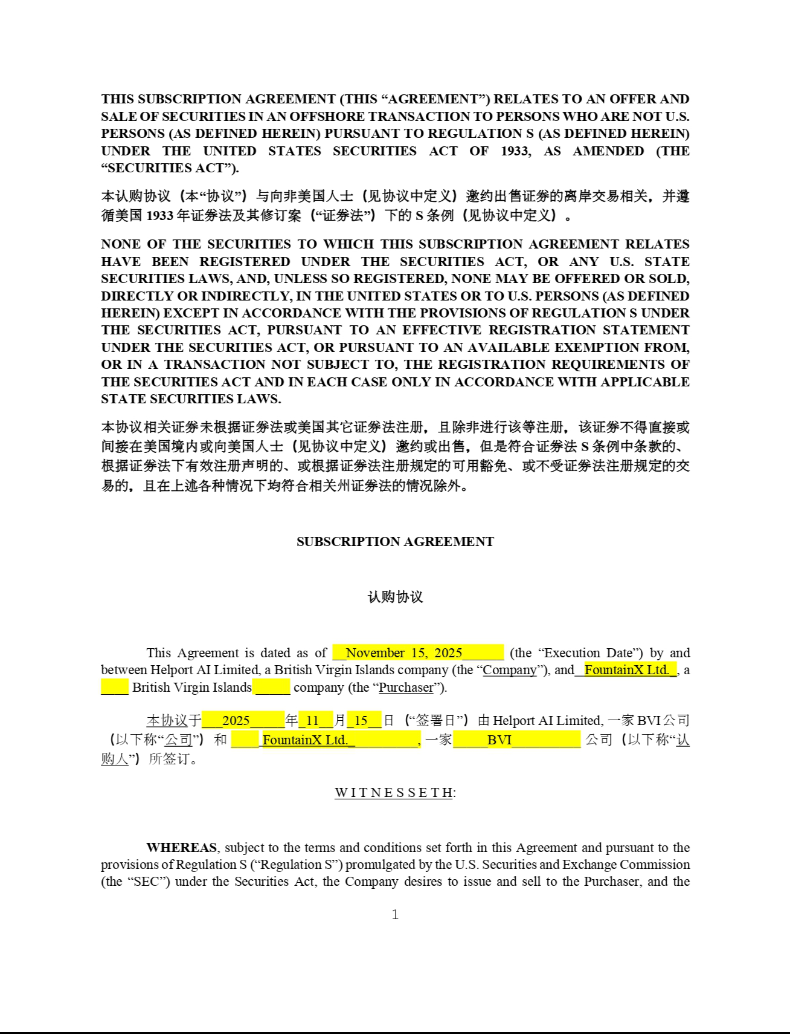

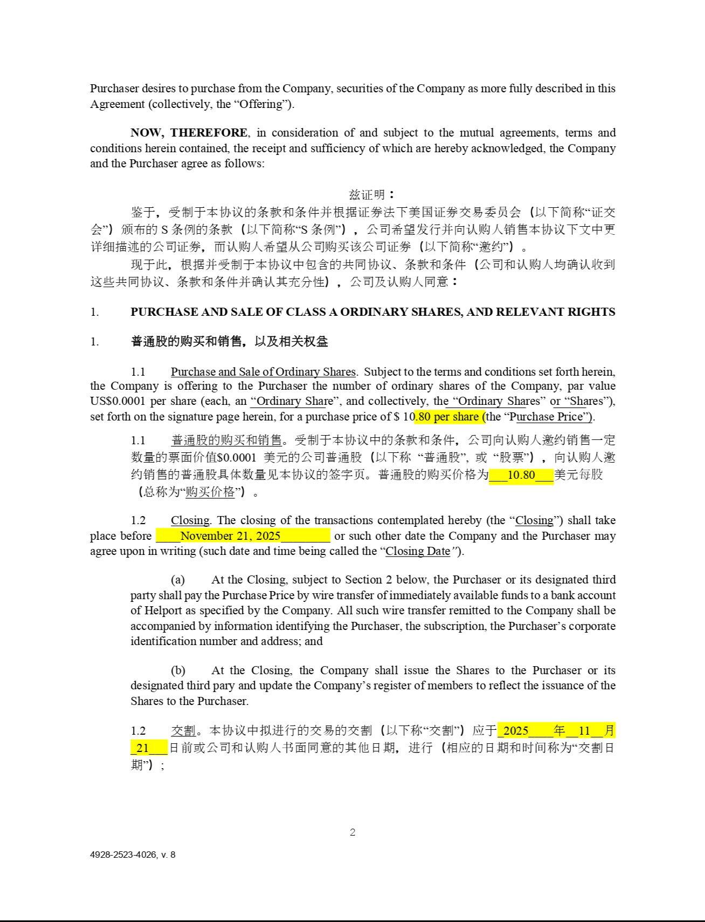

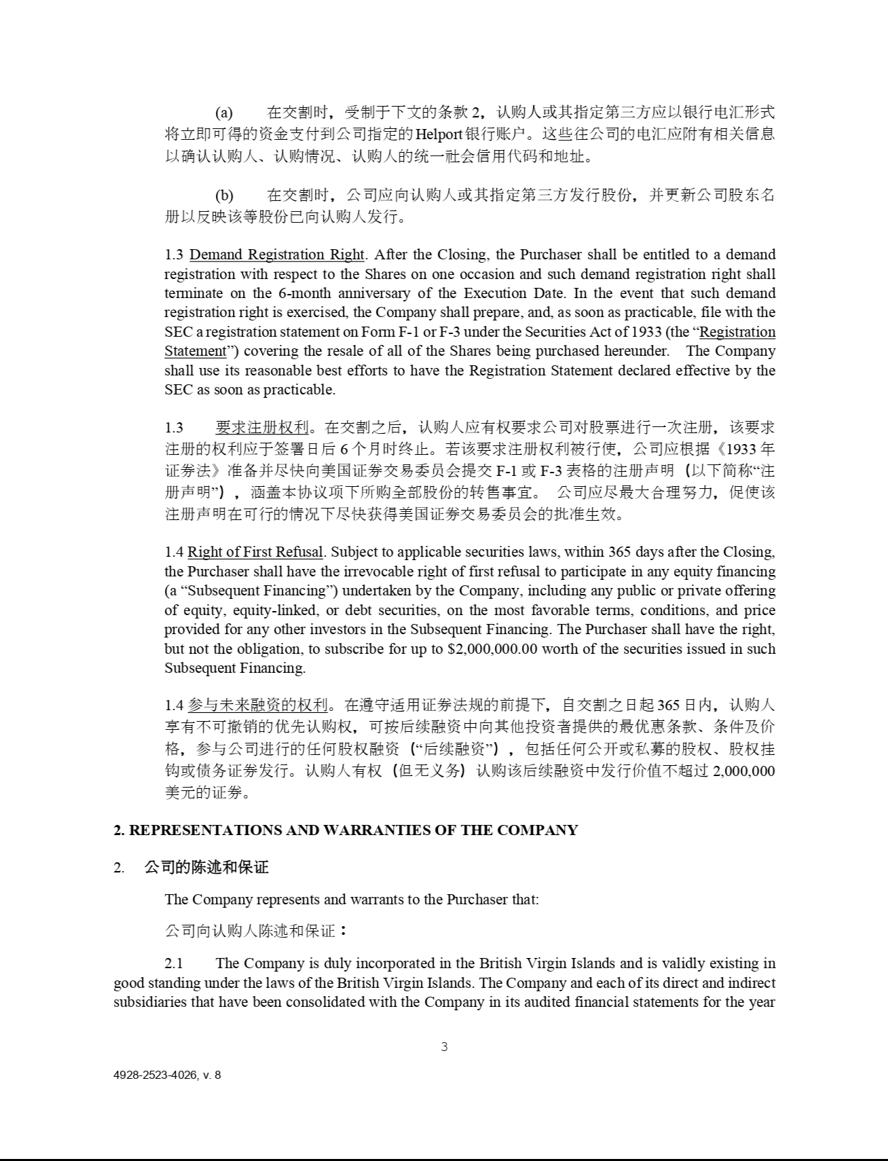

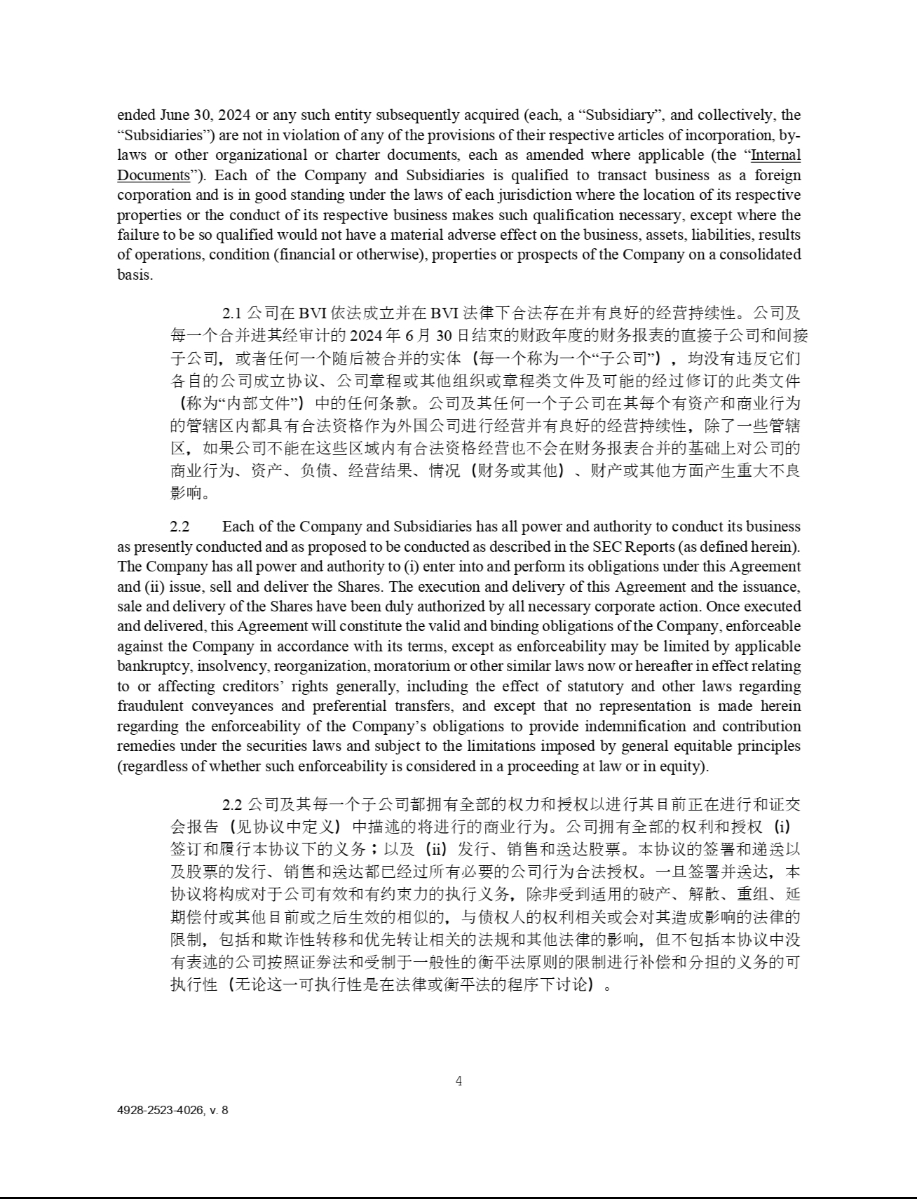

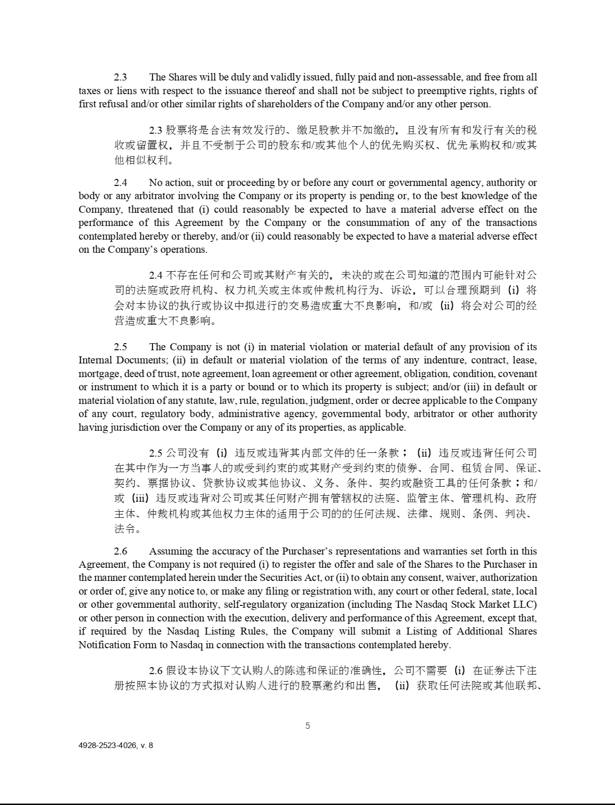

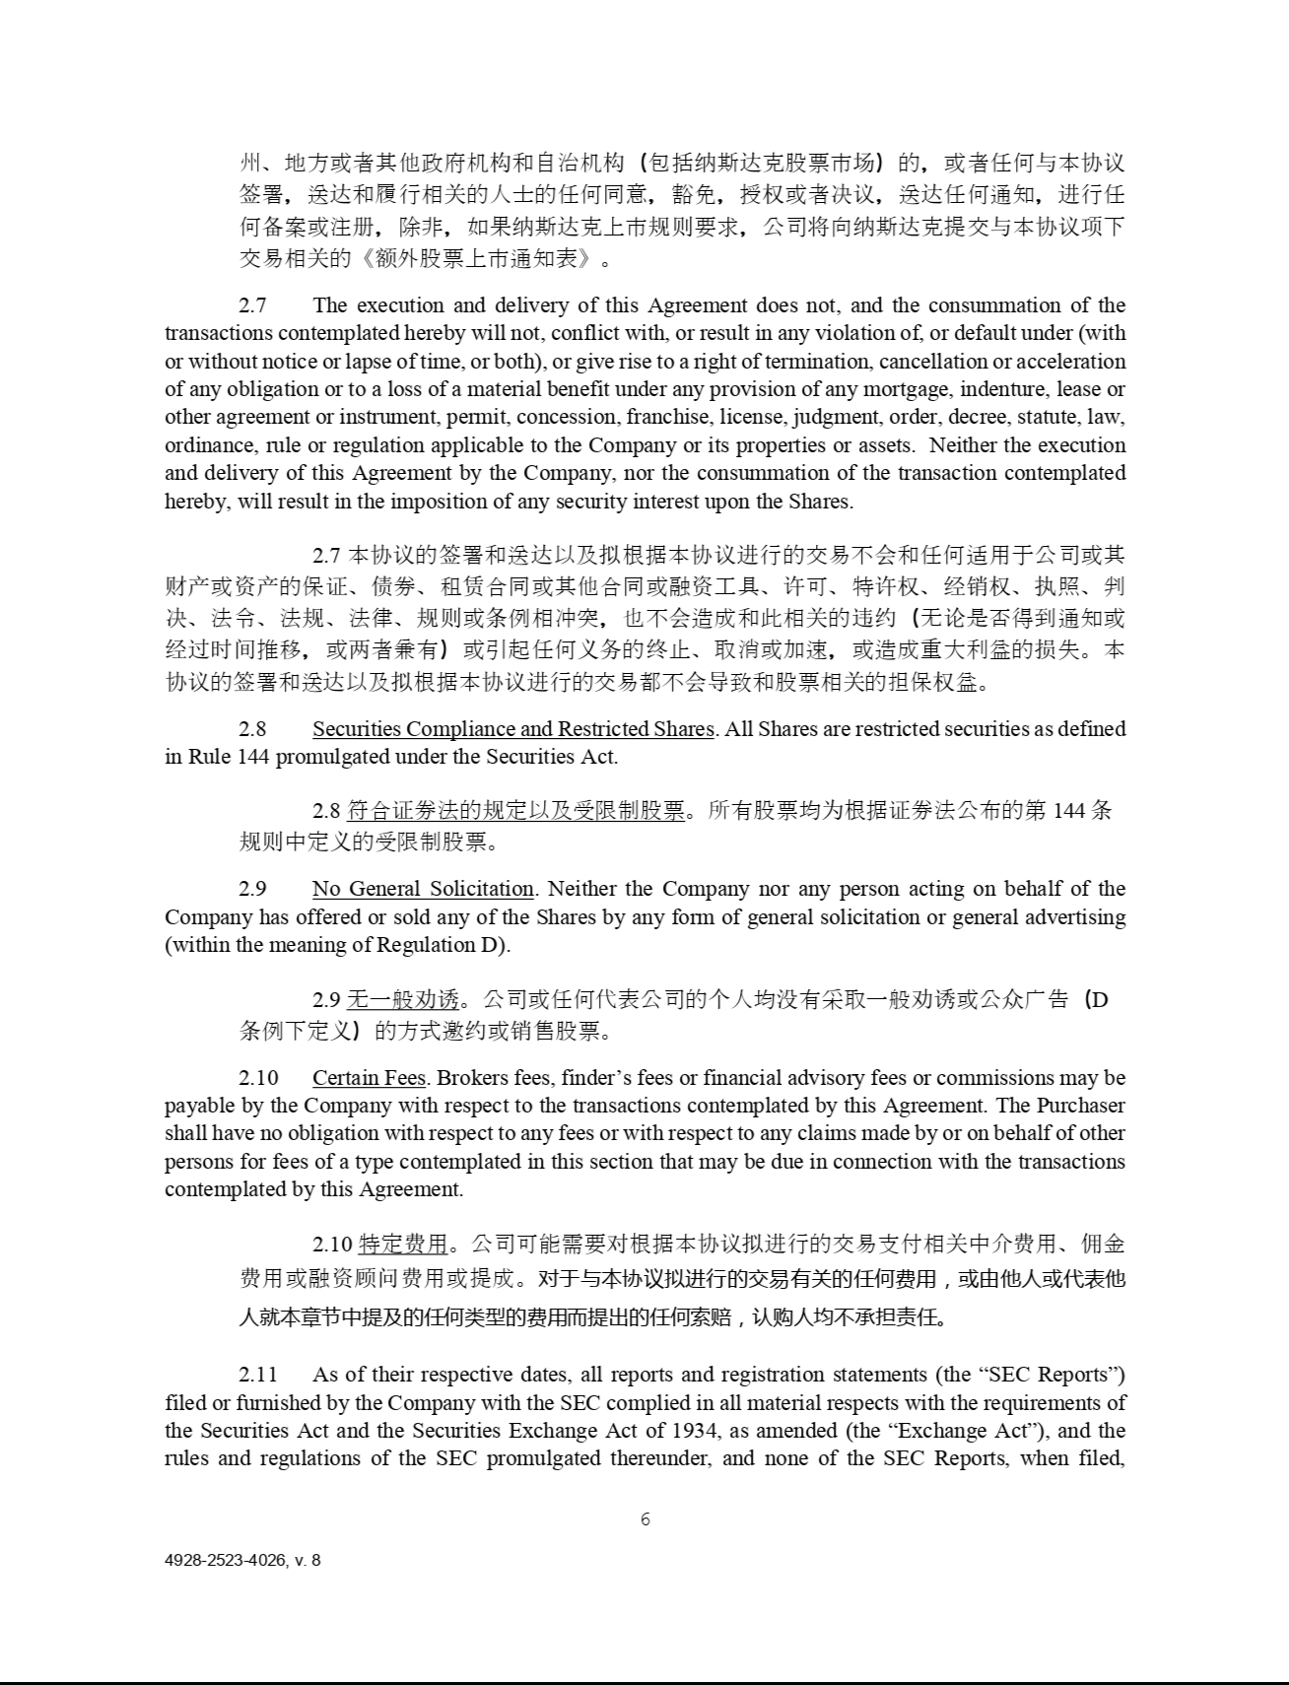

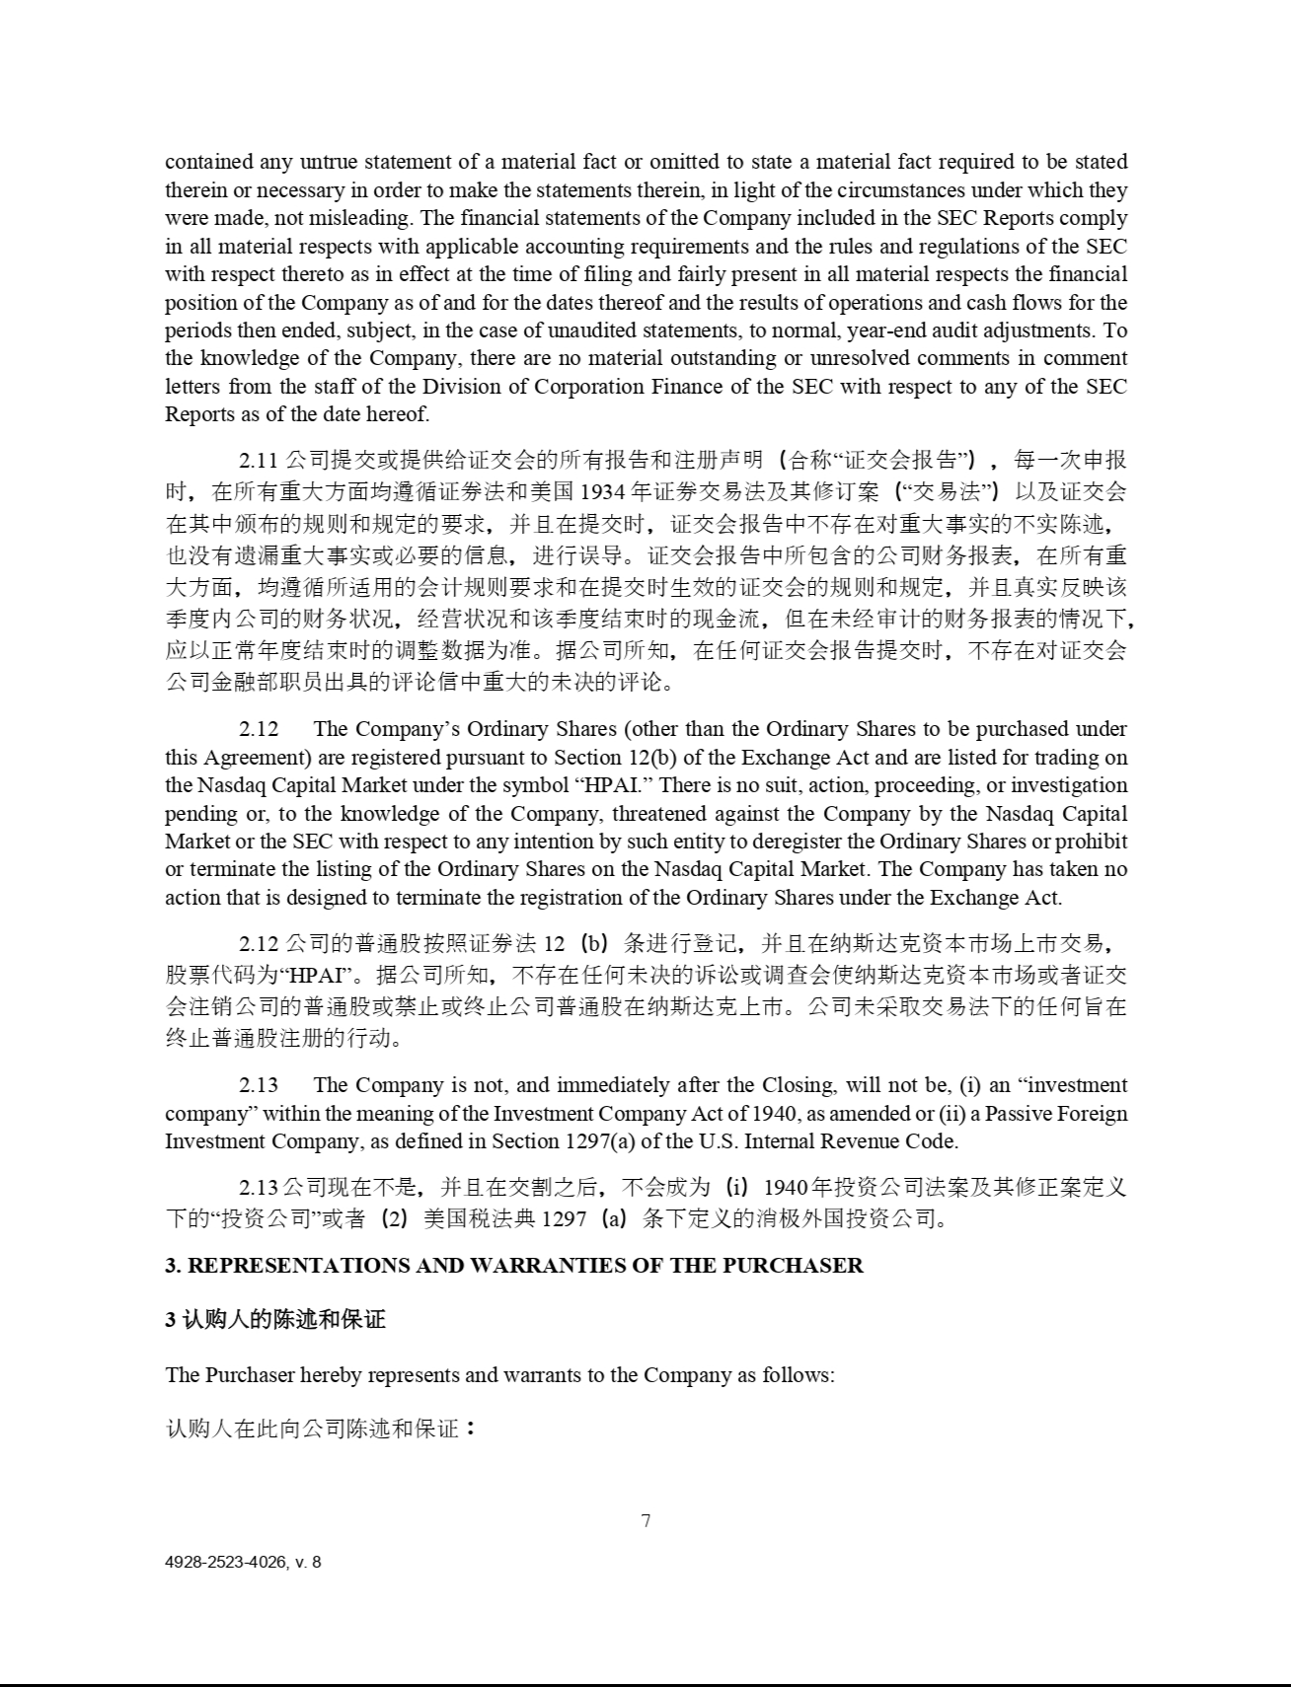

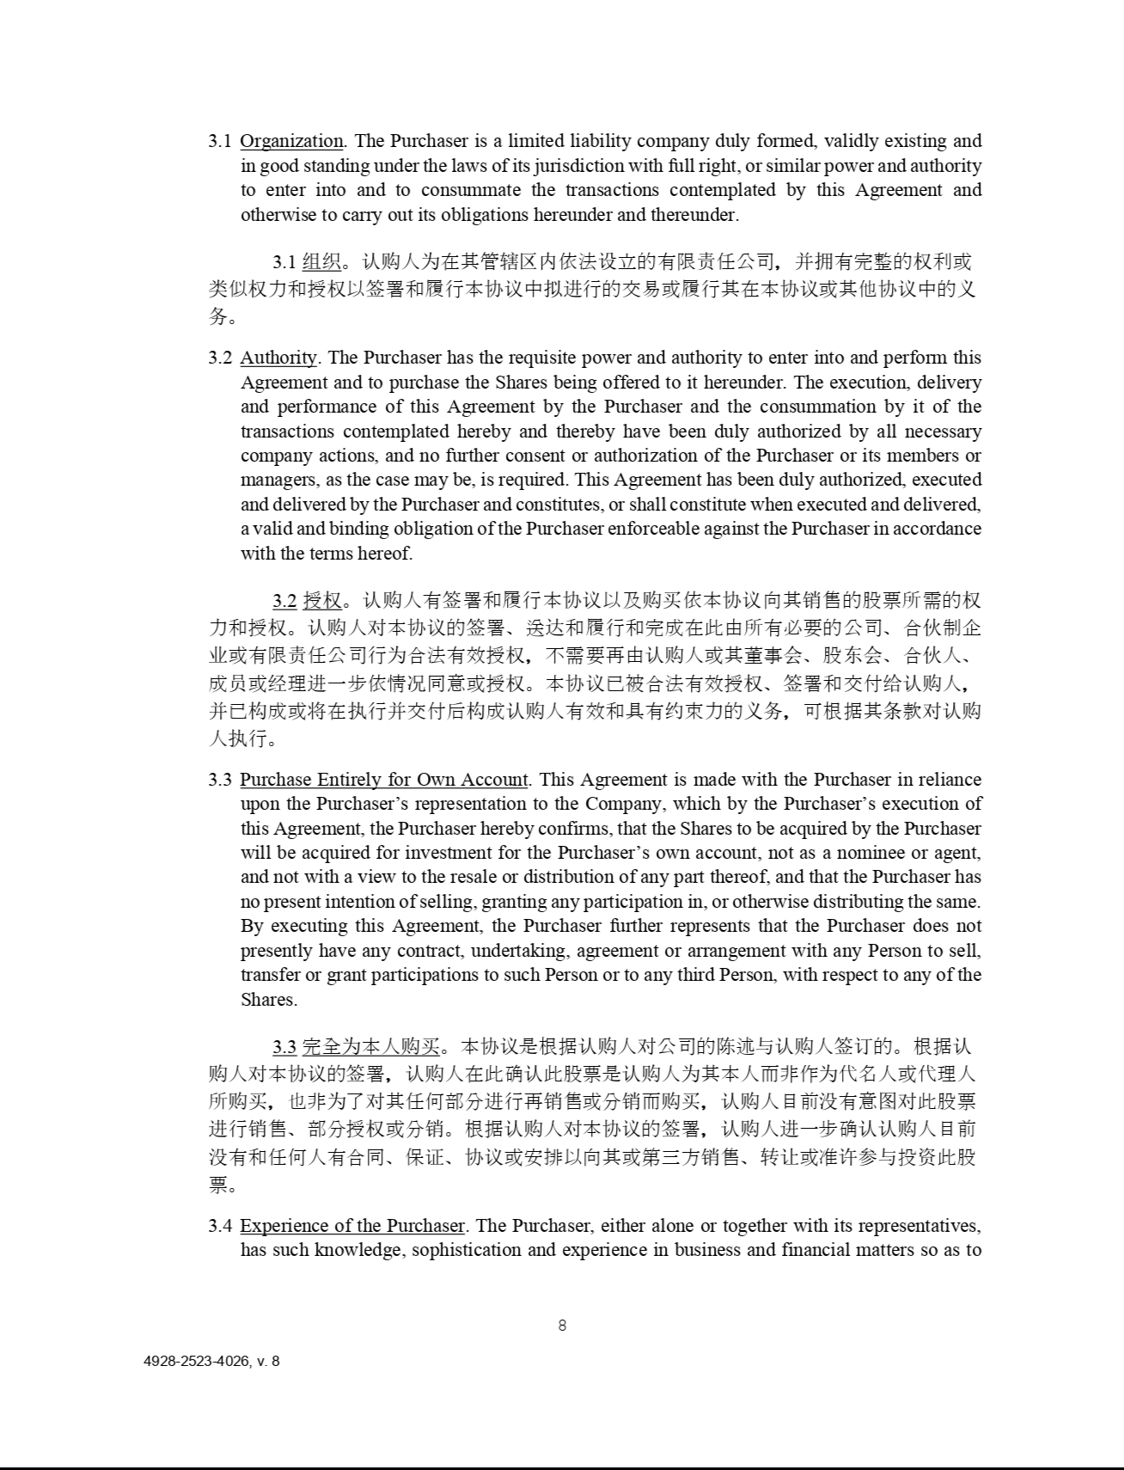

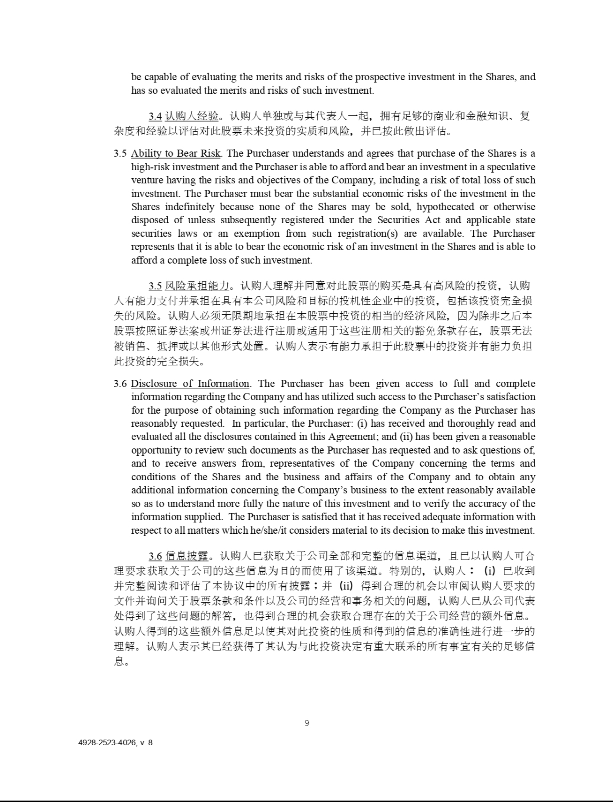

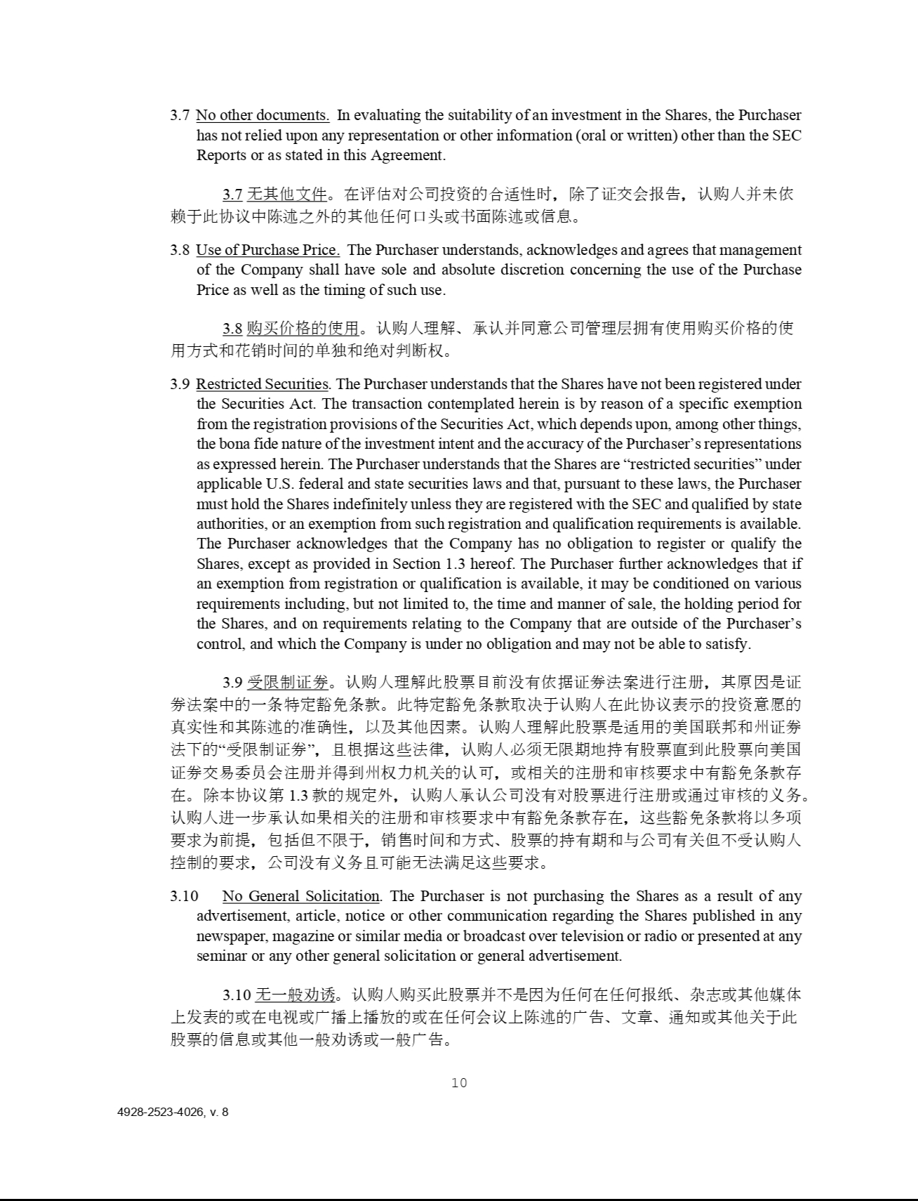

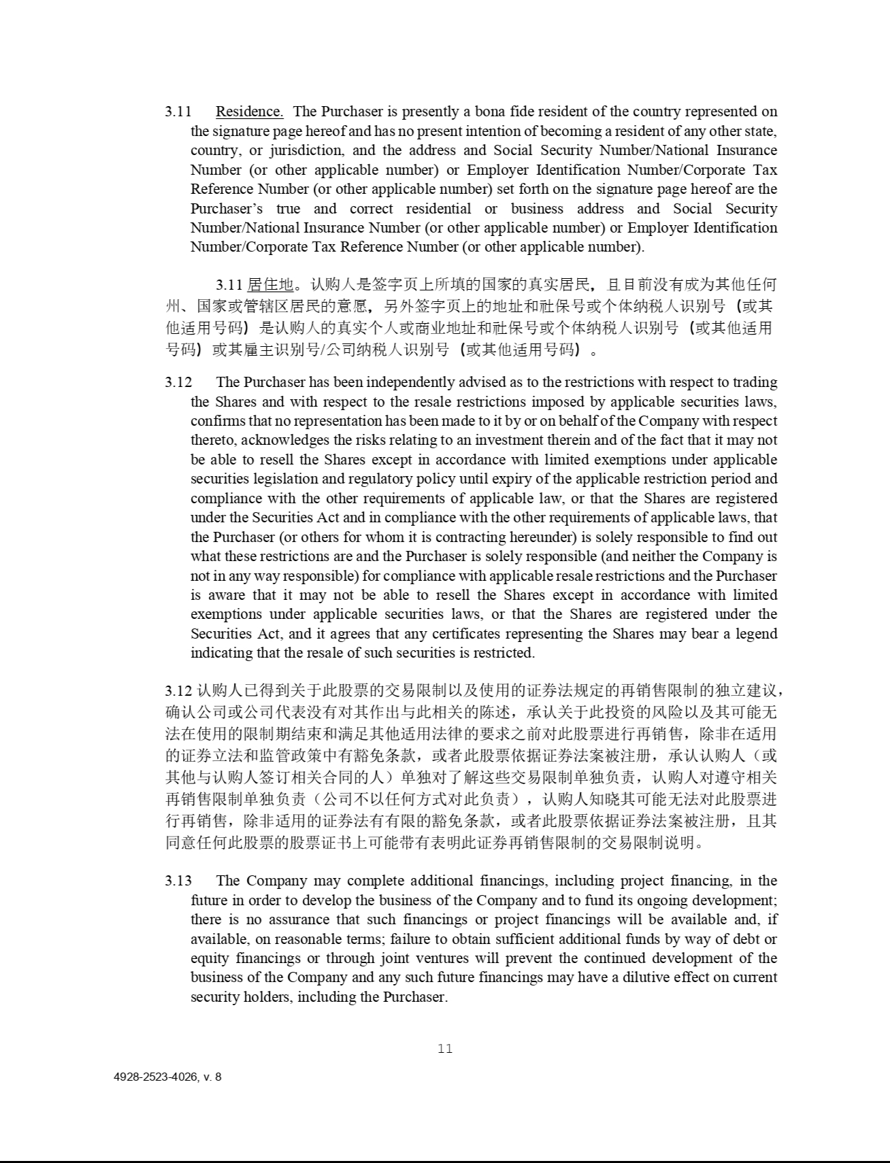

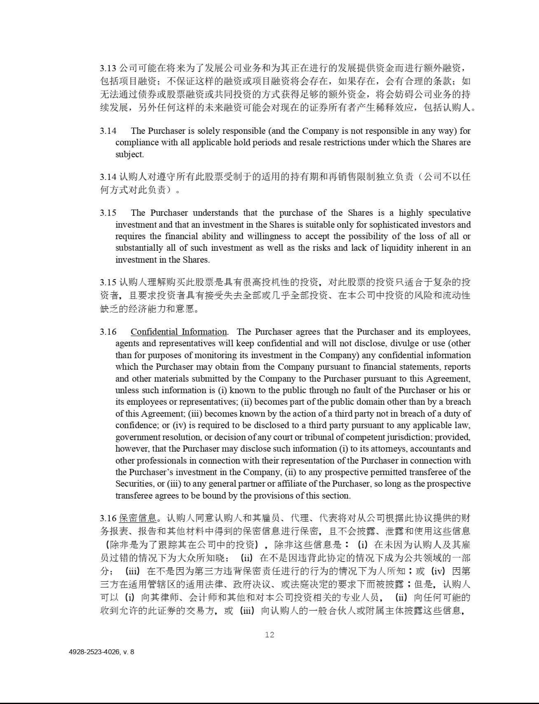

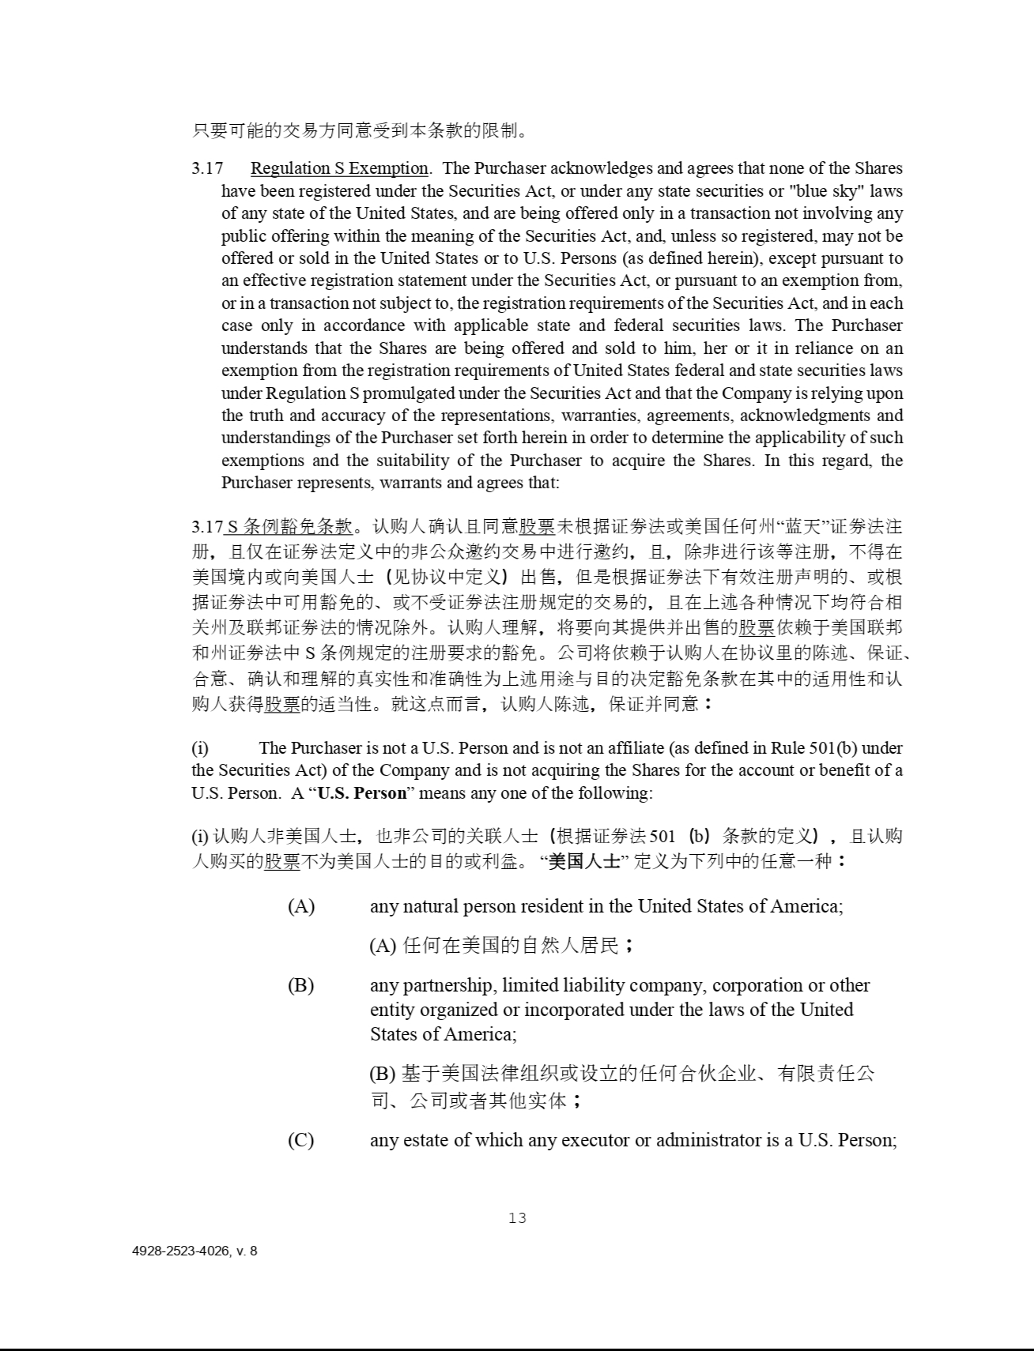

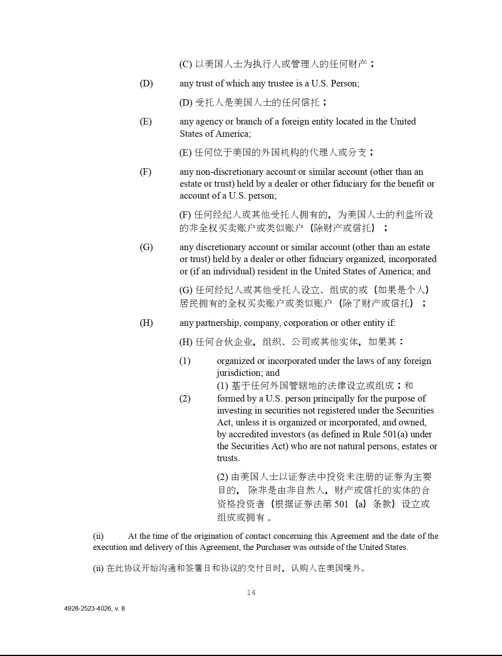

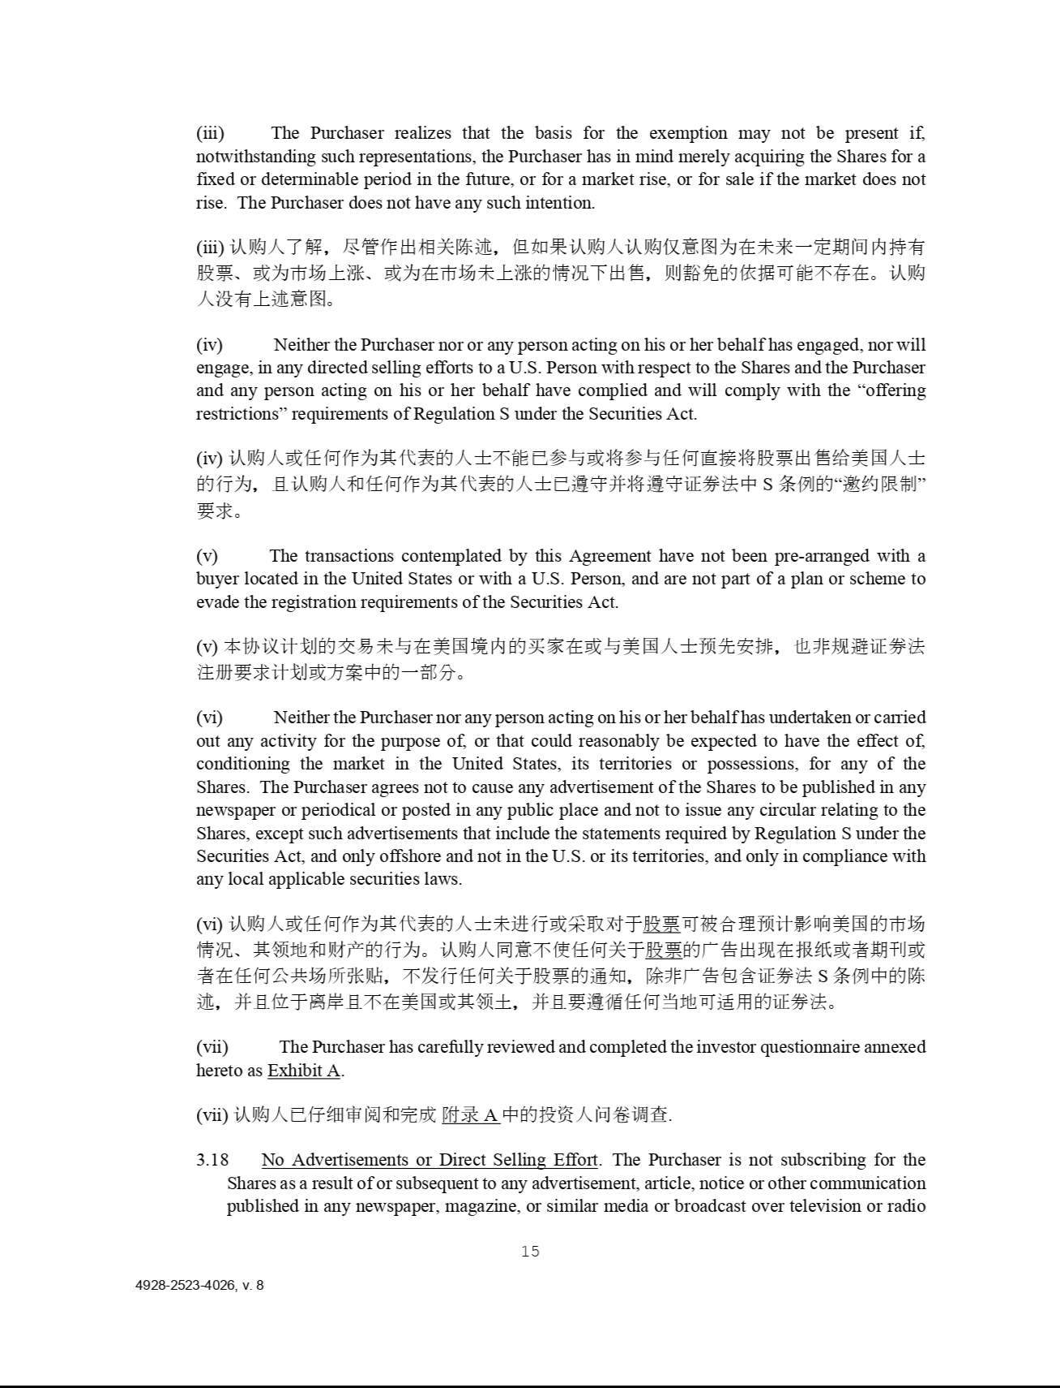

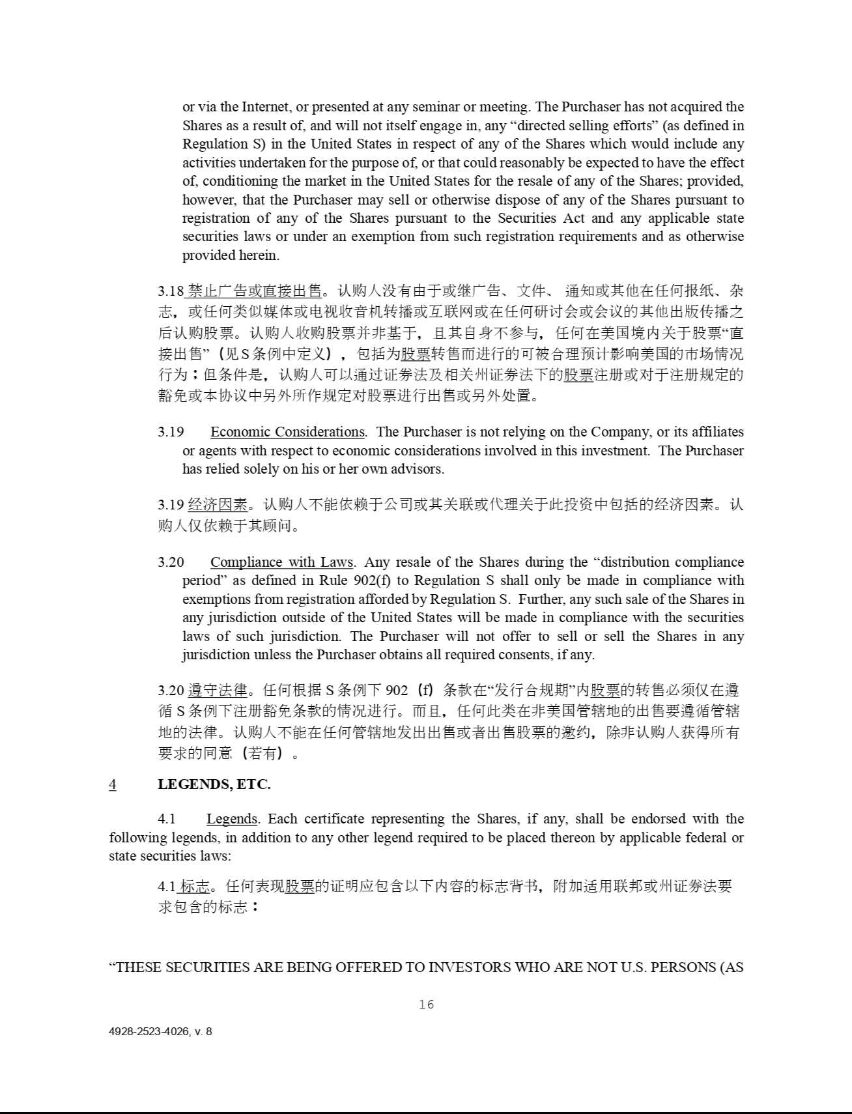

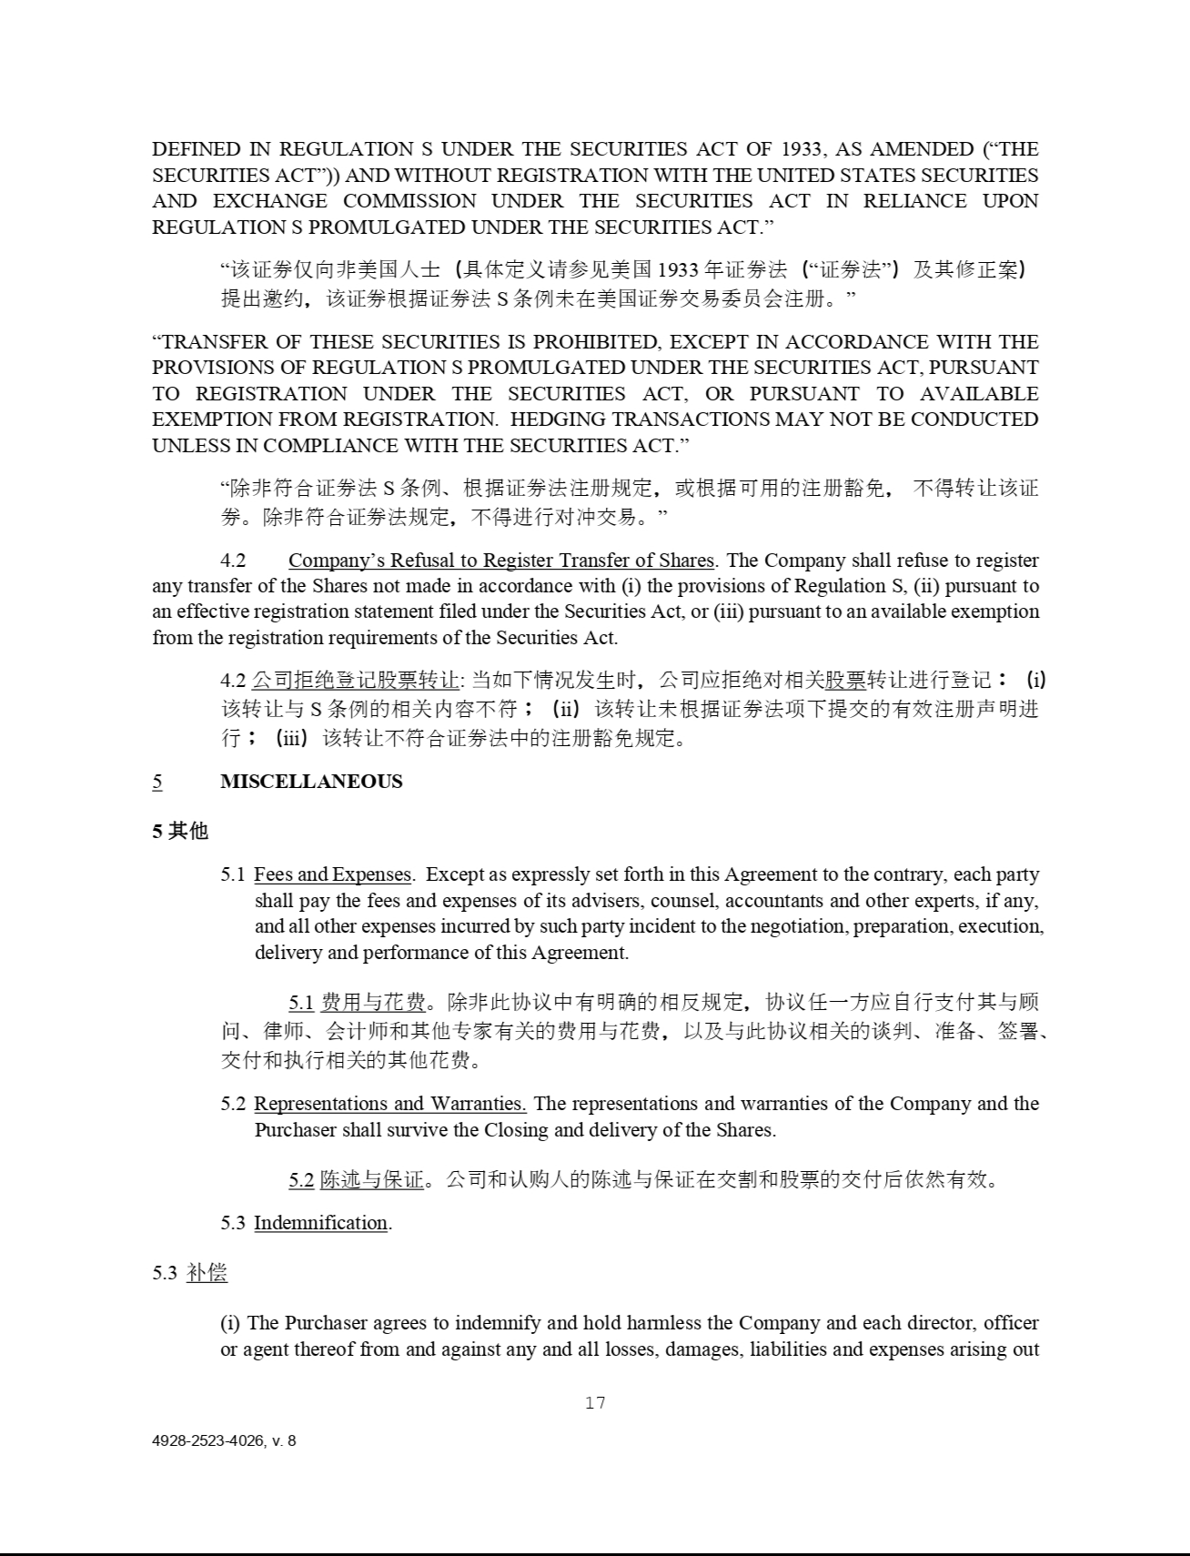

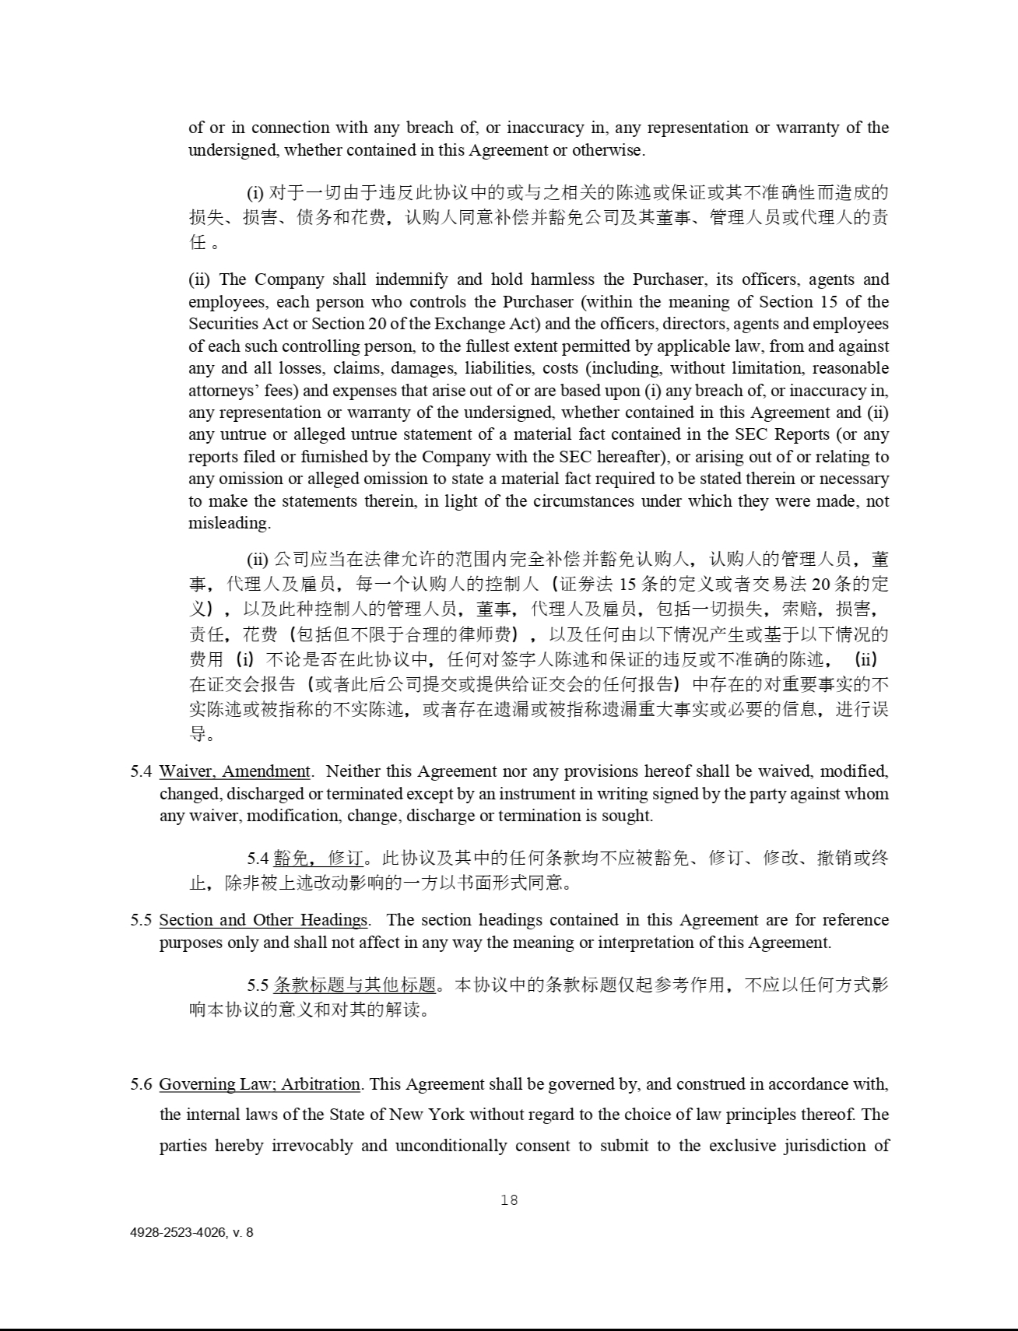

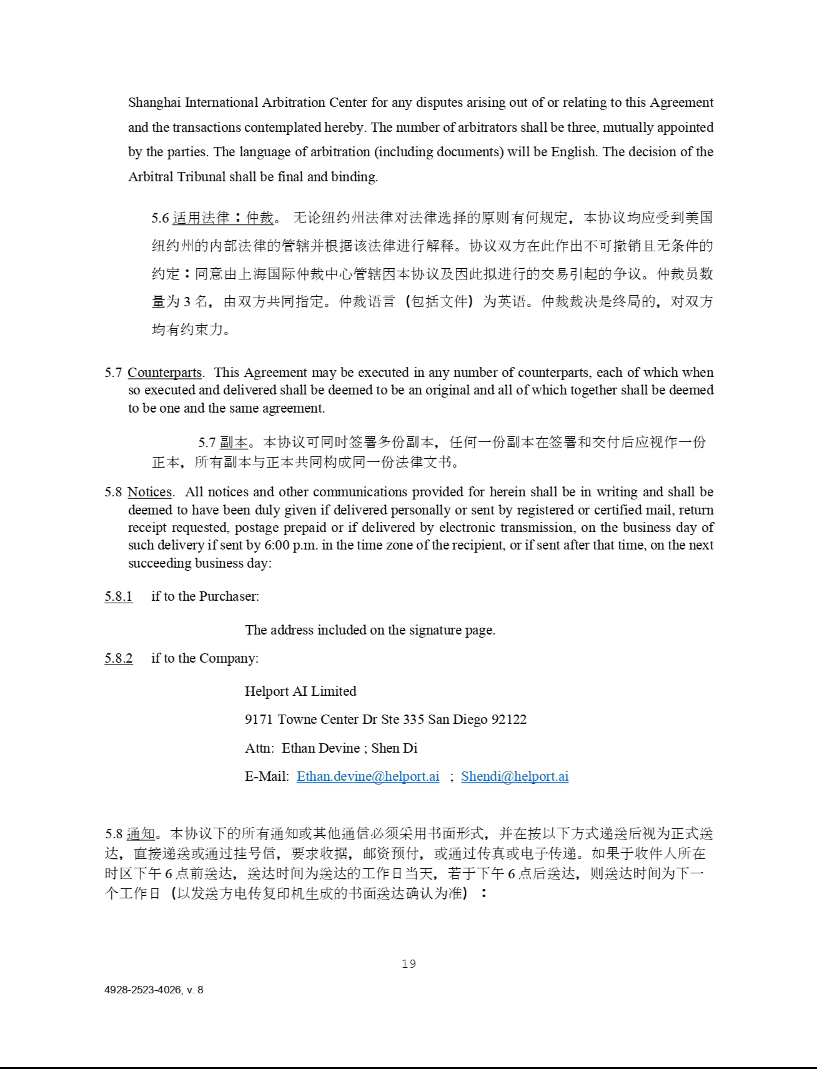

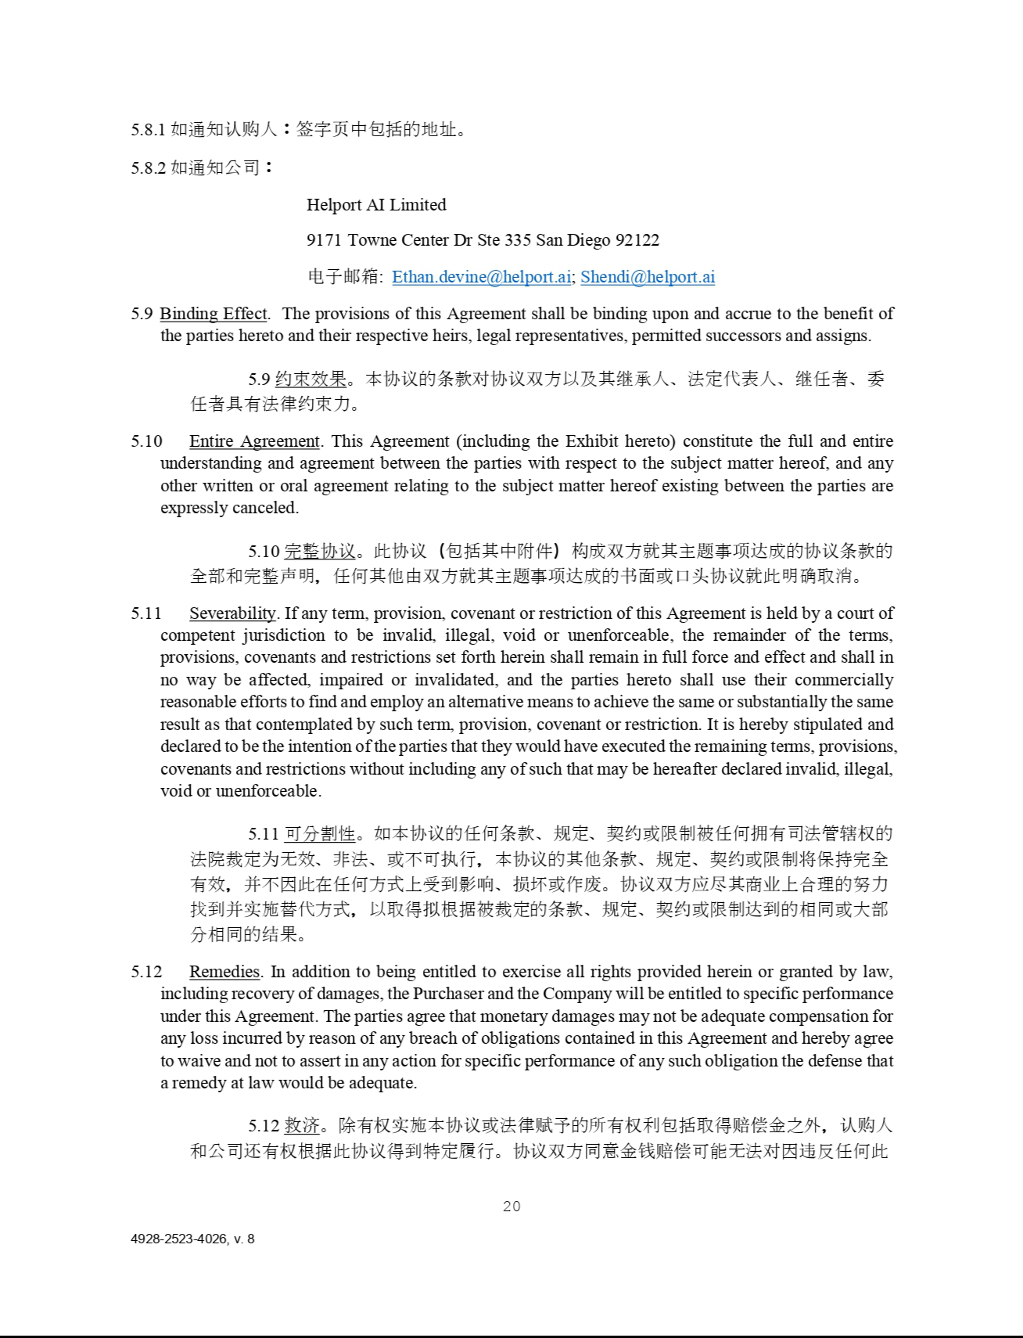

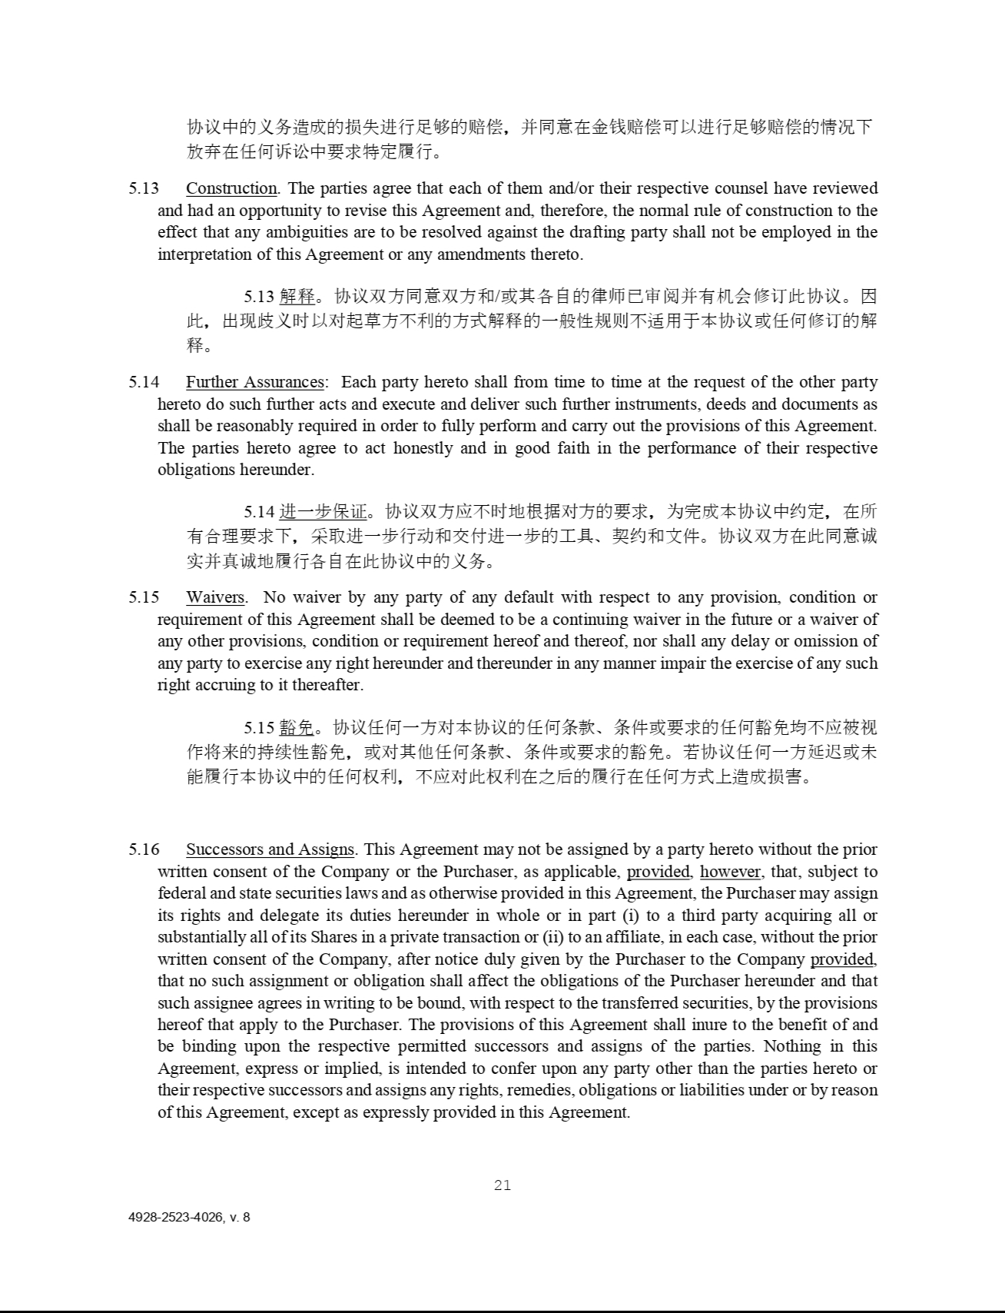

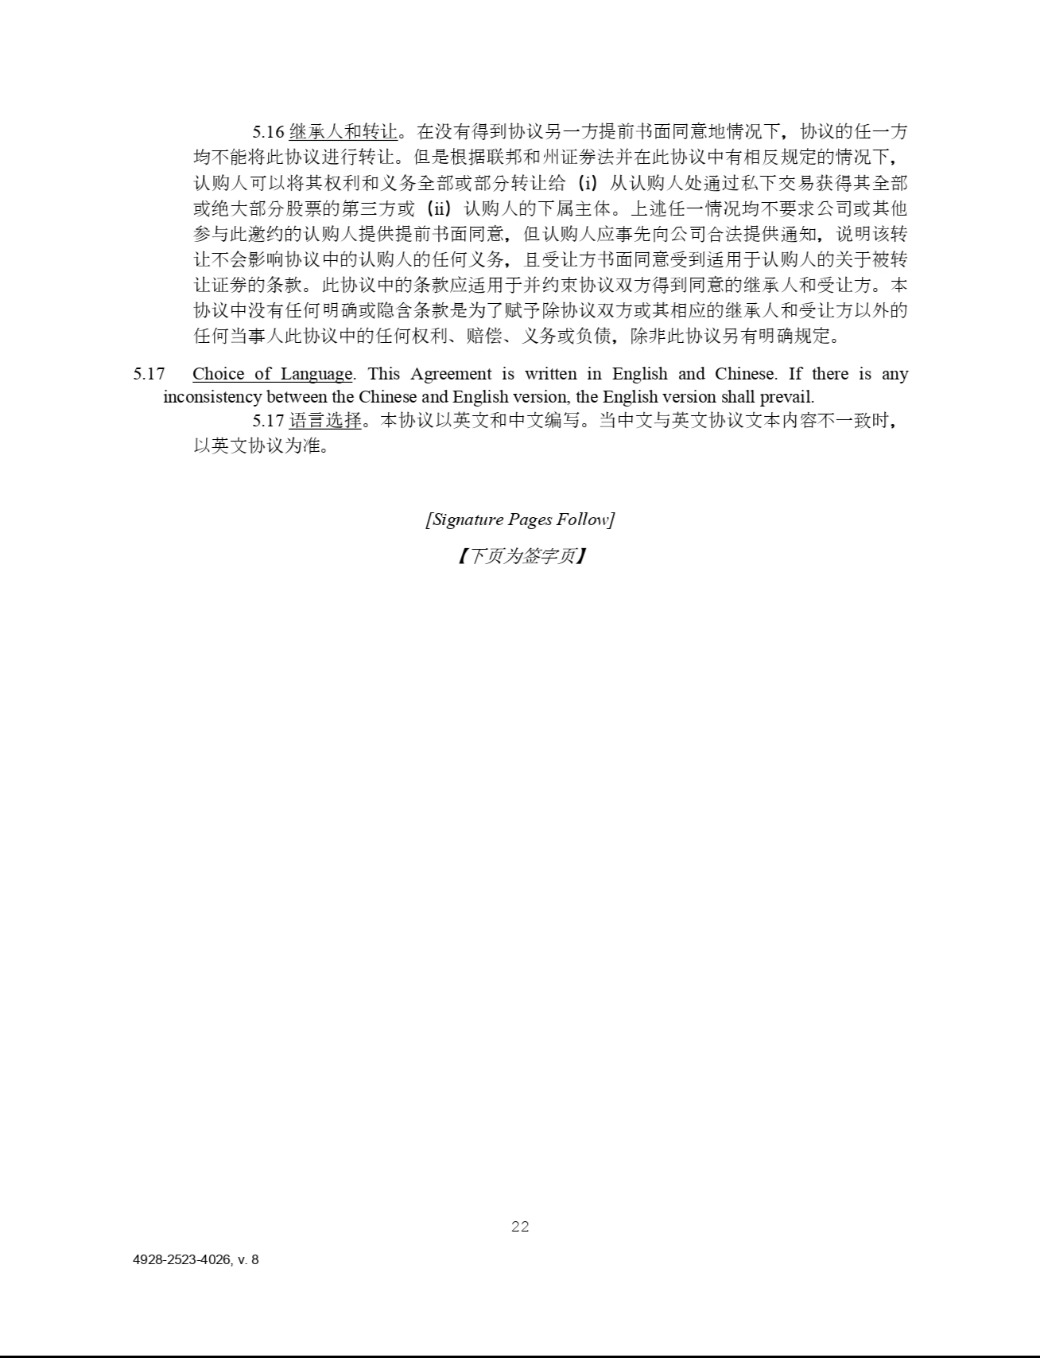

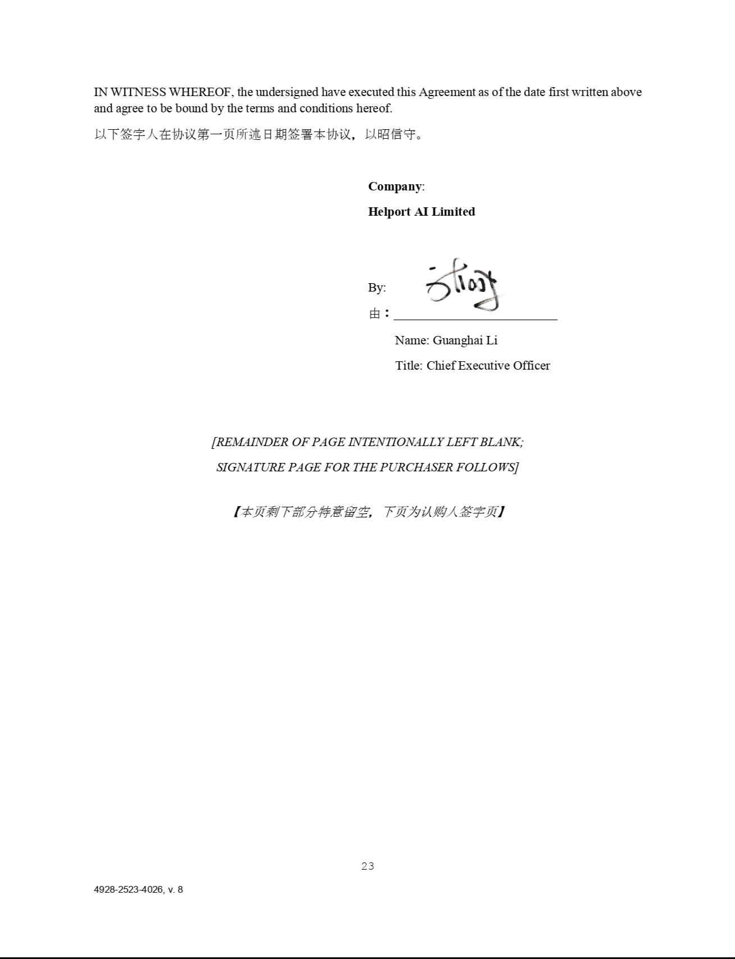

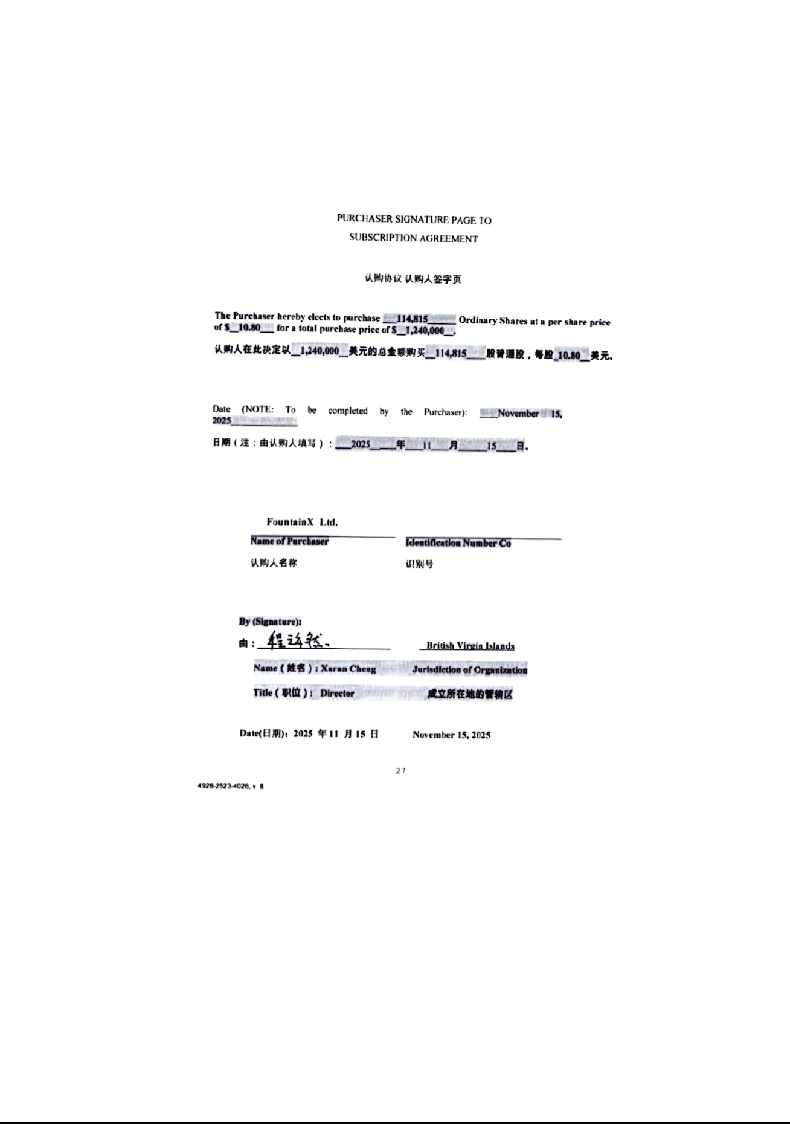

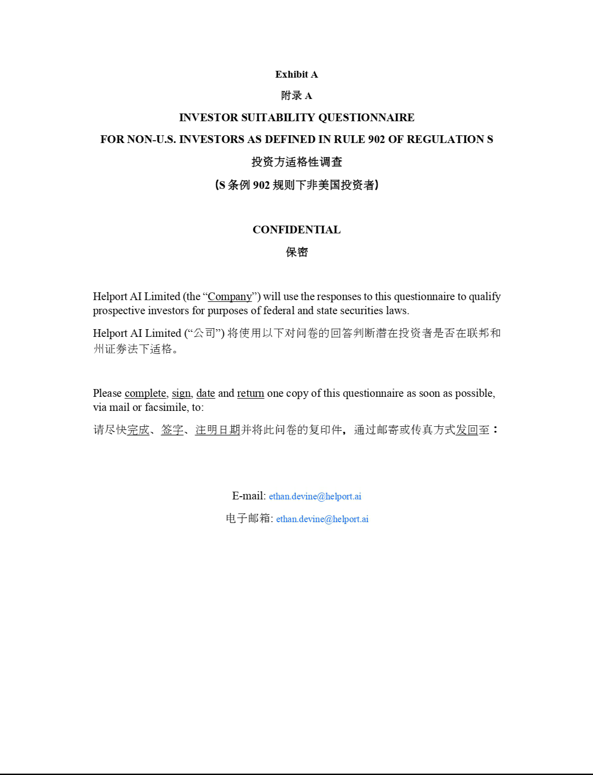

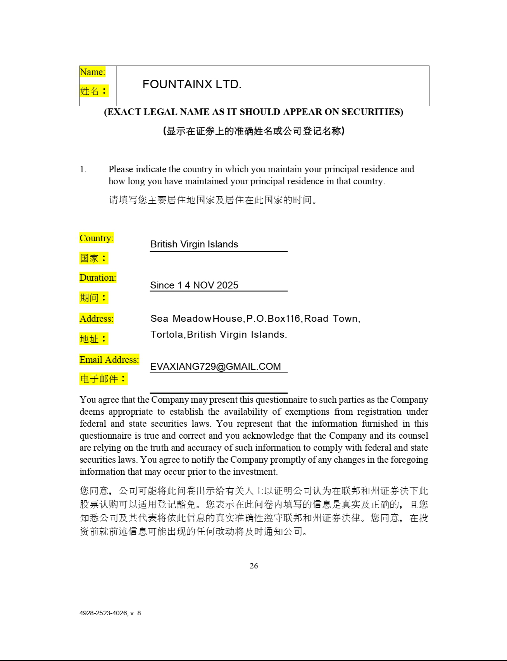

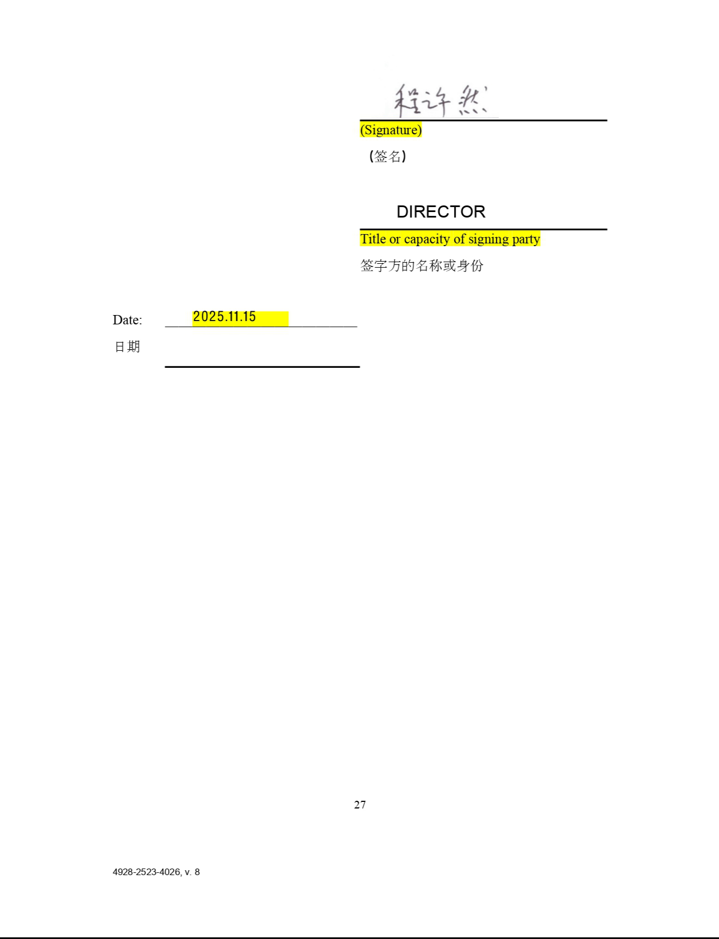

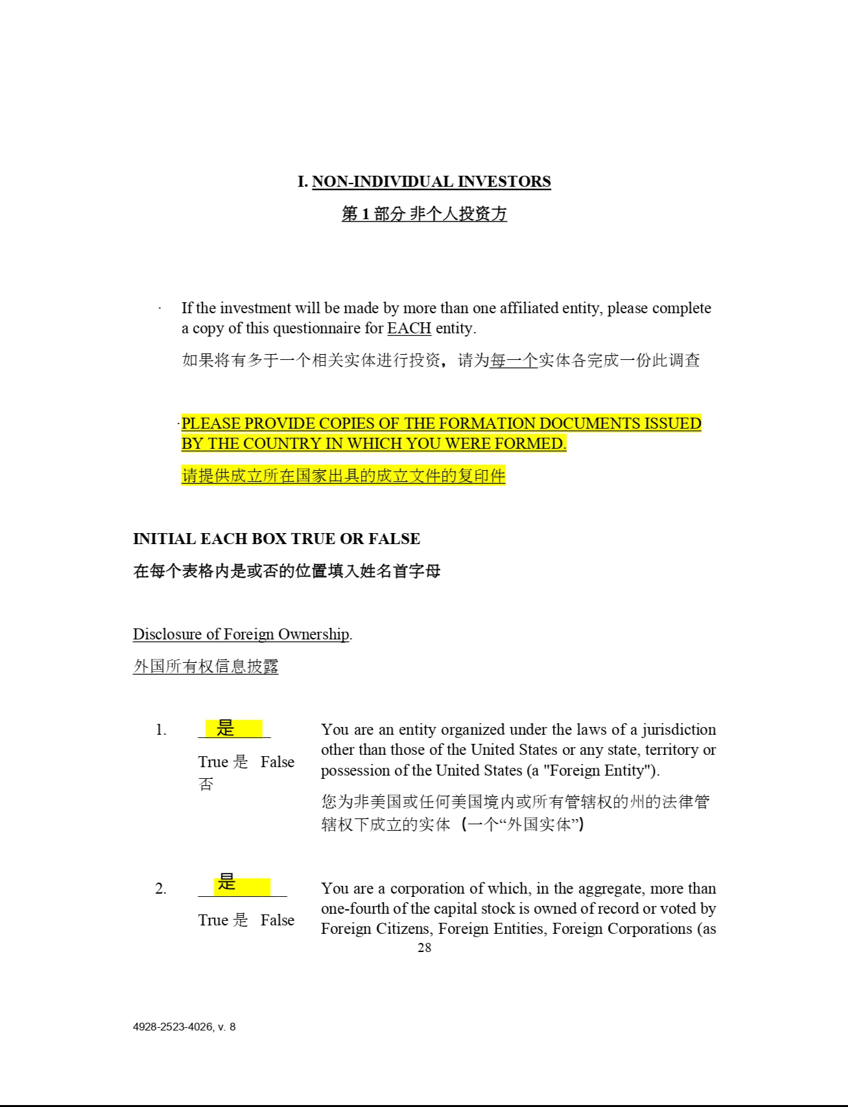

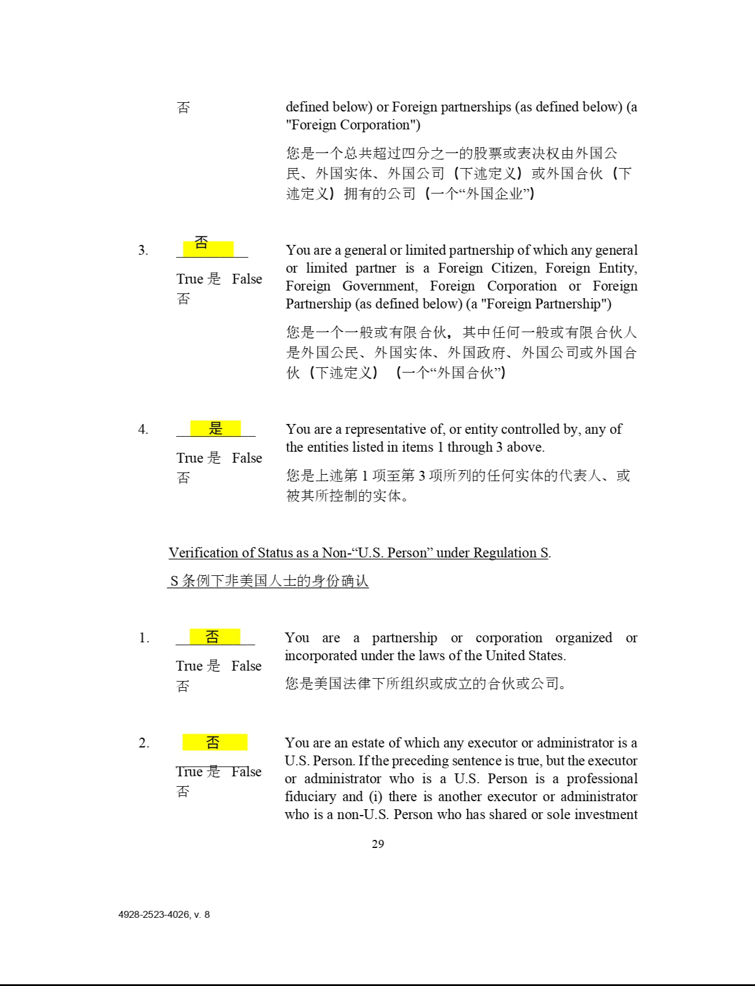

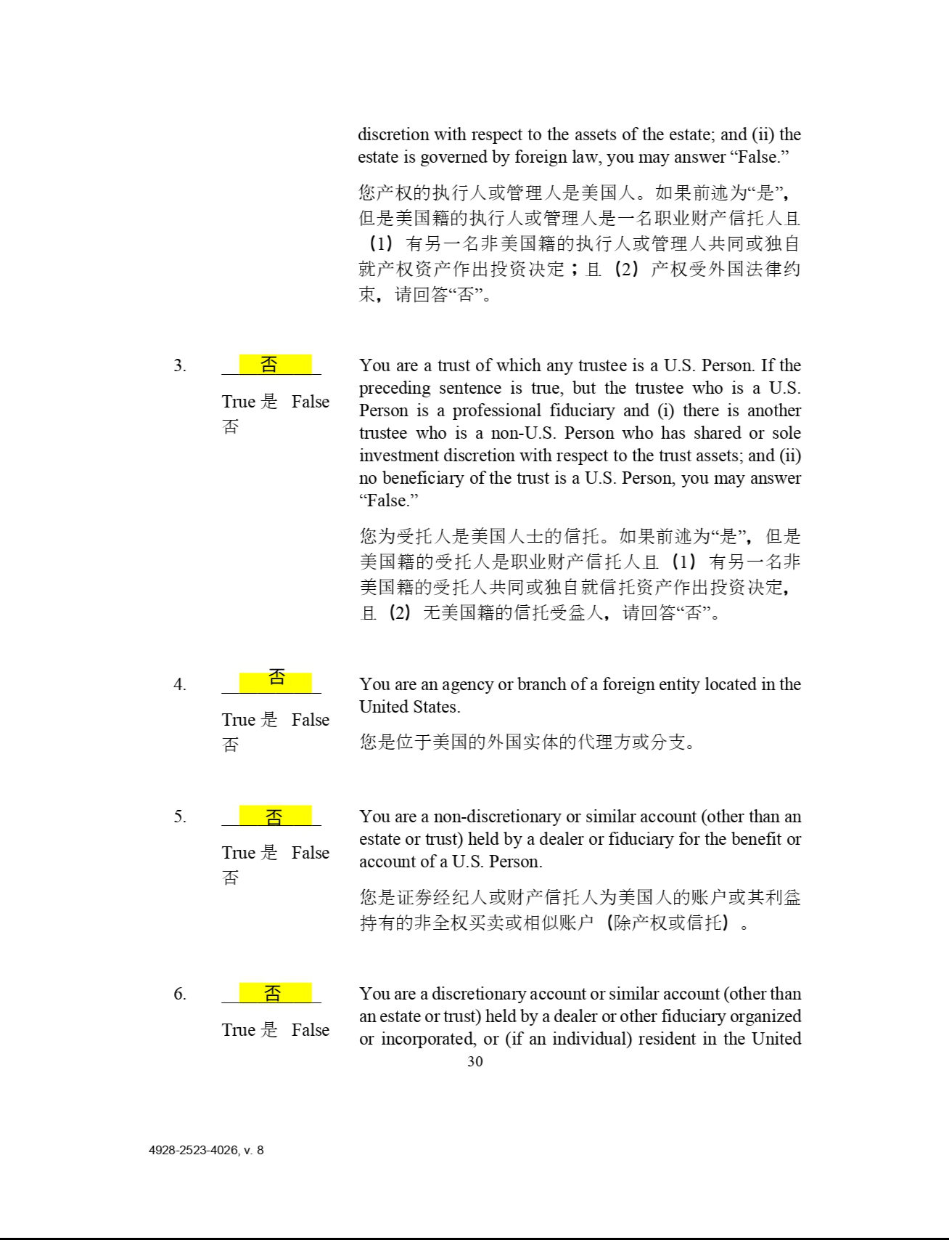

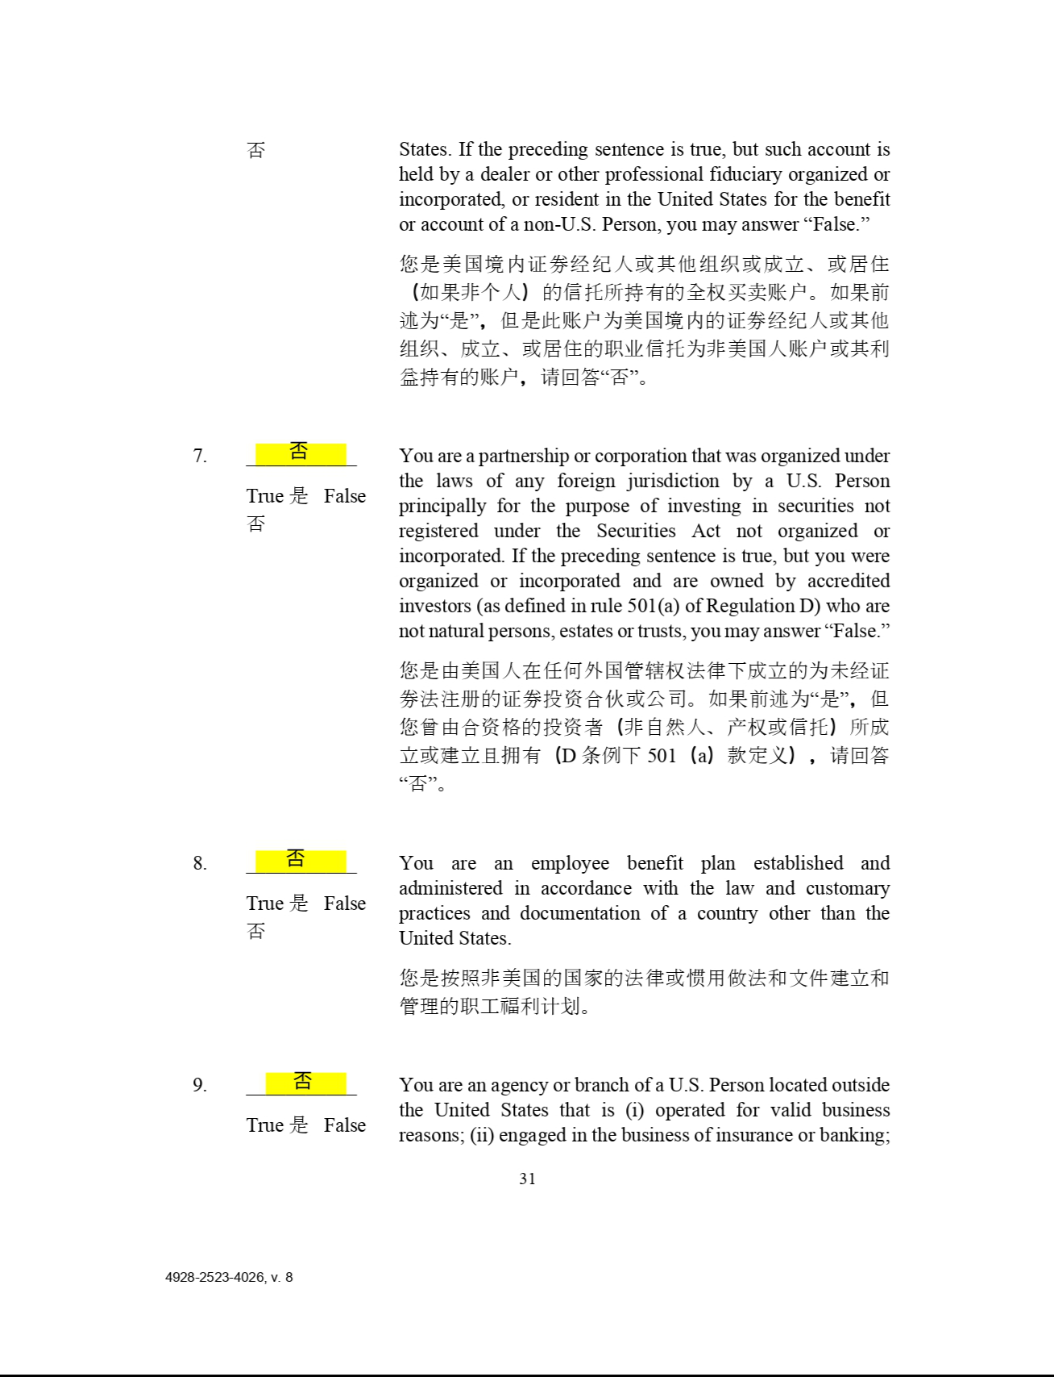

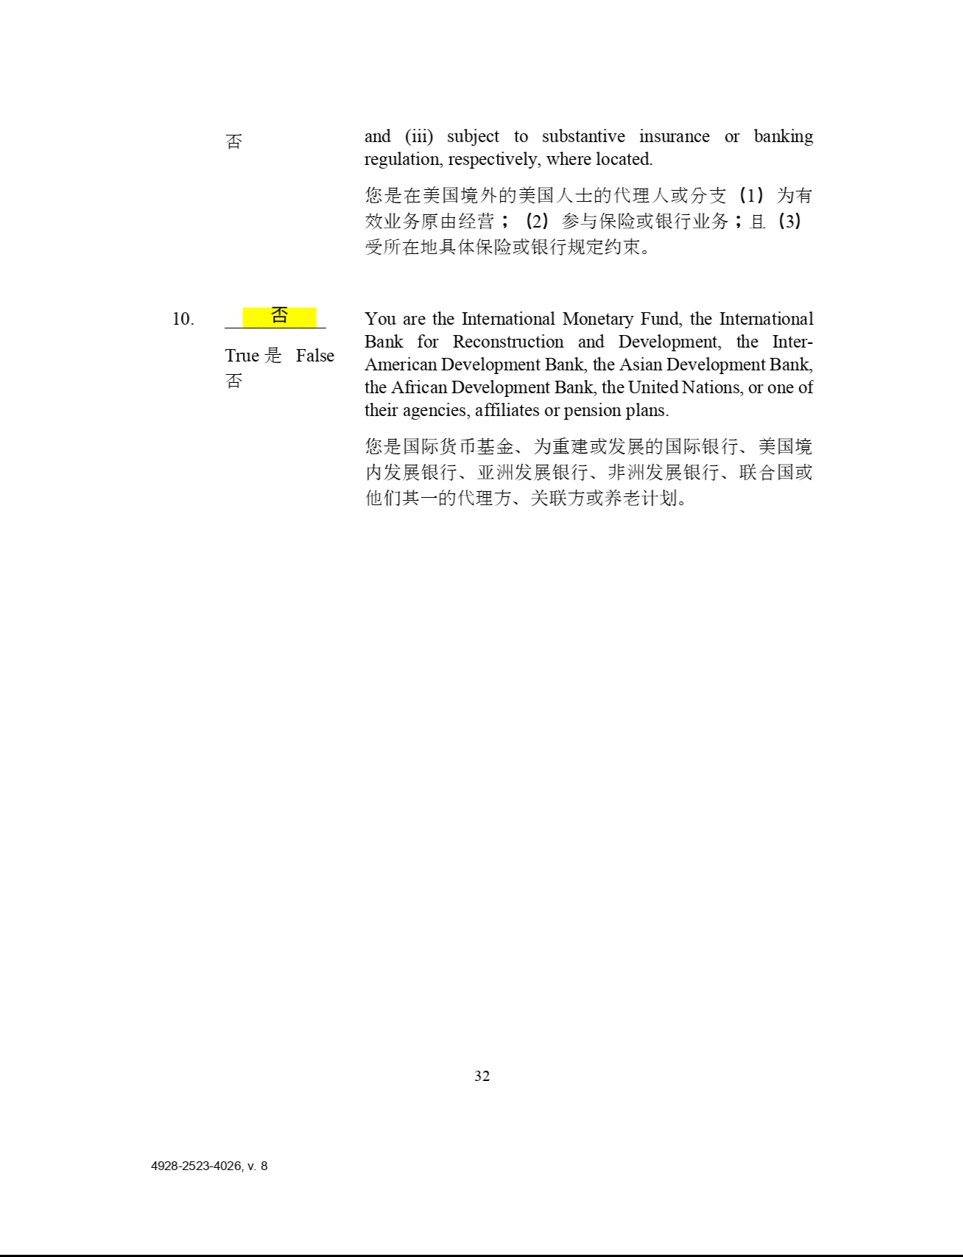

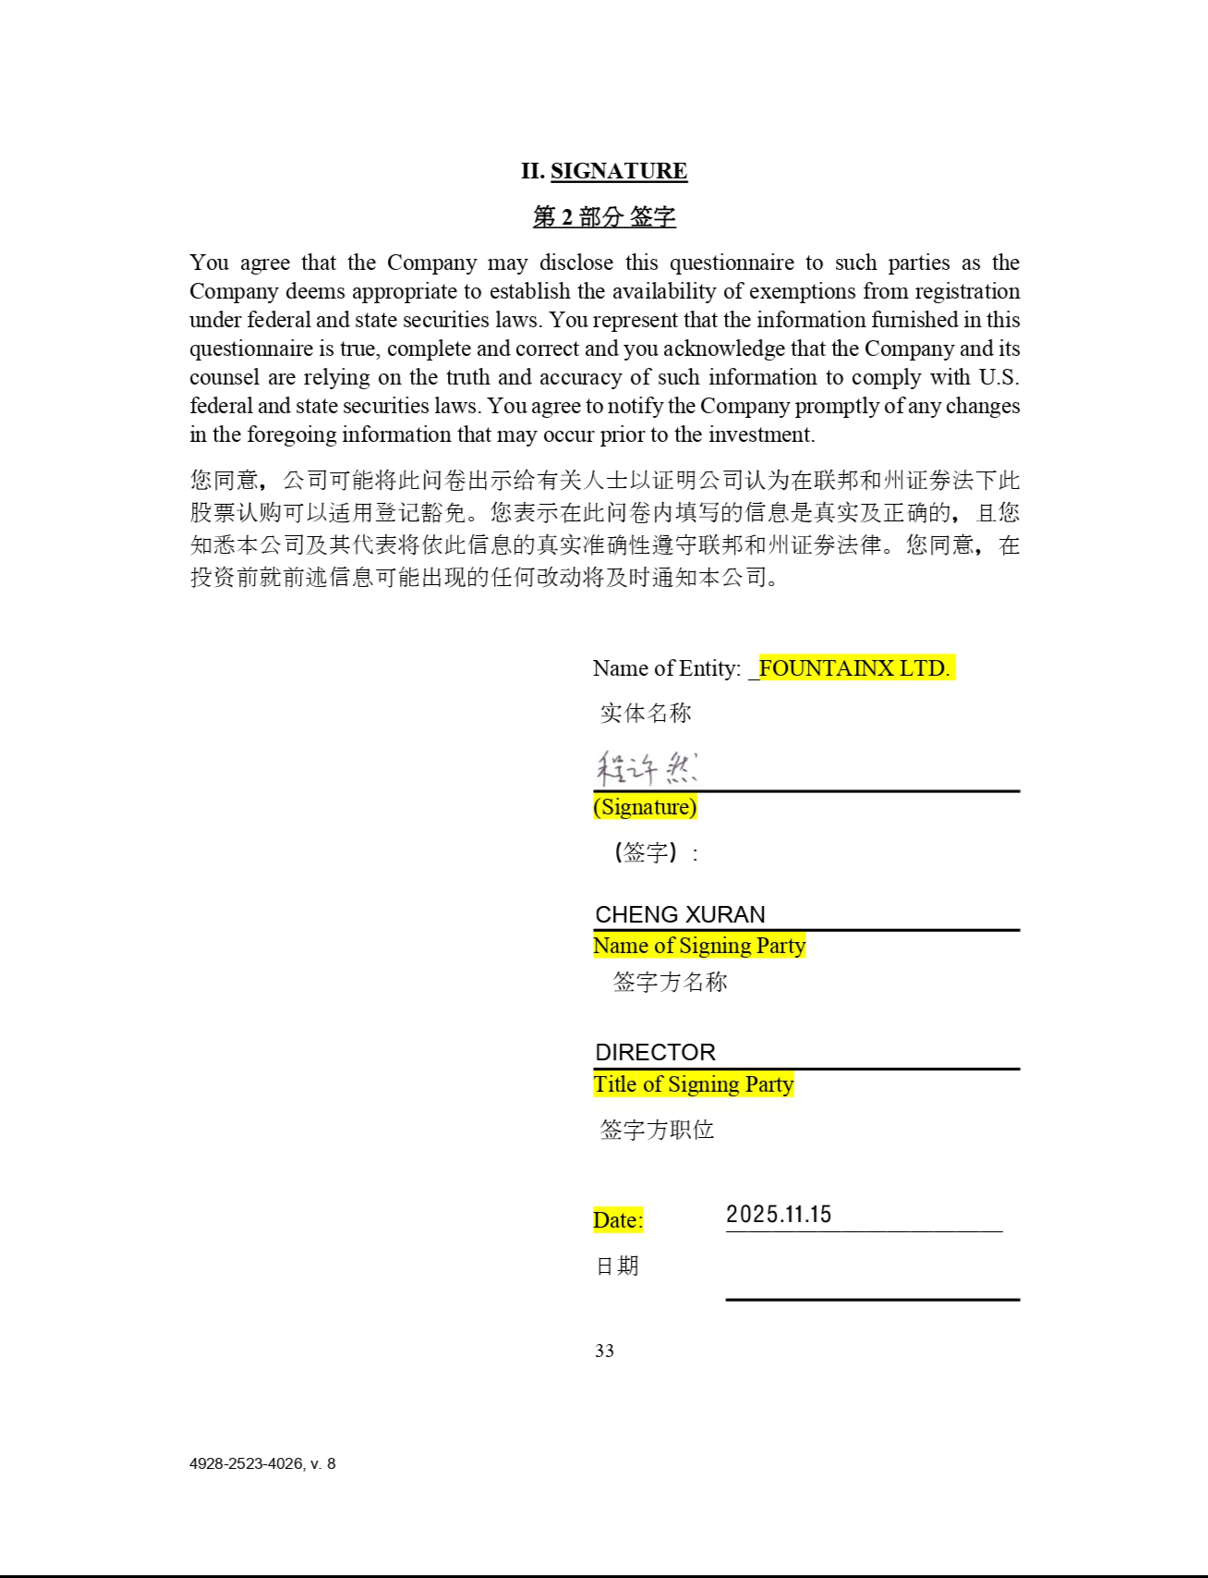

Exhibit 23.1


CONSENT OF INDEPENDENT REGISTERED PUBLIC

ACCOUNTING FIRM

We consent to the use in this Registration Statement on Form F-3 of our report dated November 17, 2025, relating to the consolidated financial statements of Helport AI Limited and its subsidiaries as of June 30, 2025 and 2024 and for the years ended June 30, 2025, 2024, and 2023. We also consent to the reference to us under the heading “Experts” in such Registration Statement.

/s/ Enrome LLP

Singapore

March 26, 2026

Enrome LLP

143 Cecil Street #19-03/04

GB Building Singapore 069542

admin@enrome-group.com

www.enrome-group.com

Ex-Filing Fees

CALCULATION OF FILING FEE TABLES

F-3

Helport AI Limited

Table 1: Newly Registered and Carry Forward Securities

 |  |  |  |  |  |  |  |  |  |  |  |  | Proposed
 |  |  |  |  |  |  |  | Fee |  |  |  |  | Maximum |  |  |  |  | Maximum |  |  |  |  | Amount of
 |  |  |  |  |  |  |  |  |  | Amount |  |  | Offering |  |  |  |  |  |  |  |  |  | Amount of
Line Item Type |  | Security Type |  | Security Class Title |  | Notes |  | Calculation |  |  |  |  | Price Per |  |  |  | Aggregate Offering |  |  | Fee Rate |  | Registration
Line Item Type |  | Security Type |  |  |  |  |  | Rule |  | Registered |  |  |  | Unit |  |  |  | Price |  | Fee Rate |  |  | Fee
 |  |  |  | Newly Registered Securities
Fees to be Paid |  | Equity | Ordinary shares, |  |  | (1) |  | Other |  | 215,942 |  | $ |  | 2.35 |  | $ |  | 507,463.70 |  | 0.0001381 |  | $ | 70.08
 |  |  | par value $0.001
 |  |  | per share
Fees to be Paid |  | Equity | Preferred shares, |  |  | (2) |  | 457(o) |  |  |  |  |  |  |  |  |  |  |  | 0.0001381
 |  |  | $0.0001 par
 |  |  | value per share
Fees to be Paid |  | Other | Warrants |  |  | (3) |  | 457(o) |  |  |  |  |  |  |  |  |  |  |  | 0.0001381
Fees to be Paid |  | Debt | Debt Securities |  |  | (4) |  | 457(o) |  |  |  |  |  |  |  |  |  |  |  | 0.0001381
Fees to be Paid |  | Other | Units |  |  | (5) |  | 457(o) |  |  |  |  |  |  |  |  |  |  |  | 0.0001381
Fees to be Paid |  | Other | Rights |  |  | (6) |  | 457(o) |  |  |  |  |  |  |  |  |  |  |  | 0.0001381
Fees to be Paid |  | Unallocated (Universal) Shelf |  |  |  | (7) |  | 457(o) |  |  |  | $ |  |  |  | $ |  | 100,000,000.00 |  | 0.0001381 |  | $ | 13,810.00
 |  |  |  |  |  |  |  | Total Offering Amounts:
 |  |  |  |  |  |  |  |  |  |  |  |  |  |  |  |  | $ | 100,507,463.70 |  |  |  |  | 13,880.08
 |  |  |  |  |  |  |  | Total Fees Previously Paid: |  |  |  |  |  |  |  |  |  |  |  |  |  |  | 0.00
 |  |  |  |  |  |  |  |  |  | Total Fee Offsets: |  |  |  |  |  |  |  |  |  |  |  |  | 0.00
 |  |  |  |  |  |  |  |  |  | Net Fee Due: |  |  |  |  |  |  |  |  |  |  |  | $ | 13,880.08

__________________________________________

Offering Note(s)

- Pursuant to Rule 416 under the Securities Act of 1933, as amended (the “Securities Act”), an indeterminate number of additional securities are registered hereunder that may be issued to prevent dilution in connection with a stock split, stock dividend, recapitalization, or similar event or adjustment. In addition, an indeterminate number of ordinary shares are registered hereunder that may be issued upon conversion of or exchange for any other securities.

There are being registered hereunder such indeterminate number of the securities of each identified class being registered as may be sold from time to time at indeterminate prices, with an initial aggregate public offering price not to exceed $100,000,000. Separate consideration may or may not be received for securities that are issuable on exercise, conversion or exchange of other securities or that are issued in units. To the extent that separate consideration is received for any such securities, the aggregate amount of such consideration will be included in the aggregate offering price of all securities sold. If any debt securities are issued at an original issue discount, then the offering may be in such greater principal amount as shall result in a maximum aggregate offering price not to exceed $100,000,000, less the aggregate dollar amount of all securities previously issued hereunder. Any securities registered hereunder may be sold separately or as part of units, which may consist of any combination of the securities registered hereunder.

On October 2, 2025 and November 15, 2025, the Company entered into two securities purchase agreements (the “SPAs”) with the selling shareholders (the “Selling Shareholders”), pursuant to which the Company agreed to sell up to an aggregate of 239,815 ordinary shares of the Company, par value $0.001 per share (the “Shares”). As such, 215,942 Shares have been issued to the Selling Shareholders upon the closing of the transactions.

This estimate is made pursuant to Rule 457(c) of the Securities Act, solely for purposes of calculating the registration fee. The proposed maximum offering price is calculated on the average of the high ($2.05) and low ($2.65) prices for the Registrant’s ordinary shares as listed on the Nasdaq Capital Market on March 23, 2026.

- Pursuant to Rule 416 under the Securities Act, an indeterminate number of additional securities are registered hereunder that may be issued to prevent dilution in connection with a stock split, stock dividend, recapitalization, or similar event or adjustment. In addition, an indeterminate number of ordinary shares are registered hereunder that may be issued upon conversion of or exchange for any other securities.

There are being registered hereunder such indeterminate number of the securities of each identified class being registered as may be sold from time to time at indeterminate prices, with an initial aggregate public offering price not to exceed $100,000,000. Separate consideration may or may not be received for securities that are issuable on exercise, conversion or exchange of other securities or that are issued in units. To the extent that separate consideration is received for any such securities, the aggregate amount of such consideration will be included in the aggregate offering price of all securities sold. If any debt securities are issued at an original issue discount, then the offering may be in such greater principal amount as shall result in a maximum aggregate offering price not to exceed $100,000,000, less the aggregate dollar amount of all securities previously issued hereunder. Any securities registered hereunder may be sold separately or as part of units, which may consist of any combination of the securities registered hereunder.

- Pursuant to Rule 416 under the Securities Act, an indeterminate number of additional securities are registered hereunder that may be issued to prevent dilution in connection with a stock split, stock dividend, recapitalization, or similar event or adjustment. In addition, an indeterminate number of ordinary shares are registered hereunder that may be issued upon conversion of or exchange for any other securities.

There are being registered hereunder such indeterminate number of the securities of each identified class being registered as may be sold from time to time at indeterminate prices, with an initial aggregate public offering price not to exceed $100,000,000. Separate consideration may or may not be received for securities that are issuable on exercise, conversion or exchange of other securities or that are issued in units. To the extent that separate consideration is received for any such securities, the aggregate amount of such consideration will be included in the aggregate offering price of all securities sold. If any debt securities are issued at an original issue discount, then the offering may be in such greater principal amount as shall result in a maximum aggregate offering price not to exceed $100,000,000, less the aggregate dollar amount of all securities previously issued hereunder. Any securities registered hereunder may be sold separately or as part of units, which may consist of any combination of the securities registered hereunder.

- Pursuant to Rule 416 under the Securities Act, an indeterminate number of additional securities are registered hereunder that may be issued to prevent dilution in connection with a stock split, stock dividend, recapitalization, or similar event or adjustment. In addition, an indeterminate number of ordinary shares are registered hereunder that may be issued upon conversion of or exchange for any other securities.

There are being registered hereunder such indeterminate number of the securities of each identified class being registered as may be sold from time to time at indeterminate prices, with an initial aggregate public offering price not to exceed $100,000,000. Separate consideration may or may not be received for securities that are issuable on exercise, conversion or exchange of other securities or that are issued in units. To the extent that separate consideration is received for any such securities, the aggregate amount of such consideration will be included in the aggregate offering price of all securities sold. If any debt securities are issued at an original issue discount, then the offering may be in such greater principal amount as shall result in a maximum aggregate offering price not to exceed $100,000,000, less the aggregate dollar amount of all securities previously issued hereunder. Any securities registered hereunder may be sold separately or as part of units, which may consist of any combination of the securities registered hereunder.

- Pursuant to Rule 416 under the Securities Act, an indeterminate number of additional securities are registered hereunder that may be issued to prevent dilution in connection with a stock split, stock dividend, recapitalization, or similar event or adjustment. In addition, an indeterminate number of ordinary shares are registered hereunder that may be issued upon conversion of or exchange for any other securities.

There are being registered hereunder such indeterminate number of the securities of each identified class being registered as may be sold from time to time at indeterminate prices, with an initial aggregate public offering price not to exceed $100,000,000. Separate consideration may or may not be received for securities that are issuable on exercise, conversion or exchange of other securities or that are issued in units. To the extent that separate consideration is received for any such securities, the aggregate amount of such consideration will be included in the aggregate offering price of all securities sold. If any debt securities are issued at an original issue discount, then the offering may be in such greater principal amount as shall result in a maximum aggregate offering price not to exceed $100,000,000, less the aggregate dollar amount of all securities previously issued hereunder. Any securities registered hereunder may be sold separately or as part of units, which may consist of any combination of the securities registered hereunder.

- Pursuant to Rule 416 under the Securities Act, an indeterminate number of additional securities are registered hereunder that may be issued to prevent dilution in connection with a stock split, stock dividend, recapitalization, or similar event or adjustment. In addition, an indeterminate number of ordinary shares are registered hereunder that may be issued upon conversion of or exchange for any other securities.

There are being registered hereunder such indeterminate number of the securities of each identified class being registered as may be sold from time to time at indeterminate prices, with an initial aggregate public offering price not to exceed $100,000,000. Separate consideration may or may not be received for securities that are issuable on exercise, conversion or exchange of other securities or that are issued in units. To the extent that separate consideration is received for any such securities, the aggregate amount of such consideration will be included in the aggregate offering price of all securities sold. If any debt securities are issued at an original issue discount, then the offering may be in such greater principal amount as shall result in a maximum aggregate offering price not to exceed $100,000,000, less the aggregate dollar amount of all securities previously issued hereunder. Any securities registered hereunder may be sold separately or as part of units, which may consist of any combination of the securities registered hereunder.

- Pursuant to Rule 416 under the Securities Act, an indeterminate number of additional securities are registered hereunder that may be issued to prevent dilution in connection with a stock split, stock dividend, recapitalization, or similar event or adjustment. In addition, an indeterminate number of ordinary shares are registered hereunder that may be issued upon conversion of or exchange for any other securities.

There are being registered hereunder such indeterminate number of the securities of each identified class being registered as may be sold from time to time at indeterminate prices, with an initial aggregate public offering price not to exceed $100,000,000. Separate consideration may or may not be received for securities that are issuable on exercise, conversion or exchange of other securities or that are issued in units. To the extent that separate consideration is received for any such securities, the aggregate amount of such consideration will be included in the aggregate offering price of all securities sold. If any debt securities are issued at an original issue discount, then the offering may be in such greater principal amount as shall result in a maximum aggregate offering price not to exceed $100,000,000, less the aggregate dollar amount of all securities previously issued hereunder. Any securities registered hereunder may be sold separately or as part of units, which may consist of any combination of the securities registered hereunder.

Pursuant to Instructions to the Calculation of Filing Fee Tables and Related Disclosure of Form F-3, the table does not specify by each class information as to the proposed maximum aggregate offering price. Any securities registered hereunder may be sold separately or as units with other securities registered hereunder.

